Supplementary Figure 1
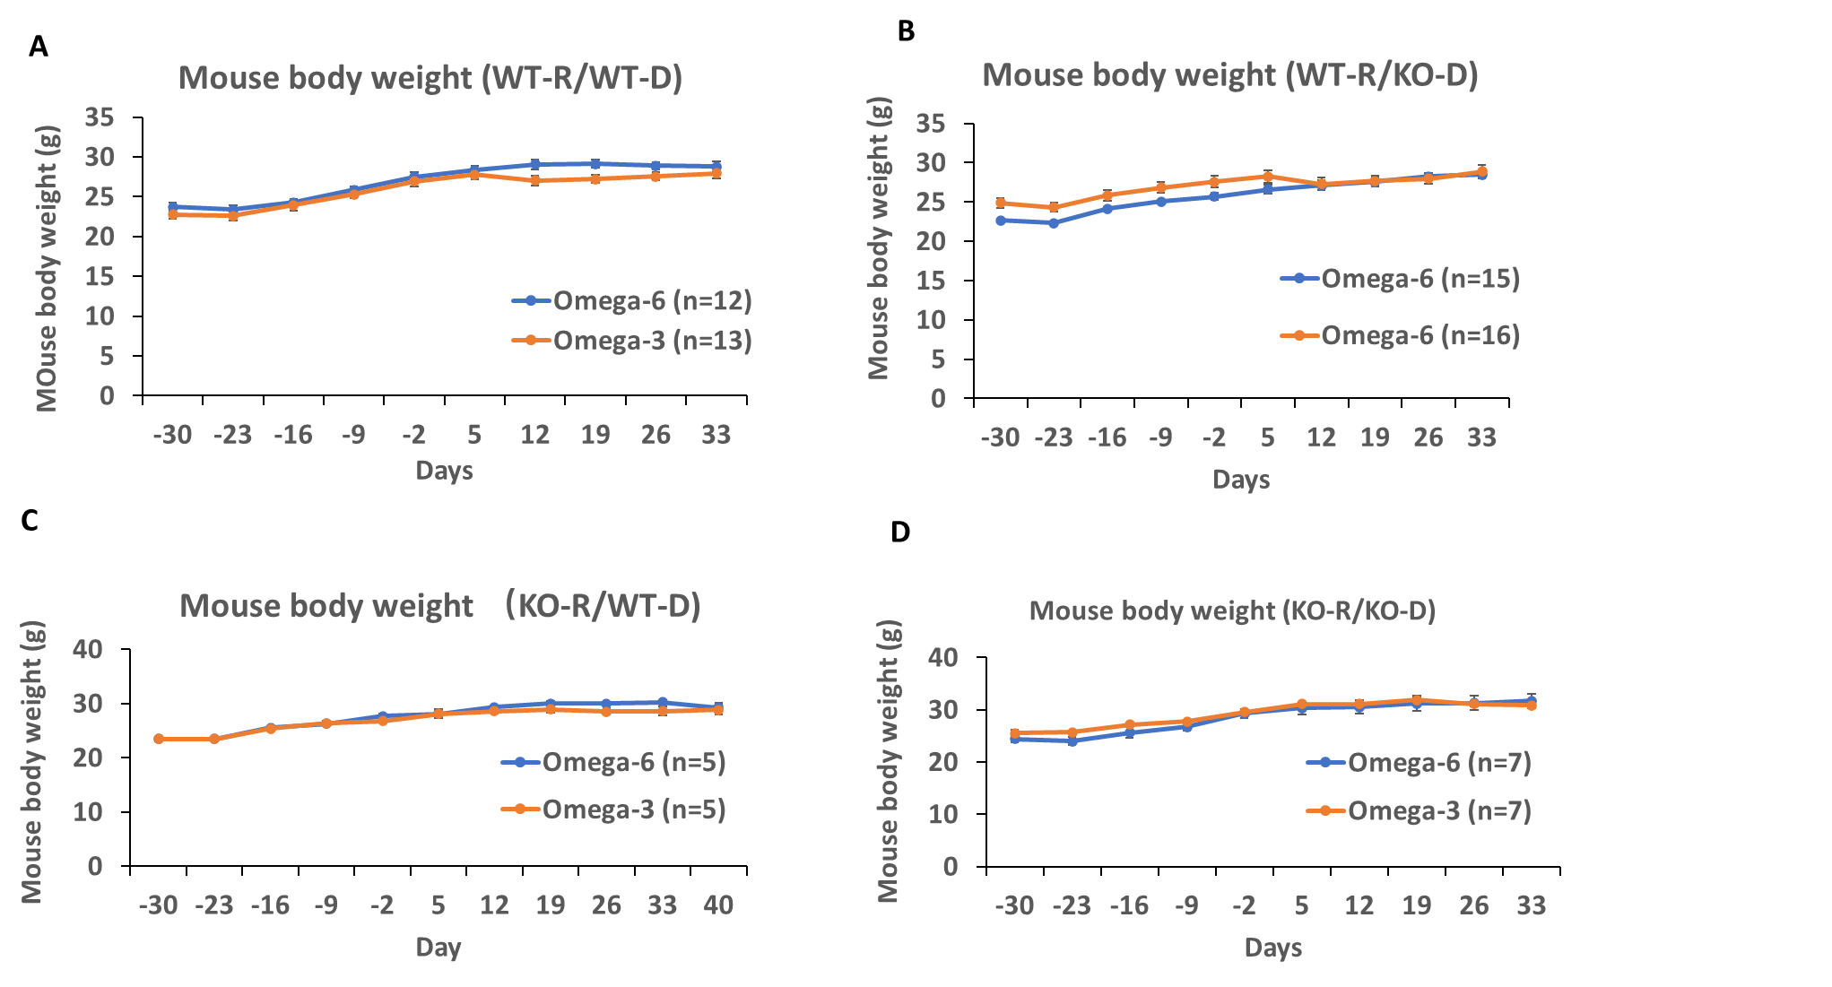

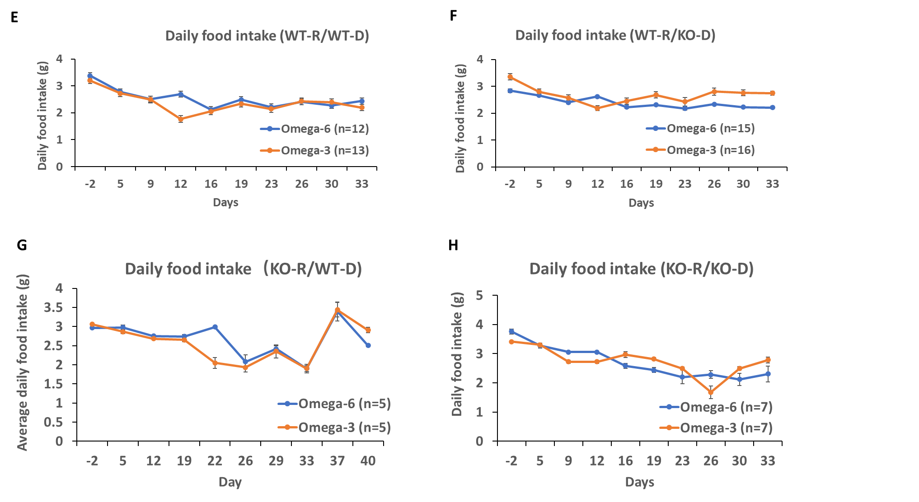
Supplementary Figure 1: Mouse body weight and food intake during the bone marrow transplant experiment. A-D) Mouse body weight. E-H) Daily food intake. WT-R = wild-type recipient, KO-R = GPR120 knockout recipient, WT-D = wild-type donor, KO-D = GPR120 knockout donor.

Supplementary Figure 2
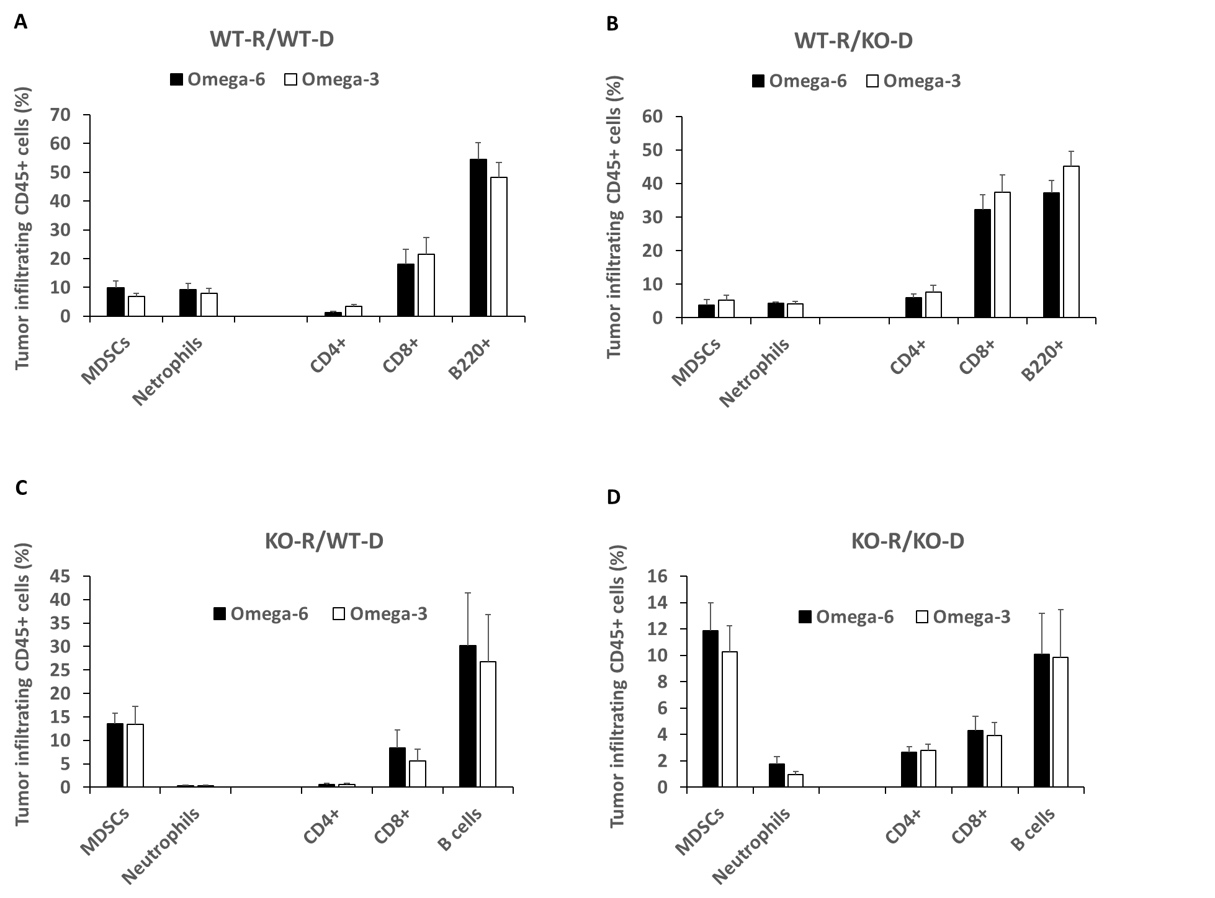
Supplementary Figure 2: GFP+ CD45+ cells infiltrating the allograft tumors. WT-R = wild-type recipient, KO-R = GPR120 knockout recipient, WT-D = wild-type donor, KO-D = GPR120 knockout donor.

Supplementary Figure 3
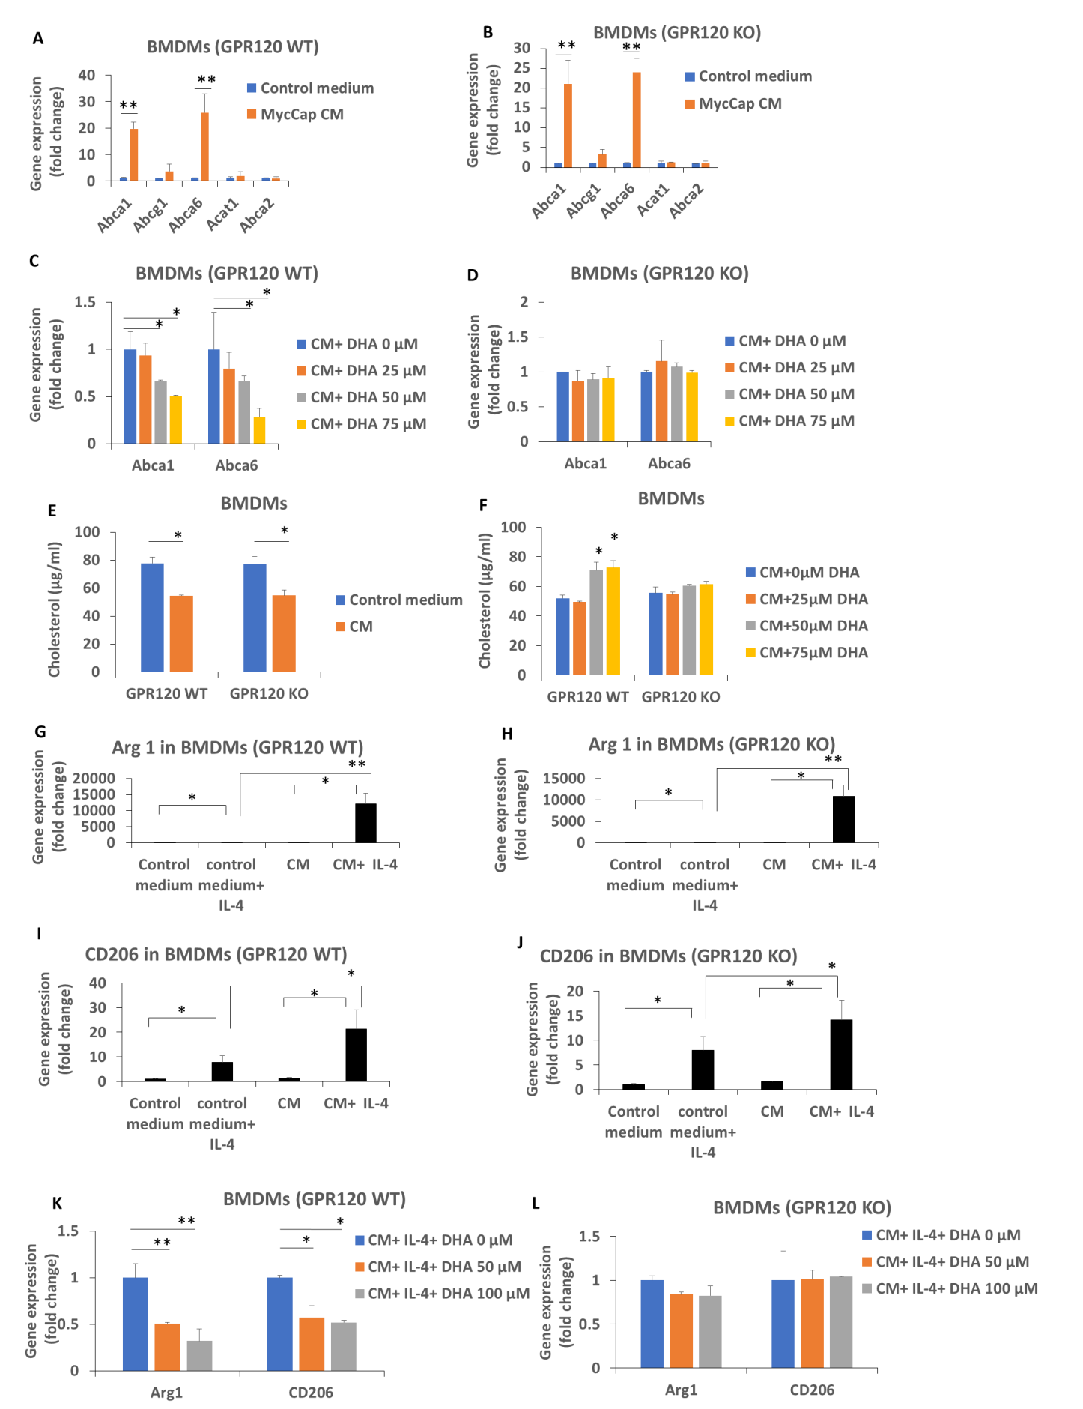

Supplementary Figure 3: MycCaP conditioned medium induced cholesterol efflux and conditioned medium induced gene expression of M2 markers was inhibited by DHA in bone marrow derived macrophages (BMDMs) with a functional GPR120 receptor. Bone marrow derived macrophages were generated as described in the methods section. (A,B) MycCaP conditioned media induced expression of cholesterol transporters in GPR120 WT and KO BMDMs. (C,D) DHA inhibition of cholesterol efflux enzymes induced by MycCaP conditioned media in GPR120 WT and KO BMDMs. (E) Effect of MycCaP conditioned media on cholesterol levels in GPR120 WT and KO BMDMs. (F) Effect of DHA on cholesterol levels in MycCaP conditioned media treated GRP120 WT and KO BMDMs. (G-J) Effect of MycCaP conditioned media on M2 markers in IL-4 treated GPR120 WT and KO BMDMs. (K,L) Effect of DHA on expression of M2 markers in MycCaP conditioned media and IL-4 treated GPR120 WT and KO BMDM’s. Significance determined by Student’s t-test (* < 0.05 and ** < 0.01).

Supplementary Figure 4
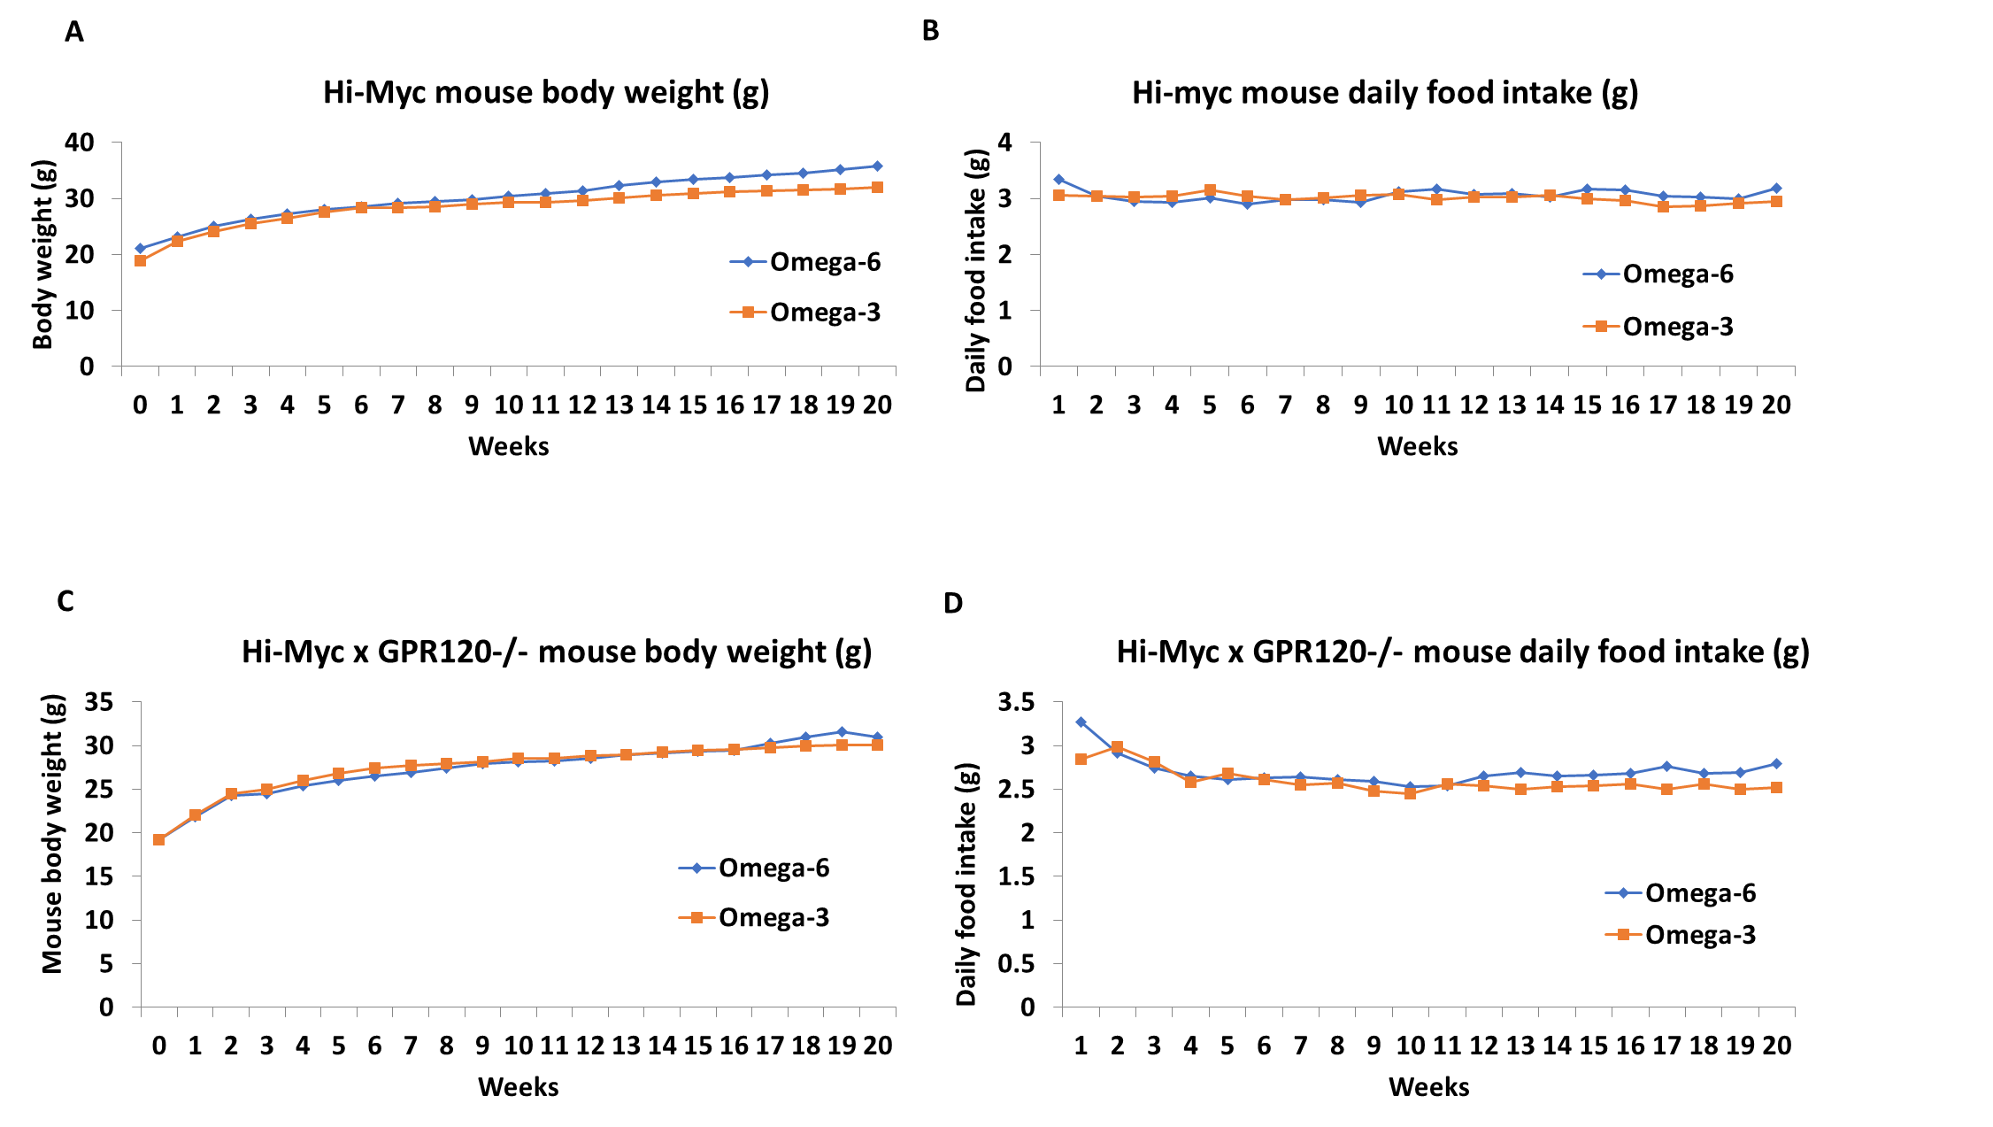

Supplementary Figure 4: Mouse body weight and and daily food intake of Hi-Myc mouse. Mouse body weight of Hi-Myc (A) or Hi-Myc x GPR120 KO mice (C). Mouse daily food intake of Hi-Myc (B) or Hi-Myc x GPR120 KO mice (D).

Supplementary Table 1： Primer list for genotyping
Hi-Myc | Gene of interest primer mix | Forward: 5’-CCTCCAGCAGAAGGTGATCC-3’  Reverse: 5’-AGCGACTCTGAGGAGGAACA-3’
Hi-Myc | Internal control primer mix | Forward: 5’-AATCGGAGAAGCAGGACCTTATC-3’  Reverse: 5’-TCCCGAAGTTGACATCAAACC-3’
Hi-Myc | Gene of interest probe | 5’-GCCTGCCTCTTTTCCACAGA-3’, probe label: FAM
Hi-Myc | Internal control probe | 5’-AGTGAAGTCCTAATTCC-3’, probe label: VIC
GFP | Gene of interest primer mix | Forward: 5’-AGT GCT TCA GCC GCT ACC-3’  Reverse: 5’- GAA GAT GGT GCG CTC CTG -3’
GFP | Internal control primer mix | Forward: 5’- CAC GTG GGC TCC AGC ATT -3’  Reverse: 5’- TCA CCA GTC ATT TCT GCC TTT G -3’
GFP | Gene of interest probe | 5’- TTC AAG TCC GCC ATG CCC GAA -3’, probe label: FAM
GFP | Internal control probe | 5’- CCA ATG GTC GGG CAC TGC TCA A -3’, probe label: VIC
GPR120 | Gene of interest primer mix | Forward: CCT GAG TGT GCA CAG ACG AC  Reverse: CAT CCG AGA AGA AAG GGA AG
GPR120 | WT Probe | 5’-CAC ACC CTG GAC CAA GTC A-3’, probe label: FAM
GPR120 | MUT Probe | 5’-CTC GCA CAC CAA GTC AAT CG-3’, probe label: VIC

Supplementary Table 2： Primer list for gene expression
Gene | Forward primer (5’3’) | Reverse primer (5’3’)
Mouse CD206 | ATGGATTGCCCTGAACAGCA | TGTACCGCACCCTCCATCTA
Mouse Arg1 | CAGCACTGAGGAAAGCTGGT | ACAGACCGTGGGTTCTTCAC
Mouse TNF-α | CACCACGCTCTTCTGTCTAC | CCATAGAACTGATGAGAGGG
Mouse CCL2 | GGCTGGAGAGCTACAAGAGG | GGTCAGCACAGACCTCTCTC
Mouse CCL22 | TGGACCTCAAAATCCTGCCG | CAGGTCCTCCTCCCTAGGAC
Mouse VEGF | ACTGGACCCTGGCTTTACTG | CTCTCCTTCTGTCGTGGGTG
Mouse MMP-9 | GACGACATAGACGGCATCCA | TGTTGTTCAGTTGTGGTGGT
Mouse IL-10 | TAGAGCTGCGGACTGCCT | TTTCCGATAAGGCTTGGC
Mouse CSF-1 | TGTTCTACAAGTGGAAGTGGAGG | TGGTGAGGGGTCATAGAA
Mouse Abca1 | GCAGAAACAGTAGCAGCAC | TCTCCTCCTCTGCCTCCAC
Mouse Abca6 | CGGAGAGCAGCCACCTACTT | ACGTGCACACTTAGCTCCTT
Mouse Abcg1 | AAGGTCTCCAATCTCGTGCC | CCCTGATGCCACTTCCATGA
Mouse Acat1 | CCAATGCCAGCACACTGAAC | TCTACGGCAGCATCAGCAAA
Mouse Acat2 | AGTGCTGGTGTCTTCCAGAAA | CTGATGCGTTCGCTGGGG
Mouse Ldlr | AGACCCAGAGCCATCGTAGT | CCACACCATTCAAACCCCCT
Mouse Hmgcr | AGAACAAGGGTTCACGCCCA | CAAAGGAAGTGACCCAGGCA
Mouse Sqle | GAGGCTACCGTGTTCTCCAG | TGGTTTCTGACAGTGGGTACG
Mouse LPl | AGCAAGACCTTCGTGGTGAT | GGCCCGATACAACCAGTCTA
Mouse Scarb1 | ATGCCCCAGGTTCTTCACTAC | CCTTATCCTGGGAGCCCTTTT
Mouse Fabp5 | CACGGCTTTGAGGAGTACAT | TCGGTTTTGACCGTGATGTT
Mouse Pparg | ATTAGATGACAGTGACTT | TGTCTTGGATGTCCTCGATG

Supplementary Table 3
 |  |  |  | Anterior | Ventral | Dorsal
Hi-Myc x GPR120 +/+ | Omega-6 | n=53 | Benign | 64.20% | 13.2% | 15.4%
Hi-Myc x GPR120 +/+ | Omega-6 | n=53 | PIN | 34.0% | 75.5% | 38.5%
Hi-Myc x GPR120 +/+ | Omega-6 | n=53 | Cancer | 1.90% | 11.30% | 46.2%
Hi-Myc x GPR120 +/+ | Omega-3 | n=62 | Benign | 74.6% | 25.4% | 25.8%
Hi-Myc x GPR120 +/+ | Omega-3 | n=62 | PIN | 25.4% | 69.8% | 38.7%
Hi-Myc x GPR120 +/+ | Omega-3 | n=62 | Cancer | 0.0% | 4.80% | 35.50%
Hi-Myc x GPR120 -/- | Omega-6 | n=37 | Benign | 37.8% | 18.9% | 13.5%
Hi-Myc x GPR120 -/- | Omega-6 | n=37 | PIN | 51.4% | 70.3% | 21.6%
Hi-Myc x GPR120 -/- | Omega-6 | n=37 | Cancer | 10.8% | 10.8% | 64.9%
Hi-Myc x GPR120 -/- | Omega-3 | n=41 | Benign | 46.3% | 26.8% | 12.2%
Hi-Myc x GPR120 -/- | Omega-3 | n=41 | PIN | 48.8% | 63.4% | 24.4%
Hi-Myc x GPR120 -/- | Omega-3 | n=41 | Cancer | 4.90% | 9.80% | 63.40%

Supplementary Table 3: Pathologic findings in Hi-Myc mice anterior, ventral, and dorsal prostate lobes receiving omega-3 or omega-6 fatty acid diets.

