Table 1: Materials properties for different parts of prosthetic leg
Model Reference | Properties
Ankle Assembly Parts
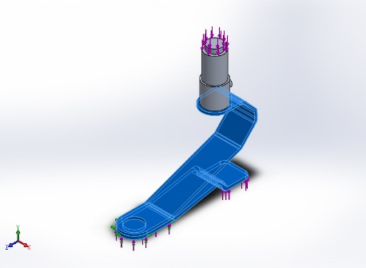
  Name: | Ti-5Al-2.5Sn Annealed (SS)
  Model type: | Linear Elastic Isotropic
  Default failure: | Max von Mises Stress
  Yield strength: | 7.44634e+008 N/m^2
  Tensile strength: | 8.61e+008 N/m^2
  Compressive strength: | 8.3e+008 N/m^2
  Elastic modulus: | 1.103e+011 N/m^2
  Poisson's ratio: | 0.31
  Mass density: | 4480 kg/m^3
  Shear modulus: | 4.8e+010 N/m^2
  Thermal expansion: | 9e-006 /Kelvin
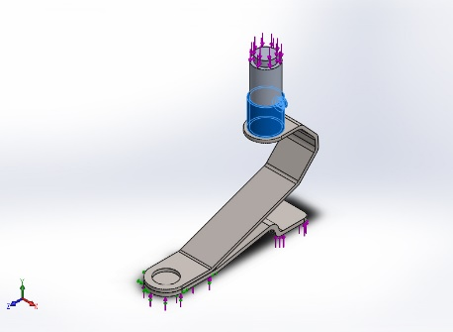
  Name: | 2024 Alloy (SN)
  Model type: | Linear Elastic Isotropic
  Default failure: | Max von Mises Stress
  Yield strength: | 7.58291e+007 N/m^2
  Tensile strength: | 1.86126e+008 N/m^2
  Elastic modulus: | 7.3e+010 N/m^2
  Poisson's ratio: | 0.33
  Mass density: | 2800 kg/m^3
  Shear modulus: | 2.8e+010 N/m^2
  Thermal expansion: | 2.3e-005 /Kelvin
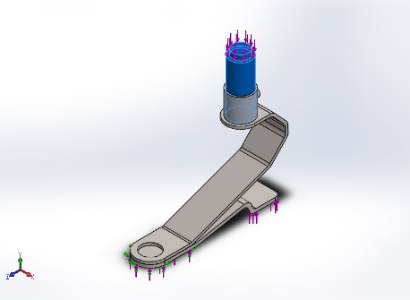
  Name: | 3003-H14, Rod (SS)
  Model type: | Linear Elastic Isotropic
  Default failure: | Max von Mises Stress
  Yield strength: | 1.45e+008 N/m^2
  Tensile strength: | 1.5e+008 N/m^2
  Elastic modulus: | 6.9e+010 N/m^2
  Poisson's ratio: | 0.33
  Mass density: | 2730 kg/m^3
  Shear modulus: | 2.5e+010 N/m^2
  Thermal expansion: | 2.3e-005 /Kelvin
Pneumatic assembly parts
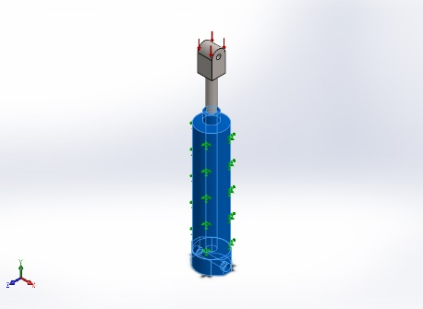
  Name: | Alumina
  Model type: | Linear Elastic Isotropic
  Tensile strength: | 3e+008 N/m^2
  Compressive strength: | 3e+009 N/m^2
  Elastic modulus: | 3.7e+011 N/m^2
  Poisson's ratio: | 0.22
  Mass density: | 3960 kg/m^3
  Shear modulus: | 1.5e+011 N/m^2
  Thermal expansion: | 7.4e-006 /Kelvin
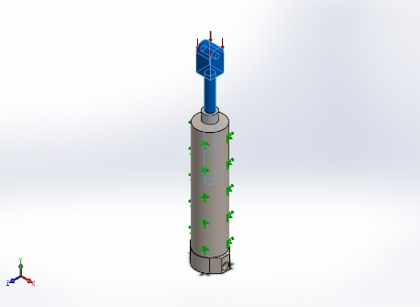
  Name: | Titanium Ti-8Al-1Mo-1V
  Model type: | Linear Elastic Isotropic
  Default failure: | Max von Mises Stress
  Yield strength: | 9.1e+008 N/m^2
  Tensile strength: | 9.37e+008 N/m^2
  Elastic modulus: | 1.2e+011 N/m^2
  Poisson's ratio: | 0.32
  Mass density: | 4370 kg/m^3
  Shear modulus: | 4.6e+010 N/m^2
  Thermal expansion: | 8.5e-006 /Kelvin
Limb shell
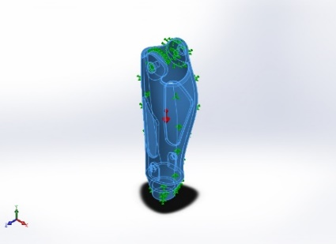
  Name: | PE High Density
  Model type: | Linear Elastic Isotropic
  Tensile strength: | 2.21e+007 N/m^2
  Elastic modulus: | 1.07e+009 N/m^2
  Poisson's ratio: | 0.4101
  Mass density: | 952 kg/m^3
  Shear modulus: | 3.772e+008 N/m^2

Table 2: volumetric properties of ankle assembly parts
Document Name and Reference | Treated As | Volumetric Properties
Fillet6  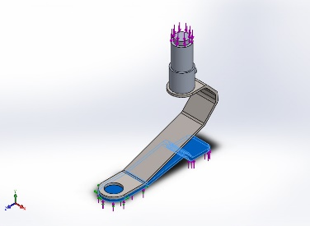 | Solid Body | Mass:0.383111 kg  Volume:8.55158e-005 m³  Density:4480 kg/m³  Weight:3.75449 N
Cut-Extrude7  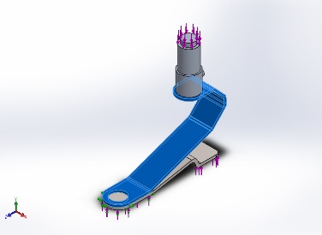 | Solid Body | Mass:0.465899 kg  Volume:0.000103995 m³  Density:4480 kg/m³  Weight:4.56581 N
Fillet1  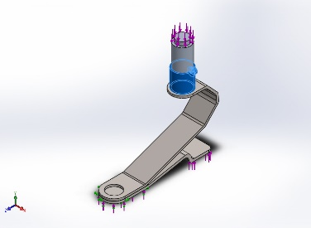 | Solid Body | Mass:0.0533369 kg  Volume:1.90489e-005 m³  Density:2800 kg/m³  Weight:0.522702 N
Revolve1  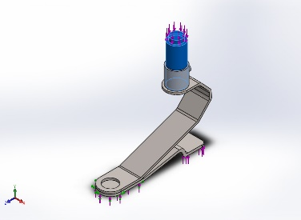 | Solid Body | Mass:0.362359 kg  Volume:0.000132732 m³  Density:2730 kg/m³  Weight:3.55112 N

Table 3: Load and fixtures for ankle part
Fixture Name | Fixture Image | Fixture Details
Fixed-1 | 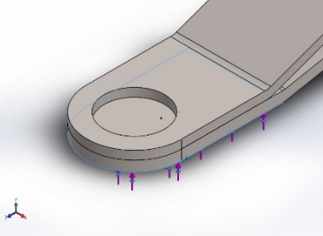 | Entities: 1 face(S)  Type: Fixed Geometry  Resultant Forces:
  Components | X | Y | Z | Resultant
  Reaction force(N) | -0.113014 | -200.049 | 0.144142 | 200.049
Load Name | Load Image | Load Details
Force-1 | 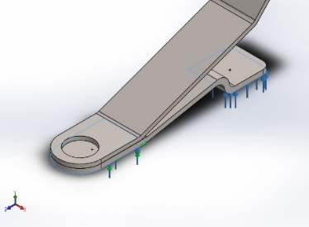
  Entities: | 2 face(s)
  Type: | Apply normal force
  Value: | 500 N
Force-2 | 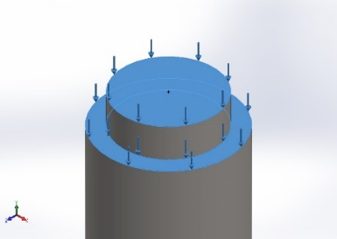
  Entities: | 2 face(s)
  Type: | Apply normal force
  Value: | 500 N

Table 4: Von-mises stress analysis for ankle assembly part
Type | Min | Max
VON: von Mises Stress | 3.776e-004N/mm² (MPa) | 1.536e+002N/mm² (MPa)
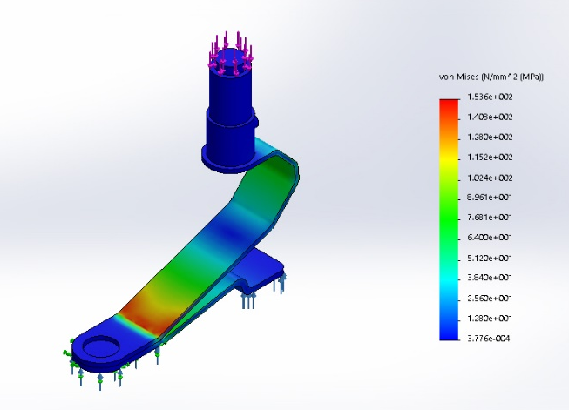

Table 5: Equivalent strain analysis for ankle assembly part
Type | Min | Max
ESTRN: Equivalent Strain | 1.611e-008 | 8.726e-004
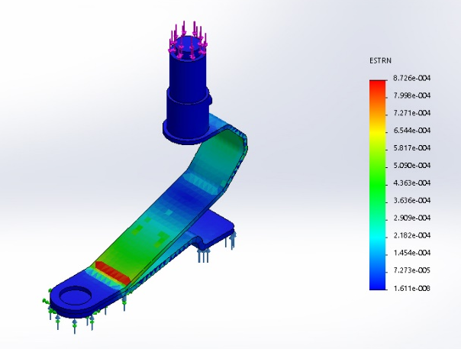

Table 6: resultant displacement analysis for ankle assembly part
Type | Min | Max
URES: Resultant Displacement | 0.000e+000mm | 6.904e+000mm
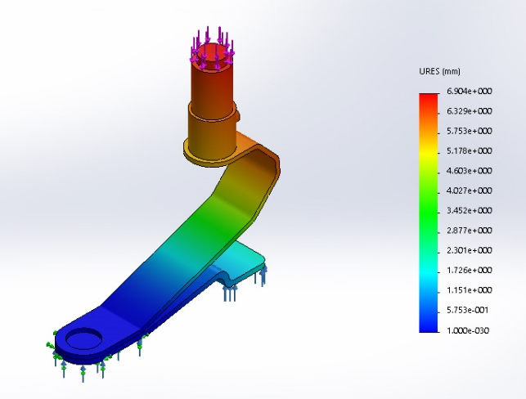

Table 7: factor of safety for ankle assemble part
Type | Min | Max
Factor of Safety | 4.848e+000 | 1.972e+006
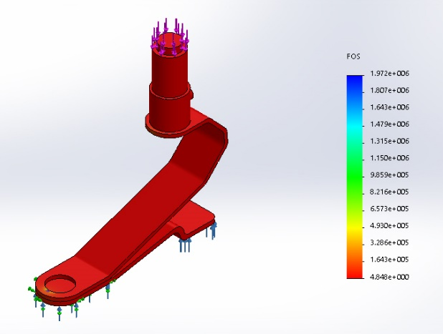

Table 8: volumetric properties of pneumatic shaft assembly
Document Name and Reference | Treated As | Volumetric Properties
Fillet1  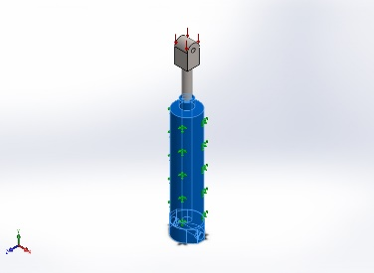 | Solid Body | Mass:0.527262 kg  Volume:0.000133147 m³  Density:3960 kg/m³  Weight:5.16717 N
Ø5.5 (5.5) Diameter Hole1  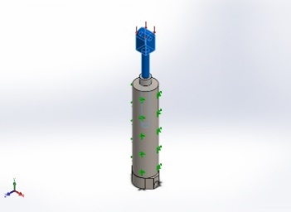 | Solid Body | Mass:0.0776634 kg  Volume:1.77719e-005 m³  Density:4370 kg/m³  Weight:0.761102 N

Table 9: load and fixtures for pneumatic shaft assembly
Fixture Name | Fixture Image | Fixture Details
Fixed-1 | 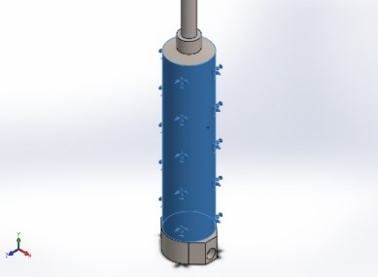 | Entities: 1 face(s)  Type: Fixed Geometry  Resultant Forces:
  Components | X | Y | Z | Resultant
  Reaction force(N) | 0.00402164 | 4806.24 | 0.142075 | 4806.24
Load Name | Load Image | Load Details
Pressure-1 | 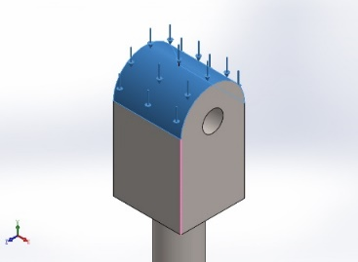
  Entities: | 1 face(s)
  Reference: | Edge< 1 >
  Type: | Along Edge
  Value: | -10
  Units: | N/mm² (MPa)
  Phase Angle: | 0
  Units: | deg

Table 10: von-mises stress for pneumatic shaft assembly
Type | Min | Max
VON: von Mises Stress | 4.123e-007N/mm² (MPa) | 7.039e+001N/mm² (MPa)
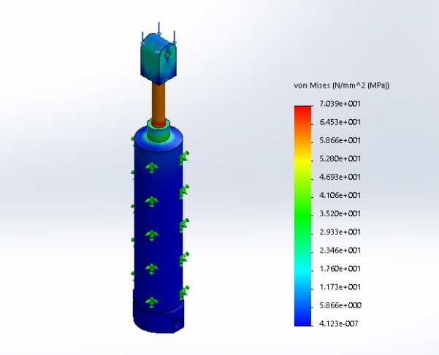

Table 11: equivalent strain for pneumatic shaft assembly
Type | Min | Max
ESTRN: Equivalent Strain | 1.058e-012 | 4.565e-004
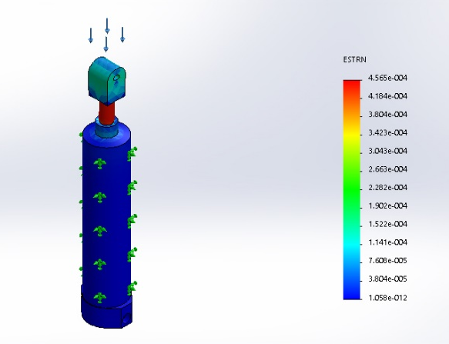

Table 12: resultant displacement for pneumatic shaft assembly
Type | Min | Max
URES: Resultant Displacement | 0.000e+000mm | 2.859e-002mm
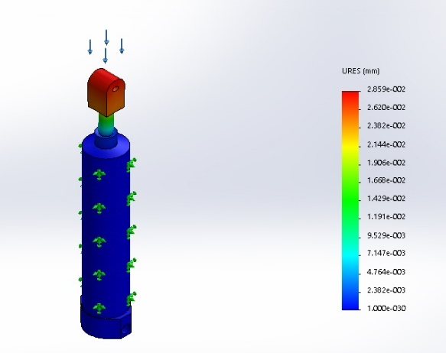

Table 13: factor of safety for pneumatic shaft assembly
Type | Min | Max
Factor of Safety | 1.000e+001 | 6.161e+011
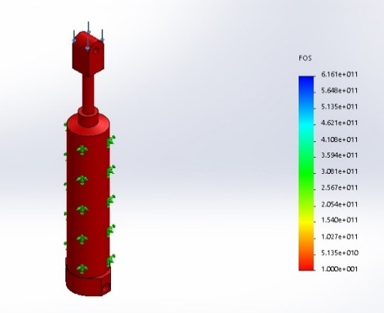

Table 14: volumetric properties of limb shell
Document Name and Reference | Treated As | Volumetric Properties
Fillet4  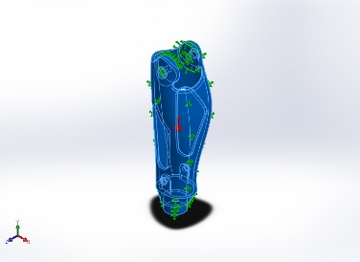 | Solid Body | Mass:0.373722 kg  Volume:0.000392565 m^3  Density:952 kg/m^3  Weight:3.66247 N
Shell Bodies
Surface-3  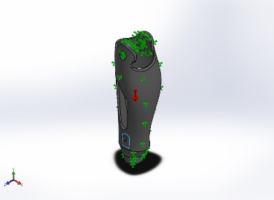 | Thin | Thickness:2 mm  Weight:0.0120009 N  Volume:1.28632e-006 m^3  Mass:0.00122458 kg  Density:952kg/m^3

Table 15: fixture details of limb shell
Fixture Name | Fixture Image | Fixture Details
Fixed-1 | 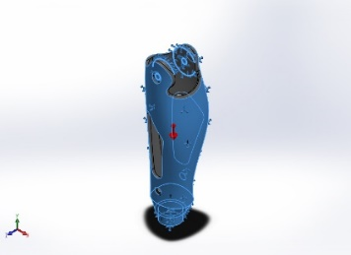 | Entities: 4edge(s), 3 face(s)  Type: Fixed Geometry  Resultant Forces:
  Components | X | Y | Z | Resultant
  Reaction force(N) | -1.83645e-008 | 3.67619 | -7.71252e-009 | 3.67619

