Table S1. Studies in EPIC and EHBCCG
Nested case-control studies in EPIC | Studies in EHBCCG
- Breast cancer in pre-menopausal women¹  - Breast cancer in post-menopausal women²  - Cervical cancer³  - Endometrial cancer⁴  - Hepatocellular carcinoma⁵  - Ovarian cancer⁶  - Thyroid cancer⁷ | - Cancer Prevention Study-II Nutrition Cohort (CPS-II), USA⁸  - Malmo/Umea, Sweden⁹  - Melbourne Collaborative Cohort Study (MCCS), Australia¹⁰  - Multiethnic Cohort (MEC), USA¹¹  - New York University Women’s Health Study (NYU WHS), USA¹²⁻¹⁴  - Nurses’ Health Study I & II (NHS I & II), USA¹⁵⁻¹⁸  - Prostate, Lung, Colorectal and Ovarian Cancer Screening Trial (PLCO), USA¹⁹  - Study of Hormones and Diet in the Etiology of Breast Tumors (ORDET), Italy²⁰  - Study of Osteoporotic Fractures (SOF), USA²¹  - UK Collaborative Trial of Ovarian Cancer Screening (UKCTOCS), UK²²  - Women’s Health Initiative, Observational Study (WHI-OS), USA²³
References
1. Kaaks R, Berrino F, Key T, et al. Serum sex steroids in premenopausal women and breast cancer risk within the European Prospective Investigation into Cancer and Nutrition (EPIC). JNCI: Journal of the National Cancer Institute. 2005;97(10):755-765.
2. Kaaks R, Rinaldi S, Key TJ, et al. Postmenopausal serum androgens, oestrogens and breast cancer risk: the European prospective investigation into cancer and nutrition. Endocrine-related cancer. 2005;12(4):1071-1082.
3. Rinaldi S, Plummer M, Biessy C, et al. Endogenous sex steroids and risk of cervical carcinoma: results from the EPIC study. Cancer Epidemiology Biomarkers &amp; Prevention. 2011;20(12):2532-2540.
4. Allen NE, Key TJ, Dossus L, et al. Endogenous sex hormones and endometrial cancer risk in women in the European Prospective Investigation into Cancer and Nutrition (EPIC). Endocrine-related cancer. 2008;15(2):485-497.
5. Lukanova A, Becker S, Hüsing A, et al. Prediagnostic plasma testosterone, sex hormone-binding globulin, IGF-I and hepatocellular carcinoma: Etiological factors or risk markers? International journal of cancer. 2014;134(1):164-173.
6. Rinaldi S, Dossus L, Lukanova A, et al. Endogenous androgens and risk of epithelial ovarian cancer: results from the European Prospective Investigation into Cancer and Nutrition (EPIC). Cancer Epidemiol Biomarkers Prev. 2007;16(1):23-29.
7. Rinaldi S, Dossus L, Kerski-Rehkonen P, et al. Circulating endogenous sex steroids and risk of differentiated thyroid carcinoma in men and women. (in preparation).
8. Gaudet MM, Patel AV, Teras LR, et al. Obesity-related markers and breast cancer in CPS-II Nutrition Cohort. International Journal of Molecular Epidemiology and Genetics. 2013;4(3):156-166.
9. Manjer J, Johansson R, Berglund G, et al. Postmenopausal breast cancer risk in relation to sex steroid hormones, prolactin and SHBG (Sweden). Cancer Causes and Control. 2003;14(7):599-607.
10. Baglietto L, English DR, Hopper JL, et al. Circulating steroid hormone concentrations in postmenopausal women in relation to body size and composition. Breast Cancer Research and Treatment. 2009;115(1):171-179.
11. Woolcott CG, Shvetsov YB, Stanczyk FZ, et al. Plasma sex hormone concentrations and breast cancer risk in an ethnically diverse population of postmenopausal women: the Multiethnic Cohort Study. Endocrine-related cancer. 2010;17(1):125-134.
12. Toniolo PG, Levitz M, Zeleniuch-jacquotte A, et al. A prospective study of endogenous estrogens and breast cancer in postmenopausal women. Journal of the National Cancer Institute. 1995;87(3):190-197.
13. Zeleniuch-Jacquotte A, Bruning PF, Bonfrer JMG, et al. Relation of serum levels of testosterone and dehydroepiandrosterone sulfate to risk of breast cancer in postmenopausal women. American Journal of Epidemiology. 1997;145(11):1030-1038.
14. Zeleniuch-Jacquotte A, Shore RE, Koenig KL, et al. Postmenopausal levels of oestrogen, androgen, and SHBG and breast cancer: Long-term results of a prospective study. Br J Cancer. 2004;90(1):153-159.
15. Eliassen AH, Missmer SA, Tworoger SS, et al. Endogenous Steroid Hormone Concentrations and Risk of Breast Cancer Among Premenopausal Women. Journal of the National Cancer Institute. 2006;98(19):1406-1415.
16. Tworoger SS, Missmer SA, Eliassen AH, et al. The association of plasma DHEA and DHEA sulfate with breast cancer risk in predominantly premenopausal women. Cancer Epidemiol Biomarkers Prev. 2006;15(5):967-971.
17. Fortner RT, Eliassen AH, Spiegelman D, Willett WC, Barbieri RL, Hankinson SE. Premenopausal endogenous steroid hormones and breast cancer risk: results from the Nurses' Health Study II. Breast Cancer Research. 2013;15(2):R19.
18. Zhang X, Tworoger SS, Eliassen AH, Hankinson SE. Postmenopausal plasma sex hormone levels and breast cancer risk over 20 years of follow-up. Breast Cancer Res Treat. 2013;137(3):883-892.
19. Fuhrman BJ, Schairer C, Gail MH, et al. Estrogen metabolism and risk of breast cancer in postmenopausal women. JNCI: Journal of the National Cancer Institute. 2012;104(4):326-339.
20. Berrino F, Muti P, Micheli A, et al. Serum sex hormone levels after menopause and subsequent breast cancer. Journal of the National Cancer Institute. 1996;88(5):291-296.
21. Elevated serum estradiol and testosterone concentrations are associated with a high risk for breast cancer. Annals of Internal Medicine. 1999;130(4_Part_1):270-277.
22. Fourkala E-O, Zaikin A, Burnell M, et al. Association of serum sex steroid receptor bioactivity and sex steroid hormones with breast cancer risk in postmenopausal women. Endocrine-related cancer. 2012;19(2):137-147.
23. Gunter MJ, Hoover DR, Yu H, et al. Insulin, insulin-like growth factor-I, and risk of breast cancer in postmenopausal women. JNCI: Journal of the National Cancer Institute. 2009;101(1):48-60.

Table S2. Studies that contributed to each hormone analysis and number of women involved
 | Oestradiol | Oestrone | Progesterone | Testosterone | Androstenedione | DHEAS | SHBG
Pre-menopausal women | 38,110 | 2,520 | 3,993 | 41,846 | 3,233 | 4,227 | 38,399
UK Biobank | 34,086 |  |  | 36,283 |  |  | 32,807
EPIC | 1,907 | 1,105 | 1,808 | 2,289 | 1,403 | 1,398 | 2,299
Breast cancer | 1,336 | 744 | 1,247 | 1,386 | 801 | 798 | 1,389
Cervical cancer | 290 |  | 283 | 305 |  | 275 | 301
Endometrial cancer |  | 80 |  | 78 | 81 | 81 | 81
Ovarian cancer |  |  |  | 238 | 240 | 244 | 242
Thyroid cancer | 281 | 281 | 278 | 281 | 281 |  | 285
Liver cancer, controls only |  |  |  | 1 |  |  | 1
EHBCCG | 2,117 | 1,415 | 2,185 | 3,274 | 1,830 | 2,829 | 3,293
NHS II phase I | 486 | 543 | 544 | 643 | 653 | 651 | 653
NHS II phase 2 | 867 | 872 | 877 | 997 |  | 1,002 | 990
NYU WHS |  |  |  | 870 | 880 | 879 | 886
ORDET | 764 |  | 764 | 764 | 297 | 297 | 764
Post-menopausal women | 10,037 | 7,362 |  | 158,285 | 7,454 | 7,938 | 145,214
UK Biobank |  |  |  | 148,491 |  |  | 135,257
EPIC | 3,221 | 2,473 |  | 4,244 | 3,550 | 3,486 | 4,318
Breast cancer | 2,188 | 1,688 |  | 2,173 | 1,735 | 1,736 | 2,193
Cervical cancer | 228 |  |  | 258 |  | 236 | 261
Endometrial cancer | 515 | 489 |  | 500 | 528 | 506 | 514
Ovarian cancer |  |  |  | 960 | 991 | 1,008 | 996
Thyroid cancer | 290 | 296 |  | 296 | 296 |  | 297
Liver cancer, controls only |  |  |  | 57 |  |  | 57
EHBCCG | 6,816 | 4,889 |  | 5,550 | 3,904 | 4,452 | 5,639
CPS-II Nutrition Cohort | 473 | 508 |  | 480 |  |  | 556
Malmö/Umeå |  | 282 |  | 275 | 275 | 276 | 283
MCCS | 971 |  |  | 979 | 980 | 979 | 983
MEC | 441 | 442 |  | 442 | 204 | 439 | 440
NHS I | 915 | 901 |  | 896 | 893 | 908 | 892
NYU WHS | 739 | 1,202 |  | 745 | 743 | 739 | 746
ORDET | 676 |  |  | 676 |  | 304 | 676
PLCO | 745 | 745
SOF | 586 | 344 |  | 599 | 344 | 344 | 600
UKCTOCS | 456 | 465 |  | 458 | 465 | 463 | 463
WHI-OS | 814
CPS II Nutrition Cohort = Cancer Prevention Study-II Nutrition Cohort, USA; EPIC = European Prospective Investigation into Cancer and Nutrition; EHBCCG = Endogenous Hormones and Breast Cancer Collaborative Group; MCCS = Melbourne Collaborative Cohort Study, Australia; MEC = Multiethnic Cohort, USA; NHS I & II = Nurses’ Health Study I & II, USA; NYU WHS = New York University Women’s Health Study, USA; ORDET = Study of Hormones and Diet in the Etiology of Breast Tumors, Italy; PLCO = Prostate, Lung, Colorectal, and Ovarian Cancer Screening Trial, USA; SOF = Study of Osteoporotic Fractures, USA; UKCTOCS = United Kingdom Collaborative Trial of Ovarian Cancer Screening, UK; WHI-OS = Women’s Health Initiative, Observational Study, USA.

Table S3. Measurement of usual alcohol intake in individual studies
Study | Measurement of usual alcohol intake
UK Biobank | Average intake of red wine (field ID: 4407, 1568), champagne and white wine (4418, 1578), beer and cider (4429, 1588), fortified wine (4451, 1608) or other alcoholic drinks (4462, 5364) over last year
EPIC* | Average intake of wine, beer, lager or cider, port, sherry, vermouth, liqueurs or spirits over last year
CPS-II Nutrition Cohort | Average intake of beer, wine or liquor over last year
Malmö/Umeå | Intake frequency over last year and dietary diary covering one week
MCCS | Average intake of wine, beer or spirits during the decade of life corresponding to age at baseline attendance
MEC | Average intake of beer, wine or liquor over last year
NYU WHS | Average intake of beer, wine or liquor in a week (assessed retrospectively in the 2nd follow-up questionnaire)
NHS I & II | Average intake of beer, wine or liquor over last year
PLCO | Average intake of beer, wine or liquor over last year
ORDET | Average intake of wine, spirits or fortified wine over last year
SOF | Average intake in past 30 days
UKCTOCS | Average intake each week
WHI-OS | Average intake during lifetime
CPS II Nutrition Cohort = Cancer Prevention Study-II Nutrition Cohort, USA; EPIC = European Prospective Investigation into Cancer and Nutrition; EHBCCG = Endogenous Hormones and Breast Cancer Collaborative Group; MCCS = Melbourne Collaborative Cohort Study, Australia; MEC = Multiethnic Cohort, USA; NHS I & II = Nurses’ Health Study I & II, USA; NYU WHS = New York University Women’s Health Study, USA; ORDET = Study of Hormones and Diet in the Etiology of Breast Tumors, Italy; PLCO = Prostate, Lung, Colorectal, and Ovarian Cancer Screening Trial, USA; SOF = Study of Osteoporotic Fractures, USA; UKCTOCS = United Kingdom Collaborative Trial of Ovarian Cancer Screening, UK; WHI-OS = Women’s Health Initiative, Observational Study, USA.
* Measurement in EPIC UK (Oxford and Cambridge)
Table S4. Blood sample, assay used and coefficient of variation (CV) % for each hormone and SHBG
 | Sample | Oestradiol |  | Oestrone |  | Progesterone |  | Testosterone |  | Androstenedione |  | DHEAS |  | SHBG
 | Sample | Method | CV % | Method | CV % | Method | CV % | Method | CV % | Method | CV % | Method | CV % | Method | CV %
Pre-menopausal women
UK Biobank | Serum | CIA | 6.47-15.26 |  |  |  |  | CIA | 3.66-8.34 |  |  |  |  | CIA | 5.22-5.67
EPIC
Breast cancer | Serum | RIA | 3.2/7.2 | RIA | 4.9/12.6 | RIA | 7.4/9.4 | RIA | 8.4/15.3 | RIA | 5.8/18.9 | RIA | 6.1/12.4 | IRMA | 6.7/16.5
Cervical cancer | Mainly serum | RIA | 2.3 |  |  | RIA | 4.4 | RIA | 8.5 |  |  | RIA | 8.8 | IRMA | 7.2
Endometrial cancer | Serum | RIA | 8.4/20.0 | RIA | 7.4/16.0 |  |  | RIA | 6.6/12.0 | RIA | 3.0/8.4 | RIA | 5.5/14.0 | IRMA | 3.9/11.0
Ovarian cancer | Serum |  |  |  |  |  |  | RIA | 6.6/11.0 | RIA | 3.0/8.4 | RIA | 3.4/11.6 | IRMA | 4.2/10.7
Thyroid cancer | Plasma | LC-MS | 14.6/14.2 | LC-MS | 14.7/12.4 | LC-MS | 17.3/16.3 | LC-MS | 7.2/6.1 | LC-MS | 9.0/8.0 |  |  | IRMA | 5.4/10.6
Liver cancer, controls only |  |  |  |  |  |  |  | RIA | 7.4/17.0 |  |  |  |  | IRMA | 4.6/9.7
EHBCCG
NHS II phase I | Plasma | E RIA | -/≤14 | E RIA | -/≤14 | CIA | 3/17 | E RIA | -/9 | RIA | -/≤14 | CIA | -/≤12 | CIA | -/≤14
NHS II phase 2 | Plasma | LC-MS | -/≤13 | LC-MS | -/≤10 | CIA |  | LC-MS | -/≤14 |  |  | CIA | -/≤11 | CIA | -/≤14
NYU WHS | Serum |  |  |  |  |  |  | RIA | 8.7/15.8 | RIA | 7.8/13.5 | RIA | 5.4/14.7 | IRMA | 5.6/13.5
ORDET | Serum | RIA | 5.9-14.0/ 7.4-16.4 |  |  | RIA | 8.7/10.6 | RIA | 4.6/9.1 | RIA | 2.7/4.8 | RIA | 7.0/13.8 | IRMA | 3.5/9.6
Post-menopausal women
UK Biobank* | Serum |  |  |  |  |  |  | CIA | 3.66-8.34 |  |  |  |  | CIA | 5.22-5.67
EPIC
Breast cancer
Cervical cancer | Mainly serum | RIA | 2.3 |  |  |  |  | RIA | 8.5 |  |  | RIA | 8.8 | IRMA | 7.2
Endometrial cancer | Serum | RIA | 8.4/20.0 | RIA | 7.4/16.0 |  |  | RIA | 6.6/12.0 | RIA | 3.0/8.4 | RIA | 5.5/14.0 | IRMA | 3.9/11.0
Ovarian cancer | Serum |  |  |  |  |  |  | RIA | 6.6/11.0 | RIA | 3.0/8.4 | RIA | 3.4/11.6 | IRMA | 4.2/10.7
Thyroid cancer | Plasma | LC-MS |  | LC-MS |  |  |  | LC-MS |  | LC-MS |  |  |  | IRMA
Liver cancer, controls only | Plasma |  |  |  |  |  |  | RIA | 7.4/17.0 |  |  |  |  | IRMA | 4.6/9.7
EHBCCG
CPS-II Nutrition Cohort | Serum | LC-MS/MS | 10 | LC-MS/MS | 7 |  |  | LC-MS/MS | 13 |  |  |  |  | LC-MS/MS | 5
Malmö/Umeå | Plasma |  |  | RIA | 20.6 |  |  | E RIA | ≤15 | E RIA | ≤15 | RIA | ≤15 | IMF | ≤15
MCCS | Plasma | ECIA | 10 |  |  |  |  | ECIA | 7 | RIA | 15 | CoIA | 10 | IRMA | 7
MEC | Plasma | E RIA | 9 | E RIA | 10 |  |  | E RIA | 3.5 | E RIA | 6 | RIA | 4.5 | CIA | 8
NHS I | Plasma | E RIA | 11 | E RIA | 12.1 |  |  | E RIA | 12.3 | E RIA | 12.1 | RIA | 9 | IA | 15.5
NYU WHS | Serum | RIA | 13.2 | RIA | 14.4 |  |  | RIA | 15.8 | RIA | 13.5 | RIA | 14.7 | IRMA | 13.5
ORDET | Serum | E RIA | 9.6 |  |  |  |  | RIA | 7.3 |  |  | RIA | 3.7 | IRMA | 4.4
PLCO | Serum | LC-MS | <3 | LC-MS | <3
SOF | Serum | E RIA | 11 | E RIA | 17 |  |  | CP RIA | 13 | E RIA | 16 | RIA | 12 | RIA | 7.8
UKCTOCS | Serum | IA | 1.6-5.7/2.3-6.2 | IA | 4.5-9.3/7.4-12.9 | IA | 1.5-2.7/3.7-5.4 | IA | 0.9-4.6/1.6-7.4 | IA | 3.5-11.3/4.4-13.2 | IA | 0.8-1.8/1.9-5.2 | IA | 2.1-2.7/2.6-5.6
WHI-OS | Serum | IA | 5.9
CV = coeffiecient of variation, intra-assay/inter-assay
Studies: CPS II Nutrition Cohort = Cancer Prevention Study-II Nutrition Cohort, USA; EPIC = European Prospective Investigation into Cancer and Nutrition; EHBCCG = Endogenous Hormones and Breast Cancer Collaborative Group; MCCS = Melbourne Collaborative Cohort Study, Australia; MEC = Multiethnic Cohort, USA; NHS I & II = Nurses’ Health Study I & II, USA; NYU WHS = New York University Women’s Health Study, USA; ORDET = Study of Hormones and Diet in the Etiology of Breast Tumors, Italy; PLCO = Prostate, Lung, Colorectal, and Ovarian Cancer Screening Trial, USA; SOF = Study of Osteoporotic Fractures, USA; UKCTOCS = United Kingdom Collaborative Trial of Ovarian Cancer Screening, UK; WHI-OS = Women’s Health Initiative, Observational Study, USA.
Assays: CIA = chemiluminescent immunoassay; CoIA = competitive immunoassay; CP = chromatographic purification; ECIA = electrochemiluminescence immunoassay; E RIA = radioimmunoassay with extraction; IA = immunoassay; IMF = immunofluorometry; IRMA = immunoradiometric assay; LC-MS = liquid chromatography-tandem mass spectrometry; RIA = radioimmunoassay
* Oestradiol for post-menopausal women in UK Biobank was not reported as almost all women had a very low concentration that was below the reportable range for the assay.

Table S5. Studies included in subgroup analyses by assay type
 | Pre-menopausal women | Post-menopausal women
Direct | UK Biobank | UK Biobank
 | EPIC excluding thyroid cancer substudy | EPIC excluding thyroid cancer substudy
 | EHBCCG: NYU WHS* | EHBCCG: MCCS
 | ORDET | NYU WHS
 |  | ORDET
 |  | Swedish Malmö/Umeå*
 |  | UKCTOCS
 |  | WHI-OS
Extraction | EHBCCG: NHS II phase 1 | EHBCCG: Malmö/Umeå**
 |  | MEC
 |  | NHS I (cases diagnosed before 1 June 1998 and matched controls)
 |  | SOF
Mass spectrometry | EPIC: thyroid cancer substudy | EPIC: thyroid cancer substudy
 | EHBCCG: NHS II phase 2 | EHBCCG: CPS II Nutrition Cohort
 |  | NHS I (cases diagnosed after 31 May 1998 and matched controls)
 |  | PLCO**
* Assay used to measure testosterone only
** Assay used to measure oestrogens only
CPS II Nutrition Cohort = Cancer Prevention Study-II Nutrition Cohort, USA; EPIC = European Prospective Investigation into Cancer and Nutrition; EHBCCG = Endogenous Hormones and Breast Cancer Collaborative Group; MCCS = Melbourne Collaborative Cohort Study, Australia; MEC = Multiethnic Cohort, USA; NHS I & II = Nurses’ Health Study I & II, USA; NYU WHS = New York University Women’s Health Study, USA; ORDET = Study of Hormones and Diet in the Etiology of Breast Tumors, Italy; PLCO = Prostate, Lung, Colorectal, and Ovarian Cancer Screening Trial, USA; SOF = Study of Osteoporotic Fractures, USA; UKCTOCS = United Kingdom Collaborative Trial of Ovarian Cancer Screening, UK; WHI-OS = Women’s Health Initiative, Observational Study, USA.

Table S6. Association parameters of rs1229984 (effect allele: C; other allele: T; chromosome: 4; position: 100239319)
 | β | SE | p-value
Self-reported alcohol intake* | 0.145 | 0.008 | 1.12E-65
Total testosterone** | 0.023 | 0.010 | 0.021
Free testosterone** | 0.043 | 0.010 | 2.9E-05
SHBG** | -0.044 | 0.009 | 9.9E-07
* Effect estimates for 1 SD increment in self-reported alcohol intake (SD ~ 9 drinks/week)
** Effect estimates for 1 SD increase in hormone concentrations (SD ~ 1 nmol/L for total testosterone; 10 pmol/L for free testosterone and 30 nmol/L for SHBG)
SE = standard error

Figure S1. Associations of usual alcohol intake (per 10 g/day increment) with hormones and SHBG, restricted to pre- and post-menopausal women who reported intake of <15 g/day
DHEAS = Dehydroepiandrosterone sulphate; SHBG = Sex hormone binding globulin
* Percent difference in concentrations of hormones and SHBG per 10 g/day increment in usual alcohol intake
** Relative difference in concentrations of hormones and SHBG per 10 g/day increment in usual alcohol intake

Figure S2. Z-Z Locus plot depicting correlations between Z-scores for alcohol intake and those for free testosterone and SHBG at the locus of interest, i.e., window ±75 kb from rs1229984
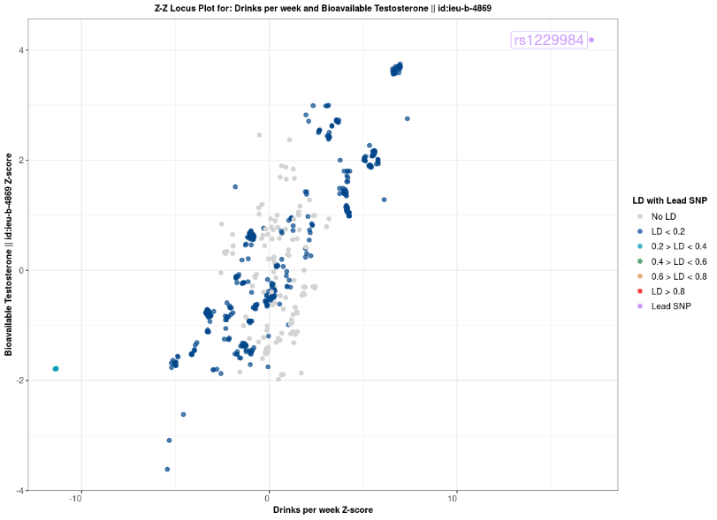
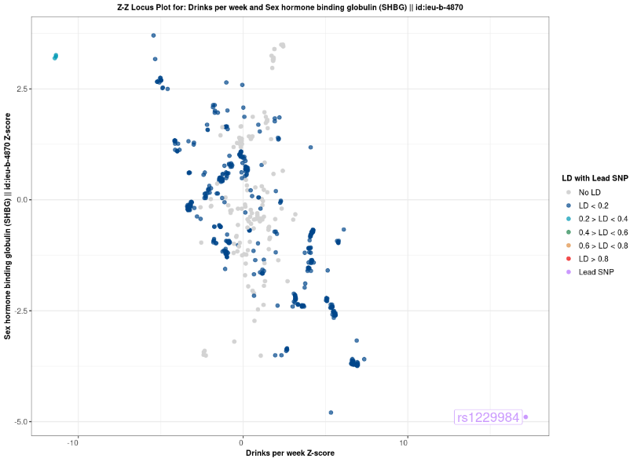
Free testosterone
SHBG

