Figure.1. Inhibition of glycolysis improves motor function and alleviates microglial activation in PD mice.
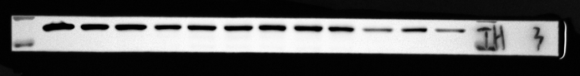
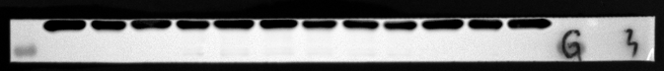
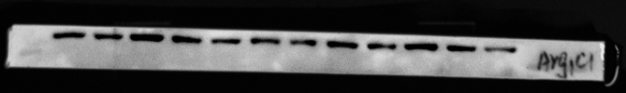
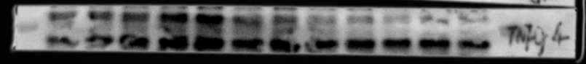
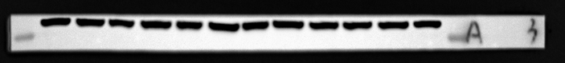
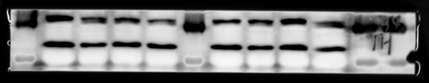
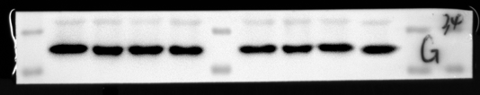

FIG.S1.Inhibition of glycolysis improved motor function and reduced microglial activation in PD mice
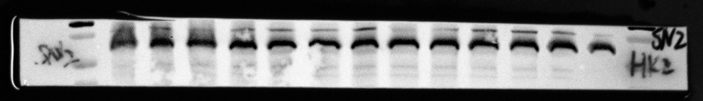
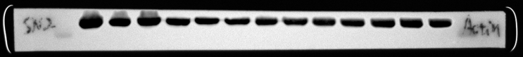
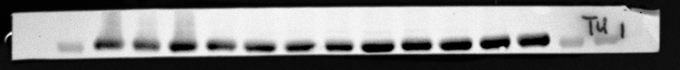
Figure.2. Enhanced glycolysis-derived lactate promotes microglial activation.
LDHA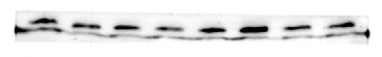
β-actin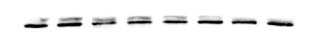
iNOS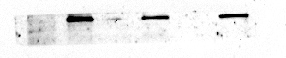
actin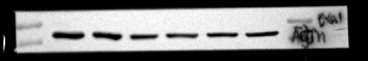

Figure. S2. Enhanced glycolysis-derived lactate promotes microglial activation.

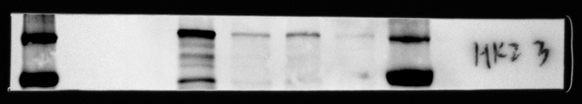
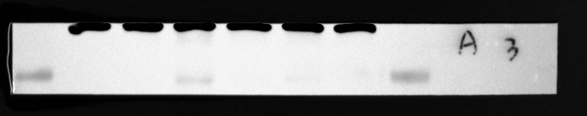
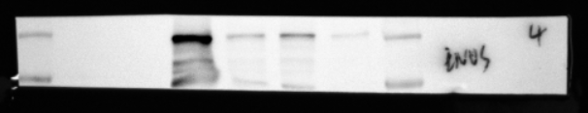

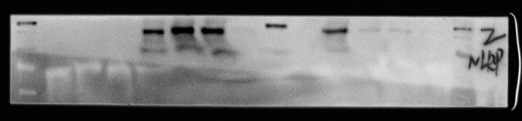

Figure.3. Enhanced glycolysis-derived lactate promotes microglial activation through histone lactylation.
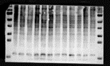
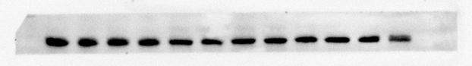
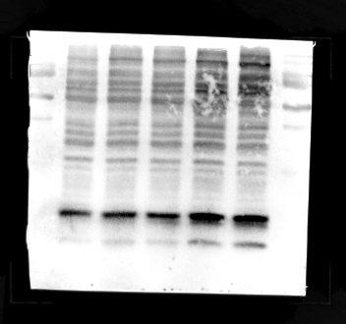
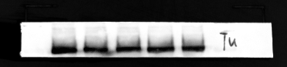

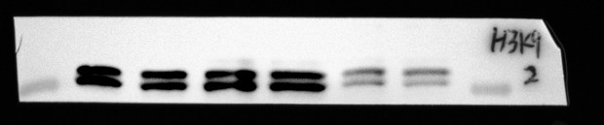
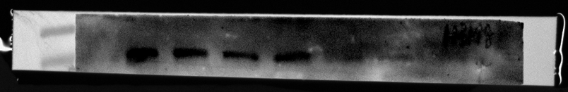
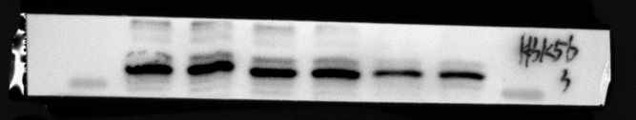
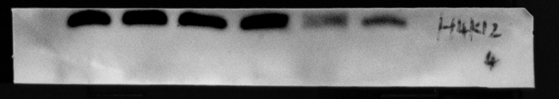
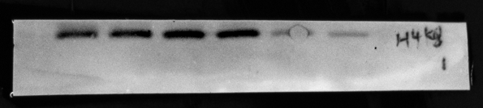
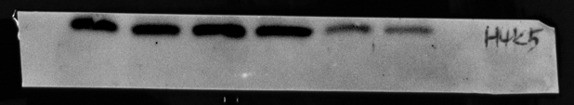
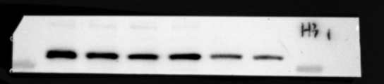

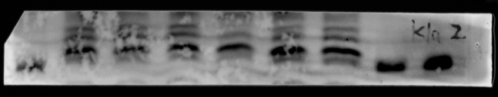
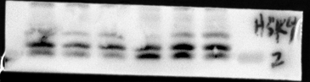
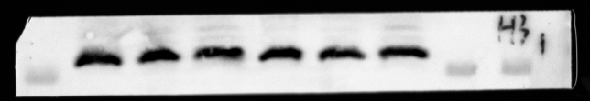

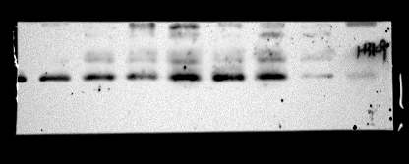
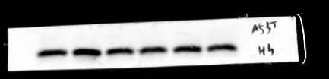

Figure.S3. Enhanced glycolysis-derived lactate promotes microglial activation through histone lactylation
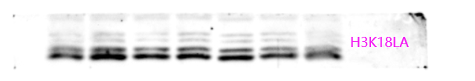
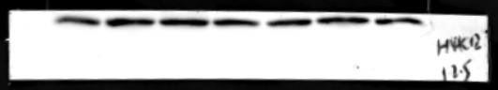
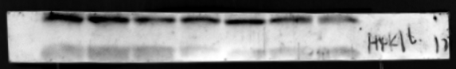
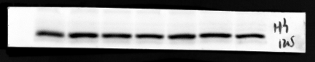

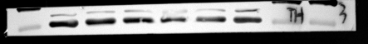

Figur. 4. Inhibition of glycolysis reduces the activation of microglia by reducing histone lactylation.
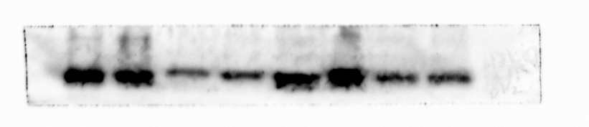
H3K9la
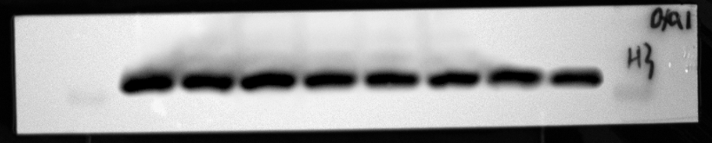
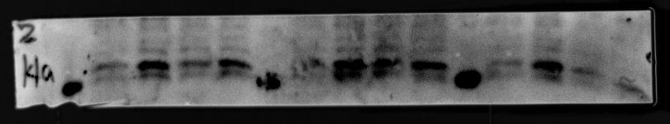

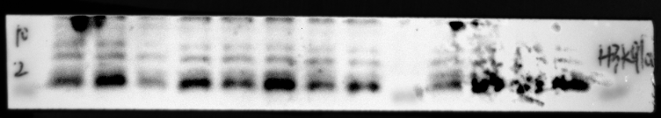
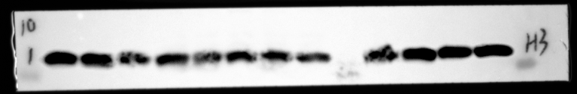

Figure.S4. Inhibition of glycolysis reduces the activation of microglia by reducing histone lactylation.
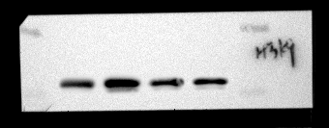
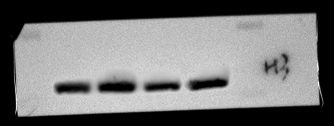
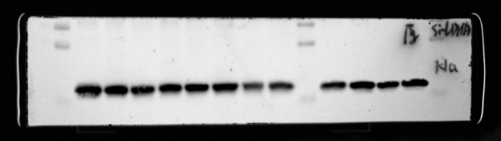
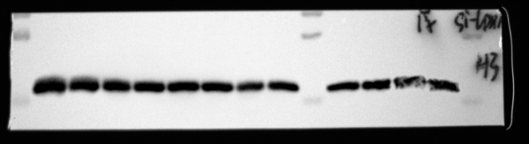

Figure. 5. Slc7a11 is the target of H3K9la and inhibition of SLC7A11 alleviates microglial activation.

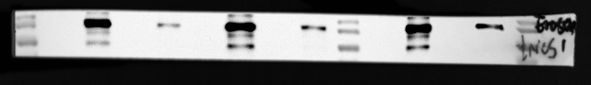
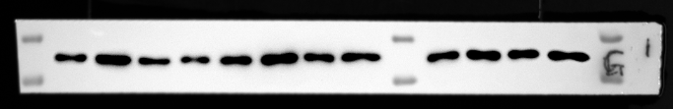
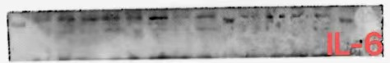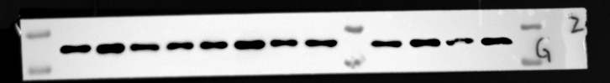
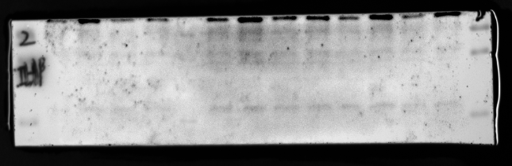
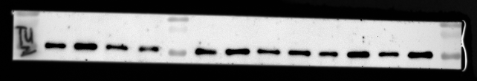

Figure 7. p300/CBP mediates pan-Kla and H3K9la in LPS-stimulated primary microglia.
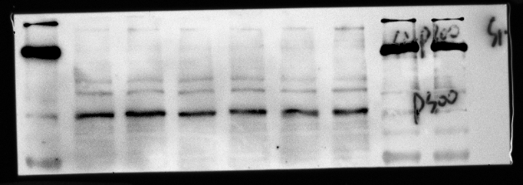
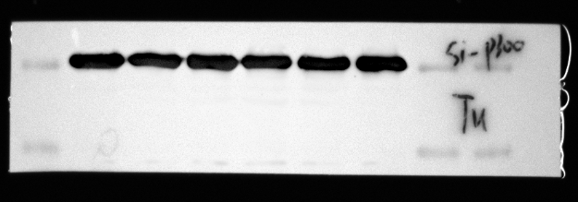
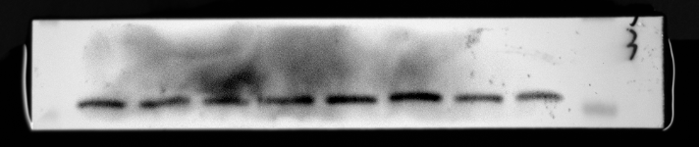
pan-kla
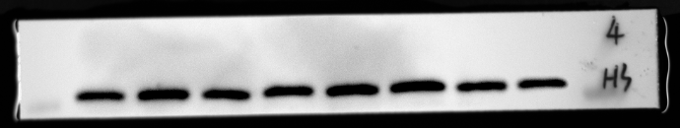
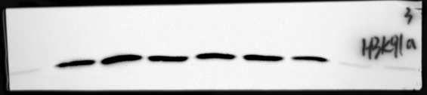
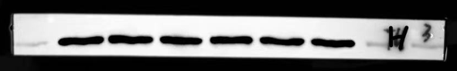

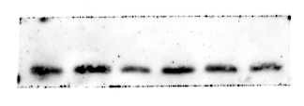
pan-kla
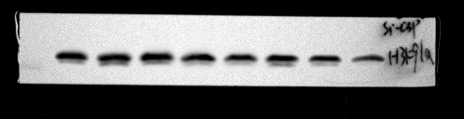
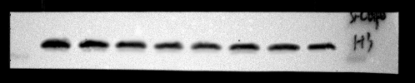

Figure.7S. C646 reduces histone lactylation and expression of proinflammatory cytokines in LPS-stimulated primary microglia
