Supplementary Material
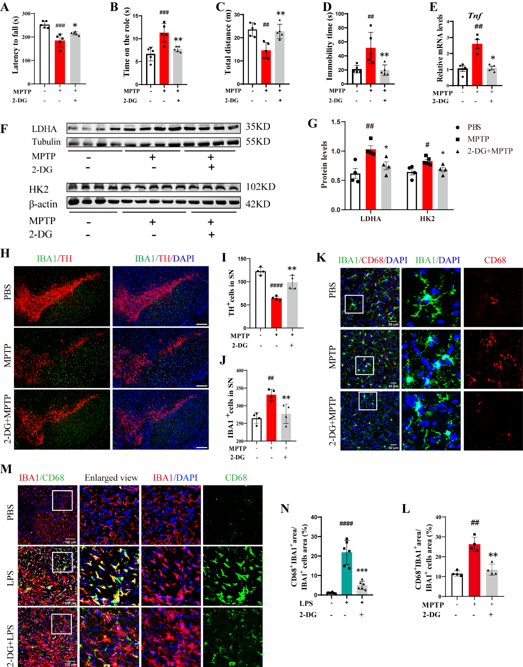
Figure S1. Inhibition of glycolysis improved motor function and reduced microglial activation in PD mice. (A-D) Quantification of latency to fall in rotarod test, time on the pole in pole test, total distance and immobility time in OFT of Control, MPTP, and 2-DG+MPTP mice. N=5 per group. (E) Tnf mRNA expression in the SN of Control, MPTP, and 2-DG+MPTP mice. N=4 per group. (F-G) Representative western blot and quantification of LDHA and HK2 in the SN of Control, MPTP, and 2-DG+MPTP mice. N=4 per group. (H) Representative images of TH (red) and IBA1 (green) in the SN of Control, MPTP, and 2-DG+MPTP mice. Scale bar, 200µm. (I-J) Quantification of TH⁺ cells and IBA1⁺ cells in the SN of Control, MPTP, and 2-DG+MPTP mice. N=4 per group. (K) Representative confocal images of IBA1 (green) and CD68 (red) in the SN of Control, MPTP, and 2-DG MPTP mice. Scale bar, 50µm. (L) Quantification of the ratio of CD68⁺IBA1⁺ area to IBA1⁺ cells areas of Control, MPTP, and 2-DG+MPTP mice. N=4 per group. (M) Representative confocal images of IBA1 (green) and CD68 (red) in the SN of Control, LPS, and 2-DG-LPS mice. Scale bar, 100µm. (N) Quantification of the ratio of CD68⁺IBA1⁺ area to IBA1⁺ cells areas of Control, LPS, and 2-DG-LPS mice. N=6 per group. Data are shown as the mean ± SEM and analyzed with one-way ANOVA followed by Tukey’s multiple comparisons test. Compared to PBS group, #P < 0.05, ##P < 0.01, ###P < 0.001, ####P < 0.0001; compared to MPTP group, *P < 0.05, **P < 0.01, ***P < 0.001.

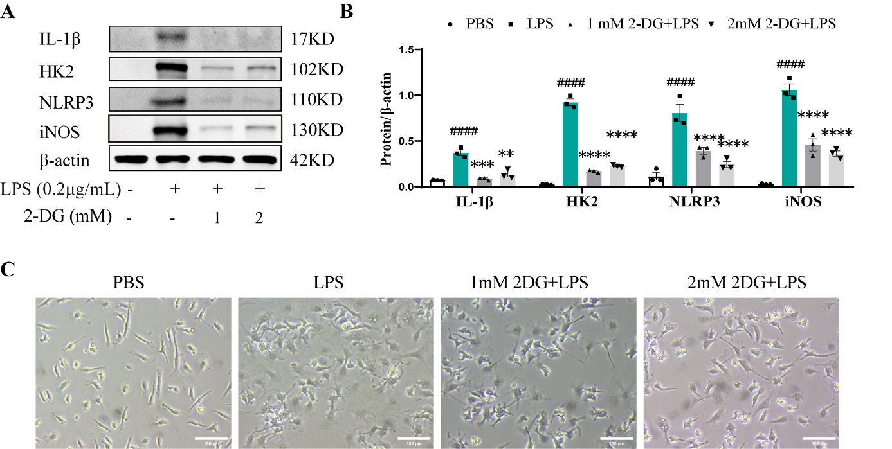
Figure S2. Enhanced glycolysis-derived lactate promotes microglial activation. (A-B) Representative western blot and quantification of IL-1β，HK2, NLRP3 and iNOS in LPS stimulated primary microglia treated with or without 2-DG. N=3 per group. (C) Representative image of morphology in primary microglia. Data are shown as the mean ± SEM and analyzed with one-way ANOVA followed by Tukey’s multiple comparisons test. Compared to PBS group, ####P < 0.0001; compared to LPS group, **P < 0.01, ***P < 0.001, ****P < 0.001.

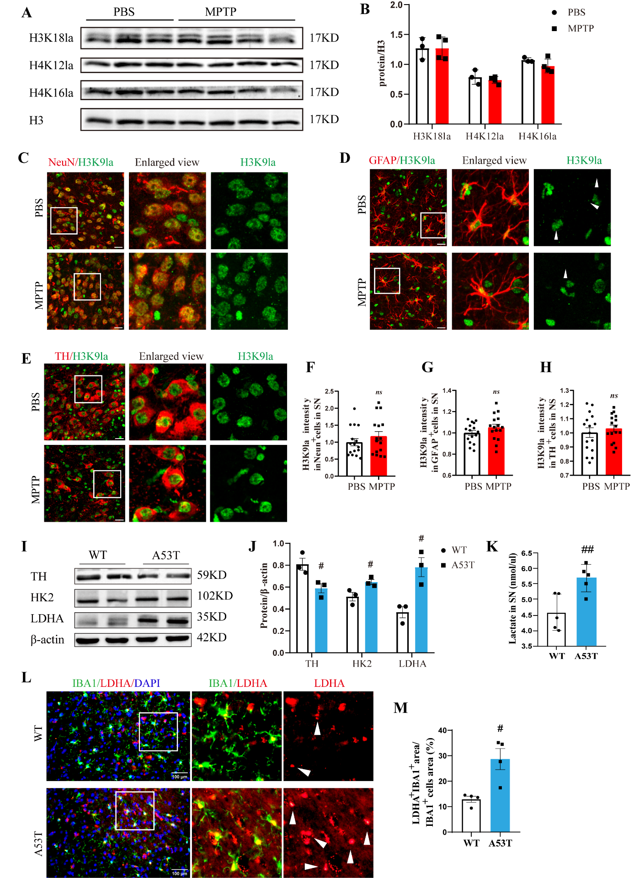
Figure S3. Enhanced glycolysis-derived lactate promotes microglial activation through histone lactylation. (A-B) Representative western blot and quantification of H3K18la, H4K12la and H4K16la in control and MPTP mice. N=3~4 per group. (C-E) Representative confocal images of H3K9la (green) and NeuN (red) or GFAP (red) or TH (red) in the SN of control and MPTP mice. Scale bar, 50 μm. (F-H) Quantification of fluorescence intensity of H3K9la in NeuN⁺ cells and GFAP⁺ cells and TH⁺ cells. N=4 per group. Four different layers of brain slices were taken from each brain for staining. Two brain slices were 120μm apart, and 4~6 visual fields were taken from each brain slice to averaged, so there were 4 points in each brain. (I-J) Representative western blot and quantification of TH, HK2 and LDHA in the SN of WT and A53T mice. N=3 per group. (K) Lactate concentration in the SN of WT and A53T mice. N=5 per group. (L) Representative images of IBA1 (green) and LDHA (red) in the SN of WT and A53T mice. Scale bar, 100 μm. (M) Quantification of the ratio of LDHA⁺IBA1⁺ area to IBA1⁺ cells area. N=4 per group. Data are shown as the mean ± SEM and analyzed with two-tailed unpaired Student’s t-test. Compared to PBS or WT group, #P < 0.05, ##P < 0.01; ns, the difference was not statistically significant.

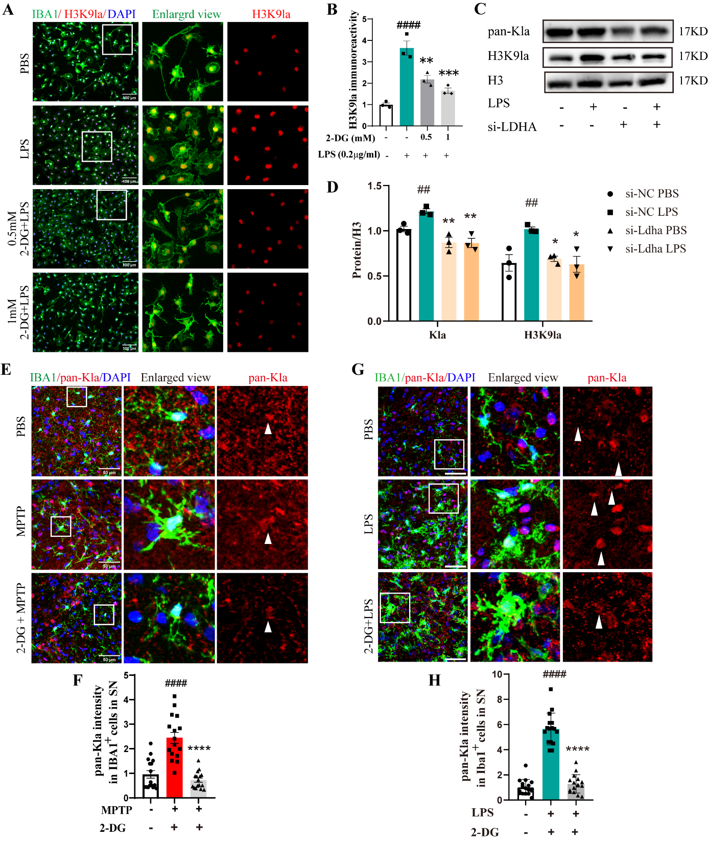
Figure S4. Inhibition of glycolysis reduces the activation of microglia by reducing histone lactylation. (A) Representative images of IBA1 (green) and H3K9la (red) in LPS-stimulated primary microglia treated with or without 2-DG. Scale bar, 100 μm. (B) Quantification of fluorescence intensity of H3K9la. N=3 per group. (C-D) Representative western blot and quantification of pan-Kla and H3K9la in primary microglia transfected with si-Ldha and stimulated with or without LPS. N=3 per group. (E) Representative confocal images of IBA1 (green) and pan-Kla (red) in microglia in the SN of Control, MPTP and 2-DG+MPTP mice. Scale bar, 50 μm. (F) Quantification of fluorescence intensity of pan-Kla in microglia. N=4 per group. (G) Representative confocal images of IBA1 (green) and pan-Kla (red) in microglia in the SN of Control, LPS and 2-DG+LPS mice. Scale bar, 50 μm. (H) Quantification of fluorescence intensity of pan-Kla in microglia. N=4 per group. For fluorescence intensity of pan-Kla, four different layers of brain slices were taken from each brain for staining. Two brain slices were 120μm apart, and 4~6 visual fields were taken from each brain slice to average, so there were 4 points in each brain. Data are shown as the mean ± SEM and analyzed with one-way ANOVA followed by Tukey’s multiple comparisons test. Compared to PBS group, ##P < 0.01, ####P < 0.0001; compared to MPTP group or LPS group, *P < 0.05, **P < 0.01, ***P < 0.001, ****P < 0.0001.

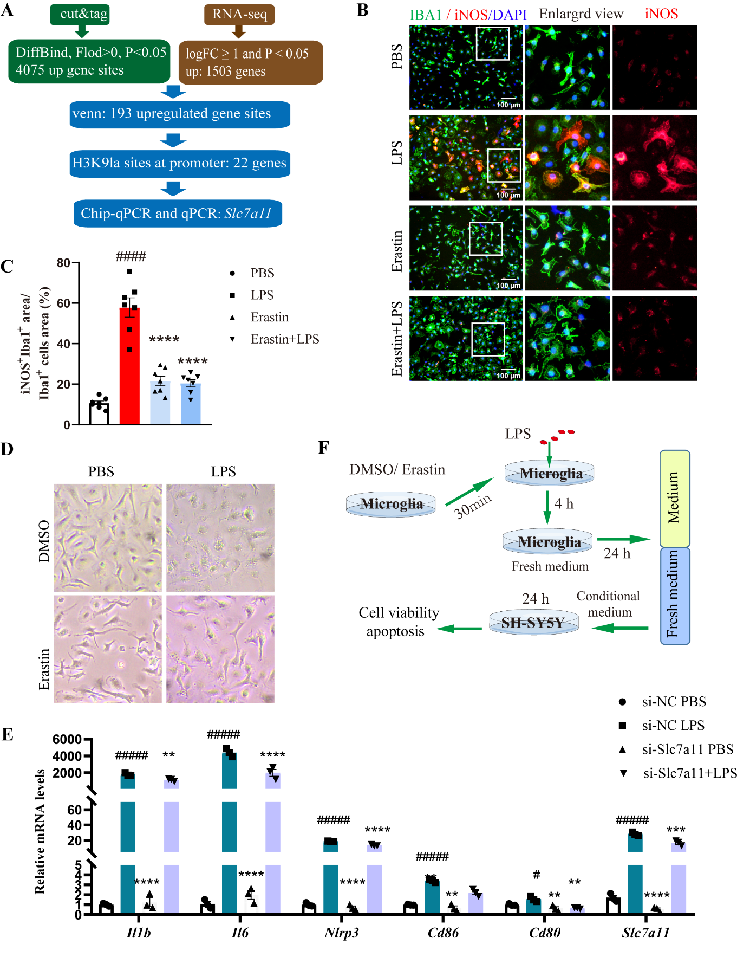
Figure S5. Inhibition of SLC7A11 alleviates microglial activation and microglia-mediated SH-SY5Y cells apoptosis. (A) Flow chart of H3K9la target genes screening. (B) Representative images of IBA1 (green) and iNOS (red) in LPS-stimulated primary microglia treated with or without erastin. Scale bar, 100 μm. (C) Quantification of the ratio of iNOS⁺IBA⁺ area to IBA⁺ cells area. N=7 per group. (D) Representative image of morphology in LPS-stimulated primary microglia treated with or without erastin. (E) Il1b, Il6, Nlrp3, Cd86, Cd80 and Slc7a11 mRNA expression in primary microglia transfected with si-Slc7a11 and stimulated with or without LPS. N=3 per group. (F) Experimental schedule of SH-SY5Y cells stimulated with MCM. Data are shown as the mean ± SEM and analyzed with one-way ANOVA followed by Tukey’s multiple comparisons test. Compared to PBS group, #P < 0.05, ####P < 0.0001; compared to LPS group, *P < 0.05, **P < 0.01, ***P < 0.001, ****P < 0.0001.

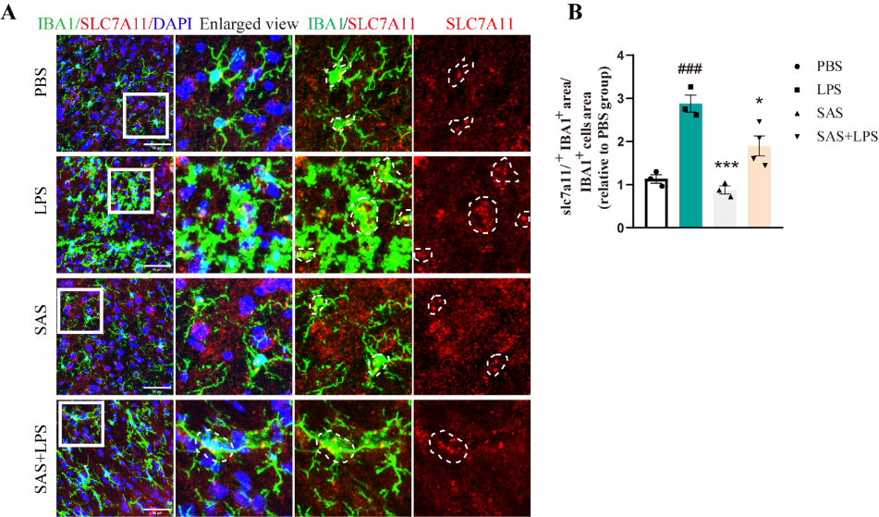
Figure S6. SAS reduces the levels of SLC7A11 in microglia. (A) Representative confocal images staining of IBA1 (green) and SLC7A11 (red) in the SN of Control, LPS, and 2-DG LPS mice. Scale bar, 50µm. (B) Quantification of the ratio of SLC7A11⁺IBA1⁺ area to IBonetwo-way ANOVA followed by Tukey’s multiple comparisons test. Compared to PBS group, ###P < 0.001; compared to LPS group, *P < 0.05, ***P < 0.001.

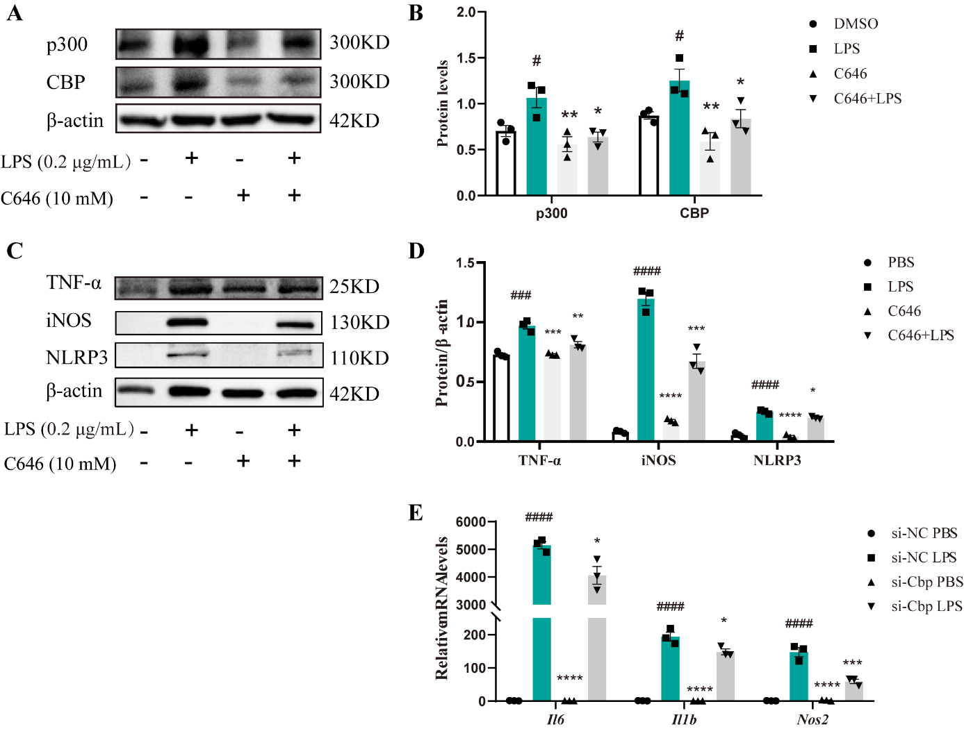
Figure S7. C646 reduces histone lactylation and expression of proinflammatory cytokines in LPS-stimulated primary microglia. Primary microglia pretreated with or without 10 mM C646 for 30 min then stimulate with 0.2μg/mL LPS for 24h. (A-B) Representative western blot and quantification of p300 and CBP. N=3 per group. (C-D) Representative western blot and quantification of TNF-α, iNOS, and NLRP36. N=3 per group. (E) Il6, Il1b and Nos2 mRNA expression in in primary microglia transfected with si-Cbp and stimulated with or without LPS. N=3 per group. Data are shown as the mean ± SEM and analyzed with one-way ANOVA followed by Tukey’s multiple comparisons test. Compared to PBS group, #P < 0.05, ###P < 0.001, ####P < 0.0001; compared to LPS group, *P < 0.05, **P < 0.01, ***P < 0.001, ****P < 0.0001.

