Supplementary Information

Synthesis of high entropy alloy polyhedra
Jingjing Liang,^{1†} Guanghui Cao,^{2†} Yile Zhang,^{2†} Zeyuan Li,^{3,4†} Xuhao Wan,³ Yuzheng Guo,³ Mengqi Zeng,² Lei Fu,^{1,2*}
¹The Institute for Advanced Studies, Wuhan University, Wuhan 430072, China. ²College of Chemistry and Molecular Sciences, Wuhan University, Wuhan 430072, China. ³School of Electrical Engineering and Automation, Wuhan University, Wuhan 430072, China. ⁴School of Power and Mechanical Engineering, Wuhan University, Wuhan 430072, China.
*E-mail: leifu@whu.edu.cn
†These authors contributed equally to this work.
Methods
Materials and reagents
Gallium, Platinum (II) nitrate solution and Cobalt (II) nitrate hexahydrate were purchased from Shanghai Aladdin Biochemical Technology Co., Ltd. Iron (Ⅲ) nitrate nonahydrate and Nickel (Ⅱ) nitrate hexahydrate were purchased from Sinopharm Chemical Reagent Co., Ltd. Copper (II) nitrate hydrate was purchased from Shanghai Macklin Biochemical Co., Ltd. All the materials were utilized without further purification.
Preparation of high entropy alloy (HEA) polyhedra
A molten Ga droplet was pressed with a silicon wafer several times in the glove box, which would be exfoliated onto the silicon wafer²⁹. Then the precursor was prepared by dropping the metal nitrates dispersed in ethanol solution onto the Ga-treated silicon wafer. The silicon substrate with precursor loaded was placed in a horizontal tube furnace for reaction. The temperature of the furnace was elevated from room temperature to 1073 K within 40 min and maintained at 1073 K for 12 h under 100 sccm Ar and 300 sccm H₂ atmosphere. After that, the furnace was cooled down to room temperature under Ar/H₂ flow. As a result, the HEA polyhedra were obtained. For Au and Pt alloy systems (AuPtFeCoNiCu and PtFeCoNiCu), the Au film and Pt film were deposited onto a silicon wafer by thermal evaporation and ion sputtering, respectively.
Material characterizations
Scanning electron microscope (SEM) images were obtained from a Zeiss Merlin Compact SEM. The SEM images and energy dispersive spectroscopy (EDS) mapping were also collected on Tescan MIRA and Zeiss GeminiSEM 500. For transmission electron microscopy (TEM) characterization, the scanning transmission electron microscopy (STEM) imaging and energy-dispersive X-ray spectroscopy (EDX) mapping were acquired on a JEOL JEM-ARM200CF microscope operated at 200 kV with a Schottky cold-field emission gun. The EDX elemental mapping was also carried out using the JEOL SDD-detector with two 100 mm² X-ray sensors. The XRD measurements were performed on a Rigaku Miniflex600 diffractometer equipped with Cu-Kα radiation.
Electrochemical measurements
All electrochemical measurements were performed on a CHI 660 with a conventional three-electrode system, where Hg/HgO and graphite rod were utilized as the reference electrode and counter electrode, respectively. GaPtFeCoNiCu HEA polyhedra were directly synthesized on the carbon cloth as the working electrode. For comparison, we also tested the GaPtFeCoNiCu HEA nanoparticles and commercial Pt/C catalysts. We employed an impregnation process to synthesize GaPtRuCoNiCr HEA nanoparticles on carbon black (Vulcan XC-72R). Then the prepared 5 mg GaPtFeCoNiCu HEA nanoparticles were dispersed in 980 μL of isopropanol and 20 μL of 5 wt% Nafion solution under sonication for 30min to form a homogeneous ink. Afterwards, 10 μL of the ink was dropped onto the carbon cloth for comparison. Moreover, after a similar process, the commercial 20 wt% Pt/C catalyst was also loaded onto the carbon cloth. It should be noted that the three samples for the HER tests possessed the same noble metal loading with about 10 μg on the carbon cloth with an area of 0.5×0.5 cm². The obtained potentials for all LSV curves were referenced to the reversible hydrogen electrode (RHE). Besides, all the polarization curves were presented with iR compensation. The electrolyte was 1.0 M KOH aqueous solution, which was saturated by Ar. The LSV curves were all performed with a scan rate of 5 mV/s. And the corresponding Tafel plots were obtained by fitting the linear portion of the curve into the Tafel equation η = b log (j) + a, in which b is the Tafel plot.
Density functional theory (DFT) calculation
All the first-principles calculations were conducted by employing the DFT method, as implemented in the Vienna ab initio Simulation Package (VASP). The projector augmented wave (PAW) basis set was used to describe the ion-electron interaction, with cut-off energy of 500 eV³⁰. The Perdew-Burke-Ernzerhof (PBE) functional of the generalized gradient approximation (GGA) was applied to deal with the exchange-correlation interaction³¹. The free energies of different surfaces were obtained from 4-layer slabs created from a 32-atom supercell of HEAs with Monkhorst-Pack’s k-points of 5 × 5 × 1. To avoid periodic interaction in the z-direction, all surfaces were created such that the z dimension is at least 20 Å. The self-consistent convergence threshold for electronic minimization was set to 10⁻⁵ eV. In the structure relaxation step, the lattice parameters and atomic positions were optimized until the forces on individual atoms were less than 0.02 eV/Å. The van der Waals interactions were treated by the empirical Grimme’s scheme (DFT-D3)³². The lattice constant was determined by averaging the lattice constants of the component elements according to their composition ratio, in accordance with Vegard’s law.
Dynamics simulation
Ab initio molecular dynamics (AIMD). The training dataset of the machine learning process was obtained by AIMD based on the DFT. The DFT calculations were performed using the VASP³³. The GGA with the PBE functional and PAW PBE pseudopotentials were used to describe the exchange-correlation interaction³¹. A k-points grid of 1×1×1 was adopted, and the cutoff energy of the plane wave basis set was 384 eV. The AIMD calculation was carried out at 300 K, 500 K, 800 K and 1000 K in the canonical ensemble (NVT). Periodic boundary conditions (PBC) and the Nosé-Hoover thermostat were employed to simulate the isothermal molecular dynamics of 128 atoms for 10 ps.
Deep learning potential (DLP). We trained our interatomic potential using a deep-learning neural network architecture with a novel attention mechanism implemented in the DeePMD-kit package³⁴. The descriptor was set to “sel-atten”, which would use DPA-1 structures. The size of the embedding net is 25, 50, and 100 from left to right, and the size of the submatrix of the embedding matrix is 16. We used a cutoff distance of 8 Å to represent the local internal structure around any atom in our training data set, and the smoothing started at 0.5 Å. The length of a hidden vector during scale-dot attention computation was set to 128, and the number of layers in attention mechanism was set to 2. During the training process, we used the sum of mean square deviations in energy, force, and virial as the loss function and minimized it. The accuracy of the GaPtFeCoNiCu DLP model was checked by comparing it with the DFT calculations. The correlation plot for the force predicted by the deep learning neural network related to that computed from DFT is shown at the top of Supplementary Fig. 11, and the bottom of Supplementary Fig. 11 illustrates an error distribution of the prediction error in the force. The results reveal that the DP model agrees well with the DFT calculations, where the prediction errors in the energy, force, and virial are 0.66 meV/atom, 44.5 meV/Å, and 3.95 meV/atom, respectively.
Monte Carlo and time-stamped force-bias Monte Carlo (MC/tf-MC). To investigate the evolution process of GaPtFeCoNiCu, we carried out Monte Carlo, Molecular Dynamics, and time-stamped force-bias Monte Carlo by Large-scale Atomic/Molecular Massively Parallel Simulator (LAMMPS)³⁵. Our evolution studies were performed at 1000 K for the bulk model and at 300 K for the polyhedron model. The bulk model consisted of 3456 atoms in a 34.7 Å×34.7 Å ×34.7 Å box with periodic boundary conditions in all three dimensions. The polyhedron model consisted of 2747 atoms in a 69.3 Å× 69.3 Å × 69.3 Å box bounded by vacuum in all three dimensions. A hybrid MC/tf-MC simulation was used to explore more HEA structures and increase the acceptance probability of atomic displacements, thus allowing faster evolution to equilibrium. After each atom/swap MC step, the system is allowed to relax by employing a tf-MC simulation stage through 500 steps. Simulation data were visualized using OVITO³⁶.
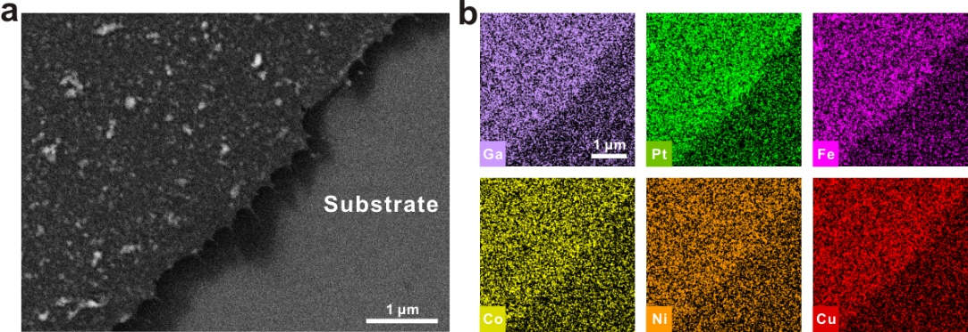
Supplementary Fig. 1 | SEM image (a) and SEM-EDS maps (b) of the precursor. The elements were uniformly distributed on the substrate.
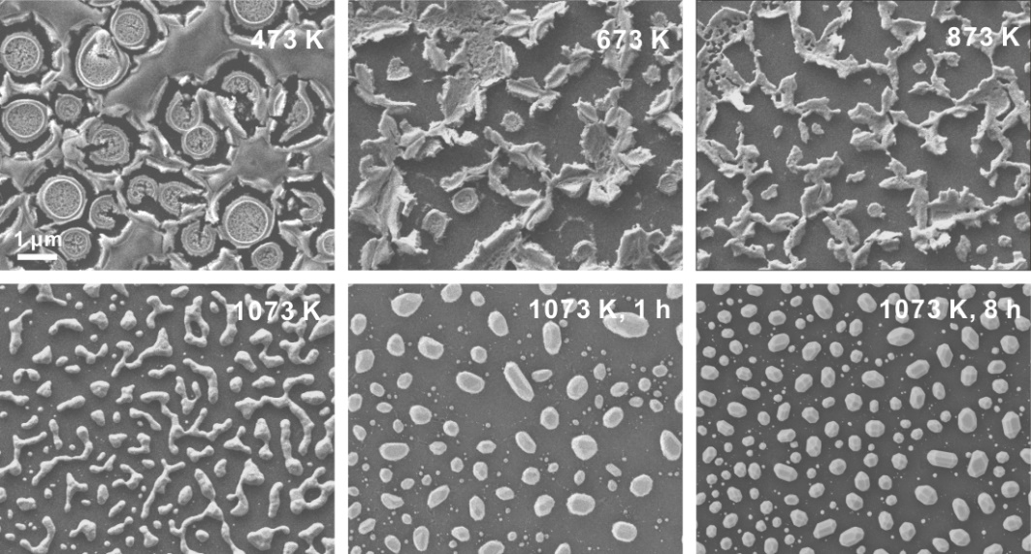
Supplementary Fig. 2 | Ex-situ SEM images during different reaction stages. With the annealing time increasing, the unstable precursor film decomposed and aggregated. Then irregularly island-shaped particles formed, which would finally evolve into polyhedra.
Supplementary Fig. 3 | XRD pattern of GaPtFeCoNiCu system. The standard XRD pattern (PDF# 42-0913) and substrate pattern were also shown for comparison.

Supplementary Fig. 4 | XRD pattern of GaPtFeCoNi system. The standard XRD pattern (PDF# 42-0913) and substrate pattern were also provided for comparison.

Supplementary Fig. 5 | XRD pattern of SnPtCoNiCu system. The standard XRD pattern (PDF# 27-1124) and substrate pattern were also shown for comparison. Referring to the standard XRD pattern, the crystal structure of the SnPtCoNiCu system could be demonstrated as a hexagonal symmetry.

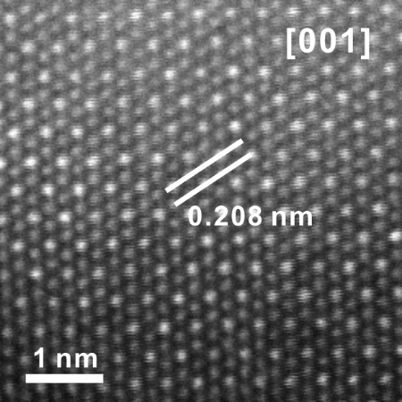
Supplementary Fig. 6 | Atomic-resolution high-angle annular dark-field STEM (HAADF-STEM) image of SnPtCoNiCu system. The image was captured from the [001] direction and showed a lattice spacing of 0.208 nm.

Supplementary Fig. 7 | Morphology and elemental distribution of PtFeCoNiCu system synthesized with Pt film. a, SEM image of PtFeCoNiCu on the substrate. b, The STEM image and corresponding EDS elemental mappings of PtFeCoNiCu.
Supplementary Fig. 8 | Morphology and elemental distribution of AuPtFeCoNiCu system synthesized with Au film. a, SEM image of AuPtFeCoNiCu on the substrate. b, The STEM image and corresponding EDS elemental mappings of AuPtFeCoNiCu.
Supplementary Fig. 9 | Morphology and elemental characterization of PtFeCoNiCu system synthesized with only metal salts. a, SEM image of PtFeCoNiCu product. b, The STEM image and EDS elemental mappings of the particle.
Supplementary Fig. 10 | The statistics diagram of surface energy calculated by DFT, and the experimental result of GaPtFeCoNiCu with high-index facets. a, Specific surface energies of different crystal facets in GaPtFeCoNiCu and Ga-free HEA systems. b, The depicted crystal model of GaPtFeCoNiCu system based on the surface energy value in Supplementary Table 5 (top), and SEM image of the product with experiment (bottom).
Supplementary Fig. 11 | Comparison of force predicted by GaPtFeCoNiCu DLP model with DFT calculations (top) and probability density distributions of prediction errors on force (bottom).
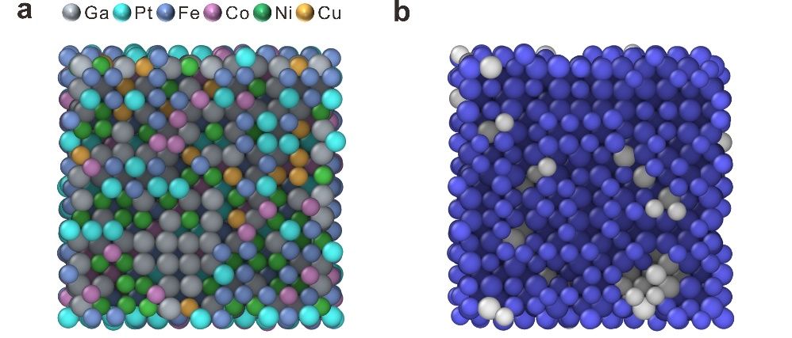
Supplementary Fig. 12 | The dynamic simulation for GaPtFeCoNiCu HEA at 1000 K. a, The atomic configuration for GaPtFeCoNiCu HEA after dynamic simulation. b, The cross-section picture of the corresponding phase structure, where the blue part is the body-centred cubic (BCC) structure and the other phase is the amorphous phase structure.

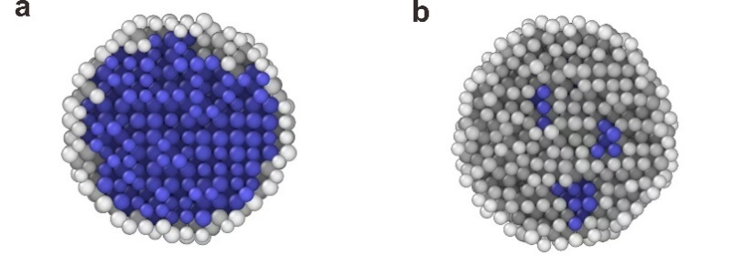
Supplementary Fig. 13 | The cross-section pictures of phase structure for GaPtFeCoNiCu (a) and PtFeCoNiCu (b) systems at 300 K after dynamic simulation, where the blue part is the BCC structure and the other phase is the amorphous phase structure.
Supplementary Fig. 14 | The electrocatalytic activity of the senary HEA polyhedra (GaPtFeCoNiCu) in 1 M KOH. (a, b) Polarization curves and Tafel slopes of HEA polyhedra, HEA nanoparticles and commercial Pt/C, respectively.
Supplementary Table 1 | The surface energy data of metal elements obtained from the Materials Project database³⁷, respectively, where the minimum surface energy is listed.
Elements | Surface | Surface energy (J/m²)
Pt | (111) | 1.488
Fe | (110) | 2.447
Ni | (111) | 1.924
Cu | (111) | 1.339
Co | (001) | 2.108
Ir | (111) | 2.359
Mn | (001) | 3.394
Cr | (110) | 3.223
Rh | (111) | 1.984
Pd | (111) | 1.359
Ru | (001) | 2.598
V | (100) | 2.381
Ga | (100) | 0.476
Sn | (221) | 0.543
Note: The values of surface energy were acquired from the online database: https://materialsproject.org/materials.
Supplementary Table 2 | Statistics of chemical compositions of different GaPtFeCoNiCu HEA polyhedra particles of Fig. 2 analyzed by EDS.
Sample | Ga (at%) | Pt (at%) | Fe (at%) | Co (at%) | Ni (at%) | Cu (at%)
1 | 32.39 | 17.37 | 14.64 | 13.58 | 14.19 | 7.83
2 | 33.04 | 17.21 | 13.73 | 13.67 | 13.57 | 8.78
3 | 35.14 | 17.32 | 11.89 | 12.37 | 14.03 | 9.25
4 | 33.07 | 17.09 | 13.32 | 14.40 | 13.99 | 8.13
5 | 30.89 | 17.90 | 15.31 | 14.05 | 14.43 | 7.42
6 | 26.62 | 18.12 | 15.94 | 16.55 | 16.40 | 6.37
7 | 26.16 | 17.86 | 16.66 | 15.92 | 15.26 | 8.15
8 | 28.17 | 19.26 | 16.21 | 14.55 | 14.73 | 7.07

Supplementary Table 3 | Statistics of element content of different GaPtFeCoNiCu HEA polyhedra particles of Fig. 3b analyzed by EDS.
Sample | Ga (at%) | Pt (at%) | Fe (at%) | Co (at%) | Ni (at%) | Cu (at%)
1 | 26.27 | 3.64 | 19.44 | 19.40 | 19.27 | 11.98
2 | 26.76 | 3.78 | 19.89 | 18.11 | 19.64 | 11.82
3 | 26.48 | 3.59 | 19.78 | 18.32 | 20.57 | 11.25
4 | 26.91 | 3.53 | 19.06 | 17.15 | 20.65 | 12.70
5 | 26.45 | 3.39 | 19.78 | 17.97 | 20.05 | 12.35
6 | 26.68 | 4.04 | 19.50 | 18.16 | 20.38 | 11.23
7 | 26.03 | 3.58 | 20.14 | 18.82 | 20.11 | 11.32
8 | 26.77 | 3.66 | 20.02 | 17.60 | 20.03 | 11.92

Supplementary Table 4 | The surface energy values of GaPtFeCoNiCu HEA with low-index facets of Fig. 2 and PtFeCoNiCu systems calculated by DFT.
Surface | Ga₁₇Pt₁₀Fe₇Co₇Ni₇Cu₆ (J/m²) | Pt₁₈Fe₉Co₉Ni₉Cu₉ (J/m²)
(100) | 2.447 | 4.523
(110) | 2.330 | 4.763
(111) | 2.537 | 5.067

Supplementary Table 5 | The surface energy values of GaPtFeCoNiCu HEA with high-index facets of Fig. 3b and PtFeCoNiCu systems calculated by DFT.
Surface | Ga₁₄Pt₂Fe₁₁Co₁₀Ni₁₁Cu₆ (J/m²) | Pt₅Fe₁₅Co₁₅Ni₁₅Cu₄ (J/m²)
(100) | 3.037 | 5.962
(110) | 2.813 | 5.466
(111) | 3.053 | 6.010
(211) | 3.117 | 6.361
(311) | 3.133

References
- Kochat, V. et al. Atomically thin gallium layers from solid-melt exfoliation. Sci. Adv. 4, e1701373 (2018).
- Blöchl, P. E. Projector augmented-wave method. Phys. Rev. B 50, 17953–17979 (1995).
- Perdew, J., Burke, K. & Ernzerhof, M. Generalized gradient approximation made simple. Phys. Rev. Lett. 77, 3865–3868 (1996).
- Grimme, S. Semiempirical GGA-type density functional constructed with a long-range dispersion correction. J. Comput Chem, 27, 1787–1799 (2006).
- Kresse, G. & Furthmüller, J. Efficient iterative schemes for ab initio total-energy calculations using a plane-wave basis set. Phys. Rev. B 54, 11169–11186 (1996).
- Wang, H., Zhang, L., Han, J. & E, W. DeePMD-kit: A deep learning package for many-body potential energy representation and molecular dynamics. Comput. Phys. Commun. 228, 178–184 (2018).
- Plimpton, S. Fast parallel algorithms for short-range molecular dynamics. J. Comput. Phys. 117, 1–19 (1995).
- Stukowski, A. Visualization and analysis of atomistic simulation data with OVITO–the open visualization tool. Modelling Simul. Mater. Sci. Eng. 18, 015012 (2009).
- Jain, A. et al. Commentary: The Materials Project: A materials genome approach to accelerating materials innovation. APL Mater. 1, 011002 (2013).

