College of Software, Xinjiang University, Urumqi 830000, China
Subject: Submission of manuscript
Dear Sir:
We would like to submit the following manuscript for possible evaluation:
Incorporating Connectivity Information in Spatiotemporal Graph Convolution Model for Traffic Flow Prediction
In this material, we have added mainly pictures of the distribution of nodes for the selected data and a visualization of the effect of the traffic flow at different forecast times, as shown in the figure below.
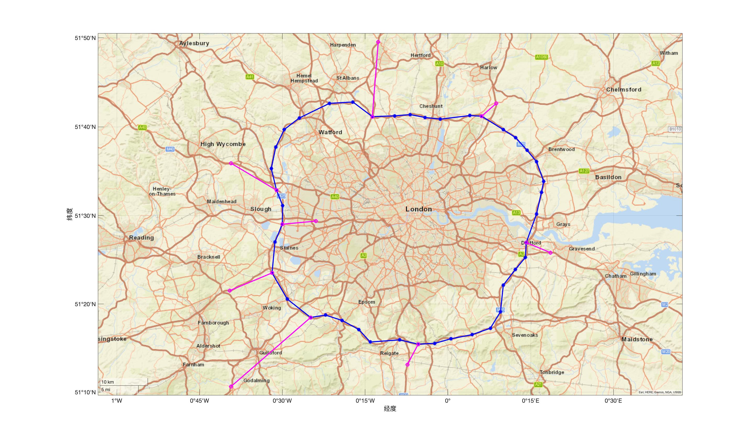
Fig. 1. Node distribution

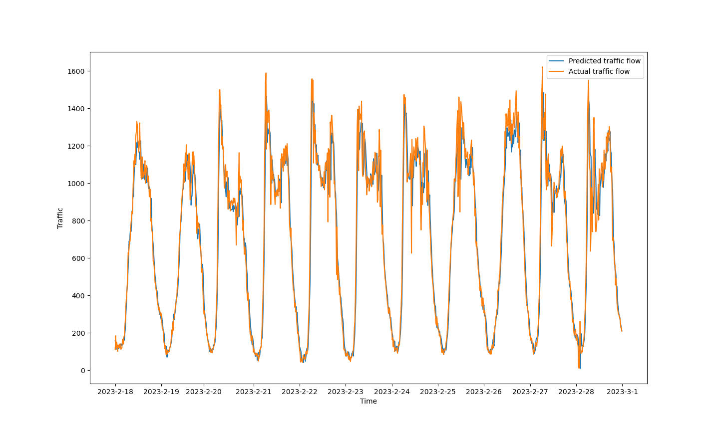
(a)
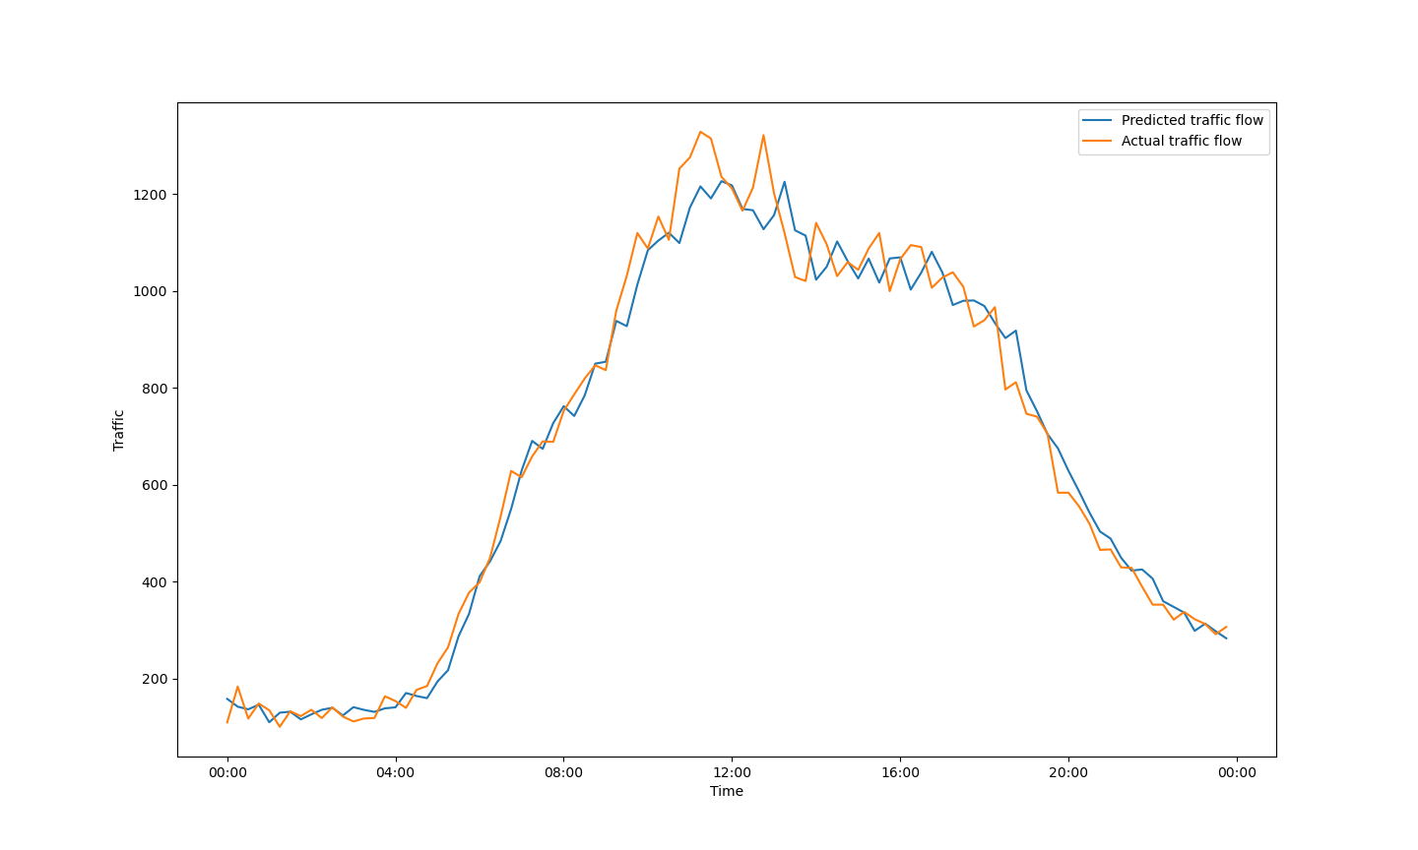
(b)
Fig. 2. (a) Visualization of predictive performance within a 15-minute forecast time range from February 18th to February 28th.
(b) Visualization of predictive performance within a 15-minute forecast time range on February 18th.

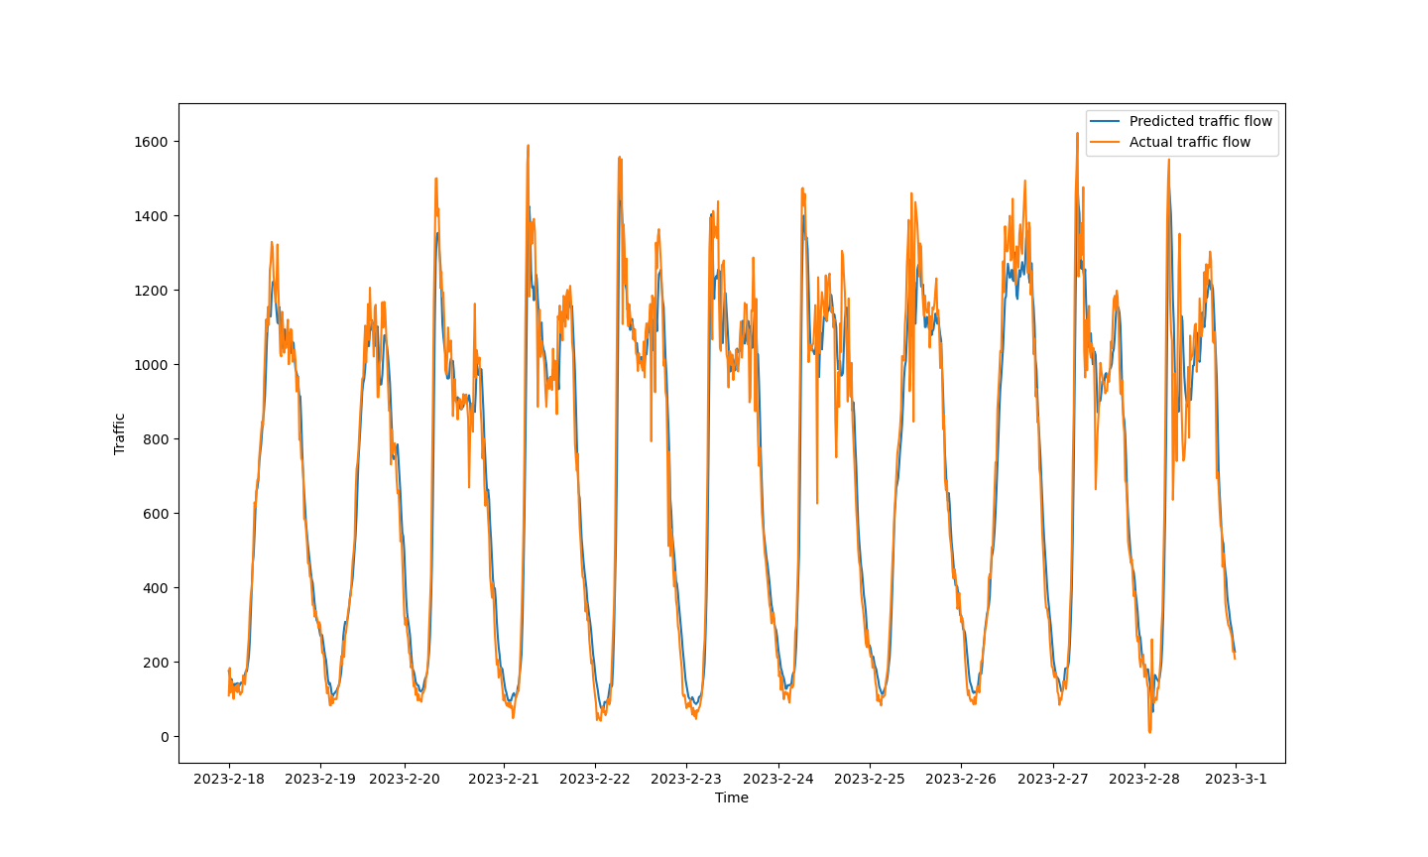
(a)
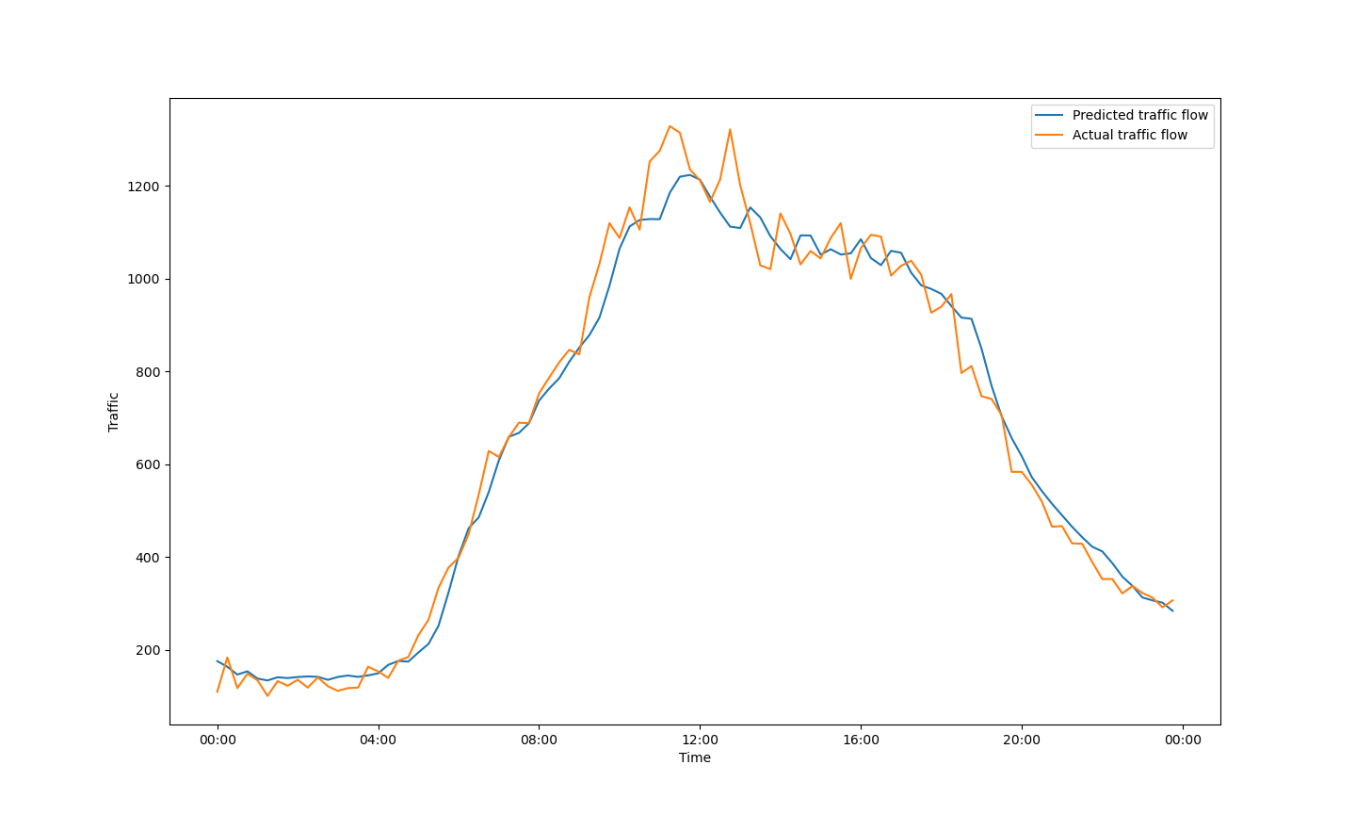
(b)
Fig. 3. (a) Visualization of predictive performance within a 30-minute forecast time range from February 18th to February 28th.
(b) Visualization of predictive performance within a 30-minute forecast time range on February 18th.
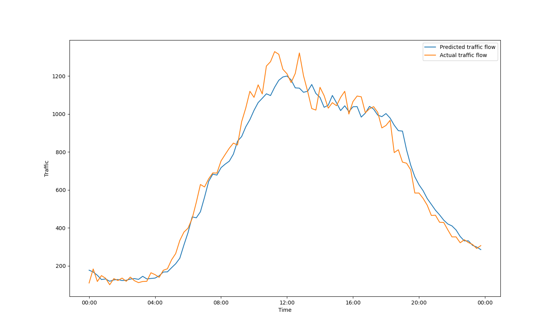
(a)
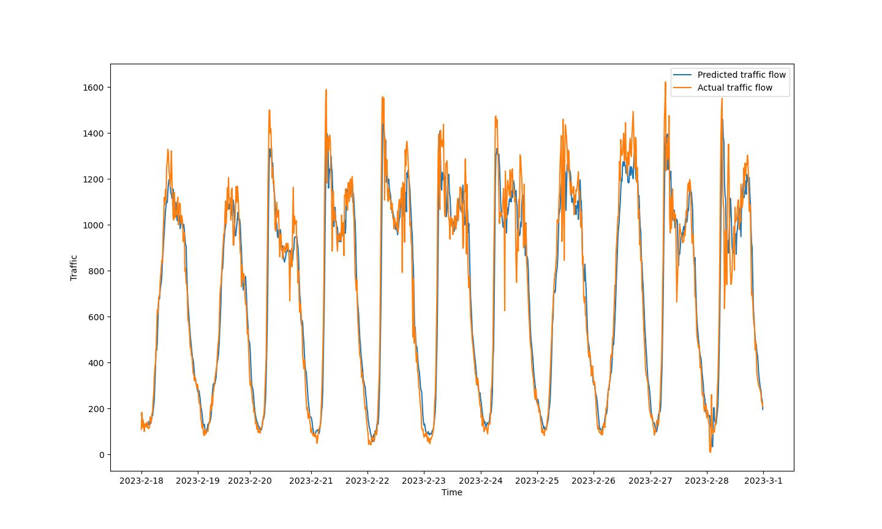
(b)
Fig. 4. (a) Visualization of predictive performance within a 45-minute forecast time range from February 18th to February 28th. (b) Visualization of predictive performance within a 45-minute forecast time range on February 18th.
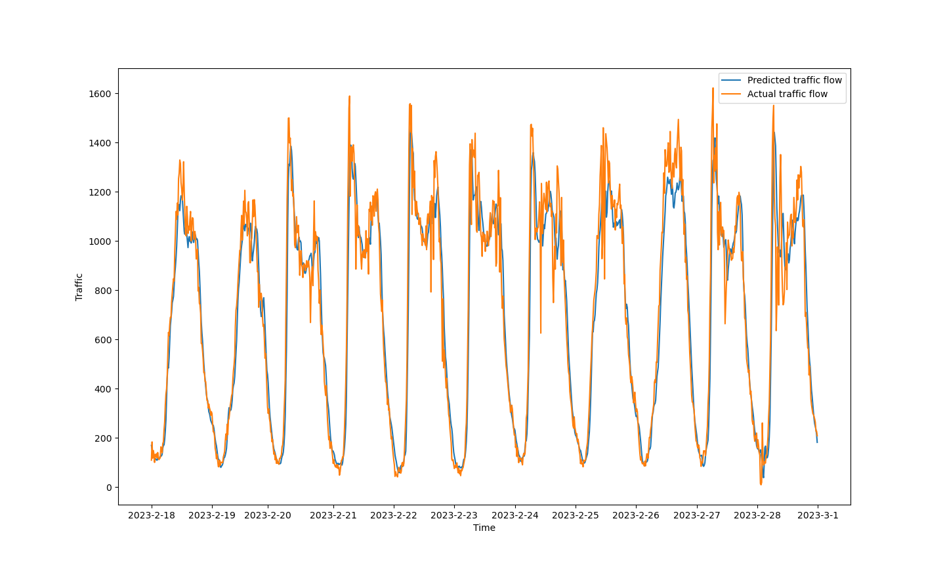
(a)
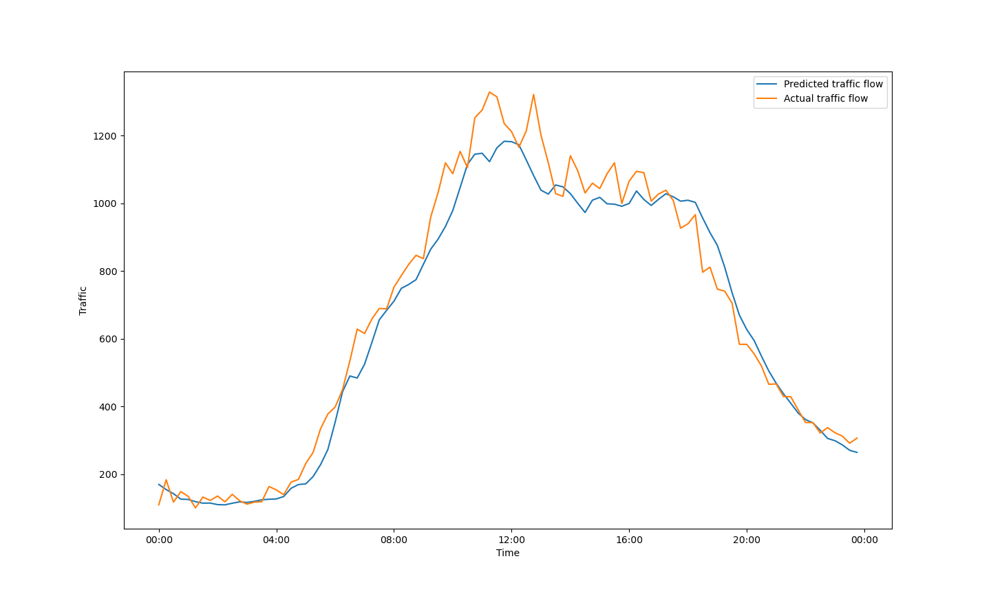
(b)
Fig. 5. (a) Visualization of predictive performance within a 60-minute forecast time range from February 18th to February 28th. (b) Visualization of predictive performance within a 60-minute forecast time range on February 18th.

We hope that these additional materials will be helpful in evaluating our manuscript. Please let us know if you require any further information or have any questions.

