High-Content Screening of Thai Medicinal Plants Reveals Boesenbergia rotunda Extract and its Component Panduratin A as Anti-SARS-CoV-2 Agents

Phongthon Kanjanasirirat,^{1,+} Ampa Suksatu,^{2,+} Suwimon Manopwisedjaroen,² Bamroong Munyoo,¹ Patoomratana Tuchinda,^{1,3} Kedchin Jearawuttanakul,¹ Sawinee Seemakhan,¹ Sitthivut Charoensutthivarakul,^{1,4,9} Patompon Wongtrakoongate,^{5,9} Noppawan Rangkasenee,¹ Supaporn Pitiporn,⁷ Neti Waranuch,⁸ Napason Chabang,⁴ Phisit Khemawoot,¹⁰ Somchai Chutipongtanate,¹¹ Suradej Hongeng,^{1,11} Suparerk Borwornpinyo,^{1,6,}* Arunee Thitithanyanont^{2,}*

¹ Excellence Center for Drug Discovery (ECDD), Faculty of Science, Mahidol University, Bangkok 10400 Thailand.
² Department of Microbiology, Faculty of Science, Mahidol University, Bangkok 10400 Thailand.
³ Department of Chemistry, Faculty of Science, Mahidol University, Bangkok 10400 Thailand.
⁴ School of Bioinovation and Bio-based Product Intelligence, Faculty of Science, Mahidol University, Bangkok 10400 Thailand.
⁵ Department of Biochemistry, Faculty of Science, Mahidol University, Bangkok 10400 Thailand.
⁶ Department of Biotechnology, Faculty of Science, Mahidol University, Bangkok 10400 Thailand.
⁷ Chao Phraya Aphaiphubet Hospital, Prachin Buri 25000 Thailand.
⁸ Department of Pharmaceutical Technology, Faculty of Pharmaceutical Sciences, Naresuan University, Phitsanulok 65000 Thailand.
⁹ Center for neuroscience, Faculty of Science, Mahidol University, Bangkok 10400 Thailand
¹⁰ Chakri Naruebodindra Medical Institute, Faculty of Medicine Ramathibodi Hospital, Mahidol University, Samutprakarn 10540 Thailand.
¹¹ Department of Pediatrics, Faculty of Medicine Ramathibodi Hospital, Mahidol University, Bangkok 10400 Thailand.

⁺ These authors contributed equally to this work

* Shared co-corresponding authors:
Suparerk Borwornpinyo, Ph.D.
Excellence Center for Drug Discovery (ECDD), Faculty of Science, Mahidol University, Bangkok 10400 Thailand.
email: bsuparerk@gmail.com

Arunee Thitithanyanont, M.D.
Department of Microbiology, Faculty of Science, Mahidol University, Bangkok 10400 Thailand.
email: arunee.thi@mahidol.edu

SUPPLEMENTARY INFORMATION

Supplementary Methods

High-content image analytical sequence
Each images were analyzed by using Harmony software (PerkinElmer) with the following analytical sequence;
1. Input image – Individual planes, Flatefield Correction: Basic
2. Find Nuclei – Channel: HOECHST 33342; Method: C; Output Population: Total cells
3. Find Cytoplasm – Channel: HOECHST 33342; Nuclei: Total cells; Method: A
4. Find Spots – Channel: Alexa 488; ROI Population: Total cells; ROI Region: Cytoplasm; Method: B; Output population: Spots
5. Calculate Intensity Properties – Channel: Alexa 488; Population: Total cells; Region: Cytoplasm; Method: Standard; Output Properties: Intensity Cytoplasm Alexa 488
6. Select Population – Population: Total cells; Method: Filter by Property (Number of Spots and Intensity Cytoplasm Alexa 488); Output Population: Infected cells
7. Calculate Intensity Properties (2) – Channel: Alexa 488; Population: Infected cells; Region: Cytoplasm; Method: Standard; Output Properties: Intensity of infected cells
8. Define Results:
8.1 Method – List of outputs:
- Total cells: Number of objects
- Infected cells: number of objects
8.2 Method – Formula output:
- Formula: (100*a)/b
- Variation a: Infected cells – Number of objects
- Variation b: Total cells – Number of objects
- Output name: % Infected cells
8.3 Single cell results: All

Supplementary Table

Supplementary Table 1. A list of 122 natural extracts and compounds being screened by high-content screening for the candidate anti-SARS-CoV-2 agents.

ECDD Code | Scientific name | %Inhibition at 10 μg/ml (or μM)
ECDD-NAM | alpha-mangostin | 9.08
ECDD-NAD | Andrographolide | 99.97
ECDD-EGM | Garcinia mangostana L. | 8.42
ECDD-EGME | Garcinia mangostana L. | 15
ECDD-EVTE | Vitex trifolia | 61.69
ECDD-ECLE | Chan Leela recipe | 23.07
ECDD-EAPE | Andrographis paniculata | 68.29
ECDD-EAP | Andrographis paniculata | 37.15
ECDD-E461103 | Andrographis paniculata | 66.54
ECDD-EX630209VANN | Andrographis paniculata | 67.59
ECDD-EBP-1 | Buppo-1 recipe | 6.7
ECDD-EBP-2 | Buppo-2 recipe | 14.76
ECDD-EBP-3 | Buppo-3 recipe | 6.32
ECDD-DPM-N94 | 6-Gingerol | 7.78
ECDD-DPM-N95 | 8-Gingerol | 17.59
ECDD-DPM-N96 | 10-Gingerol | 23.51
ECDD-DPM-N97 | 6-Shogaol | 12.17
MUC1775 | 10-Shogaol | 5.7
ECDD-DPM-E50 | Zingiber officinale | 35.97
ECDD-DPM-E51 | Zingiber officinale | 26.02
ECDD-DPM-E227 | Zingiber officinale | 9.98
ECDD-DPM-E228 | Zingiber officinale | 65.58
ECDD-DPM-E229 | Zingiber officinale | 99.97
ECDD-DPM-E55 | Clitoria ternatea | 6.58
ECDD-DPM-E116 | Allium sativum | 17
ECDD-DPM-E117 | Allium ampeloprasum var. ampeloprasum | 23.62
ECDD-DPM-E118 | Allium ampeloprasum var. ampeloprasum | 36.29
ECDD-DPM-E119 | Allium chinense | 30.07
ECDD-DPM-E120 | Allium sativum | 15.76
ECDD-DPM-E121 | Allium sativum | 60.45
ECDD-DPM-E122 | Allium sativum | 58.56
ECDD-DPM-E123 | Honey garlic recipe | 61.23
ECDD-DPM-E124 | Allium chinense | 60.67
ECDD-DPM-E125 | Plukenetia volubilis | 37.49
ECDD-DPM-E126 | Curcuma Longa Linn. | 13.37
ECDD-DPM-E127 | Curcuma longa | 23.11
ECDD-DPM-E128 | Curcuma domestica Valeton | 39.29
ECDD-DPM-E129 | Kaempferia parviflora | 5.89
ECDD-DPM-E130 | Plukenetia volubilis | 9.13
ECDD-DPM-E131 | Helianthus tuberosus | 68.44
ECDD-DPM-E132 | Zingiber montanum | 33.47
ECDD-DPM-E133 | Kaempferia galanga | 87.73
ECDD-DPM-E134 | Curcuma amarissima Roscoe. | 53.7
ECDD-DPM-E135 | Boesenbergia rotunda | 99.95
ECDD-DPM-E136 | Curcuma zanthorrhiza | 61.55
ECDD-DPM-E137 | Talinum paniculatum (Jacq.) Gaertn | 24.65
ECDD-DPM-E138 | Boesenbergia rotunda | 64.23
ECDD-DPM-E139 | Hibiscus sabdariffa | 41.78
ECDD-DPM-E140 | Curcuma longa | 14.91
ECDD-DPM-E141 | Zingiber officinale | 6.95
ECDD-DPM-E142 | Curcuma mangga Valeton & Zijp | 61.79
ECDD-DPM-E143 | Phyllanthus emblica | 10.4
ECDD-DPM-E144 | Zingiber montanum (J.Koenig) Link ex A.Dietr. | 25.66
ECDD-DPM-E145 | Alpinia galanga | 31.9
ECDD-DPM-E146 | Senna siamea | 21.48
ECDD-DPM-E147 | Anamirta cocculus (L.) Wight & Arn. | 44.16
ECDD-DPM-E148 | Carthamus tinctorius | 69.16
ECDD-DPM-E149 | Derris scandens | 64.33
ECDD-DPM-E150 | Tinospora cordifolia | 32.68
ECDD-DPM-E151 | Gynostemma pentaphyllum | 28.73
ECDD-DPM-E152 | Cissus quadrangularis | 26.58
ECDD-DPM-E153 | Phum chiwa recipe | 76.95
ECDD-DPM-E154 | Momordica charantia | 7.74
ECDD-DPM-E155 | Moringa oleifera | 5.04
ECDD-DPM-E156 | Shasthara recipe | 70.57
ECDD-DPM-E157 | Murdannia loriformis | 64.29
ECDD-DPM-E158 | Acanthus ebracteatus | 4.68
ECDD-DPM-E159 | Centella asiatica | 28.2
ECDD-DPM-E160 | Vernonia cinerea (L.) Less. | 9.92
ECDD-DPM-E161 | Camellia sinensis (L.) Kuntze | 22.68
ECDD-DPM-E162 | Piper nigrum | 70.03
ECDD-DPM-E163 | Piper longum | 15.25
ECDD-DPM-E164 | Zingiber officinale | 44.87
ECDD-DPM-E165 | Ipomoea pes-caprae | 27.74
ECDD-DPM-E166 | Asparagus racemosus Willd. | 24.02
ECDD-DPM-E167 | Pogostemon cablin | 55.18
ECDD-DPM-E168 | Aquilaria crassna | 21.42
ECDD-DPM-E169 | Musa acuminata Colla | 53.46
ECDD-DPM-E170 | Morus | 2.29
ECDD-DPM-E171 | Artocarpus lacucha | 29.8
ECDD-DPM-E172 | Terminalia chebula | 10.16
ECDD-DPM-E173 | Terminalia bellirica | 1.45
ECDD-DPM-E174 | Phyllanthus emblica | 3.34
ECDD-DPM-E175 | Curcuma longa | 38.09
ECDD-DPM-E176 | Aloe vera | 60.42
ECDD-DPM-E177 | Thunbergia laurifolia | 10.19
ECDD-DPM-E178 | Raphanus sativus var. Longipinnatus | 23.2
ECDD-DPM-E179 | Tectona grandis | 2.89
ECDD-DPM-E180 | Bombyx Mori. | 50.79
ECDD-DPM-E181 | Anacardium occidentale | 18.71
ECDD-DPM-E182 | Equisetidae | 79.95
ECDD-DPM-E183 | Plantago major | 16.46
ECDD-DPM-E184 | Cymbopogon citratus | 96.47
ECDD-DPM-E185 | Polygala chinensis L. | 56.05
ECDD-DPM-E186 | Senna alata | 33.73
ECDD-DPM-E187 | Glycyrrhiza glabra | 2.81
ECDD-DPM-E188 | Paederia pilifera Hook.f. | 7.94
ECDD-DPM-E189 | Saururaceae | 69.65
ECDD-DPM-E190 | Chromolaena odorata | 80.28
ECDD-DPM-E191 | Gymnema inodorum Decne. | 94.59
ECDD-DPM-E192 | Oroxylum indicum | 52.59
ECDD-DPM-E193 | Centotheca lappacea (L.) Desv. | 30.72
ECDD-DPM-E194 | Nelumbo nucifera Gaertn. | 77.16
ECDD-DPM-E195 | Boesenbergia rotunda | 95.78
ECDD-DPM-E196 | Gymnanthemum extensum | 18.35
ECDD-DPM-E197 | Curcuma zedoaria | 17.01
ECDD-DPM-E198 | Kaempferia galanga | 61.83
ECDD-DPM-E199 | Cissus quadrangularis | 68.98
ECDD-DPM-E200 | Momordica charantia | 6.94
ECDD-DPM-E201 | Derris scandens | 24.91
ECDD-DPM-E202 | Murdannia loriformis | 50.8
ECDD-DPM-E203 | Gynostemma pentaphyllum | 19.58
ECDD-DPM-E204 | Vernonia cinerea (L.) Less. | 55.41
ECDD-DPM-E205 | Justicia gendarussa Burm.f. | 52.44
ECDD-DPM-E206 | Salacia chinensis L. | 27.73
ECDD-DPM-E207 | Salacia verrucosa | 28.52
ECDD-DPM-E208 | Elephantopus scaber | 35.7
ECDD-DPM-E209 | Rhinacanthus nasutus | 55.85
ECDD-DPM-E210 | Cryptolepis dubia (Burm.f.) M.R. Almeida | 46.68
ECDD-DPM-E1029 | Wan dok hemn recipe | 4.42
ECDD-EEFE | Eupatorium fortunei Turcz. | 1.89
ECDD-NPA | Panduratin A | 99.97

Supplementary Figures

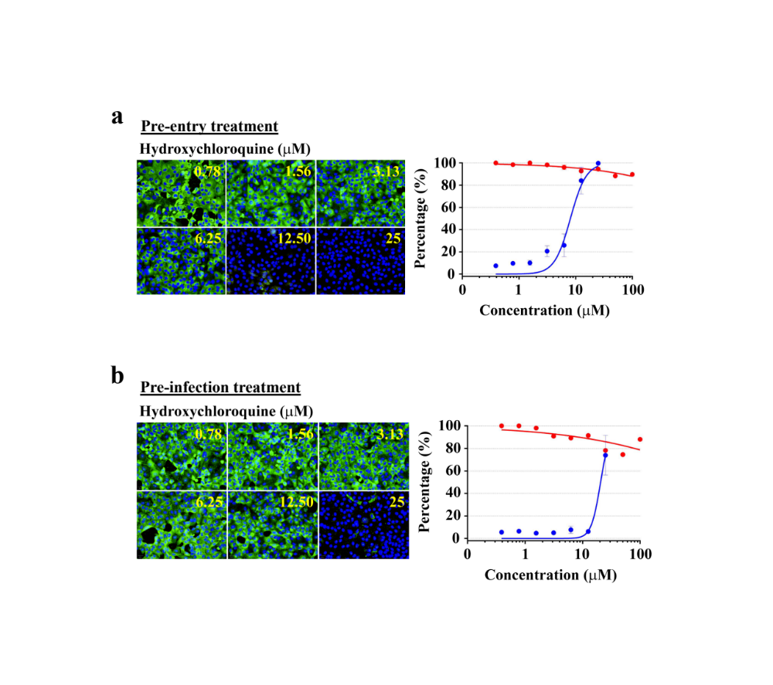
Supplementary Figure 1. Dose-dependent anti-SARS-CoV-2 activities of hydroxychloroquine at the pre-entry and pre-infectious phases. (a). At the pre-entry phase, hydroxychloroquine had the IC₅₀ of 8.07 μM and CC₅₀ >100 μM. (b). At the pre-infection phase, hydroxychloroquine exhibited the IC₅₀ of 20.55 μM and CC₅₀ >100 μM.

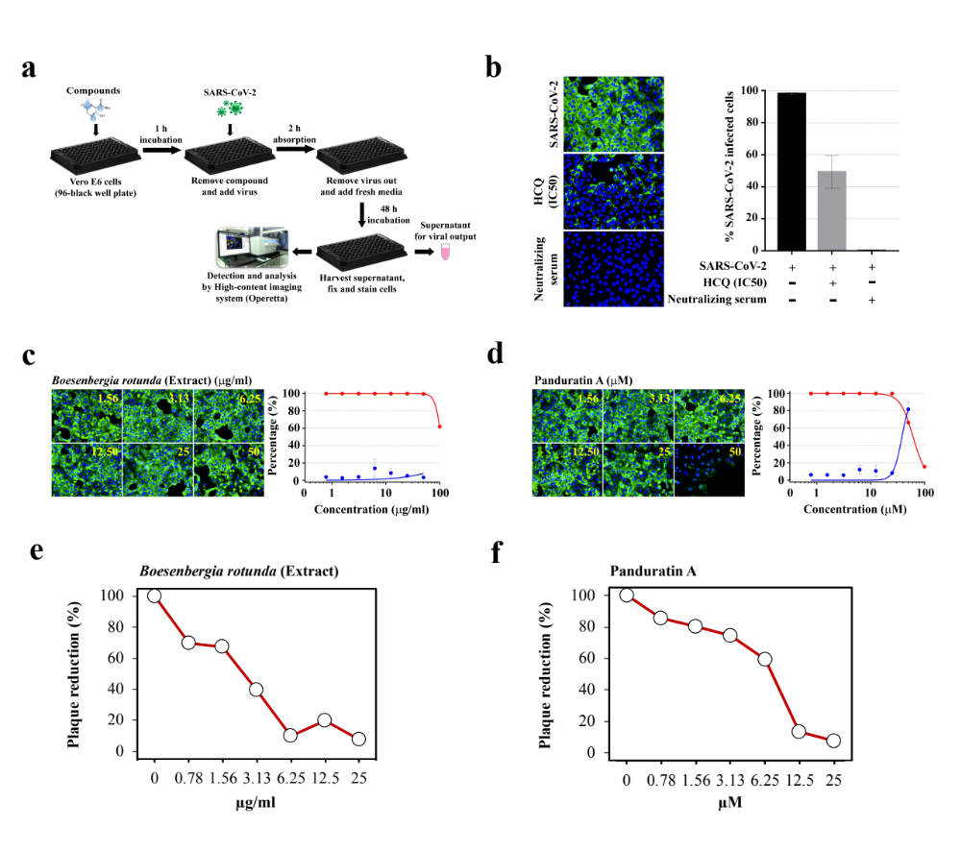
Supplementary Figure 2. Dose-dependent anti-SARS-CoV-2 effects of B. rotunda extract and panduratin A at the pre-infection phase. (a). Study design. the extract/compound were incubated with Vero E6 cells for 1 hr before washing by fresh media. Thereafter, SARS-CoV-2 at 25TCID₅₀ were inoculated into Vero E6 cells and viral adsorption was allowed for 2 hrs. Next, the cells were washed again to remove unbound virions and the culture was maintained in fresh media for 48 hrs before harvest. (b). Controls. Hydroxychloroquine (HCQ) at the IC50 (20.55 µM) for pre-infection treatment (details in Supplementary Figure 1b), and the neutralizing serum served as the positive conditions (n=3 biological replicates). (c-d). High content imaging analysis of B. rotunda extract (c) and Panduratin A (d) (the left panel), and %inhibition (red) and %cytotoxicity (blue) (the right panel) (n=3 biological replicates). Fluorescent signals: green, anti-SARS-CoV-2 NP mAb; blue, Hoechst. (e-f). Plaque reduction assay of B. rotunda extract (e) and panduratin A (f) (n=2 biological replicates).

