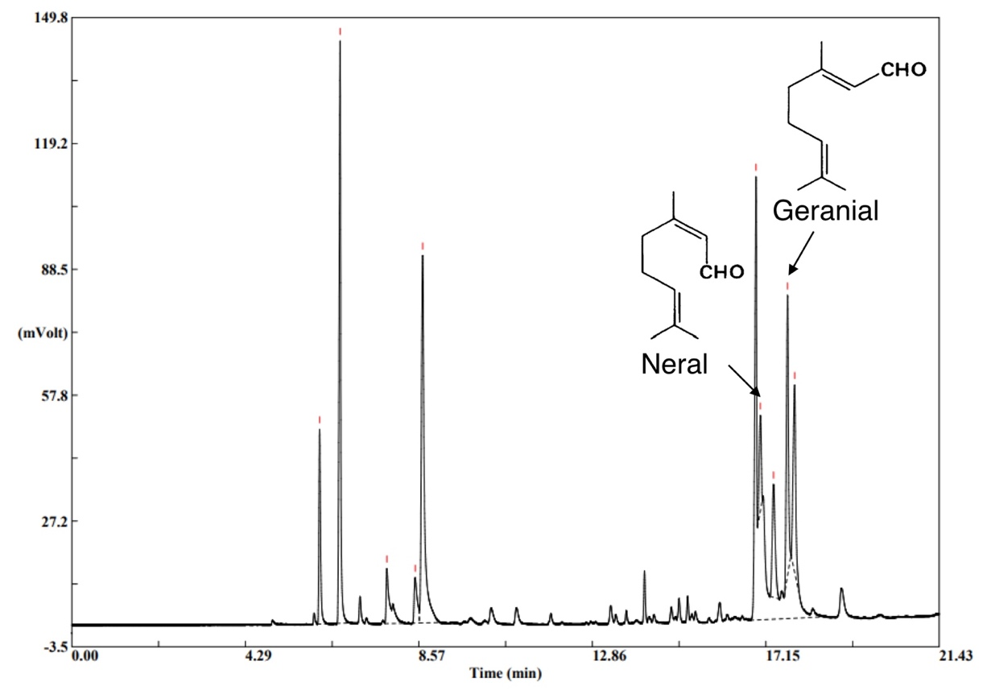
Supplementary Fig. 1| Gas chromatography chromatogram of ginger essential oil (GEO) shows citral as the major compound. The GC demonstrates that citral comprises a mixture of the two geometric isomers geranial and neral. Citral was the main component of GEO; approximately 31% of it comprised 18.8% neral and 12.2% geranial isomers.

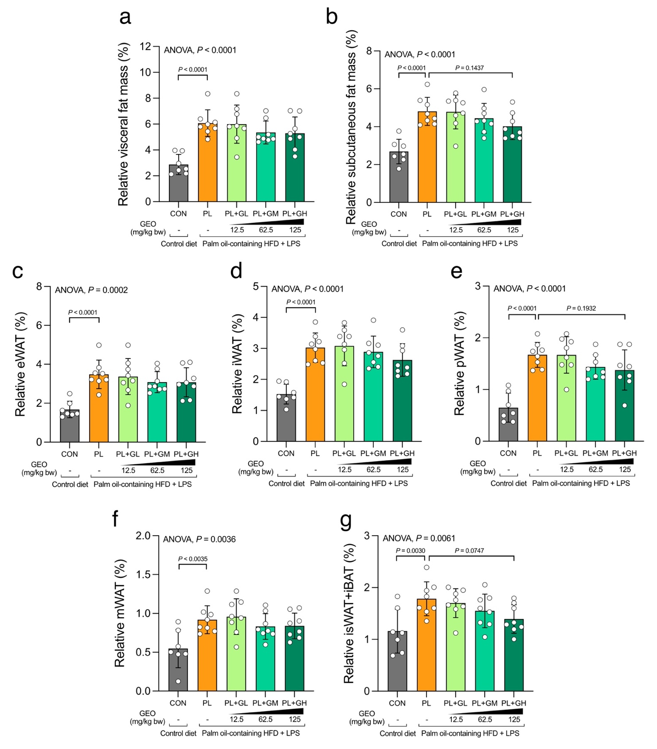
Supplementary Fig. 2| Effect of PL and supplementation with GEO on relative fat mass. Relative (a) visceral, (b) subcutaneous, (c) epididymal white adipose tissue (WAT) (eWAT), (d) inguinal WAT (iWAT), (e) perirenal WAT (pWAT), (f) mesenteric WAT (mWAT), and (g) inguinal subcutaneous white adipose tissue (isWAT) and interscapular brown adipose tissue (iBAT) in C57BL/6 mice, which were treated with either control or a palm oil-containing HFD with LPS i.p. (PL) with or without ginger essential oil (GEO) (12.5 (GL), 62.5 (GM), and 125 (GH) mg/kg bw) supplementation by daily oral gavage for 12 weeks. Each value was expressed as the mean ± SD (n = 7–8). Statistical analyses were performed by a one-way ANOVA with Dunnett's multiple comparison test for comparing group means against the PL group.
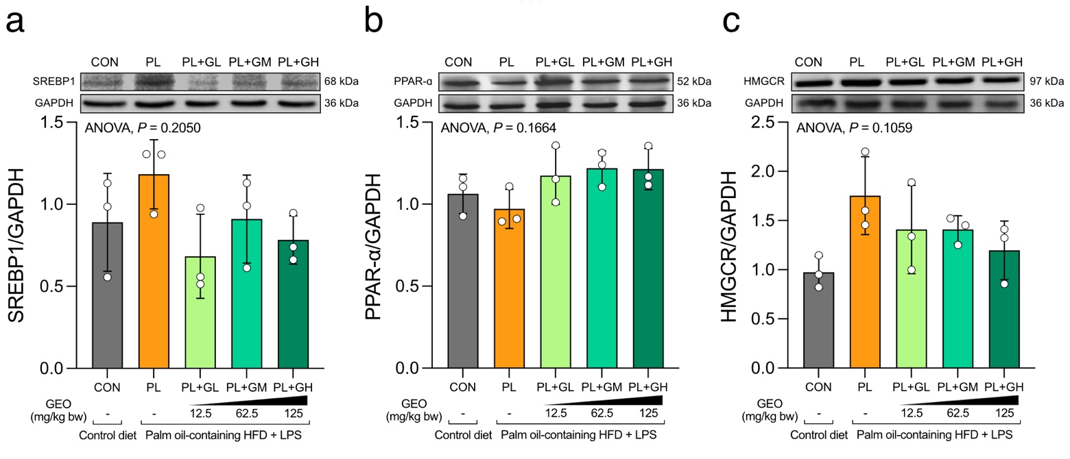
Supplementary Fig. 3| GEO tends to modulate fatty acid synthesis and β-oxidation related proteins. (a) SREBP1, (b) PPAR-ɑ, and (c) HMGCR protein expression in the livers of C57BL/6 mice, which were treated with either control or a palm oil-containing HFD with LPS i.p. (PL) with or without ginger essential oil (GEO) (12.5 (GL), 62.5 (GM), and 125 (GH) mg/kg bw) supplementation by daily oral gavage for 12 weeks. Each value was expressed as the mean ± SD (n = 3). Statistical analyses were performed by a one-way ANOVA with Dunnett's multiple comparison test for comparing group means against the PL group.
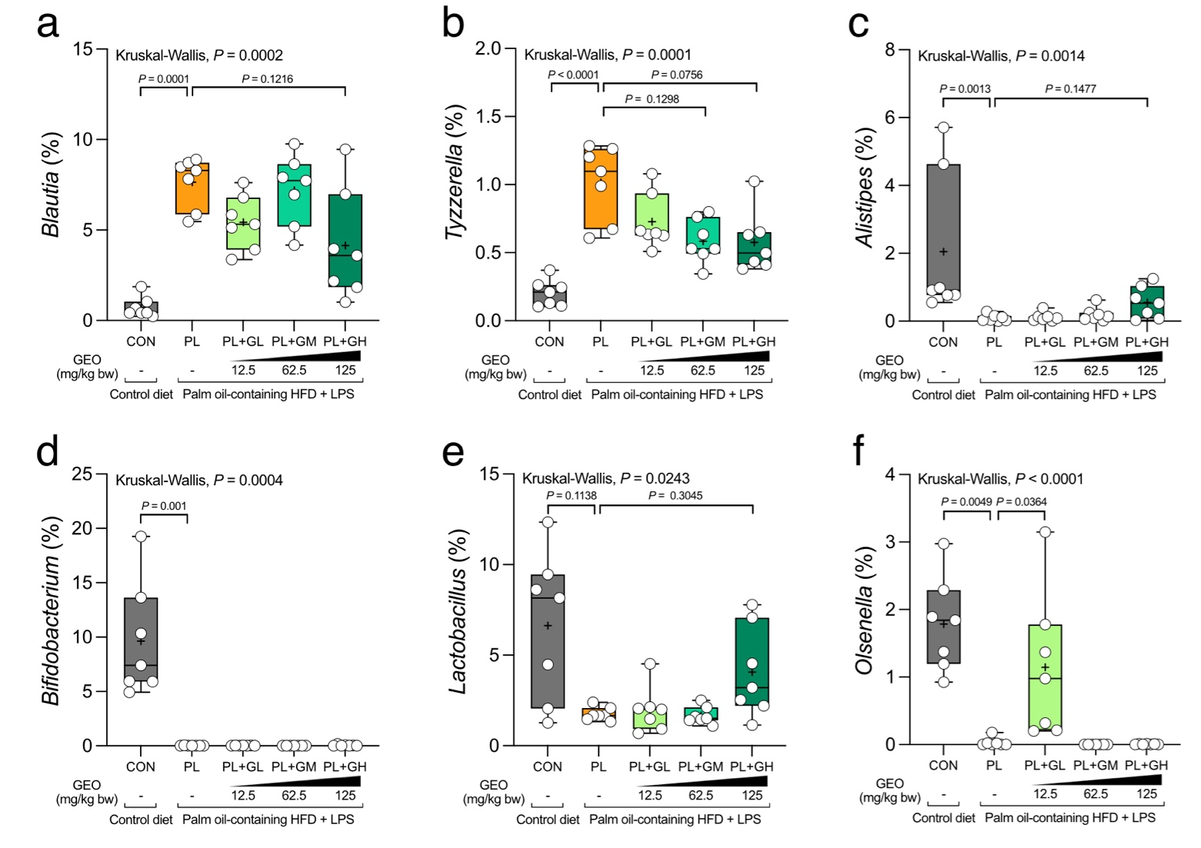
Supplementary Fig. 4| PL and GEO shape the NASH-associated and beneficial fecal microbiota at genus level. Relative abundance of (a) Blautia, (b) Tyzzerella, (c) Alistipes, (d) Bifidobacterium, (e) Lactobacillus, and (f) Olsenella in C57BL/6 mice, which were treated with either control or a palm oil-containing HFD with LPS i.p. (PL) with or without ginger essential oil (GEO) (12.5 (GL), 62.5 (GM), and 125 (GH) mg/kg bw) supplementation by daily oral gavage for 12 weeks. Box plots display median, mean (+), quartiles (boxes), and range (whiskers) (n = 7). Statistical analyses were performed by a one-way ANOVA with Dunnett's multiple comparison test for comparing group means against the PL group.

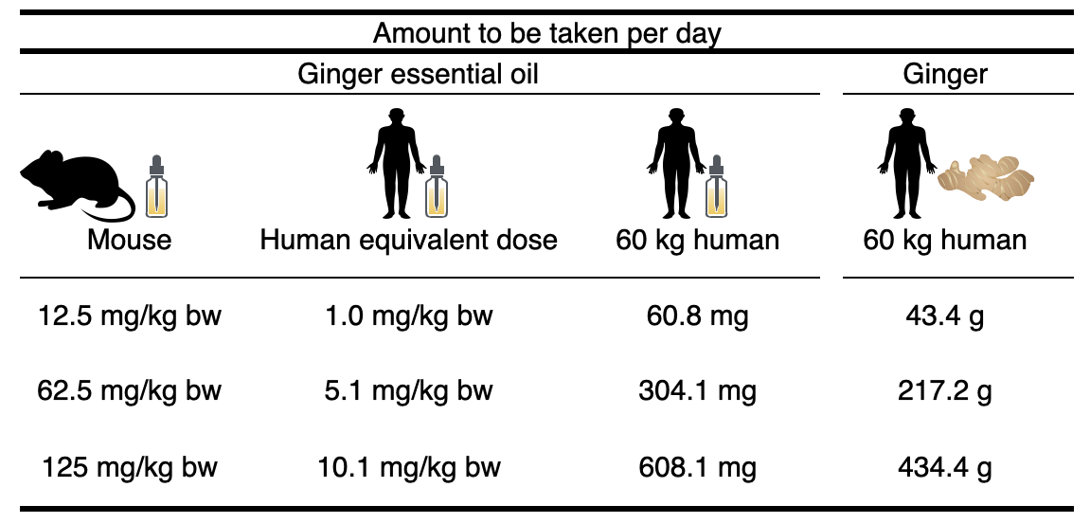
Supplementary Fig. 5| Mouse to human equivalent dose translation of ginger essential oil and ginger.

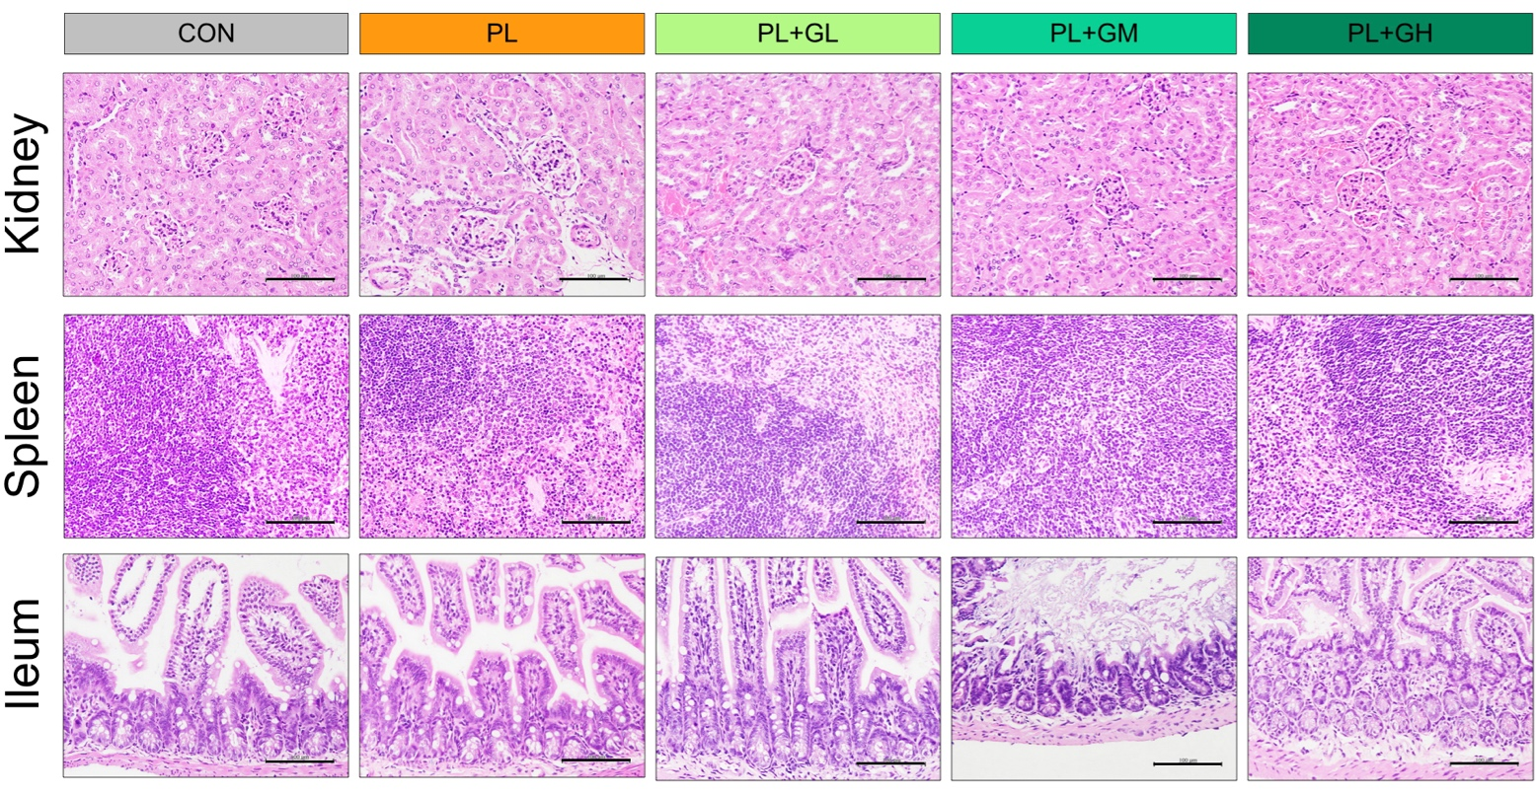
Supplementary Fig. 6| Representative histological features of hematoxylin and eosin-stained kidney, spleen, and ileum section (400X magnification; scale bar: 100 µm) with no significant change. C57BL/6 mice were treated with either control or a palm oil-containing HFD with LPS i.p. (PL) with or without ginger essential oil (GEO) (12.5 (GL), 62.5 (GM), and 125 (GH) mg/kg bw) supplementation by daily oral gavage for 12 weeks.

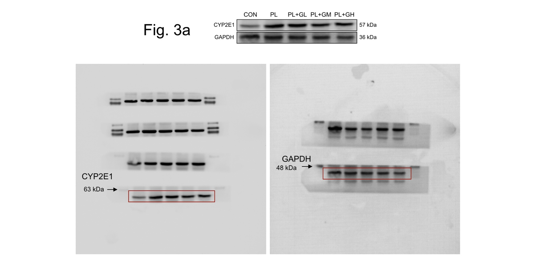
Supplementary Fig. 7| The original western blot images of CYP2E1 and GAPDH as presented in Figure 3a.

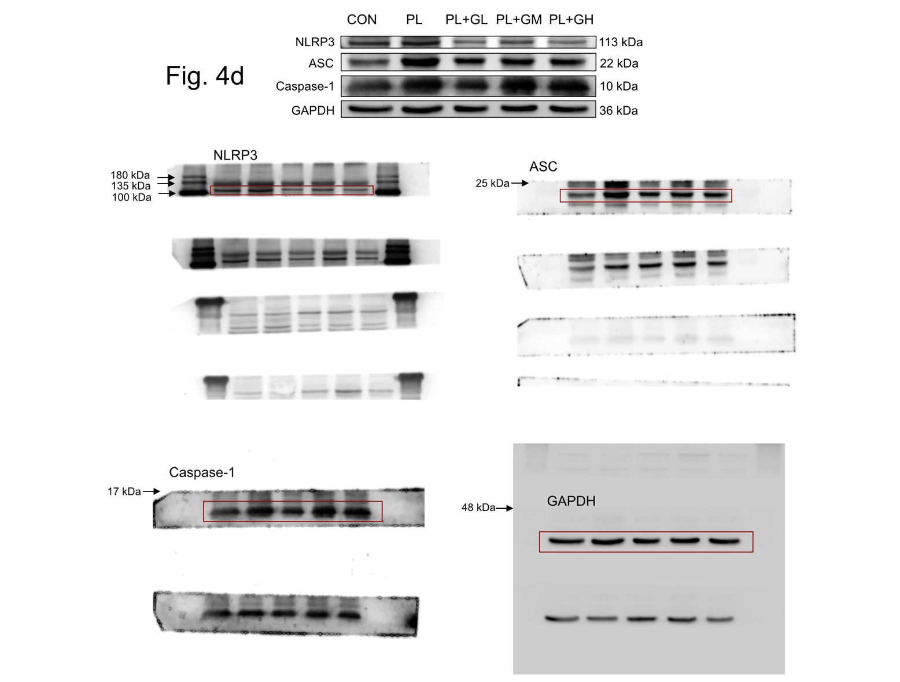
Supplementary Fig. 8| The original western blot images of NLRP3, ASC, Caspase-1, and GAPDH as presented in Figure 4d.

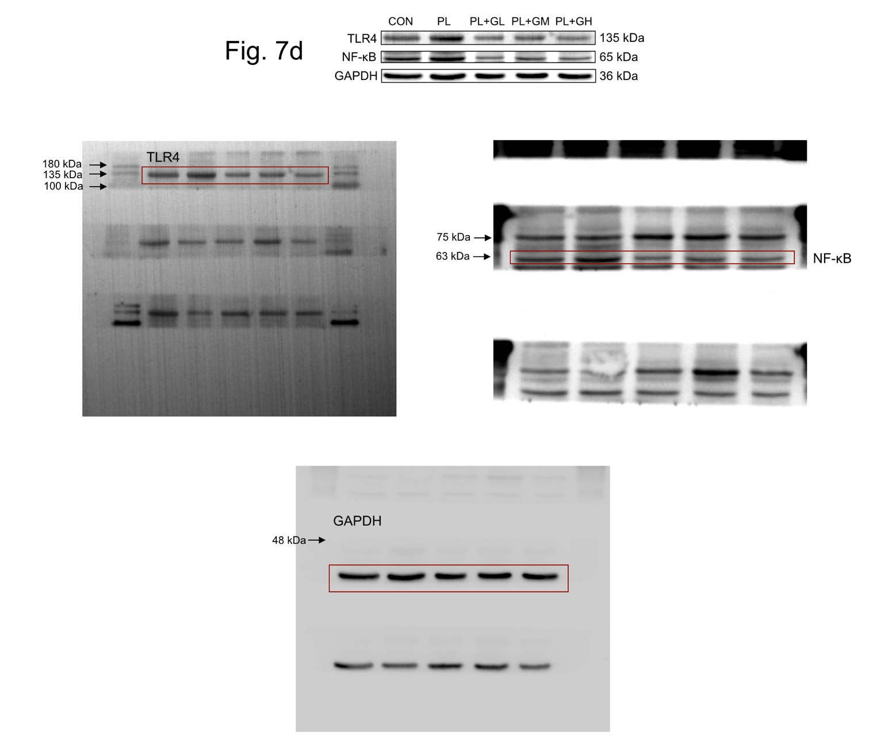
Supplementary Fig. 9| The original western blot images of TLR4, NF-κB, and GAPDH as presented in Figure 7d.

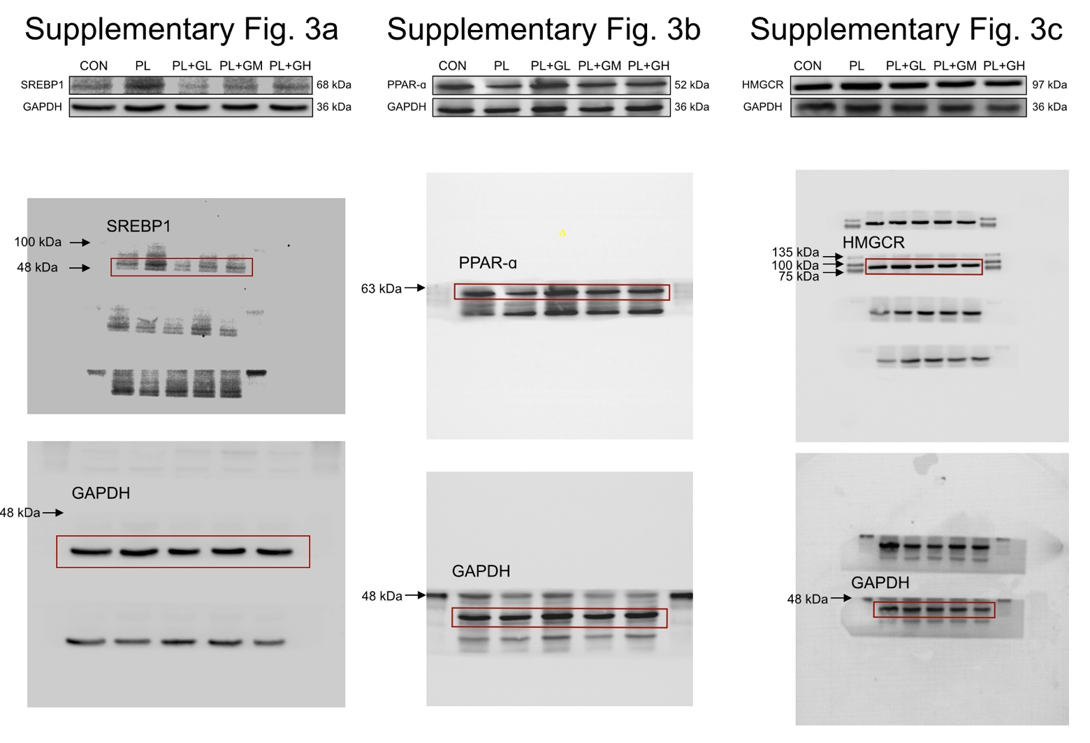
Supplementary Fig. 10| The original western blot images of SREBP1, PPAR-ɑ, HMGCR, and GAPDH as presented in Supplementary Figure 3a-c.

