Supporting Information for

Microbiome transplant and host genetic background shape Daphnia tolerance: Implications for ecological and ecotoxicological effect assessment

Rehab El-Shehawy¹, Sandra Luecke-Johansson¹, Björn Brindefalk¹, Magnus Breitholtz¹, Elena Gorokhova¹*
¹Department of Environmental Science, Stockholm University, 10691 Stockholm, Sweden
*Corresponding author
Email: elena.gorokhova@aces.su.se

This PDF file includes:

Supporting text S1
Figures S1 to S4
Tables S1 to S9
SI References (4)

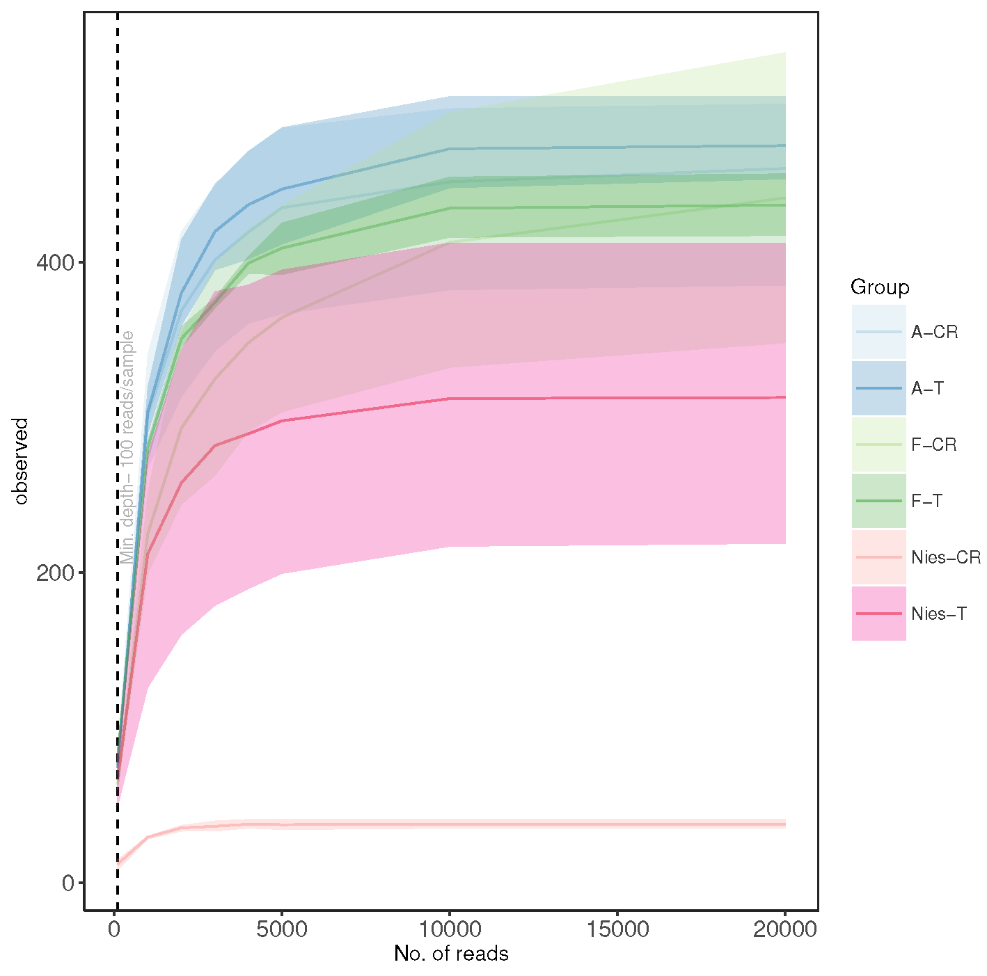

Figure S1. Rarefaction curves of 16S rRNA gene amplicon sequence variant (ASV) for bacterial assemblages detected in the gut samples of each clone (A, F, and Nies) and line (CR and T) combination. Saturation of the observed richness is achieved at approx. 10000 reads.

Table S1. Number of singletons, sequences and Good’s coverage in the sequenced samples. Sample names in our study consist of a clone identifier (A, F, or Nies) followed by a line designation (CR or T), and a numerical replicate code.

Sample | Nr. Singletons | Nr. sequences | Good’s coverage
A-CR-1 | 8 | 9628 | 99.91
A-CR-2 | 5 | 22756 | 99.97
A-CR-3 | 4 | 11931 | 99.96
A-T-1 | 10 | 8339 | 99.88
A-T-2 | 6 | 17354 | 99.96
A-T-3 | 13 | 8655 | 99.84
F-CR-1 | 12 | 29385 | 99.95
F-CR-2 | 0 | 32140 | 100
F-CR-3 | 1 | 30992 | 99.99
F-T-1 | 8 | 10755 | 99.92
F-T-2 | 3 | 13605 | 99.97
F-T-3 | 6 | 13347 | 99.95
Nies-CR-1 | 0 | 3928 | 100
Nies-CR-2 | 4 | 4238 | 99.90
Nies-CR-3 | 2 | 5104 | 99.96
Nies-T-1 | 3 | 8333 | 99.96
Nies-T-2 | 2 | 17927 | 99.98
Nies-T-3 | 9 | 7500 | 99.88

Text S1. Alpha diversity assessment
The multifaceted nature of the concept of diversity has motivated the development of a wide panel of indices, which have different purposes, units of measures and mathematical formulations, and thus are suited for responding to specific biological questions (Kim et al., 2017). In these indices, the components of diversity are accounted for in various ways; moreover, some of the indices encode the same information, but with slightly different mathematical formulations. Diversity is often quantified in terms of richness and evenness, as well as community composition. Although the quantitative definition of alpha diversity has been disputed, a sample has high alpha diversity when it contains a high number of equally abundant species, and low diversity otherwise (Finotello et al., 2018).
We tested several common diversity indices (Finotello et al., 2018) in a range of simple to complex metrics (Error! Reference source not found.) to test whether they behaved similarly and to select indices carrying complementary information in our dataset of the sequence results at the ASV level (unfiltered). All indices were calculated using PAST software (Hammer et al., 2001), version 4.02. For each index, we obtained 95% confidence intervals calculated using an unbiased bootstrap method based on 9999 replications. The resulting mean and 95% confidence limits were used to compare the index performance (Error! Reference source not found.), evaluate the relationships between the indices by cluster analysis, and select indicators representative of each cluster (Figure ) and avoiding highly correlating indices carrying redundant information.
The calculated indices were normalized and used in cluster analysis with Euclidean distance matrix and the UPGMA method as implemented in the PAST software (Hammer et al., 2001). Using this approach, we selected Dominance index, Chao1, and Shannon (H) indices that belonged to different clusters and exhibited the maximal variability due to clone and treatment factors (Figure S2b).
The Dominance index (D) ranges from 0 (all ASVs are equally present) to 1 (one ASV dominates the community completely); it is a measure of dominance by a single strain. Chao1, bias corrected, is an estimate of total species richness based on the numbers of singleton and doubleton ASVs. Shannon index H (entropy) is a diversity measure that takes into account the number of reads as well as number of ASVs and varies from 0 in a single-ASV community to high values for communities with many ASVs, each with only a few reads (Finotello et al., 2018). Therefore, these three conceptually complementary indices were the best combination for addressing different sides of the diversity responses in our data.
For these three indices as response variables, two-way analysis of variance (ANOVA; Table S2) with Tukey pairwise comparisons were applied to test for significant differences between the clones and lines, including the Clone × Line interaction using GraphPad Prism 7 (La Jolla, CA, USA). To evaluate correlations between the diversity indices and the LC₅₀ values obtained in Exp. I and Exp II for each clone/line combination, we used Spearman rho coefficient and α set at 0.05 (Figure S3).

a)
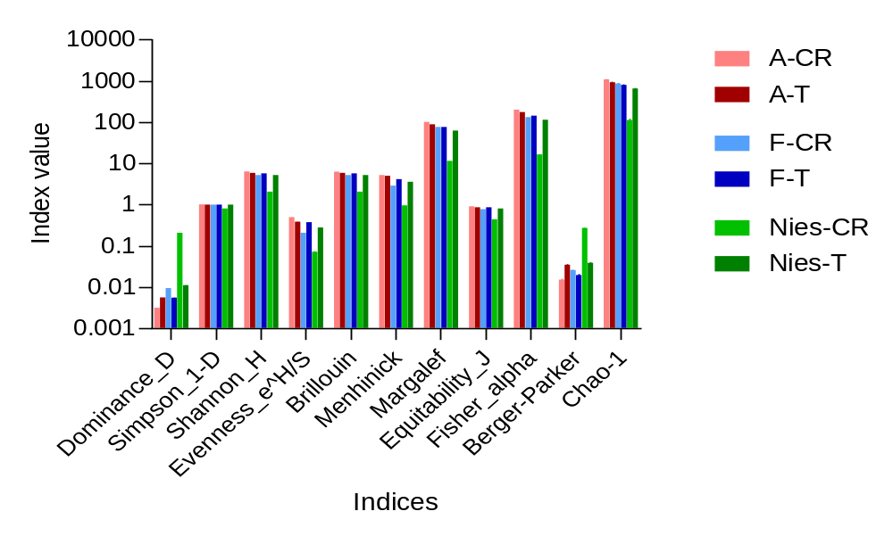

b)
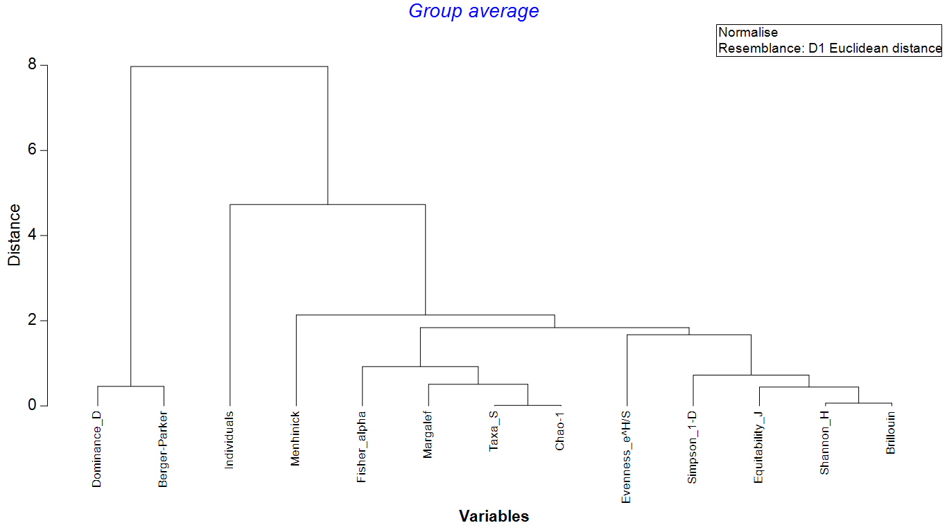

Figure S2. Eleven alpha diversity indices were calculated for samples from different clones (A, F, and Nies) and lines (CR, conventionally raised, and T, those with transplanted microbiome) to identify indices that would be most representative for the alpha diversity analysis: (A) mean and 95% confidence interval; the latter is not always visible, and (B) cluster analysis across the line/clone combinations. Dominance D, Chao1 and Shannon indices were selected as representative for the global diversity response in the data set.
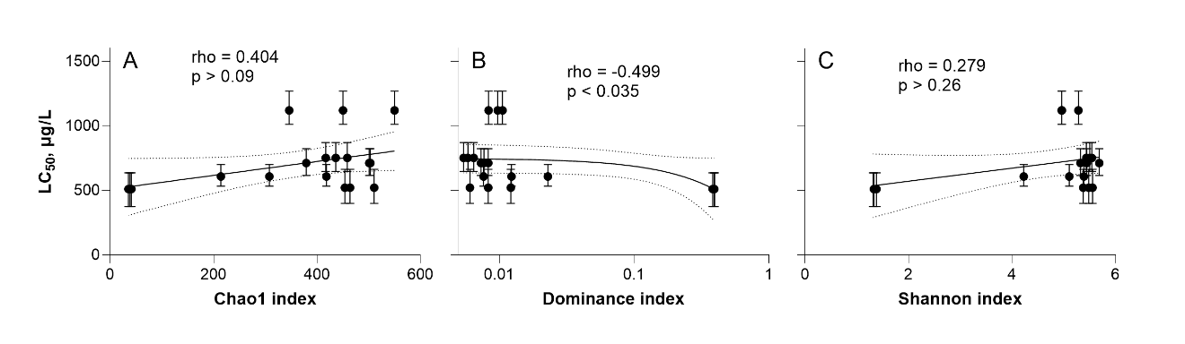

Figure S3. Spearman correlations between the diversity indices (Chao1, Dominance D, and Shannon H) and the LC₅₀ values (mean and 95%-confidence interval) that were obtained for the respective clone/line combinations in Exp. I. On each panel, Spearman rho and the corresponding p-value are shown. The solid line is the linear correlation with the dotted lines indicating 95% prediction interval.

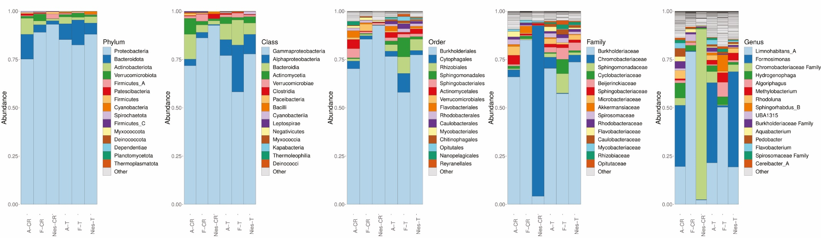

Figure S4. Relative abundances of the top 15 most numerous taxonomic groups from phylum to genus (left to right). All less numerous taxa are merged as others. Analysis was based on the relative abundances of the entire dataset; only eukaryotic (mitochondria/chloroplast) sequences were removed. Within clone Nies, 27 ASVs were classified as members of the family Chromobacteriaceae; however, they could not be assigned to any known genus in the RDP database. Additionally, one ASV showed a distant relationship to the genus Vogesella.

Table S2. Pairwise comparisons of the LC₅₀ values between the lines (CR vs. T) within a clone (F, A, and Nies; upper part) and between the clones for CR and T lines (F vs A, Nies vs A and F vs Nies). The LC₅₀ values were compared using the Wheeler ratio test (Wheeler et al., 2006). Ratio estimates with the corresponding 95% confidence interval are given for each comparison; if the 95% confidence interval is including 1, the difference in LC₅₀ values is not considered significant. Significant difference: * (p < 0.05). See Figure 2 for a graphical representation of the data.

Lines | Clones
Between-line comparison | F | A | Nies
CR vs T | 1.49 (1.22-1.83)* | 1.37 (1.02-1.92)* | 0.84 (0.60-1.11)
Between-clone comparison | F vs A | Nies vs A | F vs Nies
CR | 1.57 (1.30-1.91)* | 1.39 (1.05-1.95)* | 2.19 (1.68-3.02)*
T | 1.34 (0.99-2.05) | 1.16 (0.88-1.64) | 1.24 (0.98-1.55)

Table S3. Two-way ANOVA results on the effect of Clone (A, F, and Nies), Line (CR and T), and the Clone × Line interaction term on the diversity indices for gut bacterial communities of Daphnia magna. See Figure S2 for the graphic output.

Index | Factor | SS | df | MS | F | P
Chao1 | Clone | 315246 | 2 | 157623 | 34.8 | <0.0001
 | Line | 38790 | 1 | 38790 | 8.564 | 0.0127
 | Clone × Line | 75182 | 2 | 37591 | 8.299 | 0.0055
 | Residual | 54355 | 12 | 4530
Dominance index | Clone | 0.1507 | 2 | 0.07533 | 3839 | <0.0001
 | Line | 0.0715 | 1 | 0.0715 | 3644 | <0.0001
 | Clone × Line | 0.1401 | 2 | 0.07007 | 3571 | <0.0001
 | Residual | 0.0002355 | 12 | 0.00001962
Shannon index | Clone | 20.48 | 2 | 10.24 | 136.5 | <0.0001
 | Line | 7.924 | 1 | 7.924 | 105.7 | <0.0001
 | Clone × Line | 11.44 | 2 | 5.718 | 76.25 | <0.0001
 | Residual | 0.8999 | 12 | 0.07499

Table S4. PERMANOVA with pairwise comparisons for centroids and PERMDISP results for dispersion for taxa merged to genus level in gut bacterial communities of Daphnia magna. The factors included Clone (A, F, and Nies), Line (CR and T), and the interaction term. Type III sums of squares regression was applied to derive p values with 999 permutations [p(perm)] or calculating Monte-Carlo tests [p(MC)]. Pseudo F, PERMANOVA F statistic; df, degrees of freedom; SS, sums of squares; Unique perm, unique permutations. t_{PERMDISP} and p_{PERMDISP} are t- and p values of PERMDISP tests, calculated for centroids, respectively. Significant effects (p < 0.05) highlighted in bold. See Figure 3A for the PCoA plot.

Source | df | SS | MS | Pseudo-F | p(perm) | Unique perms | p(MC) | p_{PERMDISP}
Clone | 2 | 368.26 | 184.13 | 2.6663 | 0.001 | 997 | 0.003 | 0.031
Line | 1 | 300.86 | 300.86 | 4.3565 | 0.001 | 998 | 0.003 | 0.002
Clone × Line | 2 | 287.17 | 143.58 | 2.0791 | 0.001 | 997 | 0.011 | 0.004
Residual | 12 | 828.71 | 69.059
Total | 17 | 1785
Pairwise comparisons
Lines |  | Clones | t | p(perm) | Unique perms | p(MC) | t_{PERMDISP} | p_{PERMDISP}
CR-lines |  | A, F | 1.3048 | 0.095 | 10 | 0.182 | 1.6234 | 0.199
 |  | A, Nies | 1.9041 | 0.096 | 10 | 0.047 | 6.5752 | 0.099
 |  | F, Nies | 1.8323 | 0.105 | 10 | 0.038 | 7.3994 | 0.076
T-lines |  | A, F | 1.6547 | 0.102 | 10 | 0.067 | 0.99118 | 0.313
 |  | A, Nies | 1.0914 | 0.287 | 10 | 0.37 | 1.4682 | 0.222
 |  | F, Nies | 1.3953 | 0.106 | 10 | 0.141 | 1.0119 | 0.206

Table S5. Percentage of the most abundant taxa in the samples. Significant changes following the transplant withing a clone (PERMANOVA, pairwise comparison; p < 0.05) are in bold.

 | Taxa |  | A-CR | A-T | F-CR | F-T | Nies-CR | Nies-T
Phylum | Proteobacteria |  | 75.2 | 85.3 | 89.1 | 82.5 | 93.1 | 88.0
 | Bacteroidetes/Bacteroidota |  | 12.9 | 8.2 | 3.9 | 13.0 | 1.9 | 5.9
 | Firmicutes |  | 1.0 | 0.8 | 0.5 | 0.7 | 3.9 | 0.4
Class | Gammaproteobacteria |  | 71.8 | 77.0 | 86.1 | 58.2 | 92.6 | 77.8
 | Alphaproteobacteria |  | 3.4 | 8.3 | 2.9 | 24.3 | 0.5 | 10.2
 | Clostridia |  | 0.3 | 0.6 | 0.2 | 0.4 | 2.5 | 0.3
Order | Bacteroidia |  | 12.9 | 8.2 | 8.2 | 13.0 | 1.9 | 5.9
 | Burkholderiales |  | 70.2 | 76.6 | 85.5 | 58.0 | 92.6 | 77.4
 | Cytophagales |  | 4.0 | 2.7 | 1.9 | 9.9 | 0.2 | 2.3
 | Burkholderiales |  | 70.2 | 76.6 | 85.5 | 58.0 | 92.6 | 77.4
Family | Burkholderiaceae |  | 66.0 | 70.4 | 85.2 | 57.3 | 4.2 | 73.6
 | Chromobacteriaceae |  | 3.8 | 5.7 | 0.0 | 0.4 | 88.3 | 3.6
Genus | Formosimonas |  | 31.8 | 41.5 | 0.4 | 0.9 | 0.2 | 49.3
 | Limnohabitans |  | 19.6 | 21.5 | 79.1 | 50.3 | 2.3 | 19.4

Table S6. PERMANOVA with pairwise comparisons and PERMDISP results for differences in the reconstructed metabolic pathways for the gut microbiome of Daphnia magna. The factors included Clone (A, F, and Nies), Line (CR and T), and the interaction term. Type III sums of squares regression was applied to derive p values with 999 permutations [p(perm)] or calculating Monte-Carlo tests [p(MC)]. Pseudo F, PERMANOVA F statistic; df, degrees of freedom; SS, sums of squares; Unique perm, unique permutations. t_{PERMDISP} and p_{PERMDISP} are t- and p values of PERMDISP tests, calculated for centroids, respectively. Significant effects (p < 0.05) are in bold. See Figure 3B for PCoA plot.

Source | df | SS | MS | Pseudo-F | p(perm) | Unique perms | p(MC) | p_{PERMDISP}
Clone | 2 | 22.949 | 11.475 | 13.917 | 0.001 | 998 | 0.001 | 0.001
Line | 1 | 12.475 | 12.475 | 15.13 | 0.001 | 999 | 0.001 | 0.001
Clone × Line | 2 | 25.882 | 12.941 | 15.696 | 0.001 | 999 | 0.001 | 0.319
Residual | 12 | 9.8941 | 0.8245
Total | 17 | 71.2
Pairwise comparisons
Lines |  | Clones | t | p(perm) | Unique perms | p(MC) | t_{PERMDISP} | p_{PERMDISP}
CR-lines |  | A, F | 2.0029 | 0.107 | 10 | 0.036 | 3.8033 | 0.095
 |  | A, Nies | 5.7606 | 0.098 | 10 | 0.003 | 1.2422 | 0.307
 |  | F, Nies | 6.5457 | 0.093 | 10 | 0.001 | 3.9542 | 0.098
T-lines |  | A, F | 1.6983 | 0.1 | 10 | 0.099 | 1.3596 | 0.501
 |  | A, Nies | 1.3182 | 0.189 | 10 | 0.212 | 0.68229 | 0.807
 |  | F, Nies | 1.42 | 0.081 | 10 | 0.157 | 2.2334 | 0.198

Table S7. Distance-based multivariate linear model (DistLM) of the LC₅₀ variability as a function of the relative abundance of genera in the Daphnia microbiome. (A) Marginal test results show how much of the variance in the LC₅₀ can be explained by each genus individually and what is the direction of the correlation (positive or negative), and (B) the overall BEST model (AICc = 142.6, adjusted R² = 0.97, RSS [residual sums of squares] = 21555; α = 0.05).
AICc: a second-order estimate of Akaike information criterion; SS (trace): sum of squares; Pseudo-F: multivariate analog to Fisher’s F test; Prop: the proportion of variance explained; Res df, residual degrees of freedom.

A. Marginal tests | Positive or negative | SS | Pseudo-F | p value | Prop
Limnohabitans | + | 6.7878E+05 | 127.07 | 0.001 | 0.8882
Hydrogenophaga | + | 2.7926E+05 | 9.2128 | 0.006 | 0.3654
Daejeonella | + | 4.0038E+05 | 17.606 | 0.002 | 0.5239
UBA2033 | + | 4.4356E+05 | 22.13 | 0.001 | 0.5804
Staphylococcus | + | 1.3369E+05 | 3.3923 | 0.093 | 0.1749
Cereibacter | + | 4.475E+05 | 22.604 | 0.001 | 0.5855
Aquabacterium | + | 2.9584E+05 | 10.105 | 0.003 | 0.3871
Algoriphagus | + | 2.4657E+05 | 7.6209 | 0.017 | 0.3226
UBA961 | + | 2.4262E+05 | 7.4419 | 0.021 | 0.3175
UBA952 | + | 3.8435E+05 | 16.187 | 0.021 | 0.5029
Phascolarctobacterium | + | 2.0971E+05 | 6.0508 | 0.018 | 0.2744
Rhizobacter | + | 2.7599E+05 | 9.044 | 0.011 | 0.3611
UBA11704 | + | 1.5828E+05 | 4.1792 | 0.041 | 0.2071
Fluviicola | + | 4.0557E+05 | 18.091 | 0.002 | 0.5307
Williamsia | + | 3.5144E+05 | 13.621 | 0.003 | 0.4598
Prevotella | + | 0.6672E+05 | 1.5303 | 0.246 | 0.0872
CAG-110 | + | 3.3124E+05 | 12.239 | 0.008 | 0.4334
UBA1315 | + | 1.5828E+05 | 4.1792 | 0.061 | 0.2071
Mesorhizobium | - | 2.4432E+05 | 7.4419 | 0.081 | 0.3174
Allorhizobium | - | 2.4657E+05 | 7.6209 | 0.174 | 0.3226

B. BEST model | AICc | SS (trace) | Pseudo-F | p value | Prop. | Cumul.
Limnohabitans | 157.18 | 678780 | 127.07 | 0.001 | 0.8882 | 0.88817
UBA2033 | 152.75 | 28641 | 7.5599 | 0.012 | 0.0374 | 0.92564
Aquabacterium | 147.38 | 21848 | 8.7446 | 0.012 | 0.0285 | 0.95423
Daejeonella | 142.58 | 13424 | 8.0961 | 0.011 | 0.0175 | 0.9718

Table S8. Distance-based multivariate linear model (DistLM) of the LC₅₀ variability as a function of the relative abundance of metabolic pathways in the Daphnia microbiome. (A) Marginal test results show how much of the variance in the LC₅₀ can be explained by each pathway individually with the first column indicating the direction of the correlation (positive or negative), and (B) four alternative BEST models based on the AIC criterion.
AICc: a second-order estimate of Akaike information criterion; SS (trace): sum of squares; Pseudo-F: multivariate analog to Fisher’s F test; Prop: the proportion of variance explained; Res df, residual degrees of freedom.

A) Marginal tests |  |  | SS | Pseudo-F | p value | Prop
Biocyc ID |  | Pathway name
- | ASPASN-PWY | Superpathway of L-aspartate and L-asparagine biosynthesis | 2.76E+05 | 9.040 | 0.009 | 0.36
- | COLANSYN-PWY | Colanic acid building blocks biosynthesis | 1.62E+05 | 4.324 | 0.049 | 0.21
- | ECASYN-PWY | Enterobacterial common antigen biosynthesis | 14318 | 0.306 | 0.567 | 0.02
+ | FUC-RHAMCAT-PWY | Superpathway of fucose and rhamnose degradation | 2.07E+05 | 5.937 | 0.018 | 0.27
+ | FUCCAT-PWY | L-fucose degradation I | 3.17E+05 | 11.36 | 0.008 | 0.41
+ | GLYCOGENSYNTH-PWY | glycogen biosynthesis I (from ADP-D-Glucose) | 1.86E+05 | 5.164 | 0.044 | 0.24
+ | HCAMHPDEG-PWY | 3-phenylpropanoate and 3-(3-hydroxyphenyl) propanoate degradation to 2-hydroxypentadienoate | 2.23E+05 | 6.606 | 0.018 | 0.29
+ | KDO-NAGLIPASYN-PWY | Superpathway of (Kdo)2-lipid A biosynthesis | 12064 | 0.257 | 0.596 | 0.02
+ | METHYLGALLATE-DEGRADATION-PWY | Methylgallate degradation II | 2.19E+05 | 6.427 | 0.029 | 0.29
+ | P163-PWY | L-lysine fermentation to acetate and butanoate | 2.08E+05 | 5.975 | 0.02 | 0.27
+ | PWY-5392 | Reductive TCA cycle II | 3.11E+05 | 10.964 | 0.007 | 0.41
+ | PWY-5705 | Allantoin degradation to glyoxylate III | 92731 | 2.209 | 0.134 | 0.12
- | PWY-5910 | Superpathway of geranylgeranyl diphosphate biosynthesis I | 2.24E+05 | 6.653 | 0.022 | 0.29
+ | PWY-6572 | Chondroitin sulfate degradation I | 3.90E+05 | 16.69 | 0.003 | 0.51
+ | PWY-6737 | Starch degradation V | 2.83E+05 | 9.398 | 0.006 | 0.37

B. BEST models | AICc | SS (trace) | Pseudo-F | p value | Prop. | Cumul.
Model 1: AICc = 167.38, adjusted R² = 0.89, RSS = 85491
PWY-5392 | 187.22 | 3.1076E+05 | 10.964 | 0.008 | 0.4066 | 0.4066
ASPASN-PWY | 179.19 | 2.0664E+05 | 12.556 | 0.003 | 0.2704 | 0.6770
PWY-5910 | 173.07 | 1.0109E+05 | 9.7087 | 0.011 | 0.1323 | 0.8093
COLANSYN-PWY | 167.38 | 60281 | 9.1665 | 0.006 | 0.0789 | 0.8881
Model 2: AICc = 168.73, adjusted R² = 0.88, RSS = 92106
PWY-6572 | 183.75 | 3.9025E+05 | 16.695 | 0.002 | 0.5106 | 0.5106
ASPASN-PWY | 174.41 | 1.8463E+05 | 14.624 | 0.002 | 0.2416 | 0.7522
PWY-5910 | 169.65 | 68816 | 7.9912 | 0.016 | 0.0900 | 0.8422
COLANSYN-PWY | 168.73 | 28455 | 4.0162 | 0.055 | 0.0372 | 0.8795

Table S9. Primers and amplicon size used for PCR of bacterial DNA.

16S Primer name | Sequence 3´-5´ | bp | Reference
341F  805R | CCTACGGGNGGCWGCAG  GACTACHVGGGTATCTAATCC | 464 | Herlemann et al., 2011
8F  1492R | AGAGTTTGATCCTGGCTCAG  CGGTTACCTTGTTACGACTT | 1484 | Turner et al., 1999, Jiang et al., 2006

References
Finotello, F., Mastrorilli, E., and Di Camillo, B. (2018). Measuring the diversity of the human microbiota with targeted next-generation sequencing. Briefings in Bioinformatics 19, 679–692. doi:10.1093/bib/bbw119.

Hammer, Ø., Harper, D. A., and Ryan, P. D. (2001). PAST: Paleontological Statistics Software Package for Education and Data Analysis. Palaeontologia Electronica 4, 1–9.

Kim, B.-R., Shin, J., Guevarra, R. B., Lee, J. H., Kim, D. W., Seol, K.-H., et al. (2017). Deciphering Diversity Indices for a Better Understanding of Microbial Communities. Journal of Microbiology and Biotechnology 27, 2089–2093. doi:10.4014/jmb.1709.09027.

Wheeler, M.W., Park, R.M., Bailer, A.J., 2006. Comparing median lethal concentration values using confidence interval overlap or ratio tests. Environmental Toxicology and Chemistry 25, 1441–1444.

