Table 12 and Figure 7 comparison of Dnorm, Shape index and Curvedness of nitrate molecule in CDGSN, FDGSN, NDGSN and GSN

nitrate | Dnorm |  |  | Shape index |  |  |  | Curvedness
 | min | mean | max | min |  | mean | max | min |  | mean |  | max
CDGSN | -0.5140 | 0.1303 | 0.6871 | -0.9829 |  | 0.5204 | 0.9977 | -2.8531 |  | -0.8039 |  | 0.2334
CDGSN | 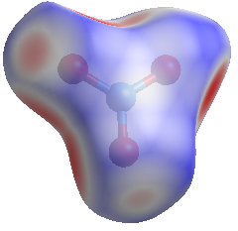 |  |  | 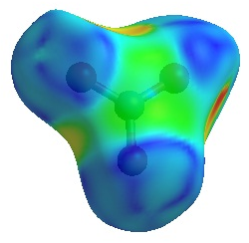 |  |  |  | 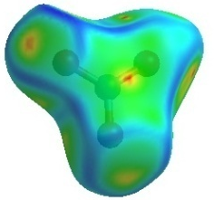
FDGSN | -0.5315 | 0.1205 | 0.6752 | -0.9861 |  | 0.5209 | 0.9944 | -3.3209 |  | -0.7993 |  | 0.2355
FDGSN | 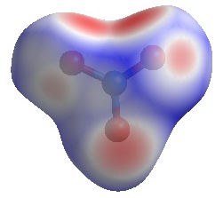 |  |  | 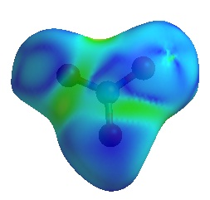 |  |  |  | 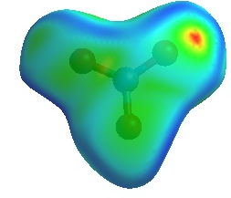
NDGSN | -0.5213 | 0.1805 | 1.059 | -0.9901 |  | 0.4612 | .9954 | -3.3118 |  | -0.8514 |  | 0.1694
NDGSN | 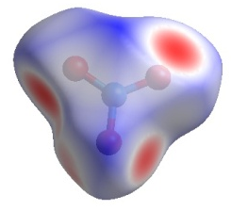 |  |  | 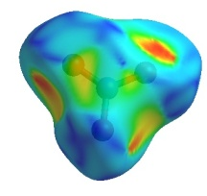 |  |  |  | 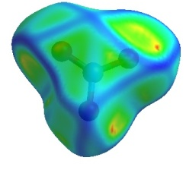
GSN | -0.2349 | 0.2523 | 1.0520 | -0.6334 | 0.5512 |  | 0.9977 | -2.6479 | -0.8738 |  | 0.0521
GSN | 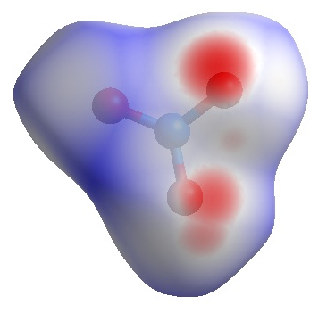 |  |  | 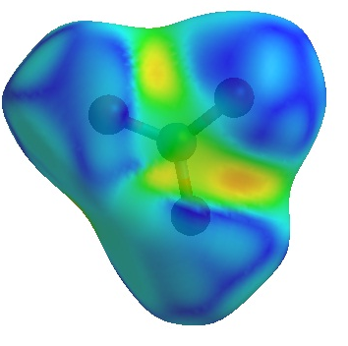 |  |  |  | 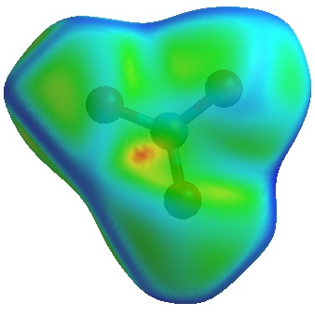

Table 13 and Figure 8 comparison of Dnorm, Shape index and Curvedness of glycine molecule in CDGSN, FDSN, NDGSN and GSN

glycine | Dnorm |  |  |  | Shape index |  |  | curvedness
 | min | mean |  | max | min | mean | max | min |  | mean |  | max
CDGSN | -0.5848 | 0.1381 |  | 0.7413 | -0.9926 | 0.4604 | 0.9965 | -3.2645 |  | -0.8253 |  | 0.2281
CDGSN | 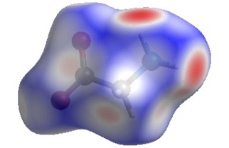 |  |  |  | 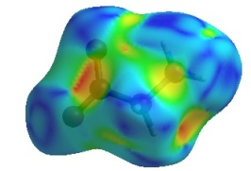 |  |  | 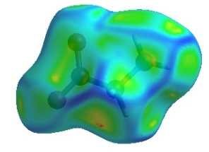
FDGSN | -0.5880 | 0.1288 | 0.7319 |  | -0.9955 | 0.4622 | 0.9963 | -2.9617 |  | -0.8243 |  | 0.2113
FDGSN | 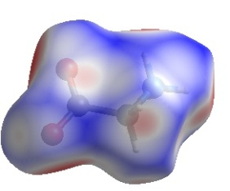 |  |  |  | 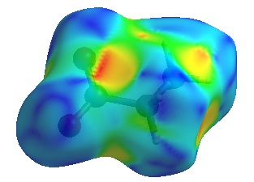 |  |  | 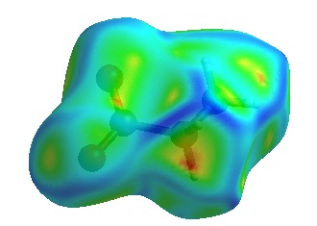
NDGSN | -0.6258 | 0.1464 | 1.0286 |  | -.9897 | 0.4350 | .9974 | -2.5825 |  | -0.8368 |  | 0.2781
NDGSN | 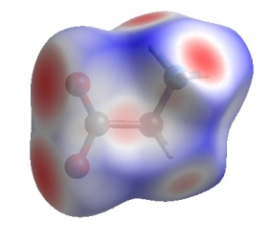 |  |  |  | 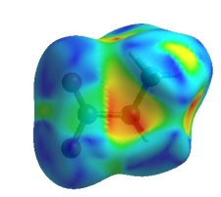 |  |  | 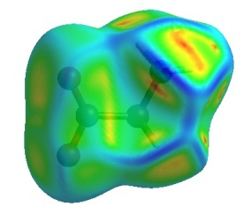
GSN | -0.6317 | 0.1625 |  | 0.9738 | -0.9647 | 0.4582 | 0.9955 | -4.2724 | -0.8998 |  | 0.2043
GSN | 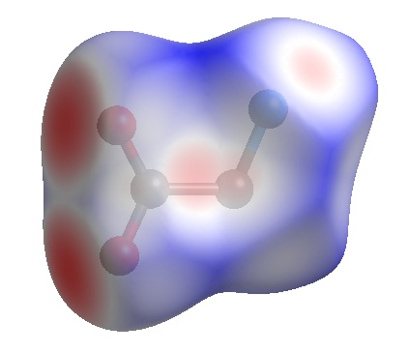 |  |  |  | 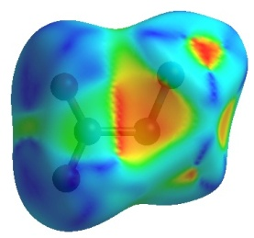 |  |  | 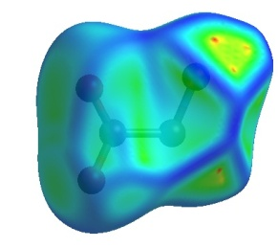

Table 14 and Figure 9 comparison of Dnorm, Shape index and Curvedness of entire molecule in CDGSN, FDSN, NDGSN and GSN

 | Dnorm |  |  | Shape index |  |  | curvedness
 | min | mean | max | min | mean | max | min | mean | max
CDGSN | -0.517 | 0.162 | 0.760 | -0.997 | 0.311 | 0.966 | -3.336 | -0.861 | 0.570
CDGSN | 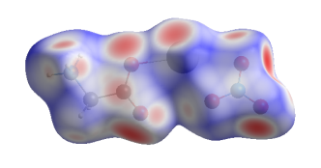 |  |  | 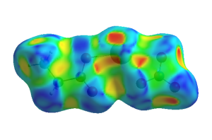 |  |  | 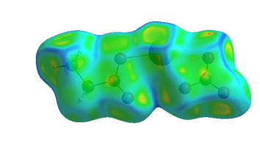
FDGSN | -0.533 | 0.152 | 0.758 | -0.991 | 0.312 | 0.998 | -3.544 | -0.857 | 0.587
 | 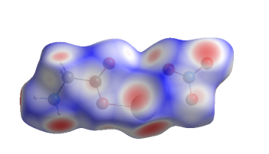 |  |  | 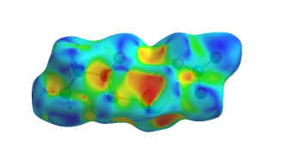 |  |  | 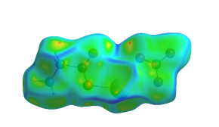
NDGSN | -0.592 | 0.164 | 1.110 | -0.975 | 0.290 | 0.995 | -4.274 | -0.873 | 0.441
NDGSN | 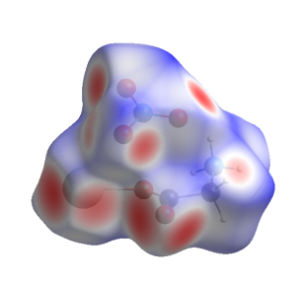 |  |  | 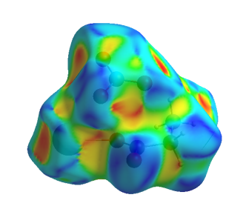 |  |  | 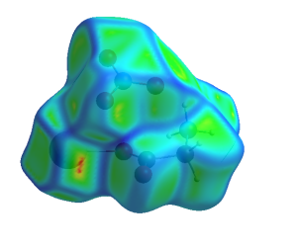
GSN | -0.632 | 0.199 | 1.088 | -0.980 | 0.314 | 0.998 | -3.799 | -0.920 | 0.411
GSN | 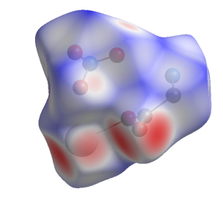 |  |  | 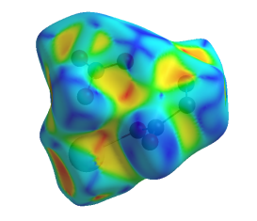 |  |  | 