Supplemental file
Supplementary Tables
Supplemental Table 1. The number of confirmed COVID-19 cases and deaths by age.
Age  Month | 60-69 |  |  | 70-79 |  |  | 80 or above
Age  Month | Confirm | Death | (%) | Confirm | Death | (%) | Confirm | Death | (%)
21-Jan | 2641 | 61 | 2.31 | 1241 | 135 | 10.88 | 903 | 302 | 33.44
21-Feb | 1756 | 17 | 0.97 | 802 | 47 | 5.86 | 451 | 107 | 23.73
21-Mar | 1963 | 15 | 0.76 | 824 | 45 | 5.46 | 376 | 60 | 15.96
21-Apr | 2791 | 15 | 0.54 | 1186 | 38 | 3.2 | 572 | 40 | 6.99
21-May | 2515 | 15 | 0.6 | 985 | 30 | 3.05 | 406 | 77 | 18.97
21-Jun | 1771 | 14 | 0.79 | 515 | 23 | 4.47 | 165 | 18 | 10.91
21-Jul | 2591 | 19 | 0.73 | 714 | 17 | 2.38 | 281 | 27 | 9.61
21-Aug | 4362 | 43 | 0.99 | 1363 | 37 | 2.71 | 630 | 56 | 8.89
21-Sep | 4985 | 47 | 0.94 | 1924 | 41 | 2.13 | 902 | 59 | 6.54
21-Oct | 6119 | 62 | 1.01 | 2748 | 96 | 3.49 | 1747 | 163 | 9.33
21-Nov | 15519 | 108 | 0.7 | 7764 | 201 | 2.59 | 4764 | 435 | 9.13
21-Dec | 33214 | 326 | 0.98 | 13587 | 535 | 3.94 | 6292 | 970 | 15.42
22-Jan | 13277 | 219 | 1.65 | 4744 | 357 | 7.53 | 3552 | 540 | 15.2
22-Feb | 176030 | 125 | 0.07 | 68473 | 281 | 0.41 | 45847 | 820 | 1.79
22-Mar | 998086 | 798 | 0.08 | 461955 | 1761 | 0.38 | 279780 | 5161 | 1.84
22-Apr | 468766 | 713 | 0.15 | 248954 | 1372 | 0.55 | 151168 | 4095 | 2.71
22-May | 91523 | 154 | 0.17 | 49260 | 298 | 0.6 | 29471 | 806 | 2.73
Age  Month | 30-39 |  |  | 40-49 |  |  | 50-59
Age  Month | Confirm | Death | (%) | Confirm | Death | (%) | Confirm | Death | (%)
21-Jan | 2192 | 3 | 0.14 | 2589 | 3 | 0.12 | 3278 | 16 | 0.49
21-Feb | 1737 | 0 | 0.00 | 1642 | 4 | 0.24 | 2021 | 7 | 0.35
21-Mar | 2128 | 1 | 0.05 | 2152 | 0 | 0.00 | 2319 | 5 | 0.22
21-Apr | 2593 | 0 | 0.00 | 3061 | 0 | 0.00 | 3552 | 4 | 0.11
21-May | 2836 | 1 | 0.04 | 3071 | 1 | 0.03 | 3254 | 7 | 0.22
21-Jun | 2780 | 0 | 0.00 | 3086 | 0 | 0.00 | 2938 | 4 | 0.14
21-Jul | 6970 | 2 | 0.03 | 7309 | 2 | 0.03 | 6812 | 8 | 0.12
21-Aug | 8923 | 2 | 0.02 | 8355 | 5 | 0.06 | 8240 | 44 | 0.53
21-Sep | 11266 | 7 | 0.06 | 10159 | 11 | 0.11 | 7223 | 29 | 0.40
21-Oct | 9015 | 6 | 0.07 | 7937 | 12 | 0.15 | 5822 | 27 | 0.46
21-Nov | 10214 | 1 | 0.01 | 9734 | 6 | 0.06 | 10344 | 23 | 0.22
21-Dec | 23263 | 9 | 0.04 | 24427 | 26 | 0.11 | 24357 | 71 | 0.29
22-Jan | 32903 | 9 | 0.03 | 33555 | 20 | 0.06 | 22356 | 45 | 0.20
22-Feb | 349016 | 6 | 0.00 | 369832 | 13 | 0.00 | 257619 | 52 | 0.02
22-Mar | 1463421 | 33 | 0.00 | 1533300 | 93 | 0.01 | 1201458 | 295 | 0.02
22-Apr | 601972 | 16 | 0.00 | 639882 | 83 | 0.01 | 546828 | 260 | 0.05
22-May | 122844 | 9 | 0.01 | 126962 | 36 | 0.03 | 114804 | 68 | 0.06
Age  Month | 0-9 |  |  | 10-19 |  |  | 20-29
Age  Month | Confirm | Death | (%) | Confirm | Death | (%) | Confirm | Death | (%)
21-Jan | 893 | 0 | 0.00 | 1433 | 0 | 0.00 | 2241 | 0 | 0.00
21-Feb | 638 | 0 | 0.00 | 828 | 0 | 0.00 | 1597 | 1 | 0.06
21-Mar | 749 | 0 | 0.00 | 979 | 0 | 0.00 | 1921 | 2 | 0.10
21-Apr | 912 | 0 | 0.00 | 1520 | 0 | 0.00 | 2732 | 0 | 0.00
21-May | 912 | 0 | 0.00 | 1469 | 0 | 0.00 | 2885 | 0 | 0.00
21-Jun | 959 | 0 | 0.00 | 1345 | 0 | 0.00 | 3062 | 0 | 0.00
21-Jul | 2479 | 0 | 0.00 | 4334 | 0 | 0.00 | 9894 | 2 | 0.02
21-Aug | 3422 | 0 | 0.00 | 5543 | 0 | 0.00 | 12238 | 3 | 0.02
21-Sep | 3879 | 0 | 0.00 | 5967 | 0 | 0.00 | 13563 | 2 | 0.01
21-Oct | 4209 | 0 | 0.00 | 6853 | 0 | 0.00 | 8961 | 2 | 0.02
21-Nov | 7210 | 1 | 0.01 | 9529 | 0 | 0.00 | 7452 | 0 | 0.00
21-Dec | 20793 | 2 | 0.01 | 19483 | 0 | 0.00 | 18192 | 0 | 0.00
22-Jan | 25564 | 0 | 0.00 | 35793 | 0 | 0.00 | 43127 | 2 | 0.00
22-Feb | 297734 | 2 | 0.00 | 329831 | 1 | 0.00 | 394365 | 3 | 0.00
22-Mar | 1279469 | 6 | 0.00 | 1352843 | 2 | 0.00 | 1390863 | 23 | 0.00
22-Apr | 448518 | 8 | 0.00 | 481776 | 5 | 0.00 | 554383 | 12 | 0.00
22-May | 74926 | 3 | 0.00 | 108232 | 1 | 0.00 | 147738 | 7 | 0.00
Source of COVID-19 death data: Korean Centers for Disease Control and Prevention (KCDC); CFR, case fatality rate, is the number of COVID-19 deaths divided by the number of confirmed COVID-19 cases during the same period.

Supplemental Table 2. Nationwide monthly mortality data.
 | 2015 | 2016 | 2017 | 2018 | 2019 | 2020 | 2021 | 2022
January | 24,760 | 24,708 | 25,902 | 31,550 | 27,366 | 28,430 | 27,230 | 29,686
February | 23,209 | 24,601 | 22,884 | 25,001 | 22,918 | 25,423 | 23,795 | 29,189
March | 26,493 | 25,208 | 24,230 | 25,252 | 24,985 | 25,850 | 26,550 | 44,487
April | 23,610 | 22,830 | 23,142 | 23,963 | 23,833 | 24,674 | 25,077 | 36,697
May | 22,935 | 23,125 | 23,766 | 23,996 | 24,756 | 24,346 | 25,577 | 28,859
June | 21,345 | 21,350 | 21,986 | 22,596 | 23,056 | 23,638 | 24,398
July | 21,534 | 22,053 | 22,245 | 23,886 | 23,216 | 23,989 | 25,748
August | 21,496 | 22,604 | 22,846 | 23,937 | 23,707 | 25,289 | 25,953
September | 21,375 | 22,081 | 22,622 | 22,906 | 23,570 | 24,352 | 25,674
October | 23,050 | 23,610 | 24,624 | 25,010 | 25,569 | 26,488 | 27,775
November | 22,678 | 23,333 | 24,404 | 24,200 | 25,412 | 25,603 | 28,363
December | 23,410 | 25,324 | 26,883 | 26,523 | 26,722 | 26,866 | 31,634
Source: Korean Statistical Information Service (KOSIS) of Statistics Korea

Supplemental Table 3. World Health Organization analysis of excess mortality by country
WHO data
Country | year | population  (per 100k) | Excess  (mean) | Excess  (low) | Excess  (high)
Korea | 2020 | 512.69183 | 0 | -6 | 7
Korea | 2021 | 513.05184 | 12 | 4 | 19
Korea | 2020-2021 | 512.871835 | 6 | 1 | 11
Japan | 2020 | 1264.76458 | -24 | -32 | -16
Japan | 2021 | 1260.50796 | 8 | -1 | 18
Japan | 2020-2021 | 1262.63627 | -8 | -14 | -2
USA | 2020 | 3310.02647 | 141 | 132 | 149
USA | 2021 | 3329.15074 | 140 | 129 | 151
USA | 2020-2021 | 3319.588605 | 140 | 134 | 147
UK | 2020 | 678.86004 | 126 | 112 | 140
UK | 2021 | 682.07114 | 93 | 78 | 109
UK | 2020-2021 | 680.46559 | 109 | 98 | 121
New Zealand | 2020 | 48.22233 | -43 | -50 | -36
New Zealand | 2021 | 48.60642 | -13 | -20 | -5
New Zealand | 2020-2021 | 48.414375 | -28 | -33 | -23

Supplemental Table 4. Lancet analysis of excess mortality by country
 | Reported  COVID-19 deaths | Estimated excess deaths | Estimated excess  mortality rate  (per 100k) | Ratio between excess mortality rate  and reported COVID-19 mortality rate
Korea | 5620 | 4630 (-658, 9580) | 4.4 (-0.6, 9.1) | 0.82 (-0.12, 1.70)
Japan | 18400 | 111000 (103000, 116000) | 44.1 (41.0, 46.4) | 6.02 (5.58, 6.33)
USA | 824000 | 1130000 (1080000, 1180000) | 179.3 (170.7, 187.5) | 1.37 (1.31, 1.44)
UK | 173000 | 169000 (163000, 174000) | 126.8 (122.3, 130.9) | 0.97 (0.94, 1.01)
New Zealand | 51 | –872 (–1330, –451) | –9·3 (–14·1, –4·8) | –17·10 (–26·06, –8·84)

Supplemental Figure Legends

Supplemental Figure 1. P-score by month (2020.01-2022.05)

Supplemental Figure 2. COVID-19 case fatality rate in Republic of Korea (the number of confirmed deaths divided by the number of confirmed cases)

Supplemental Figure 3. P-score comparison between other countries and Republic of Korea.
7a, P-score of ‘Our world in data’ and this study; 7b, P-score of United States of America and Korea; 7c, P-score of United Kingdom and Korea; 7d, P-score of New Zealand and Korea; 7e, P-score of Japan and Korea. Source of data (USA, UK, New Zealand, and Japan): Our world in data.

Supplemental Figure 4. Daily excess deaths between other countries and Republic of Korea.
8a, Comparison of daily excess deaths in Korea between ‘The Economist’ data and this study with P-score; 8b, Daily excess deaths of United States of America and Korea; 8c, Daily excess deaths of United Kingdom and Korea; 8d, Daily excess deaths of New Zealand and Korea; 8e, Daily excess deaths of Japan and Korea. Source of data (USA, UK, New Zealand, and Japan): Our world in data (2022), The Economist (2022), Johns Hopkins University (2022)

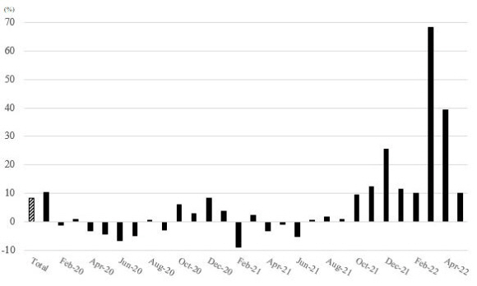
Supplemental Figure 1. P-score by month (2020.01-2022.05)

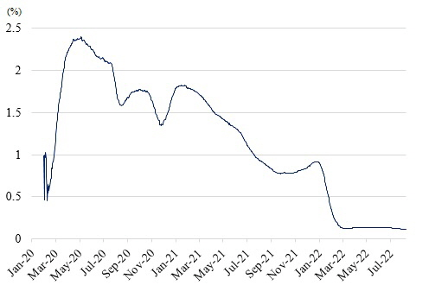
Supplemental Figure 2. COVID-19 case fatality rate in Republic of Korea (the number of confirmed deaths divided by the number of confirmed cases)

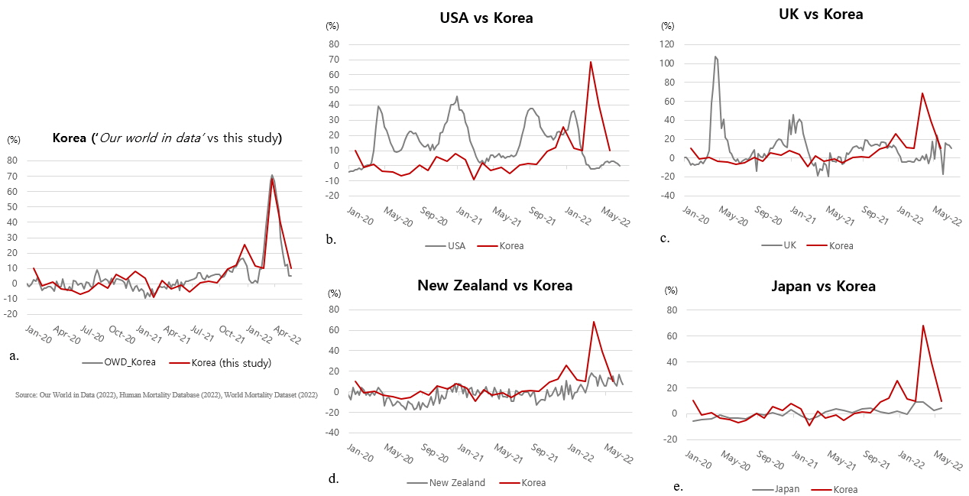
Supplemental Figure 3. P-score comparison between other countries and Republic of Korea.
7a, P-score of ‘Our world in data’ and this study; 7b, P-score of United States of America and Korea; 7c, P-score of United Kingdom and Korea; 7d, P-score of New Zealand and Korea; 7e, P-score of Japan and Korea. Source of data (USA, UK, New Zealand, and Japan): Our world in data.

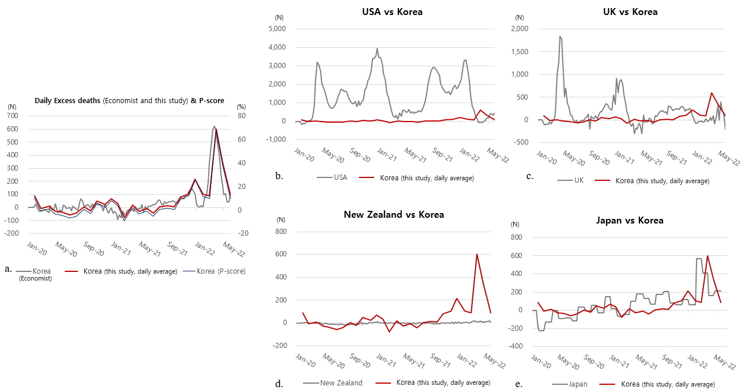
Supplemental Figure 4. Daily excess deaths between other countries and Republic of Korea.
8a, Comparison of daily excess deaths in Korea between ‘The Economist’ data and this study with P-score; 8b, Daily excess deaths of United States of America and Korea; 8c, Daily excess deaths of United Kingdom and Korea; 8d, Daily excess deaths of New Zealand and Korea; 8e, Daily excess deaths of Japan and Korea. Source of data (USA, UK, New Zealand, and Japan): Our world in data (2022), The Economist (2022), Johns Hopkins University (2022)

