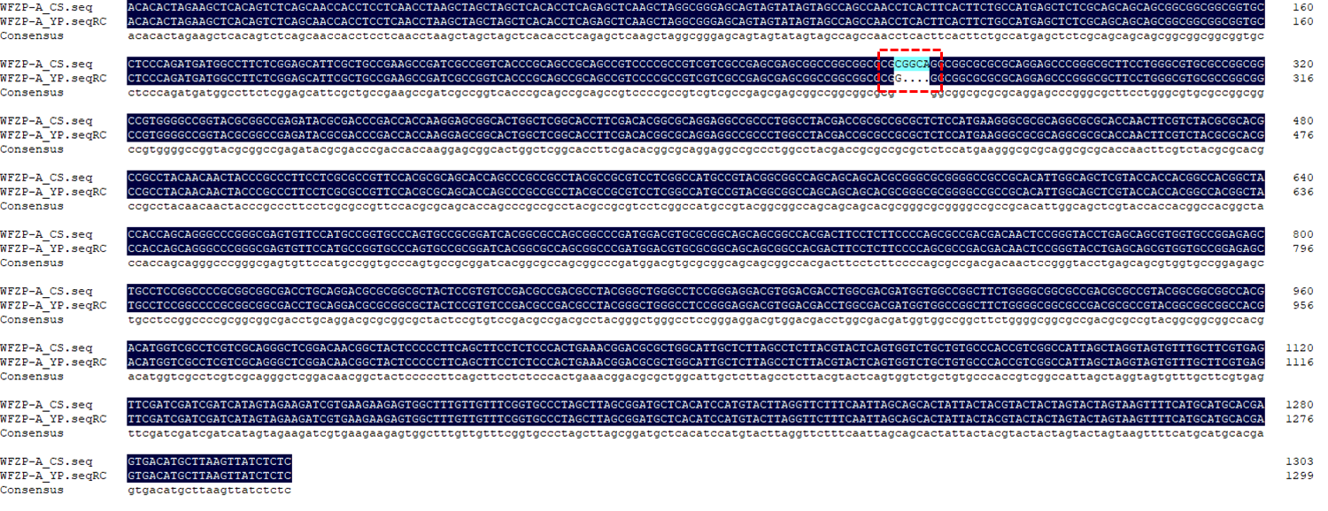
Figure S1: (a) Sequence information of WFZP-A. The red mark is the mutation type of WFZP-A in YP (CGGCA to G).
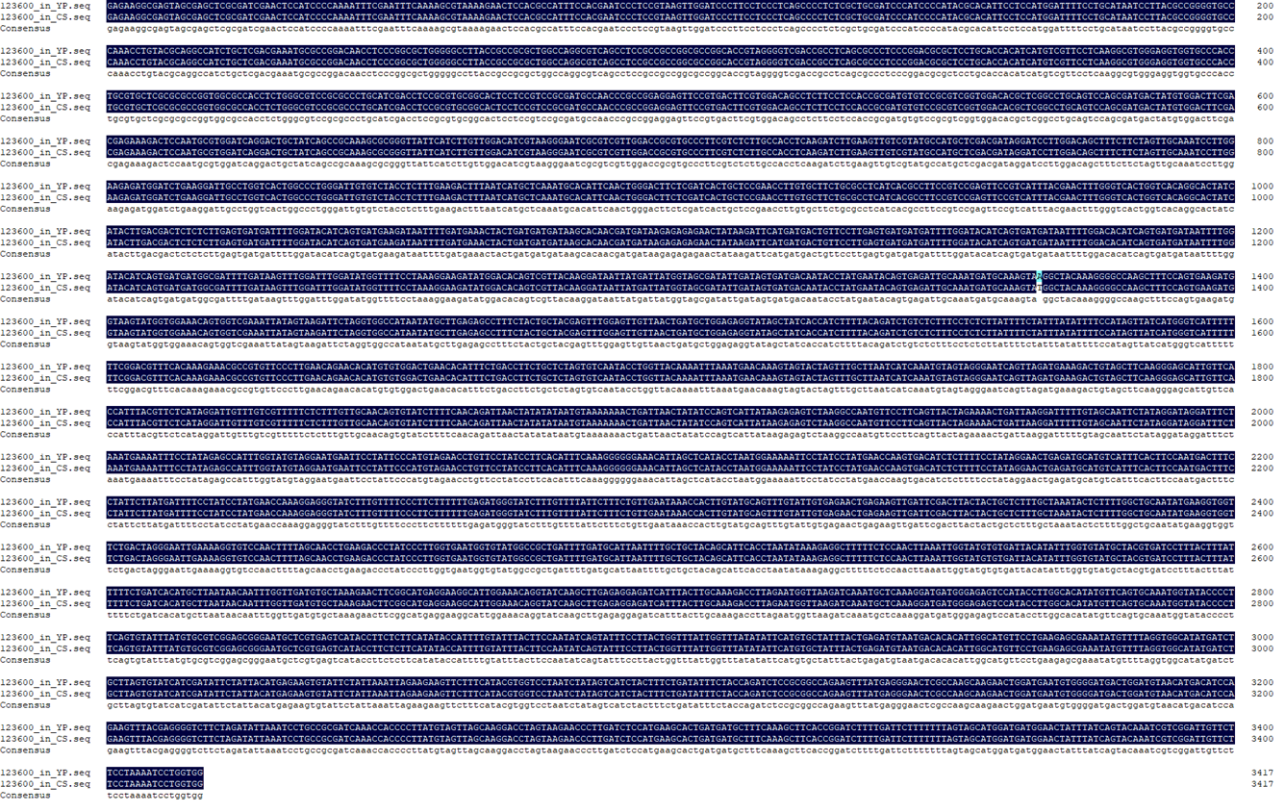
Supplementary Figure S2: (a) Sequence information of TraesCS2D03G0260700 in YP and CS. 123600 stands for TraesCS2D03G0260700.

