Supplementary Material

Endosymbiosis change under the stress of omethoate and four plant allelochemicals in cotton aphid, Aphis gossypii Glover (Hemiptera: Aphididae)
Ying Liu, Ren Li, Pingzhuo Liang, Chengyu Chen, Xiwu Gao
Correspondence: Corresponding Author: gaoxiwu@263.net.cn
Supplementary Table 1. Statistic of 16S rRNA sequences and clean data.
Sample | Raw tags | Qualified | Base(nt) | AvgLen(nt) | GC% | Effective%
Triton.1 | 52,874 | 31,914 | 13,186,688 | 429 | 48.05 | 58.17
Triton.2 | 53,727 | 33,945 | 14,106,033 | 429 | 48.12 | 61.26
Triton.3 | 66,366 | 40,714 | 16,793,023 | 429 | 48.2 | 59
LC10.1 | 61,365 | 37,702 | 15,552,649 | 429 | 47.91 | 59.09
LC10.2 | 54,823 | 34,607 | 14,441,963 | 429 | 47.95 | 61.42
LC10.3 | 68,690 | 42,053 | 17,654,377 | 429 | 47.65 | 59.92
LC90.1 | 62,105 | 39,542 | 16,641,106 | 429 | 48.31 | 62.47
LC90.2 | 55,376 | 35,144 | 14,513,057 | 429 | 48.35 | 61.11
LC90.3 | 59,617 | 37,262 | 15,456,739 | 429 | 48.54 | 60.46
CK1 | 59,909 | 36,289 | 15,218,132 | 429 | 47.66 | 59.26
CK2 | 67,825 | 42,014 | 17,683,963 | 428 | 47.77 | 60.85
CK3 | 50,829 | 31,246 | 13,077,308 | 429 | 47.78 | 60.01
SD1 | 65,503 | 40,993 | 17,197,402 | 429 | 47.63 | 61.24
SD2 | 62,577 | 39,394 | 16,660,442 | 429 | 47.55 | 62.1
SD3 | 54,278 | 34,423 | 14,543,456 | 429 | 47.69 | 62.51
SF1 | 62,780 | 37,254 | 15,433,296 | 429 | 46.64 | 57.36
SF2 | 56,785 | 35,557 | 14,674,695 | 428 | 47.95 | 60.4
SF3 | 50,550 | 30,368 | 12,275,812 | 428 | 49.22 | 56.69
SH1 | 53,095 | 33,879 | 14,351,669 | 429 | 47.73 | 63.08
SH2 | 51,328 | 31,580 | 13,313,371 | 429 | 47.65 | 60.5
SH3 | 55,192 | 33,308 | 13,984,711 | 429 | 47.78 | 59.11
ST1 | 53,292 | 32,787 | 13,740,122 | 428 | 48.25 | 60.23
ST3 | 65,024 | 40,726 | 17,055,098 | 429 | 47.76 | 61.17
ST2 | 88,270 | 71,555 | 29,815,902 | 429 | 48.27 | 78.81
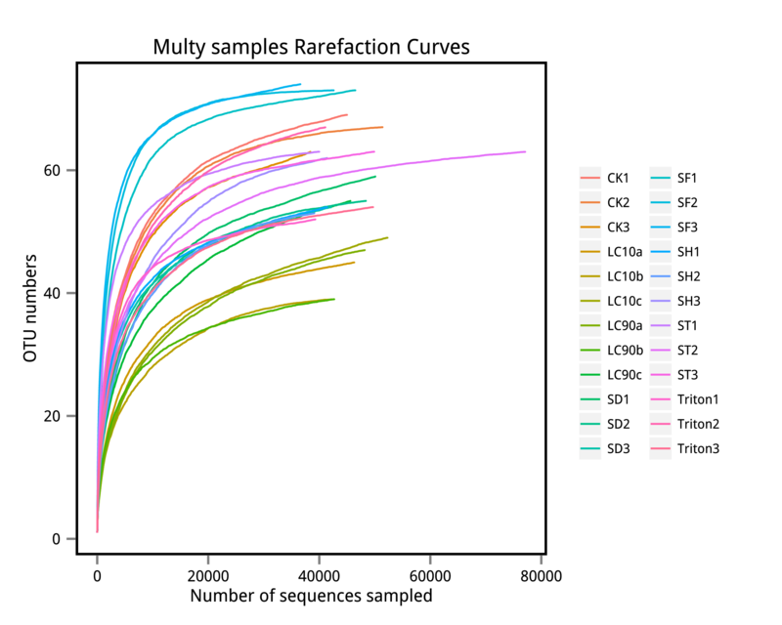
Supplementary Figure 1. Species rarefaction curves.

A
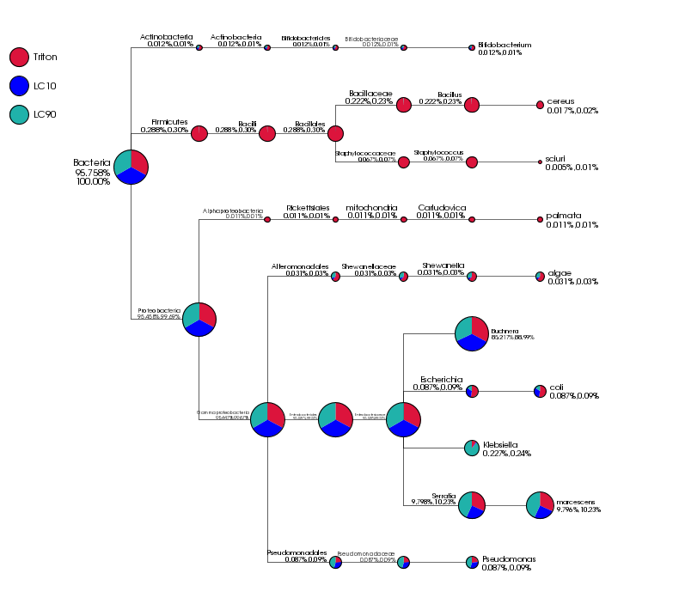
B
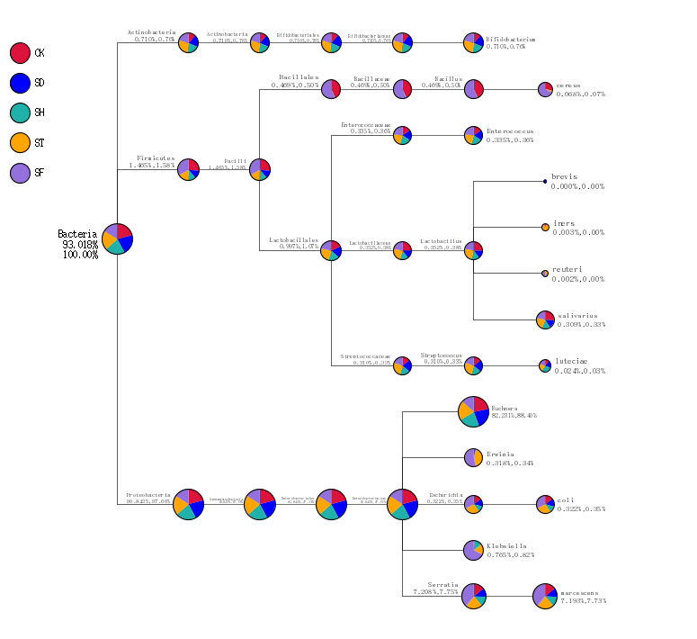
Supplementary Figure 2. Bacteria taxonomic tree.

