Supplementary Information
Quantum spin liquid signatures in monolayer 1T-NbSe₂
Quanzhen Zhang^{1,#}, Wen-Yu He^{2,#}, Yu Zhang^{1,3,#,*},Yaoyao Chen^{1,#}, Liangguang Jia¹, Yanhui Hou¹, Hongyan Ji¹, Huixia Yang¹, Teng Zhang¹, Liwei Liu¹, Hong-Jun Gao⁴, Thomas A Jung⁵, and Yeliang Wang^{1,*}
¹School of Integrated Circuits and Electronics, MIIT Key Laboratory for Low-Dimensional Quantum Structure and Devices, Beijing Institute of Technology, Beijing 100081, China.
²School of Physical Science and Technology, ShanghaiTech University, Shanghai 201210, China.
³Advanced Research Institute of Multidisciplinary Sciences, Beijing Institute of Technology, Beijing 100081, China.
⁴Institute of Physics, Chinese Academy of Sciences, Beijing 100190, China.
⁵Laboratory for X-ray Nanoscience and Technologies, Paul Scherrer Institut (PSI), 5232 Villigen, Switzerland.
*Correspondence and requests for materials should be addressed to Yu Zhang (e-mail: yzhang@bit.edu.cn) and Yeliang Wang (e-mail: yeliang.wang@bit.edu.cn).

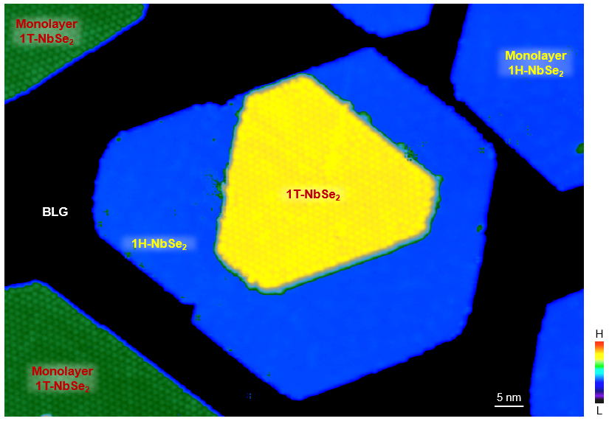
Supplementary Fig. 1 | Large-scale topographic STM image of monolayer 1H-NbSe₂, 1T-NbSe₂, and their vertical heterostructure on BLG/SiC(0001) substrate (V_{b} = -1.5 V, I_{t} = 10 pA).

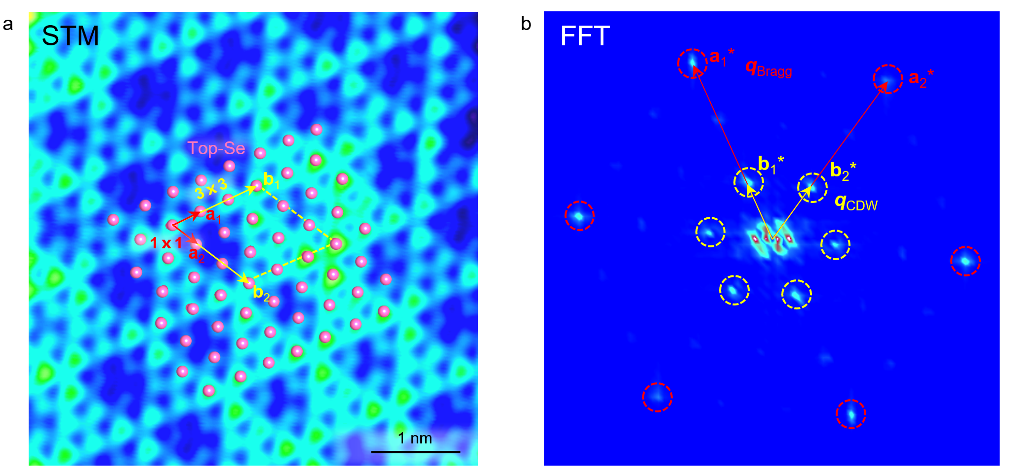
Supplementary Fig. 2 | Atomic structure of 1H-NbSe₂. a, Atomic resolution STM image of monolayer 1H-NbSe₂ on BLG/SiC(0001) substrate recorded at the sample bias of -0.1 V. b, The corresponding FFT image of the atomic STM image of monolayer 1H-NbSe₂. The six bright spots enclosed by the dashed red circles and the six bright spots enclosed by the dashed yellow circles indicate the atomic and CDW wavevectors of monolayer 1H-NbSe₂ with 1 $×$ 1 and 3 $×$ 3 patterns, respectively. The basis vectors of the atomic and CDW pattern are indicated as a₁*/a₂* and b₁*/b₂*, respectively.

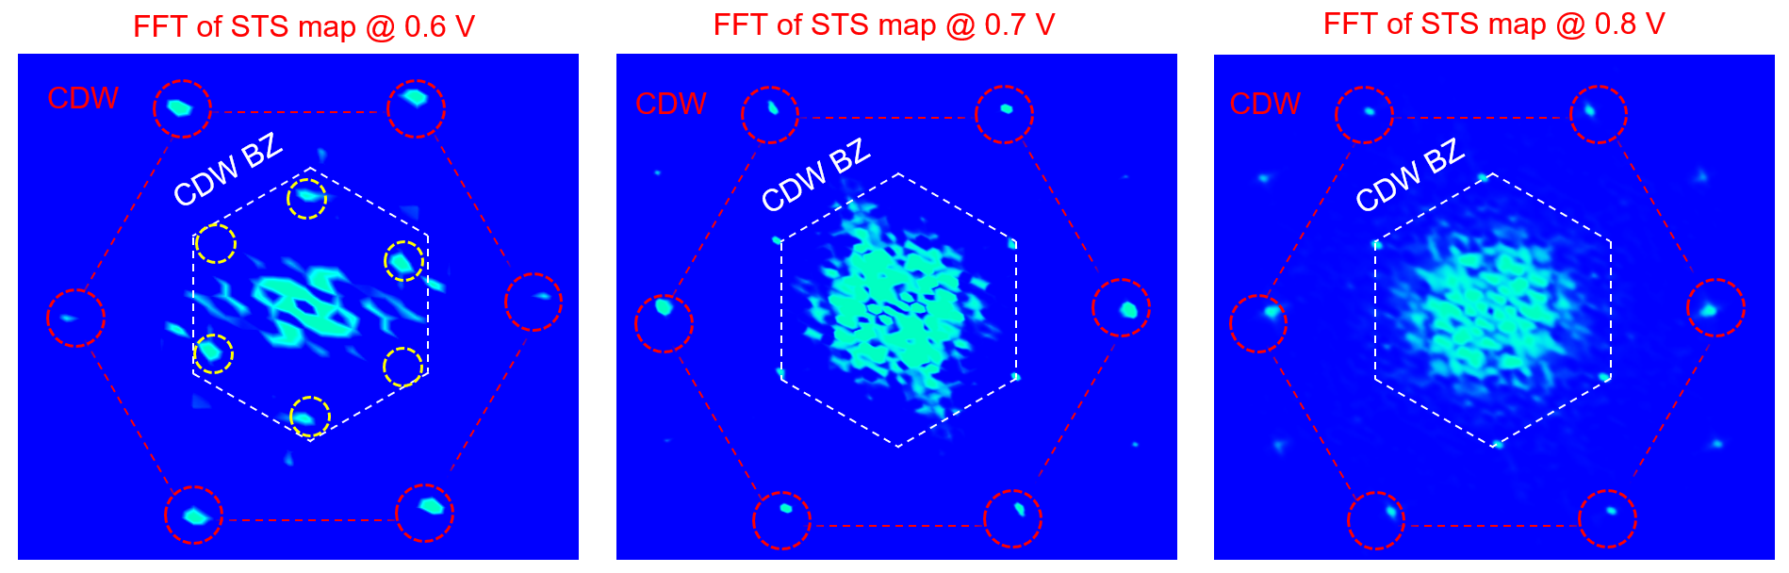
Supplementary Fig. 3 | FFT images of the STS maps at the sample bias of 0.6 V, 0.7 V, and 0.8 V, from left to right, respectively. The six bright spots enclosed by the red circles indicate the CDW wavevectors of monolayer 1T-NbSe₂, while the spots enclosed by the yellow circles are related to the charge modulation with their real-space wavelength being √3 times larger (correspondingly smaller in momentum space) of the CDW wavevectors. The white hexagon represents the CDW Brillouin zone (BZ).

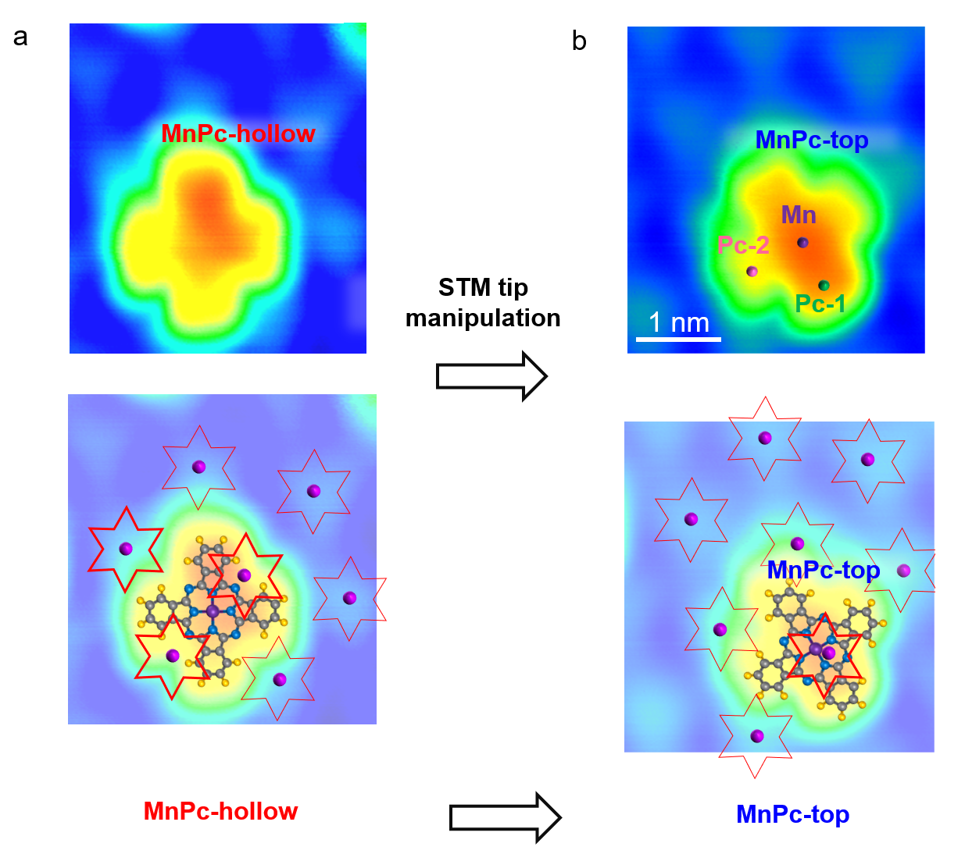
Supplementary Fig. 4 | MnPc molecules with two topographic configurations via an STM tip manipulation technique. a, Topographic STM image of MnPc molecules adsorbed off the SOD motifs. b, After the STM tip manipulation, the molecule adsorbed on the SOD motifs. The four lobes of the MnPc molecules are roughly classified into Pc-1 and Pc-2, given the lobe locating on and off a SOD motif, respectively.

Supplementary Note
The MnPc molecule with S = 3/2 is treated as an idealized local magnetic impurity in the theoretical calculation. In the underscreened Kondo regime, a local spin of S = 1 is expected to remain in the magnetic impurity, while the spin S = 1/2 undergoes Kondo spin exchange with the itinerant spinons¹. For the magnetic impurity deposited on the U(1) quantum spin liquid (QSL) with spinon Fermi surface (SFS), the magnetic impurity couples to the QSL electronic states individually in the spin and charge channels. In the slave rotor mean field description, the Matsubara Green’s functions for the auxiliary fermion and the charged boson at the impurity take the form
$G_{a, σ}\left(iω_{n}\right)=\frac{1}{iω_{n}-ϵ_{0}+h-w^{2}G_{f,σ}\left(iω_{n}, R, R\right)}$,
$G_{X_{d}}\left(iν_{n}\right)=\frac{1}{\frac{ν_{n}^{2}}{U}-\frac{2iν_{n}h}{U}+λ-u^{2}G_{X}\left(iν_{n}, R,R\right)}$,
with the imaginary-time Green’s function $G_{f, σ}\left(iω_{n},R,R\right)=\sum_{k}{\frac{1}{iω_{n}-ξ_{k}}}$ for the spinon and $G_{X}\left(iν_{n},R,R\right)=\sum_{k}{\left(\frac{1}{iν_{n}+ϵ_{k}}-\frac{1}{iν_{n}-ϵ_{k}}\right)}$ for the chargon, respectively. Here the coupling fields w, u and the Lagrangian multipliers λ, h take the value at the saddle point with the minimal free energy, based on the mean-field theory. $ϵ_{0}$ is the impurity on-site energy, $U$ is the onsite repulsion, and σ = ↑/↓ is the spin index. $ω_{n}$ and $ν_{n}$ are the fermionic and bosonic Matsubara frequencies, respectively. The spinon and chargon states in the U(1) QSL with SFS have the Matsubara Green’s function as
$G_{f, σ}^{0}\left(iω_{n}, R, R\right)=\frac{1}{G_{f, σ}^{-1}\left(iω_{n}, R,R\right)-\frac{w^{2}}{iω_{n}-ϵ_{0}+h}}$,
$G_{X}^{0}\left(iν_{n}, R,R\right)=\frac{1}{G_{X}^{-1}\left(iν_{n},R,R\right)-\frac{u^{2}}{\frac{ν_{n}^{2}}{U}-\frac{2iν_{n}h}{U}+λ}}$.
Given the mean field parameters $w=-0.03$ eV, $u=0.16$eV, $h=0.002$eV, $λ=1.28$eV, and the onsite repulsion $U=5$eV at the impurity, we obtain the auxiliary fermion density of states (DOS)
$ρ_{a, σ}^{0}\left(ω\right)=-\frac{1}{π}ImG_{a,σ}^{0}\left(iω_{n}→ω+i0^{+}\right)$,
the charged boson DOS
$ρ_{X_{d}}^{0}\left(ω\right)=\left|-\frac{1}{π}ImG_{X_{d}}\left(iν_{n}→ω+i0^{+}\right)\right|$,
the QSL spinon DOS
$ρ_{f, σ}^{0}\left(ω\right)=-\frac{1}{π}ImG_{f, σ}^{0}\left(iω_{n}→ω+i0^{+}\right)$,
and the QSL chargon DOS
$ρ_{X}^{0}\left(ω\right)=\left|-\frac{1}{π}ImG_{X}\left(iν_{n}→ω+i0^{+}\right)\right|$.
The Matsubara Green’s functions for the electronic state at the impurity and QSL electronic states are obtained through the convolution
$G_{d, σ}^{0}\left(iω_{n}\right)=\frac{1}{β}\sum_{ν_{n}}{G_{a, σ}\left(iω_{n}+iν_{n}\right)G_{X_{d}}\left(iν_{n}\right)}$,
$G_{c, σ}\left(iω_{n}, R,R\right)=\frac{1}{β}\sum_{ν_{n}}{G_{f, σ}^{0}\left(iω_{n}+iν_{n}, R, R\right)G_{X}^{0}\left(iν_{n}, R,R\right)}$.
Here $β^{-1}=k_{b}T$ is the Boltzmann constant. The corresponding DOS spectra are plotted in Supplementary Fig. 6 as well. Here the band dispersions of the spinon and chargon in the QSL are
$$ξ_{k}=2t_{f}\left(2\cos{\frac{1}{2}k_{x}a}\cos{\frac{\sqrt{3}}{2}k_{y}a}+\cos{k_{x}a}\right)-μ_{f}$$
$ϵ_{k}=2t_{X}\left(2\cos{\frac{1}{2}k_{x}a\cos{\frac{\sqrt{3}}{2}k_{y}a}}+\cos{k_{x}a}-3\right)+Δ$.

The longitudinal gauge field fluctuations in the QSL gives rise to the gauge binding interaction
$H_{U_{b}}=U_{b}\sum_{σ}{\left(f_{σ, R}^{†}f_{σ, R}a_{R}^{†}a_{R}-f_{σ, R}^{†}f_{σ, R}{b_{R}^{†}b}_{R}\right)}$,
with $f_{σ, R}^{\left(†\right)}$, $a_{R}^{\left(†\right)}$, $b_{R}^{\left(†\right)}$ being the annihilation (creation) operators for the spinon, holon, and doublon states in the QSL. Taking the gauge binding $U_{R}$ into account, the Matsubara Green’s function for the impurity electronic state reads
$G_{d, σ}\left(iω_{n}\right)=\sum_{i,j=1,2}{{\left\{G_{0,σ}^{11}\left(iω_{n}\right)+G_{0,σ}^{12}\left(iω_{n}\right)U_{R}σ_{z}{\left[1-G_{0,σ}^{22}\left(iω_{n}\right)U_{R}σ_{z}\right]}^{-1}G_{0,σ}^{21}\left(iω_{n}\right)\right\}}_{ij}}$,
with the form of $G_{0, σ}\left(iω_{n}\right)$ given in the method section. The local electronic DOS of the impurity is then $ρ_{d,σ}\left(ω\right)=-\frac{1}{π}ImG_{d, σ}\left(iω_{n}→ω+i0^{+}\right)$. As the gauge binding interaction increases, a pair of band edge resonance peaks in $ρ_{d,σ}\left(ω\right)$ gradually emerge as is plotted in Supplementary Fig. 7.

In the case that the holon-spinon hole binding interaction is effectively suppressed:
$H_{U_{b}}^{'}={-U}_{R}\sum_{σ}{f_{σ, R}^{†}f_{σ, R}{b_{R}^{†}b}_{R}}$,
the Matsubara Green’s function for the impurity electronic state takes the form
$G_{d, σ}^{'}\left(iω_{n}\right)=\sum_{i,j=1,2}{{\left\{G_{0,σ}^{11}\left(iω_{n}\right)+G_{0,σ}^{12}\left(iω_{n}\right)U_{R}σ^{'}{\left[1-G_{0,σ}^{22}\left(iω_{n}\right)U_{R}σ_{z}\right]}^{-1}G_{0,σ}^{21}\left(iω_{n}\right)\right\}}_{ij}}$ with $σ^{'}=\left(\begin{matrix}0 & 0 \\ 0 & -1\end{matrix}\right)$.
The corresponding impurity electronic DOS is $ρ_{d,σ}^{'}\left(ω\right)=-\frac{1}{π}ImG_{d, σ}^{'}\left(iω_{n}→ω+i0^{+}\right)$, which has only one single resonance peak at the bottom of the UHB as plotted in Fig. 4d (green line).

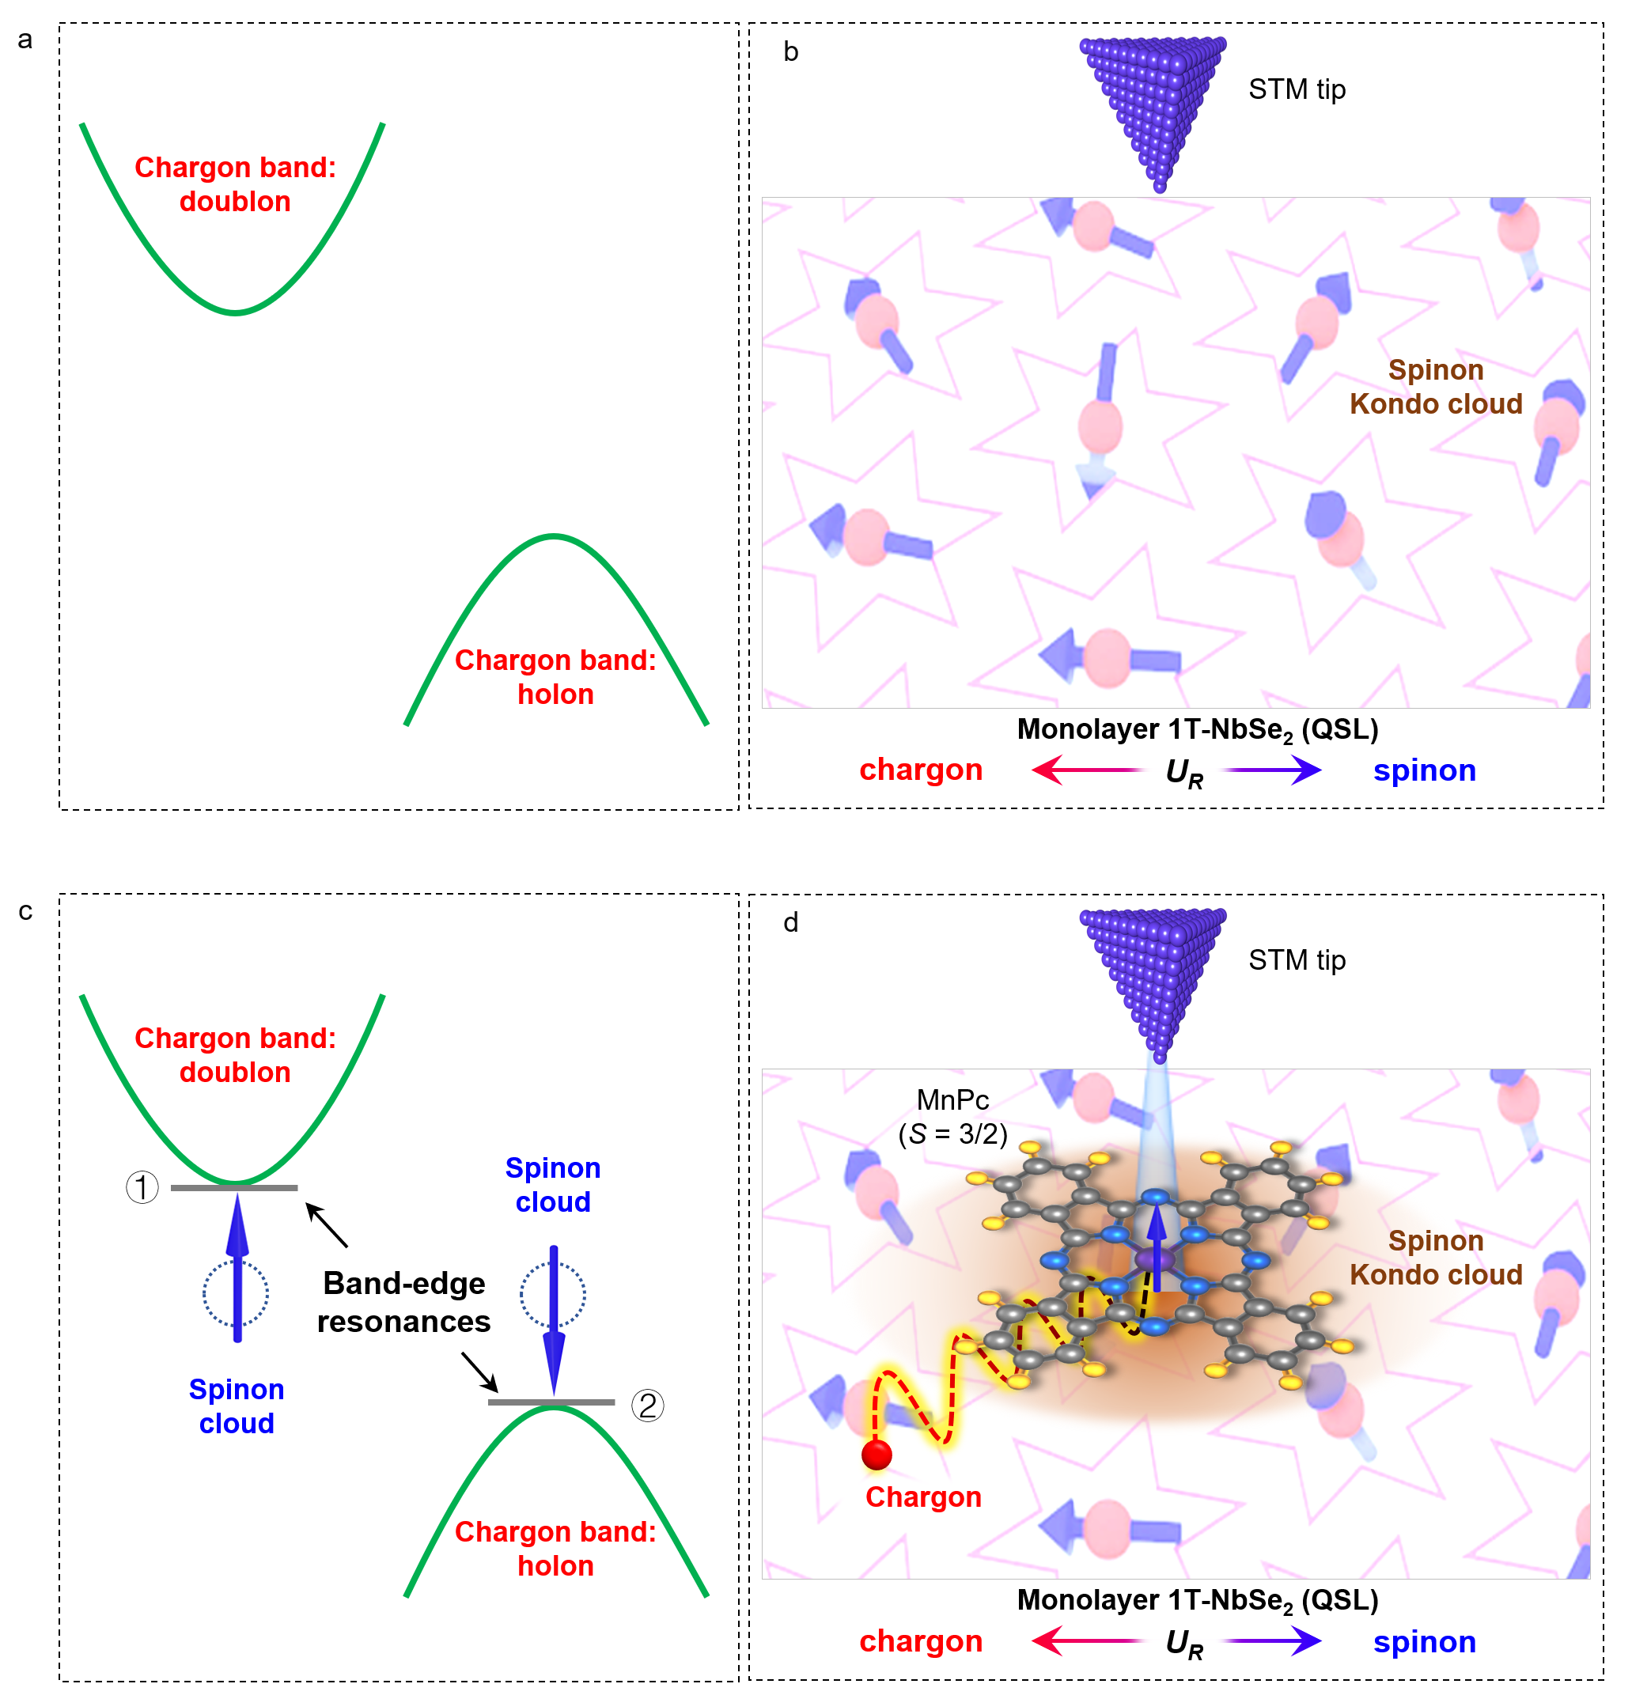
Supplementary Fig. 5 | The DOS in the pristine QSL and at the position of the adsorbate acting like a Kondo-impurity. a, Energy diagram of the QSL state. b, Schematic diagram of the QSL state detected via STM. c, Energy diagram of the band edge resonance states. d, Physical mechanism of the interaction between a QSL state and a local magnetic moment. A magnetic impurity in a QSL candidate can result in a spinon Kondo screening cloud (brown shadow). Such a cloud attracts a chargon in QSL under the spin-charge binding interaction.

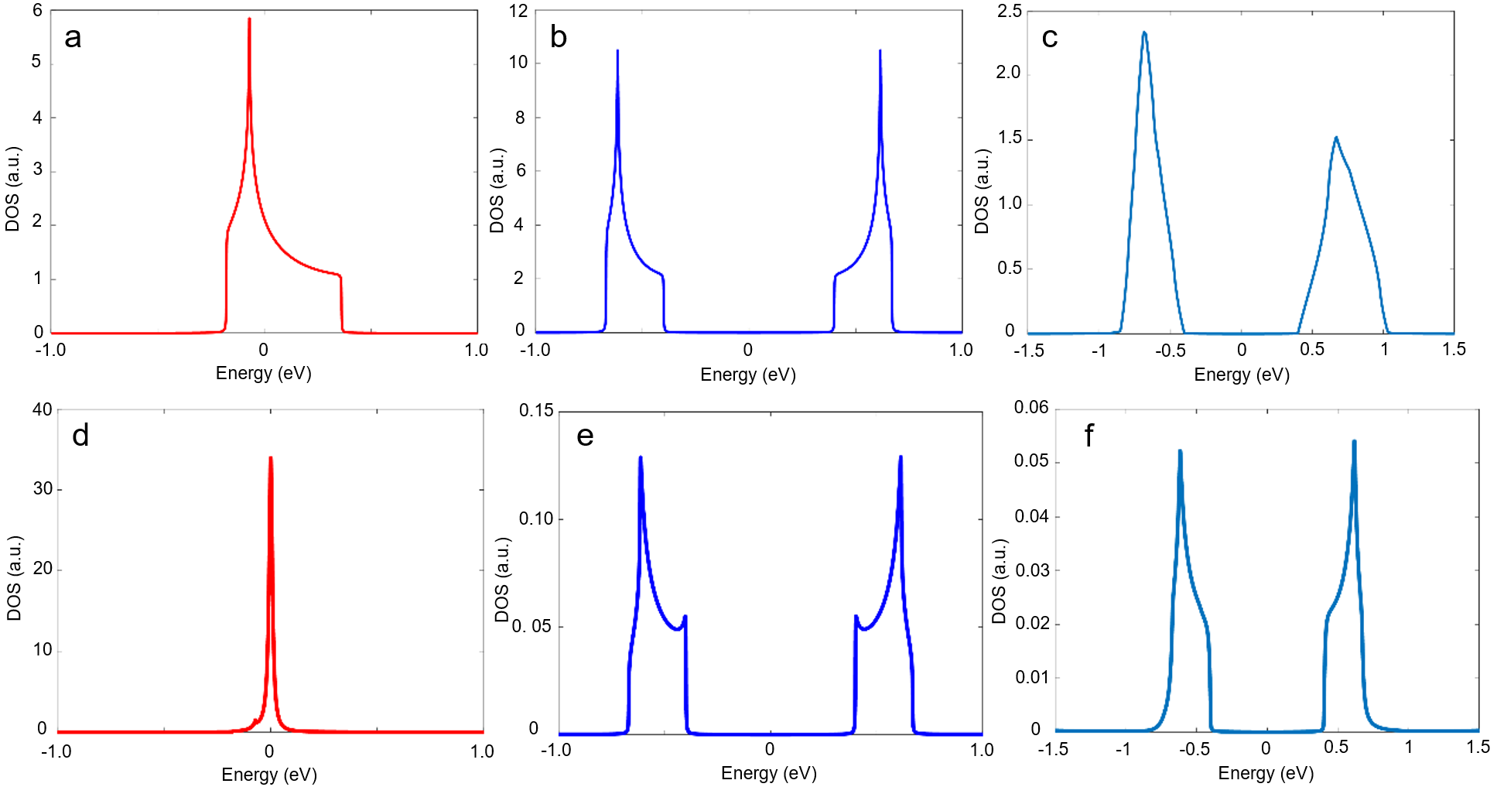
Supplementary Fig. 6 | The DOS in the pristine QSL and at the position of the adsorbate acting like a Kondo-impurity. a-c, The DOS of the spinon, chargon, and the electronic states in the pristine QSL, respectively. In the case of the pristine QSL, there is no magnetic impurity present. The DOS can be obtained from the Green’s functions through setting the coupling parameters u=w=0 eV. d-f, The DOS of the auxiliary fermion, charged boson and electronic state at the adsorbate position acting like an impurity, respectively. Here, the spin exchange between the impurity and the QSL gives rise to the spinon Kondo resonance in the spin channel.

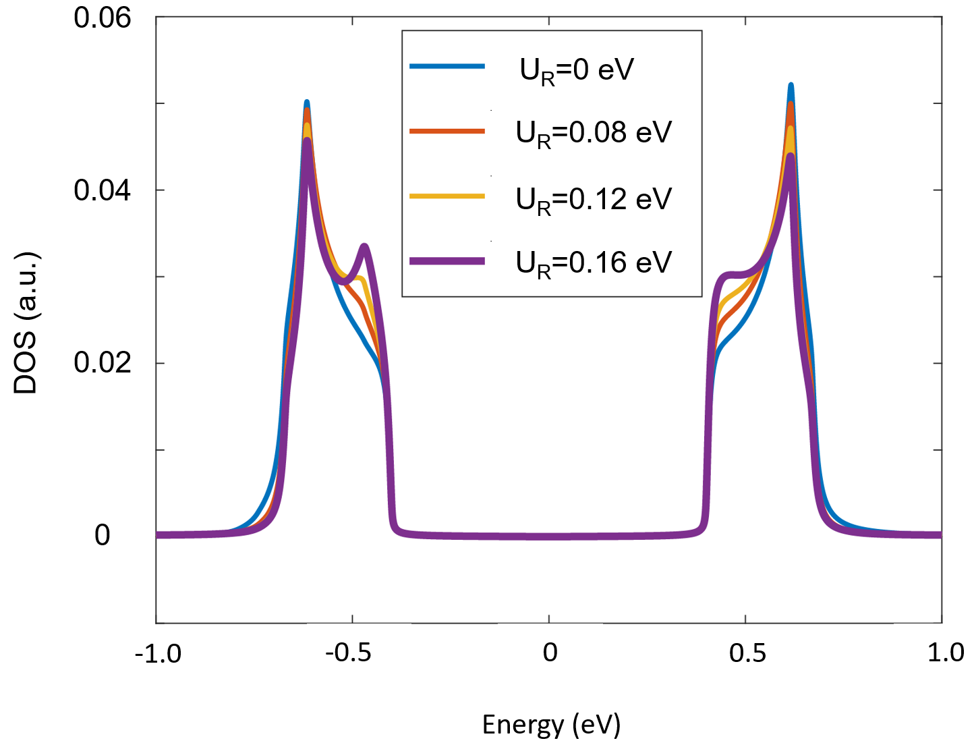
Supplementary Fig. 7 | The emergence of a pair of band edge resonance peaks in the local electronic DOS of the local magnetic impurity. The gauge binding is considered in both the doublon-spinon channel and the holon-spinon hole channel. The spinon-chargon binding interaction U_{R} modifies the impurity electronic Green’s function, which is expected to induce the spectral weight to transfer from the bulk Hubbard bands to the band edges. Experimentally, U_{R} depends on the location of a magnetic molecular related to the SOD motif.

References
- Nagaosa, N. Quantum Field Theory in Strongly Correlated Electronic Systems (Springer, 1999).

