L P N 1 2 3 4 L
500
1000
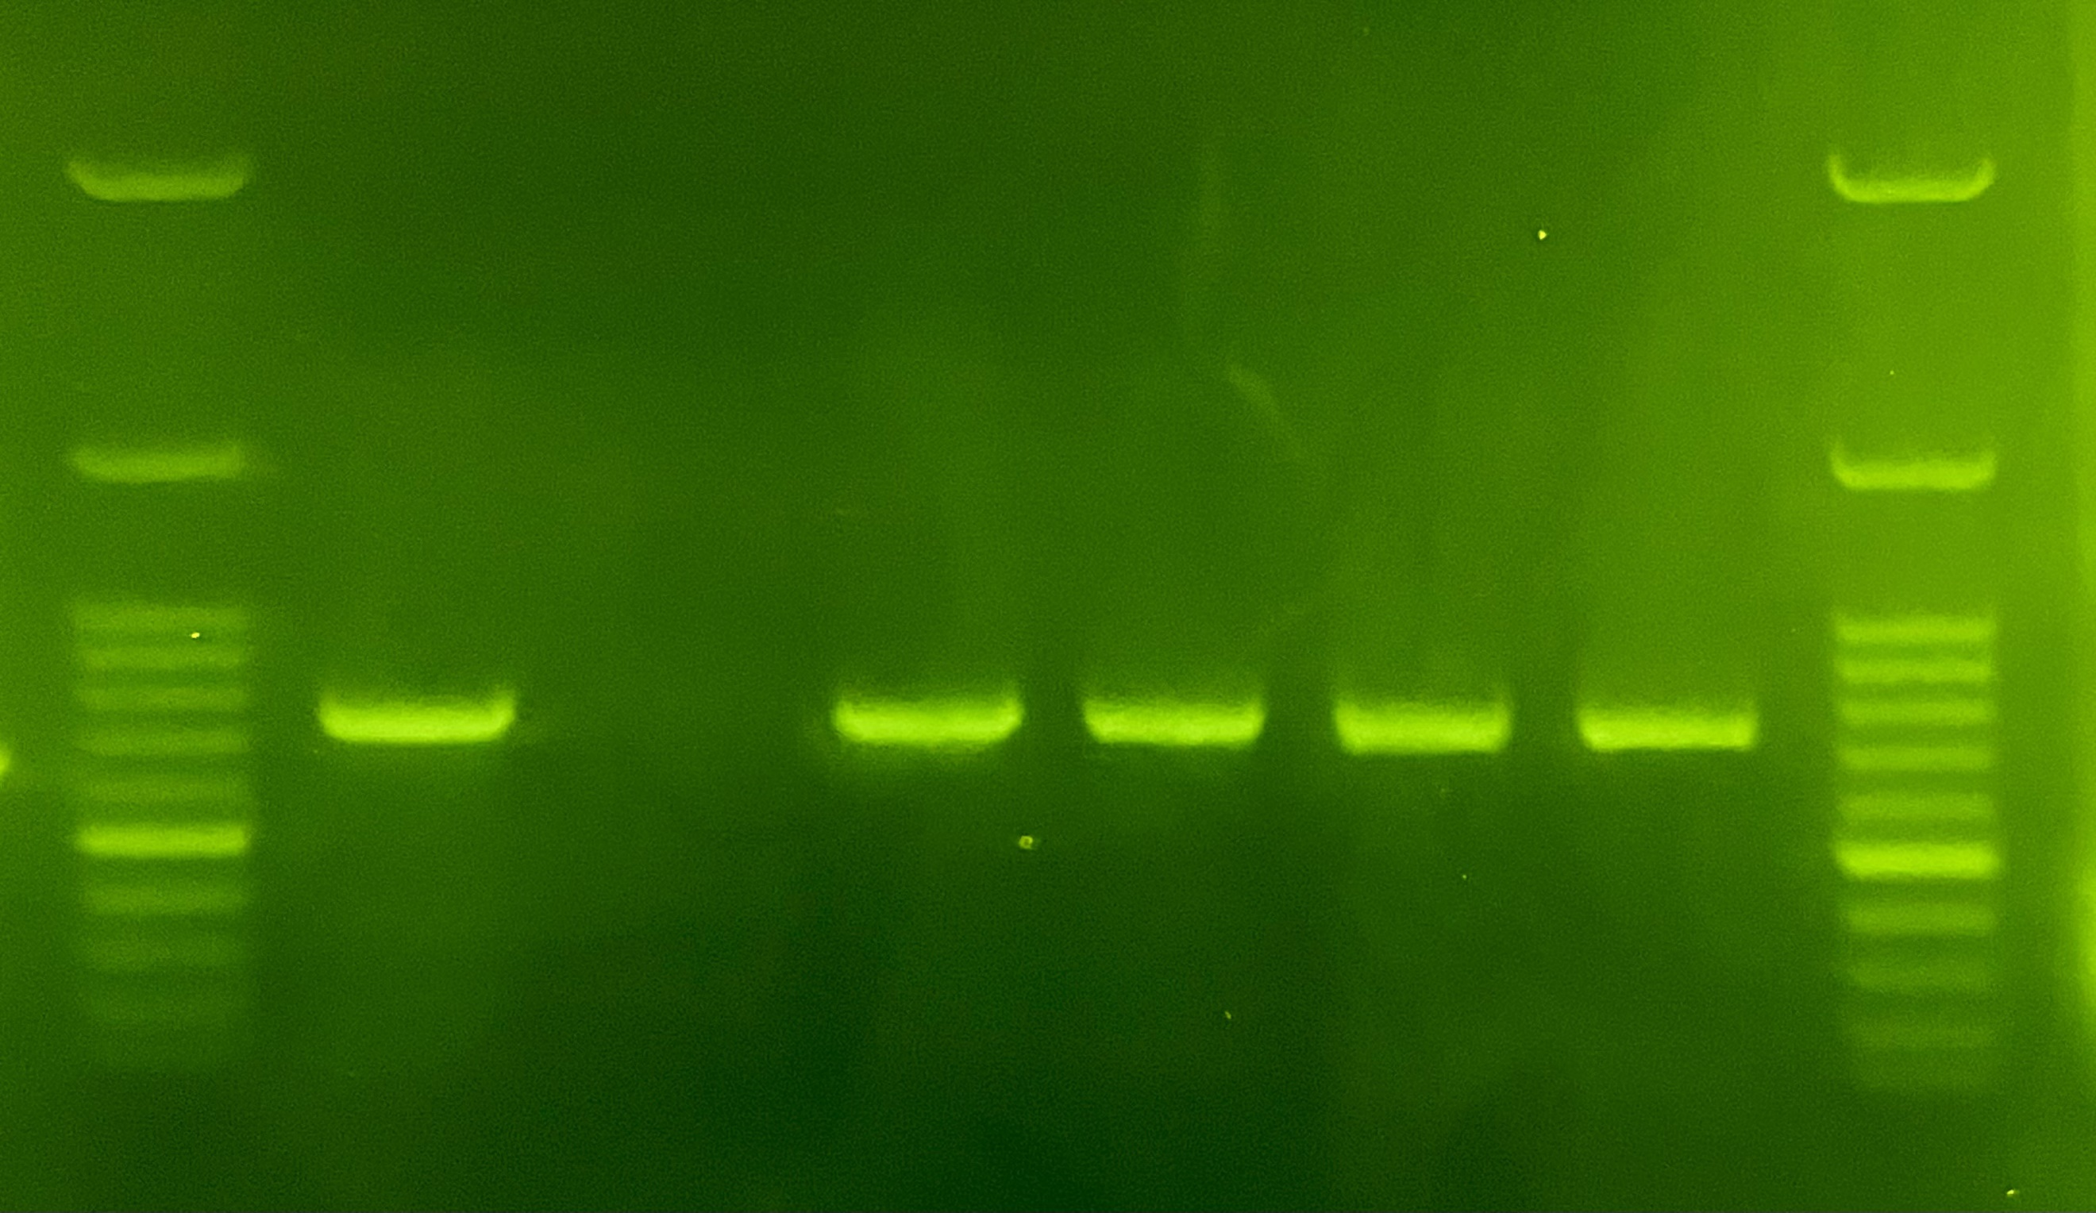

Figure S1 : Agarose gel electrophoresis pattern shows PCR amplification of the human IL6 gene. Lane L: DNA ladder (100 bp); Lane P: positive control; Lane N: negative control; Lanes 1–2: 722 bp amplicon of the IFITM3 gene of ICU admitted patients. Lanes 3–4: 722 bp amplicon of the IFITM3 gene in asymptomatic patients.

A
B
C

Figure S3: Chromatogram analysis of rs34481144 SNPs as an example of SNP genotyping (A) The CC genotype, showed homozygote alleles. (B) The CT genotype, showed heterozygote alleles. (C) The TT genotype showed homozygote alleles.

