Supplementary Materials

Broadcasters, receivers, functional groups of metabolites and the link to heart failure progression using polygenic factors

Azam Yazdani,, Raul Mendez-Giraldez^{,17}, Akram Yazdani^{,17}, Daniel J. Schaid, Sek Won Kong, Mohamad R. Hadi, Ahmad Samiei, Clemens Wittenbecher, Jessica Lasky-Su, Clary B. Clish, Francesco Marotta, Michael R. Kosorok, Samia Mora, Jochen D. Muehlschlegel¹, Daniel I. Chasman, Martin G. Larson, Sarah H. Elsea

Corresponding author: Azam Yazdani, Ph.D., M.Sc.,
ayazdani@bwh.harvard.edu
Harvard Initiative in Systems Approach,
Brigham and Women’s Hospital
Harvard Medical School
Harvard Data Science Initiative faculty affiliate

Keywords: Metabolomics, heart failure, confounding metabolites, data-driven networks, causal network, genetic variation, lifestyle

Contents
- Table S1. Characteristics of the study samples
- Table S2. Metabolites in this study
- Tables S3-8. Results of two univariate models, one adjusted for sex, age, and BMI, and the other adjusted for sex and age
- Metabolites associated with polygenic factors satisfied MR assumptions
- Supplemental Methods
  - Information about BONS hexose monophosphates
  - Polygenic factors
  - $V$-structure identification
  - Variable-Reduction test
- Isocitric acid and the underlying connectivity
- The BONS network with a focus on glycocholic acid

- Table S1. Baseline characteristics of the study sample
Table S1. Baseline characteristics of the study sample in this study. Numbers in parentheses except percent refer to standard deviations unless specified.
Characteristics | Number of samples
Women | N = 1,314 (52%)
Age | 55 (10)
Weight (kg) | 78 (14)
Height (m) | 168 (6)
Smoking | N = 455 (18%)
Diabetes | N = 152 (6%)
Systolic blood pressure (mmHg) | 126 (19)
Prevalent myocardial infarction | N = 25 (1%)
High-density lipoprotein cholesterol concentration (mg/dl) | 49 (13)
Low-density lipoprotein cholesterol concentration (mg/dl) | 127 (32)
Education  No high school degree  High school degree  Some college degree  College degree | N = 139 (5.5%)  N = 733 (29%)  N = 695 (27.5%)  N = 859 (34%)

2. Table S2. Metabolites in this study. For the name of metabolites see spreadsheet file, Table S2.
3. Tables S3-S8. Results of two univariate models. One model was adjusted for sex, age, and BMI, and the other adjusted for sex and age. See spreadsheet file: AAA, Tables S3-S4; BONS, Tables S5-S6; and lipids, Tables S7-S8.

4. The metabolites associated with polygenic factors satisfied MR assumptions. In total, 8 out of 42 AAAs were directly influenced by polygenic factors that satisfied the MR assumptions in the AAA conditional independence network (Table S9).
Table S9. Metabolites associated with polygenic factors. These polygenic factors satisfied the MR assumptions. The number of polygenic factors associated with each metabolite is also provided.
Metabolites | #Polygenic factors
serotonin | 2
aminoisobutyric | 1
5-Hydroxyindoleacetic acid | 1
hydroxyproline | 2
ureidopropionic acid | 1
asparagine | 1
creatine | 2

5. Supplemental Methods
5.1 Information about BONS hexose monophosphates. When setting up the LC-MS method, it was observed that the chromatographic method did not resolve synthetic standards of fructose-1-phosphate, fructose-6-phosphate, glucose-1-phosphate, and glucose-6-phosphate from one another; nor was found suitable, unique multiple reaction monitoring transitions that could be used to differentiate these molecules in the mass spectrometer. Consequently, it was not possible to determine the relative contributions of each isomer to the signal; therefore, the signal was reported as a hybrid of hexose monophosphates.
5.2 Polygenic factors. To extract information across the genome, first, we started by reducing the number of common single nucleotide polymorphisms (SNPs) because some SNPs were nearly perfectly correlated (> 0.80) with others, so that one SNP could thereby serve as a proxy for many others in the analysis. To determine a proxy, we used hierarchical clustering and the square of the correlation measure of linkage disequilibrium (for more details, see Yazdani and Dunson, 2015¹). Second, the genomic information was summarized using the set of principal components applied to each chromosome. We separately applied principal component analysis to each chromosome because it is a safe assumption to consider that chromosomes are independent. Third, the set of principal components responsible for > 90% of the variation over each chromosome was selected. As known, the principal components are independent of each other, and each one comprises variation of multiple SNPs and therefore, termed polygenic factors.
5.3 $V$-structure identification. Consider three variables 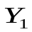,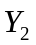, and 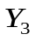. Assume from data that we obtain $Y_{1}⊥Y_{2}$, as well as $Y_{2}|Y_{3}$; graphically , which is a unique identification of the causal relationship and is called $V$-structure ², two converging arrows whose tails are not connected.
$V$-structures make the probability distributions distinguishable; therefore, they are identifiable from data.
5.4 Variable-Reduction test³: In an identified network, consider a node that has only a role as a receptor. The property of this node is arrows in, with no arrows out³. From the network, we conclude that the corresponding variable to this node does not affect any other variables. Therefore, if we remove the corresponding variable from the set of variables, and then, identify a network of the subset, we expect the connectivity among the variables in the subset to stay the same as before.

6. Isocitric acid and the underlying connectivity. Isocitric acid is directly connected to guanosine monophosphate (GMP) and quinolinic acid both associated with HF ⁴ ⁵. It is also directly connected to circulating glucuronic acid, a metabolite derived from glucose ⁶. Isocitric acid is also directly connected to cis-aconitic acid, which is directly connected to citrate. Cis-aconitic acid is an intermediate in the isomerization of citrate to isocitrate in the citric acid cycle and is acted upon by aconitase ⁷. Citrate is an important substrate in cellular energy metabolism ⁸.
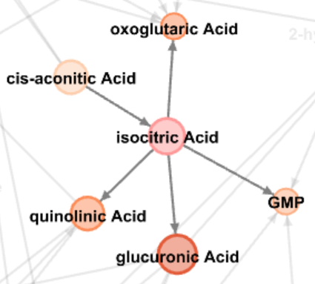
Fig. S1. The underlying connectivity of isocitric acid. The neighboring connectivity of isocitric acid with high impact on other molecules (out degree = 4) and also associated with HF risk. The direct connections were not attributed to any other BONSs in the study. Abbreviation: GMP stands for guanosine monophosphate.

7. The BONS network with a focus on glycocholic acid. The out/in degree of glycocholic acid was not identified because the direction of links directly connected to it were not identified.
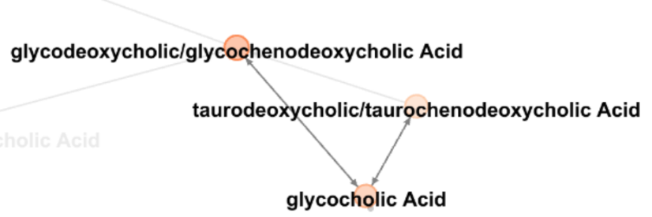
Fig. S2. The neighbors of glycocholic acid in the BONS network. The bi-directed links mean the directions between these metabolites were not identified.

References
1 Yazdani, A. & Dunson, D. B. A hybrid Bayesian approach for genome-wide association studies on related individuals. Bioinformatics 31, 3890-3896 (2015).
2 Pearl, J. in Causality: Models, Reasoning, and Inference, Second Edition (2011).
3 Yazdani, A., Yazdani, A., Samiei, A., Kosorok, M. R., & Schaid, D. J. . From classical Mendelian randomization to causal networks for systematic integration of multi-omics. Frontiers in Genetics. Frontiers in Genetics, doi:https://doi.org/10.3389/fgene.2022.990486 (2022).
4 Zhao, D. et al. Cyclic guanosine monophosphate and risk of incident heart failure and other cardiovascular events: the ARIC study. Journal of the American Heart Association 9, e013966 (2020).
5 Lund, A. et al. Plasma kynurenines and prognosis in patients with heart failure. PLoS One 15, e0227365 (2020).
6 Ho, A. et al. Circulating glucuronic acid predicts healthspan and longevity in humans and mice. Aging (Albany NY) 11, 7694 (2019).
7 <http://www.who.int/mediacentre/factsheets/fs317/en/> (
8 Iacobazzi, V. & Infantino, V. Citrate–new functions for an old metabolite. biological chemistry 395, 387-399 (2014).

Harvard Initiative in Systems Approach, Department of Anesthesiology, Perioperative and Pain Medicine, Brigham Women’s Hospital, Harvard Medical School, Boston, MA 02115, Email: ayazdani@bwh.harvard.edu
Harvard Data Science Initiative
Field Applications Scientist, Beckman Coulter
Division of Clinical and Translational Sciences, Department of Internal Medicine, at The University of Texas Health Science Center at Houston, McGovern Medical School
Department of Quantitative Health Sciences, Mayo Clinic, Rochester, MN 55902,
School of Mathematics, University of science and technology of Iran, Tehran
Computational Health Informatics Program, Boston Children’s Hospital, Boston, MA
Division of Pulmonary Medicine, Boston Children's Hospital
Division of Food and Nutrition Science, Department of Life Sciences, Chalmers University of Technology, Gothenburg, Sweden
Department of Medicine, Brigham Women’s Hospital, Harvard Medical School, Boston, MA
Broad Institute of MIT and Harvard
ReGenera R&D International for Aging Intervention and Vitality & Longevity Medical Science Commission, Femtec, Milano, Italy
Department of Biostatistics, University of North Carolina at Chapel Hill, Chapel Hill, NC, 27599
Center for Lipid Metabolomics, Divisions of Preventive and Cardiovascular Medicine, Harvard Medical School, Boston, MA 02215
Department of Medicine, Brigham Women’s Hospital, Harvard Medical School, Boston, MA
Department of Biostatistics, Boston University, Boston, MA, 02118, Email: mlarson@bu.edu
Department of Molecular & Human Genetics, Baylor College of Medicine, Houston, TX, 77030 ¹⁷ These authors are co-second author.

