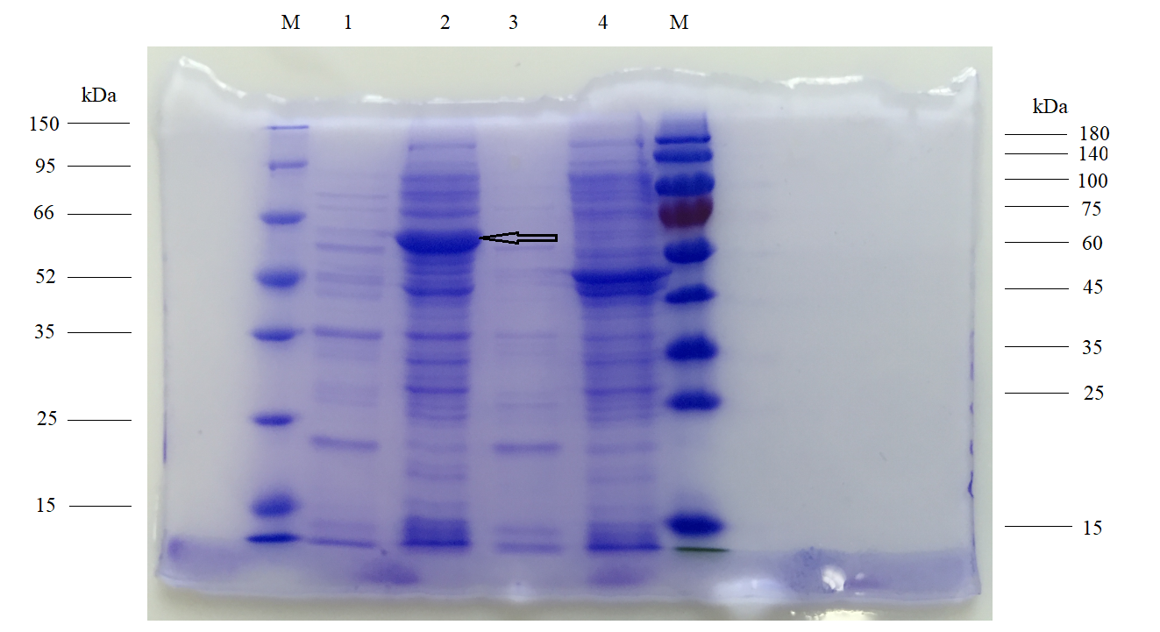
Note: This is the original, full-length gel image for the expressed recombinant R. anatipestifer RecA protein. RecA gene is 1032 bp, encoding approximately a 37.7 kDa protein. Tag protein (Trx-tag and His-tag) encoded by pET-32a vector is about 23 kDa. Thus, the recombinant RecA protein is about 60.7 kDa (37.7 kDa plus 23 kDa). The recombinant strains BL21(DE3) pET-32a-RecA were induced and lysed, and recombinant protein RecA was detected by SDS-PAGE gel. The results showed that RecA protein existed as an inclusion body. Lane M: Protien molecular weight marker; lane 1: Supernatant after BL21(DE3) pET-32a-RecA lysis; Lane 2: Sediment after BL21(DE3) pET-32a-RecA lysis, the arrow indicated the recombinant RecA protein. Lanes 3 and 4: A hypothetical protein expressed by RIA_0641 gene (720 bp) of R. anatipestifer, which is not correlated with this study.

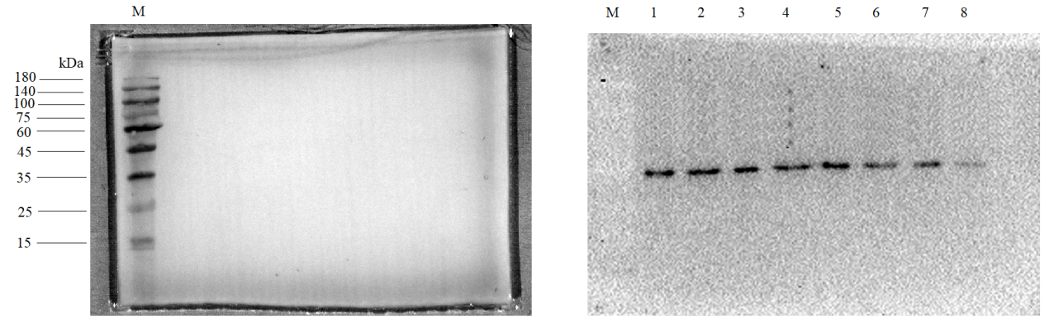
Note：This is the original, full-length Western blot images for detection of RecA protein expressed in RA-GD and RA-GD△RecA pCPRA::RecA strains with UV treatment for different time. Lane M: Protien molecular weight marker; lane 1: RA-GD (0 min); lane 2: RA-GD△RecA pCPRA::RecA (0 min); lane 3: RA-GD (15 min); lane 4: RA-GD△RecA pCPRA::RecA (15min); lane 5: RA-GD (30 min); lane 6: RA-GD△RecA pCPRA::RecA (30 min); lane 7: RA-GD (45 min); lane 8: RA-GD△RecA pCPRA::RecA (45 min). Because M and RecA protein could not be shown at the same time, M was shown in left figure and RecA protein was shown in right figure.

