Supporting Information
Title: Bismuth-Based Mesoporous Nanoball Carrying Sorafenib for Synergistic Photothermal and Molecularly-Targeted Therapy in an Orthotopic Hepatocellular Carcinoma Xenograft Mouse Model
Guang-Cong Zhang^{1,†}, Kang Song^{2,†}, Xiao-Fan Wang^{1,†}, Zong-Yan He², Jun Du², Jia-Lei Sun¹, Ru-Chen Xu¹, Zhi-Yong Liu¹, Fu Wang¹, Zhuo-Ran Qi¹, Xiang-Nan Yu¹, Yuqing Miao², Ling Dong¹, Shu-Qiang Weng¹, Xi-Zhong Shen^{1,3}, Tao-Tao Liu^{1,*}, Yuhao Li^{2*}, and Ji-Min Zhu^{1,*}
†These authors contributed equally to this work.
¹Department of Gastroenterology and Hepatology and Shanghai Institute of Liver Disease, Zhongshan Hospital, Fudan University, 180 Fenglin Rd., Shanghai 200032, China;
²School of Materials and Chemistry, Institute of Bismuth and Rhenium, Shanghai Collaborative Innovation Center of Energy Therapy for Tumors, University of Shanghai for Science and Technology, Shanghai 200093, China;
³Key Laboratory of Medical Molecular Virology, Shanghai Medical College of Fudan University, 138 Yixueyuan Rd., Shanghai 200032, China

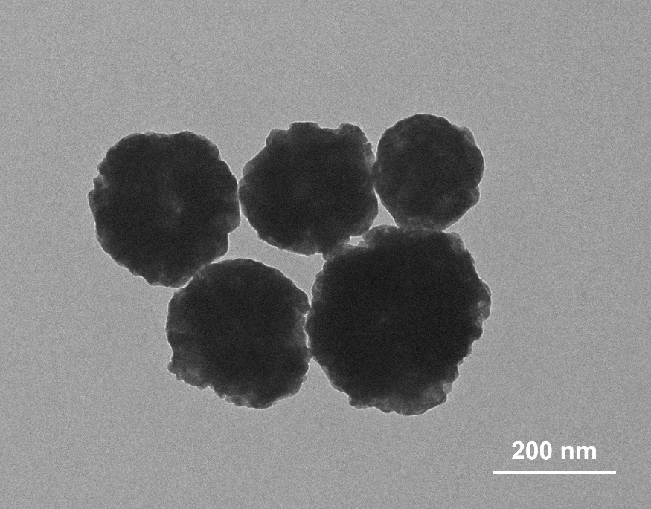
Figure S1. TEM image of Na_{0.2}Bi_{0.8}O_{0.35}F_{1.91} (NBOF).
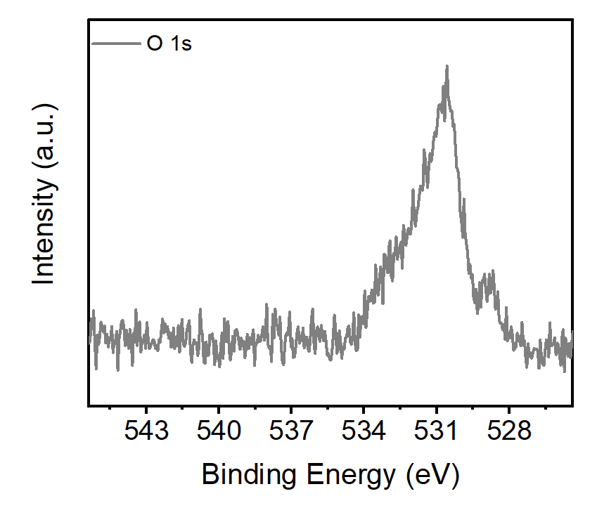
Figure S2. High-resolution XPS spectrum of O in Bi@BiO_{2−x}@Bi₂S₃.

