PEALD Ru Process with Novel Carbonyl Cyclohexadiene Ruthenium Precursor and Low Oxygen Incorporation based on Hydrogen Plasma

Geonwoo Park*, ‡, Keunhoi Kim*, ‡, Jeong Woo Shin**, ***, Geongu Han*, Dohyun Go****, †, and Jihwan An **, *****, †

*Department of Manufacturing Systems and Design Engineering (MSDE), Seoul National University of Science and Technology, Seoul, Republic of Korea
**Energy & Environment Research Institute, Seoul National University of Science and Technology, Seoul, Republic of Korea
***Department of Mechanical and Aerospace Engineering, Nanyang Technological University, Singapore
****Department of Chemistry and Biochemistry, University of California San Diego, La Jolla, USA
*****Department of Mechanical Engineering, Pohang University of Science and Technology (POSTECH), Pohang, Republic of Korea

‡These authors contributed equally to this work

†Corresponding authors
Dohyun Go, Ph.D.
Post-doctoral scholar, Department of Chemistry and Biochemistry
University of California San Diego
9500 Gilman Dr, La Jolla, CA 92093
E-mail: dogo@ucsd.edu

Jihwan An, Ph.D.
Associate Professor, Department of Mechanical Engineering
Pohang University of Science and Technology (POSTECH)
77 Cheongam-ro, Nam-gu, Pohang, Gyeongbuk, 37673 Republic of Korea
E-mail: jihwanan@postech.ac.kr, Tel: +82-54-279-2177

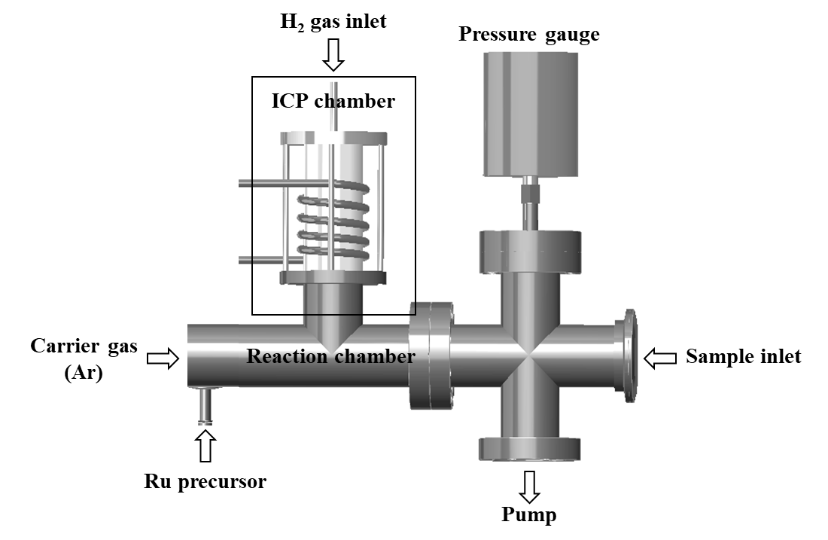
Fig. S1. Schematic figure of ICP-type PE-ALD system used in this study.

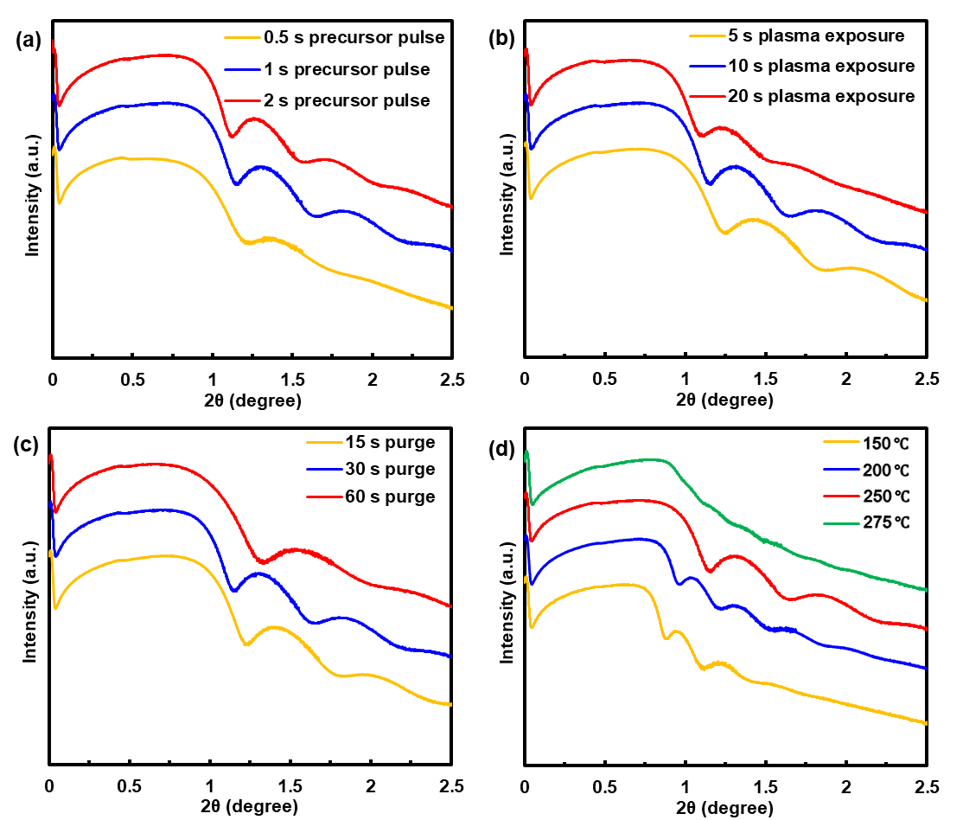
Fig. S2. X-ray reflectivity spectra of PE-ALD Ru films on Si depending on the (a) precursor pulse time, (b) H₂ plasma pulse time, (c) purge time, and (d) deposition temperature.

Table S1. Detailed GPC data according to the variation of process parameters, 1) precursor pulse time (0.5, 1, and 2 s), 2) H2 plasma pulse time (5, 10, and 20 s), 3) purge time (10, 30, and 60 s), and 4) deposition temperature (150, 200, 250, and 275 ℃).
Parameter | The number of PEALD cycle | Precursor pulse time (s) | H₂ plasma pulse time (s) | Purge time  (s) | Deposition temperature (℃) | GPC  (Å /cycle)
Precursor pulse | 100 | 0.5 | 10 | 30 | 250 | 1.2 ± 0.1
Precursor pulse | 100 | 1 | 10 | 30 | 250 | 1.2 ± 0.1
Precursor pulse | 100 | 2 | 10 | 30 | 250 | 1.5 ± 0.1
H₂ plasma pulse | 100 | 1 | 5 | 30 | 250 | 1.3 ± 0.1
H₂ plasma pulse | 100 | 1 | 10 | 30 | 250 | 1.2 ± 0.1
H₂ plasma pulse | 100 | 1 | 20 | 30 | 250 | 1.2 ± 0.1
Purge | 100 | 1 | 10 | 15 | 250 | 1.1 ± 0.1
 |  |  |  | 30 | 250 | 1.2 ± 0.1
 |  |  |  | 60 | 250 | 1.2 ± 0.1
Deposition temperature | 100 | 1 | 10 | 30 | 150 | 1.7 ± 0.4
 |  |  |  |  | 200 | 2.3 ± 0.4
 |  |  |  |  | 250 | 1.2 ± 0.1
 |  |  |  |  | 275 | 2.9 ± 0.7

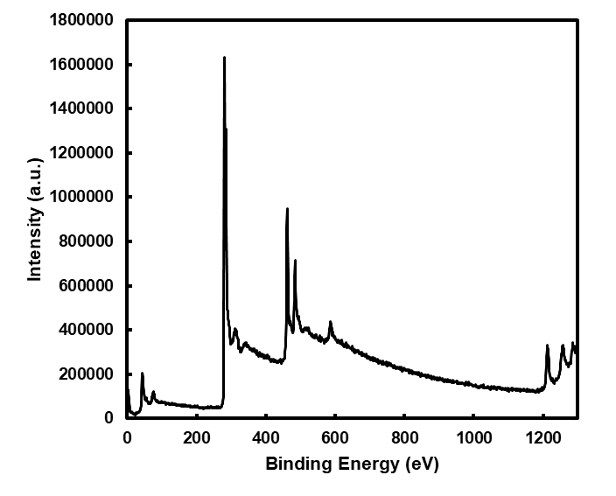
Fig. S3. XPS survey scan of PE-ALD Ru thin films which is deposited in standards recipe (1 s Ru precursor pulse – 10 s exposure time – 30 s Ar purge time – 10 s H₂ plasma pulse time – 30 s Ar purge time at a temperature of 250 ℃).

Table S2. Detailed single components of high-resolution XPS spectra of Ru 3d peak of PE-ALD Ru films on Si.
Peak | Position (eV) | Area | FWHM  (eV) | % GL  (%) | at. %
Ru 3d (5/2) | 280.23 | 343181.6 | 0.71 | 36 | 95.54302
Ru 3d (3/2) | 284.4 | 227516.3 | 1.07 | 49 | 95.54302
RuO_{x} (5/2) | 281.07 | 36927.18 | 0.79 | 72 | 95.54302
RuO_{x} (3/2) | 285.24 | 24618.12 | 1.2 | 76 | 95.54302
C 1s | 283.13 | 5750.692 | 0.75 | 100 | 3.713366
O 1s | 530.541 | 3374.168 | 1.756 | 32 | 0.743613

