Supplementary information
Effects of copper ions and copper nanomaterials on the output of amino acids from marine algae
Wenqiu Huangª, Yuping Zhou^{b}, Ting Zhaoª, Liju Tanª, Jiangtao Wang^{a*}
ª Key Laboratory of Marine Chemistry Theory and Technology of the Ministry of Education, Ocean University of China, Qingdao, 266100, China
^{b} School of Earth Science, Zhejiang University, Hangzhou, 310000, China

*Corresponding author.
Address: No.238 Songling Road (OUC Laoshan Campus)
Ocean University of China
Qingdao, 266100, China
Tel: +86-532-66782506
E-mail: jtwang@ouc.edu.cn (J Wang).
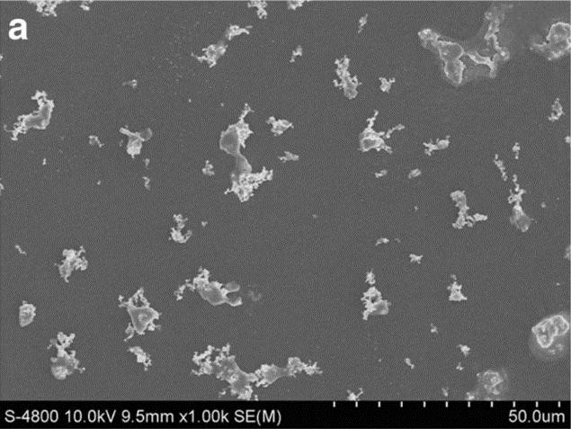
Fig. S1 SEM of nano-Cu (Zhang et al. 2018)
Zhang C, Chen XH, Tan LJ, Wang JT (2018) Combined toxicities of copper nanoparticles with carbon nanotubeson marine microalgae Skeletonema costatum. Environ Sci Pollut Res 25:13127-13133. https://doi.org/10.1007/s11356-018-1580-7

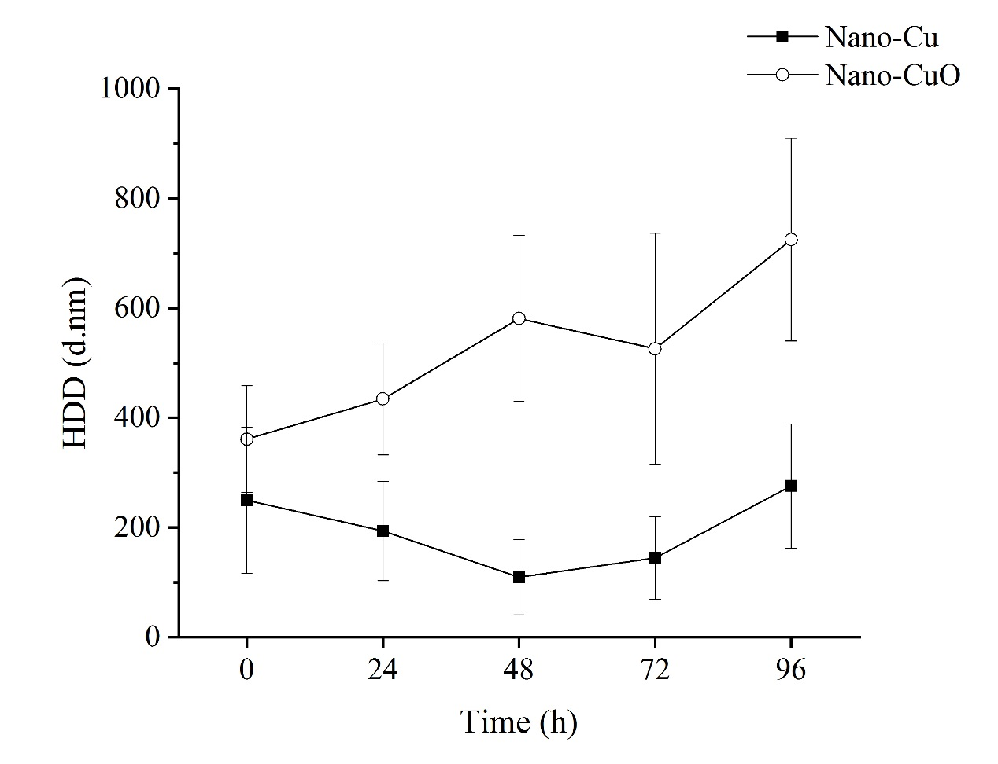

Fig. S2 Hydrodynamic diameter (HDD) of nano-Cu and nano-CuO measured in seawater at 10 mg/L over 96 hours. Error bar: standard deviation of three sample replicates. Filled circles: nano-Cu. Empty circles: nano-CuO

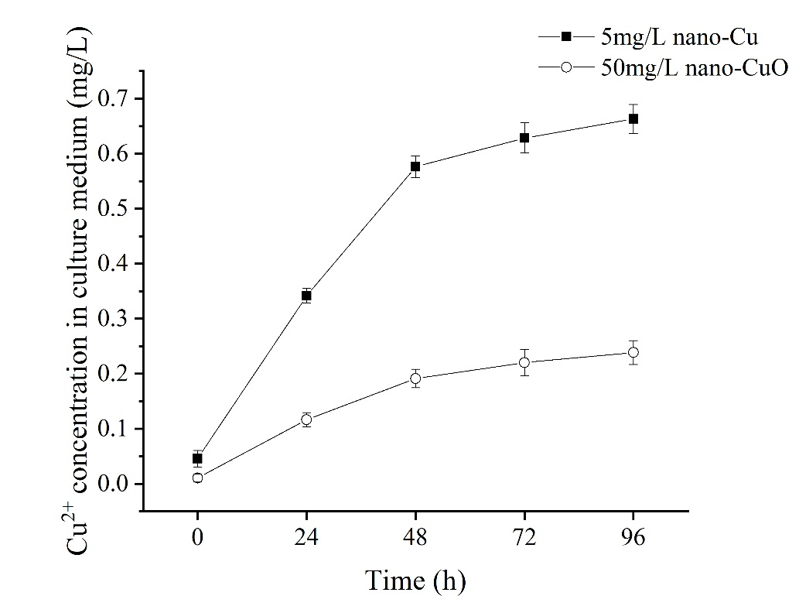
Fig. S3 Cu²⁺ dissolution in culture medium at 5 mg/L for nano-Cu and 50mg/L for nano- CuO. Error bar: standard error of three sample replicates

Microalgae | Copper Material | p for Levene's test | Sig. of ANOVA | Concentration (mg/L) | IR (%)
N. closterium | Cu²⁺ | 0.284 | 0.000 | 0.1 | 6.5±1.0e
 |  |  |  | 0.3 | 12.2±2.0^{d}
 |  |  |  | 0.5 | 33.0±3.1^{c}
 |  |  |  | 0.7 | 58.1±3.8^{b}
 |  |  |  | 1.0 | 69.8±3.3ª
N. closterium | Nano-Cu | 0.294 | 0.000 | 0.5 | 12.7±1.2^{d}
 |  |  |  | 1.0 | 26.5±3.9^{c}
 |  |  |  | 1.5 | 33.2±2.2^{b}
 |  |  |  | 2.5 | 59.6±2.3ª
 |  |  |  | 5.0 | 64.5±3.3ª
N. closterium | Nano-CuO | 0.129 | 0.000 | 5 | 2.2±0.7^{d}
 |  |  |  | 10 | 6.0±1.1^{d}
 |  |  |  | 30 | 11.1±2.6^{c}
 |  |  |  | 50 | 18.5±2.1^{b}
 |  |  |  | 70 | 34.9±4.9ª
S. costatum | Cu²⁺ | 0.506 | 0.000 | 0.05 | 16.2±1.6^{d}
 |  |  |  | 0.15 | 19.0±2.2^{d}
 |  |  |  | 0.20 | 25.9±3.3^{c}
 |  |  |  | 0.50 | 53.9±3.6^{b}
 |  |  |  | 1.00 | 87.7±2.4ª
S. costatum | Nano-Cu | 0.307 | 0.000 | 0.1 | 17.6±1.4e
 |  |  |  | 0.5 | 23.8±2.2^{d}
 |  |  |  | 1.0 | 34.7±2.4^{c}
 |  |  |  | 2.0 | 78.2±2.5^{b}
 |  |  |  | 5.0 | 85.7±4.1ª
S. costatum | Nano-CuO | 0.251 | 0.000 | 1 | 5.7±1.3^{d}
 |  |  |  | 5 | 6.0±1.0^{d}
 |  |  |  | 10 | 14.4±2.4^{c}
 |  |  |  | 20 | 34.0±3.2^{b}
 |  |  |  | 50 | 40.5±2.8ª
Tab. S1 Data of Levene's test and ANOVA analysis in inhibition ratio (IR). p > 0.05 in all treatments for Levene's test, indicating data fit in the assumption of homogeneity of variance. Values are reported as mean of 3 replicates ± standard deviation. Different small letters indicated statistically significant differences (α = 0.05).

Microalgae | Copper Material | Toxicity regression equation | χ² | p | χ_{0.05}² | df | EC₅₀(mg/L) | 95% Confidence limits for concentration
N. closterium | Cu²⁺ | Y＝0.422+2.363χ | 13.483 | 0.040ª | 7.815 | 3 | 0.663 | 0.427-1.569
N. closterium | Nano-Cu | Y＝﹣0.625+1.601χ | 4.765 | 0.190 | 7.815 | 3 | 2.455 | 2.063-3.037
S. costatum | Cu²⁺ | Y＝0.748+1.668χ | 23.229 | 0.000ª | 7.815 | 3 | 0.356 | 0.143-2.692
S. costatum | Nano-Cu | Y＝0.005+1.314χ | 30.357 | 0.000ª | 7.815 | 3 | 0.991 | 0.078-21.218
Tab. S2 Toxicity regression equation and EC₅₀ on Skeletonema costatum and Nitzschia closterium. ª: heterogeneity factors applied in the calculation of the confidence limits (p < 0.150). χ: concentration transformed into log base 10. χ²: Chi-square value. χ_{0.05}²: the critical value. df: the degree of freedom. p: significant at α = 0.05.

Microalgae | Copper Material | p for Levene's test | Sig. of ANOVA | Concentration (mg/L) | Amino acids concentration per cell (nmol·L⁻¹/cell)
N. closterium | Cu²⁺ | 0.716 | 0.000 | 0.0 | 10.84±1.52^{b}
 |  |  |  | 0.1 | 9.84±1.80^{b}
 |  |  |  | 0.3 | 10.16±1.06^{b}
 |  |  |  | 0.5 | 12.45±2.27^{b}
 |  |  |  | 0.7 | 19.27±1.95ª
 |  |  |  | 1.0 | 20.14±3.14ª
N. closterium | Nano-Cu | 0.884 | 0.008 | 0.0 | 10.84±1.52^{b}
 |  |  |  | 0.5 | 9.86±1.79^{b}
 |  |  |  | 1.5 | 15.17±1.59ª
 |  |  |  | 2.5 | 15.14±2.20ª
 |  |  |  | 5.0 | 14.87±1.79ª
N. closterium | Nano-CuO | 0.887 | 0.098 | 0 | 10.84±1.52^{ab}
 |  |  |  | 5 | 9.17±1.26^{b}
 |  |  |  | 10 | 9.45±0.97^{b}
 |  |  |  | 30 | 9.69±1.57^{b}
 |  |  |  | 50 | 10.54±1.46^{ab}
 |  |  |  | 70 | 12.66±1.68ª
S. costatum | Cu²⁺ | 0.295 | 0.276 | 0.0 | 11.87±1.53ª
 |  |  |  | 0.05 | 12.79±2.21ª
 |  |  |  | 0.15 | 11.36±0.76ª
 |  |  |  | 0.20 | 9.60±2.16^{b}
 |  |  |  | 0.50 | 10.72±1.37ª
S. costatum | Nano-Cu | 0.893 | 0.312 | 0.0 | 11.87±1.53ª
 |  |  |  | 0.1 | 11.69±1.78ª
 |  |  |  | 0.5 | 9.80±1.32ª
 |  |  |  | 1.0 | 9.93±1.82ª
S. costatum | Nano-CuO | 0.502 | 0.218 | 0 | 11.87±1.53ª
 |  |  |  | 1 | 11.78±1.71ª
 |  |  |  | 5 | 10.73±0.70ª
 |  |  |  | 10 | 9.15±1.49ª
 |  |  |  | 20 | 9.86±1.36ª
 |  |  |  | 50 | 9.59±2.14ª
Tab. S3 Data of Levene's test and ANOVA analysis in amino acids concentration per cell. p > 0.05 in all treatments for Levene's test, indicating data fit in the assumption of homogeneity of variance. Values are reported as mean of 3 replicates ± standard deviation. Different small letters indicated statistically significant differences (α = 0.05).

