Appendix
The optical properties of the final films were measured in terms of UV-VIS and photoluminescence. The strongest PL signal was measured for the film dried at 20mbar.
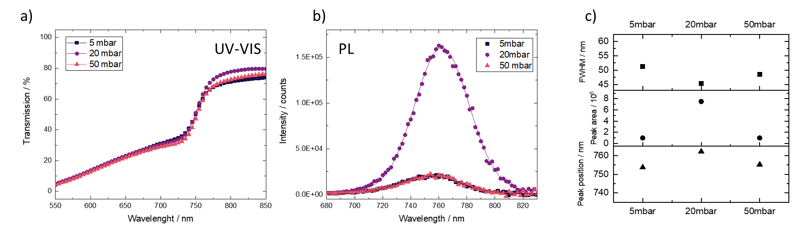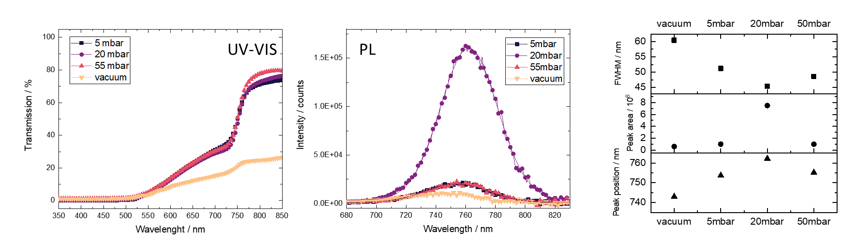
Figure S1: Absorption and photoluminescence data of the final films. Values are given in TableS1.

Table S3: Extracted PL data from the steady-state PL measurements on the annealed films
PL | vacuum | 5 mbar | 20 mbar | 55 mbar
Peak / nm | 743.0 | 753.7 | 762.2 | 755.2
Area x 10^6 | 0.6 | 1.0 | 7.5 | 1.0
FWHM / nm | 60.4 | 51.2 | 45.4 | 48.6

Penetration depth GIWAXS
Table S2: The penetration depth of the X-ray (8 keV)⁴⁵ in perovskite polycrystalline films at different incidence angles.
Incident angles (º) | Penetration depth⁴⁵ (nm) | Penetration depth (nm)
0.1 | 2 | 18
0.25 | - | 47
0.5 | 70 | 94
1 | 150 | 188
2 | 300 | 377

Phase values for XRD
Table S3: Reference of intermediate^{35–37} and perovskite phases and respective 2Theta angle.
2Theta values | Phase
6.67 | MA₂DMSO₂Pb₃I₈ - 002
7.27 | MA₂DMSO₂Pb₃I₈ - 021
9.26 | MA₂DMSO₂Pb₃I₈ - 022
11.85 | MA₂DMSO₂Pb₃I₈ - 023
12.29 | PbI₂∙DMF possible.
12.7 | PbI₂
13.28 | MA₂DMSO₂Pb₃I₈ - 004
14.12 | 3Cat – 001
In situ photoluminescence
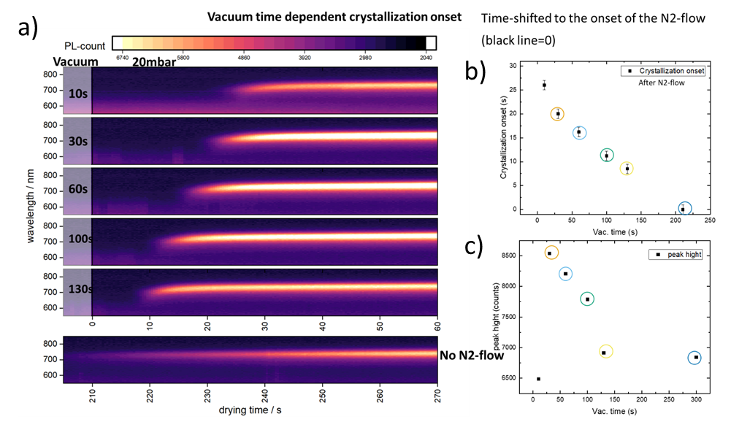
Figure S2: a) Photoluminescence signal of inkjet-printed samples dried under different gas flow-assisted vaccum drying conditions. (10,30,60,100,130s of vaccum followed by 60s of gas flow at 20mbar and 270s vacuum without additional gas flow. b) crystallization onset as function of the vacuum time, with nearly linear behavior. Calculated after the start of the additional gas-flow into the chamber. C) Max. PL intensity as function of the vacuum time.

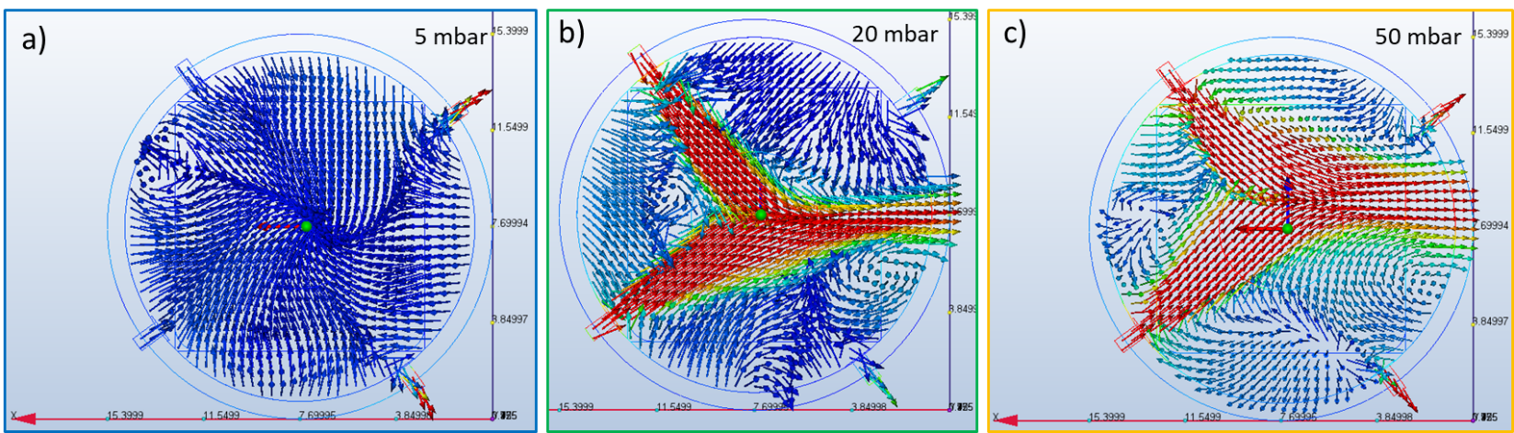
Figure S3: Topview of simulated flow insie the drying chamber for a) 5mbar b) 20mbar c) 50mbar. For a low chamber pressure (5mbar)nno homogeneneous flow is observed. Only fo 20 and 50mbar the flow is “visible” and allows to dry homogenous films.

In situ GIWAXS
The measured q-values were translated to 2θ values (Cu-Kα = 1.54 Å).
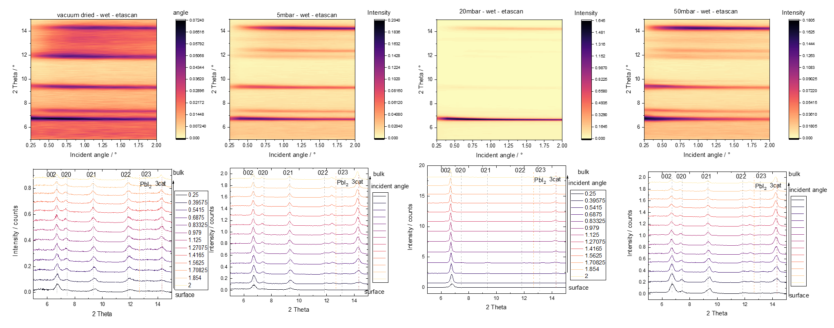
Figure S4: Mapping of the depth profile for the samples dried under the following conditions: vacuum only, at 5, 20 and 50mbar. A low incident angle corresponds to the surface, whereas a higher angle measures the bulk. Calculation of the penetration depth in the SI.
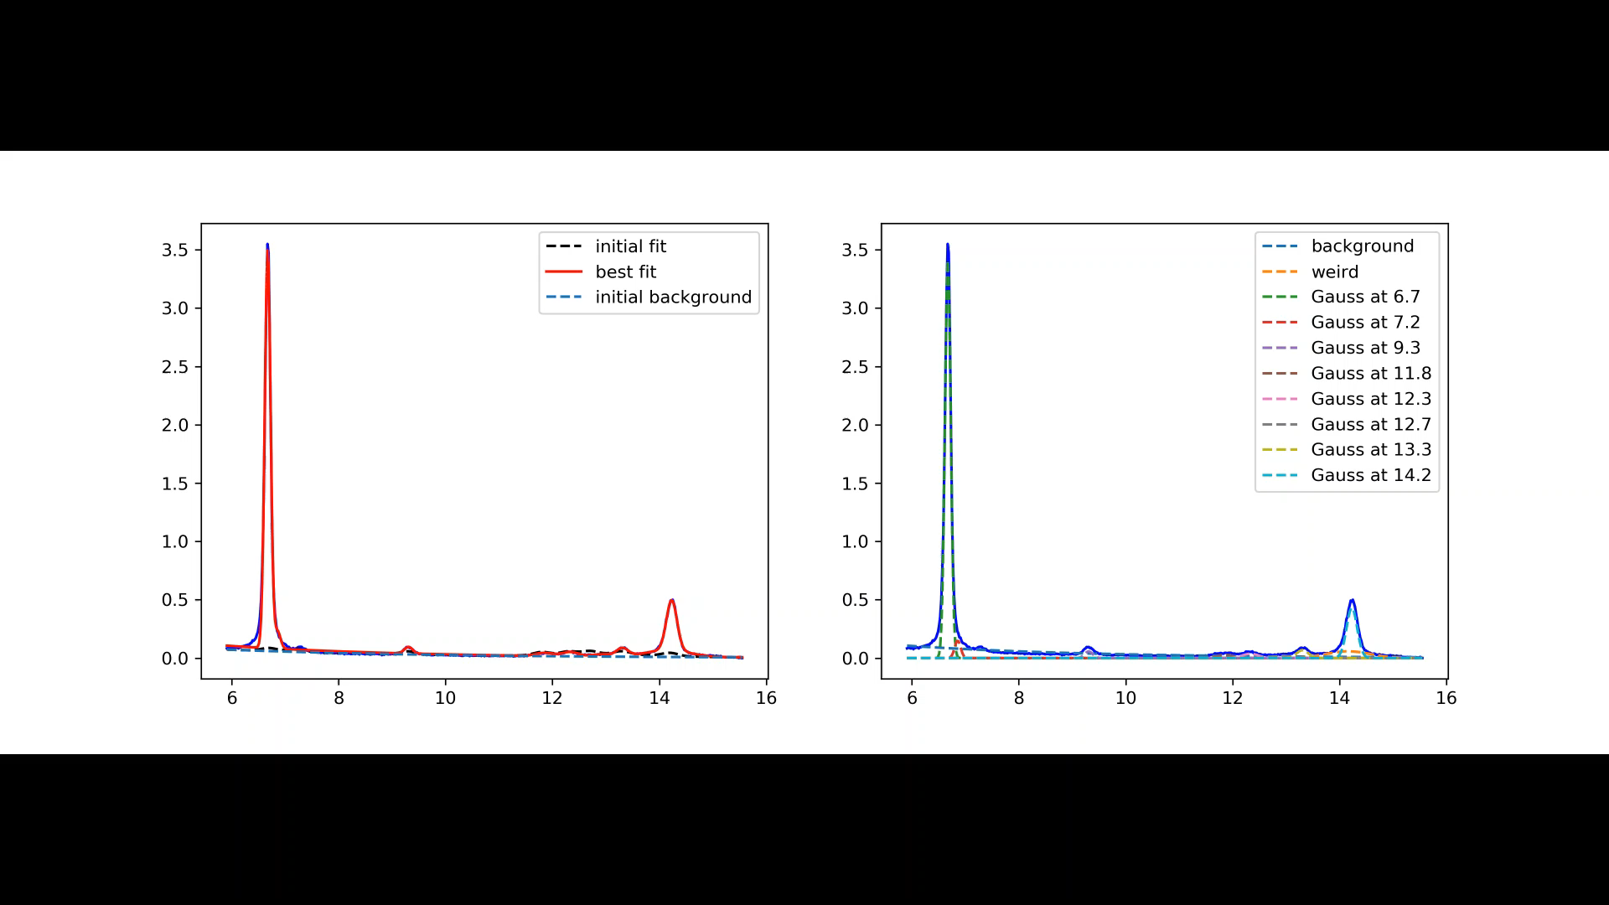
Video S1: Fitting routine for the samples dried at 20mbar and during 10min of annealing at 100°C. (also available for vac only,5,50mbar).
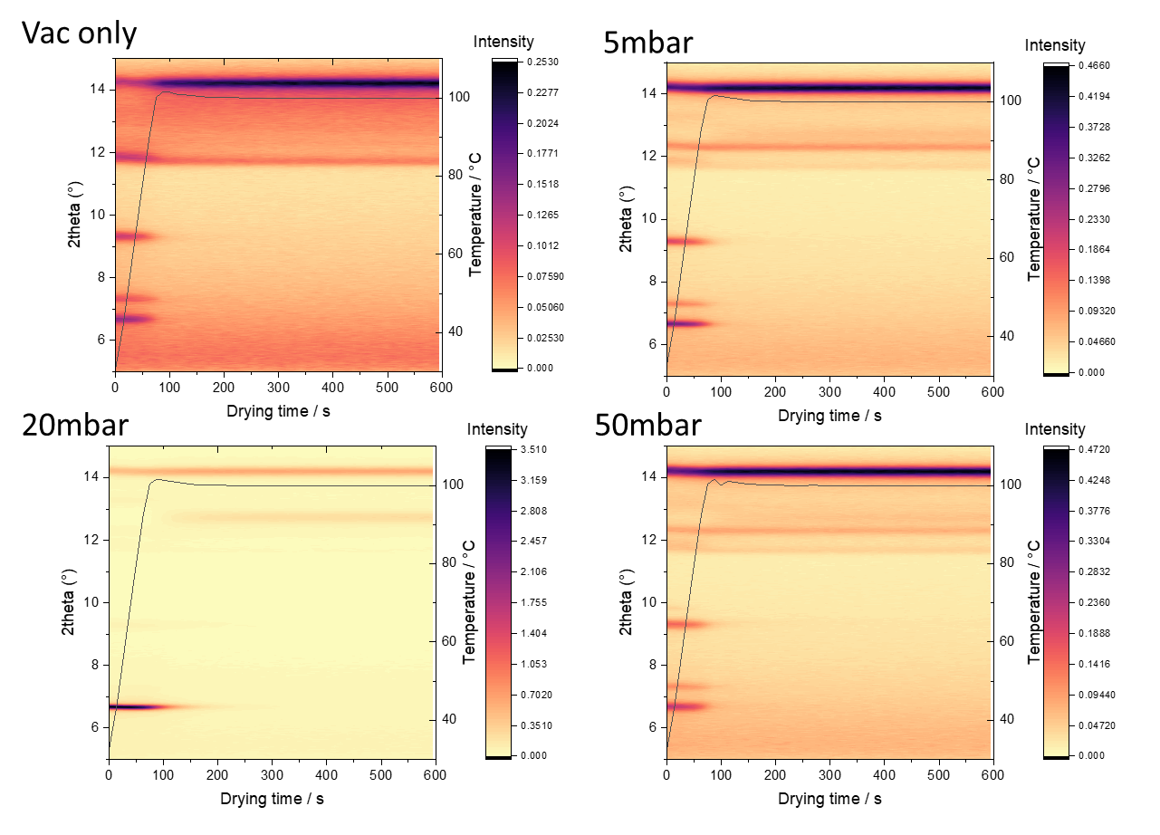
Figure S5: Heatmaps of the samples during annealing at 100°C for 600s. Temperature curve is given in light black.

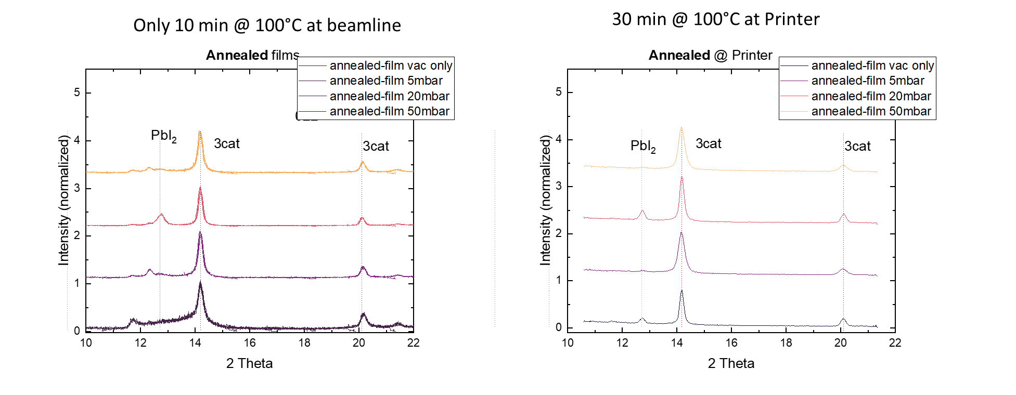
Figure S6: Comparison of XRD, measured at the beamline (only 10min @ 100°C, self-made N2 chamber) and the samples, finalized at the printer (30min@100°C, 1ppm O2, H₂0). In general, the main perovskite peaks are visible in both cases. We see a much lower perovskite phase for the films annealed during beamtime measurements. This can be traced back to the shorter annealing time of 10min compared to 30 min. In addition, the samples were transferred at ambient and seen high humidity for some 10min, before the measurement.

Crystallite Sizes from XRD
Debye Scherrer equation:
$$d_{cryst}=\frac{0.94× λ_{X-ray}}{FWHM× θ_{Bragg}}$$
Table S4: Calculated crystallite sizes of the different samples, using Debye Scherrer equation.
 |  | 10 min, 100°C @ beamline |  |  | 30 min, 100°C @ printer
 | Reflection / name | Center / 2Theta | FWHM / 2Theta | d_{cryst} / nm | Center / 2Theta | FWHM / 2Theta | d_{cryst} / nm
50mbar | 3cat | 14.22 | 0.22 | 38.02 | 14.17 | 0.14 | 59.75
20mbar | 3cat | 14.22 | 0.17 | 49.20 | 14.18 | 0.10 | 83.65
5mbar | 3cat | 14.21 | 0.22 | 38.02 | 14.15 | 0.14 | 59.75
Vac only | 3cat | 14.21 | 0.30 | 27.88 | 14.19 | 0.22 | 38.02

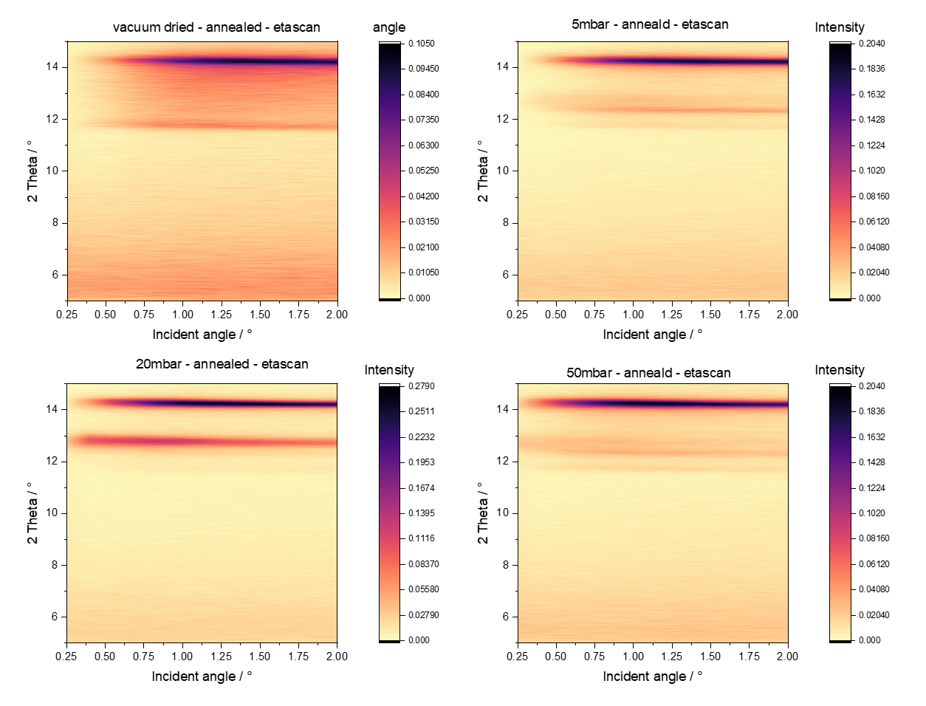
Figure S7: Mapping of the depth profile for the samples annealed at 100°C for 600s and dried under the following conditions: vacuum only, at 5, 20 and 50mbar. A low incident angle corresponds to the surface, whereas a higher angle measures the bulk. Calculation of the penetration depth in the SI.

TOC/Explanation
