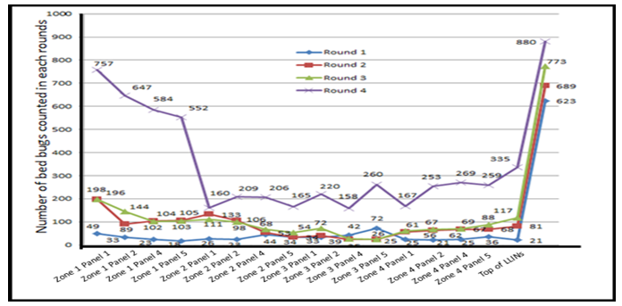
Supplement 4. The distribution of Bedbug infestations on LLINs zones and panel during each round visit, April-December 2017.

