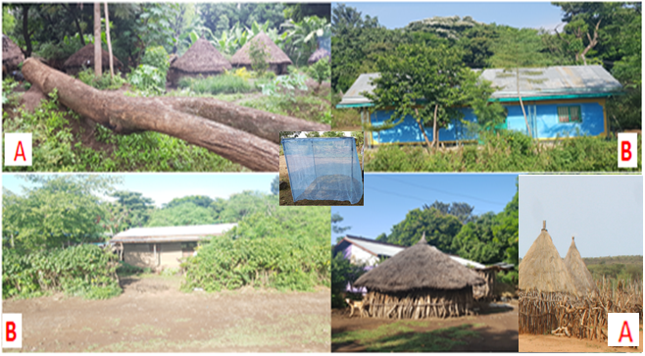
Supplement 2. Thatched Tukul (A) and corrugated iron houses (B) at Kola Shara kebele, south-west Ethiopia, April 2017.

