Supplementary Figures
1.ECG
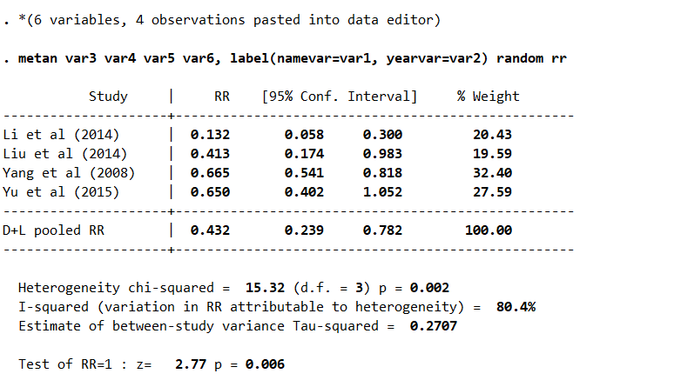
Supplementary Figure 1 Meta-analysis of ECG

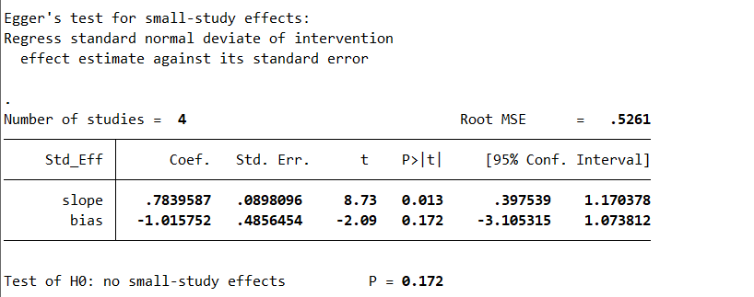
Supplementary Figure 2 Egger’s test for ECG

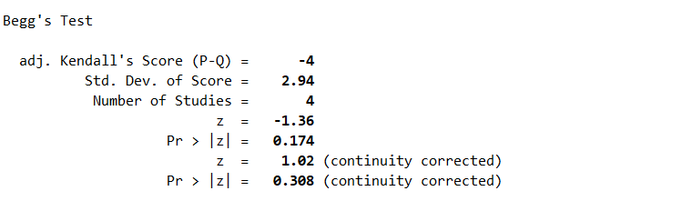
Supplementary Figure 3 Begger’s test for ECG

2.ST-T
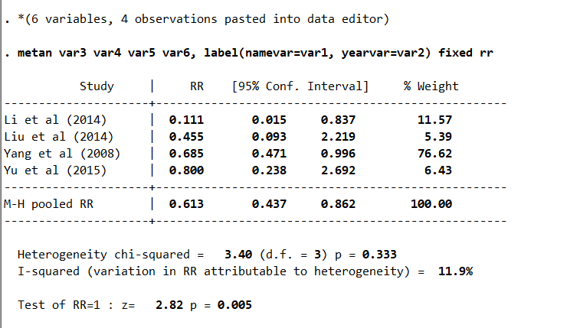
Supplementary Figure 4 Meta-analysis of ST-T

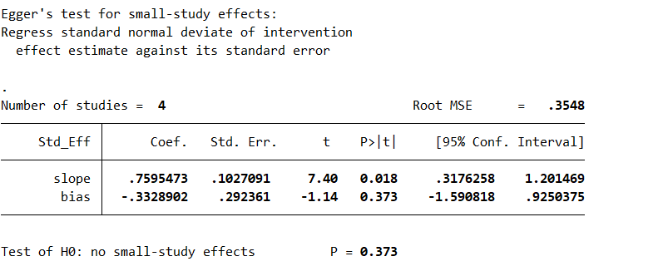
Supplementary Figure 5 Egger’s test for ST-T

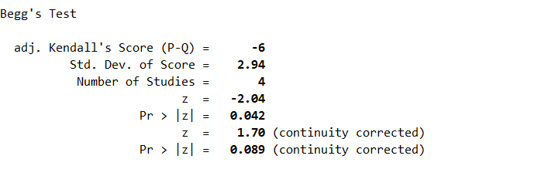
Supplementary Figure 6 Begger’s test for ST-T

3.Extrasystole
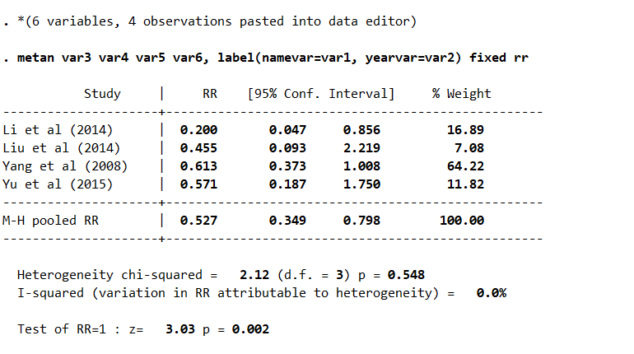
Supplementary Figure 7 Meta-analysis of extrasystole

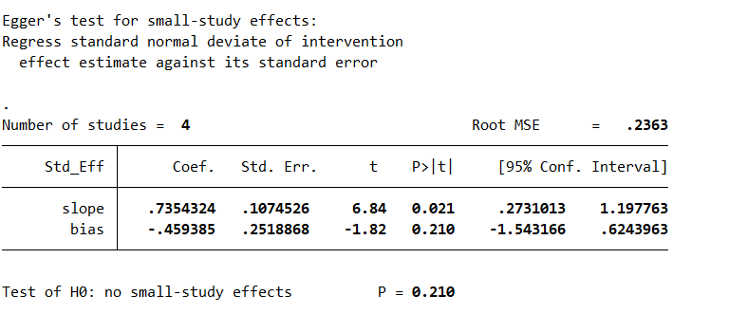
Supplementary Figure 8 Egger’s test for extrasystole

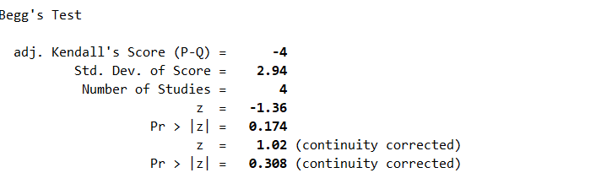
Supplementary Figure 9 Begger’s test for extrasystole

4.LVEF

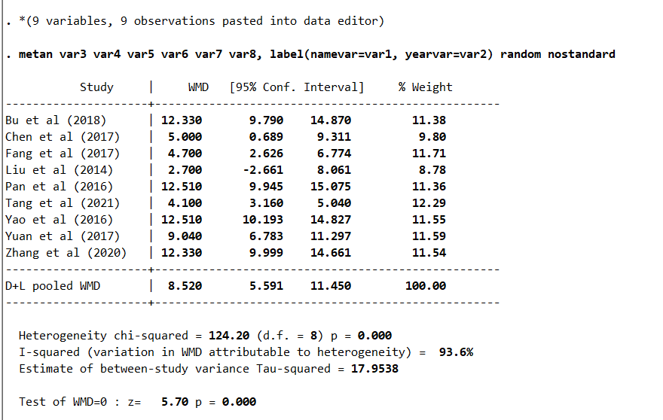
Supplementary Figure 10 Meta-analysis of LVEF

Subgroup analysis of LVEF
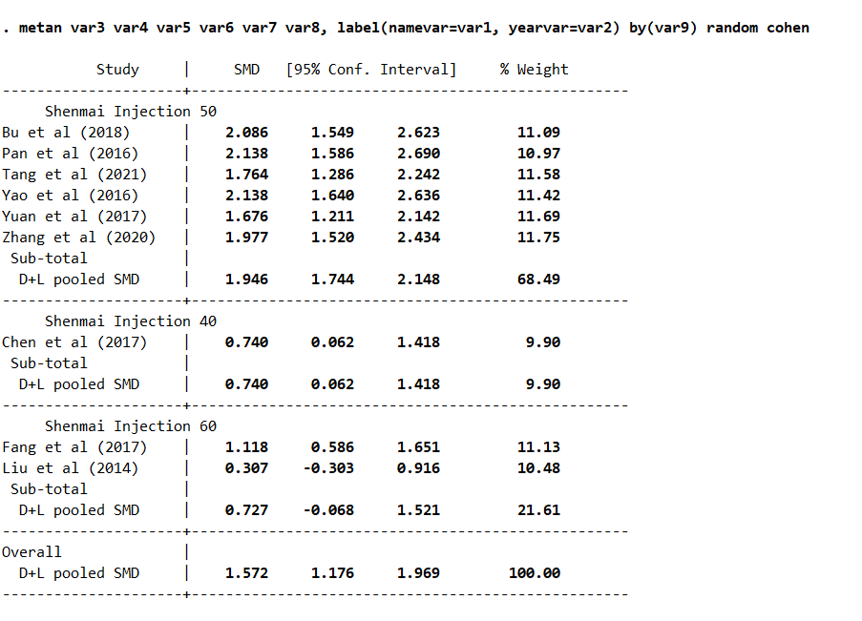
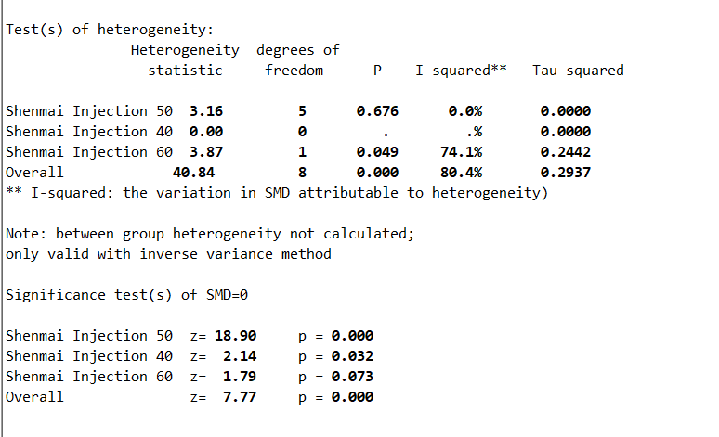
Supplementary Figure 11 Subgroup analysis of LVEF
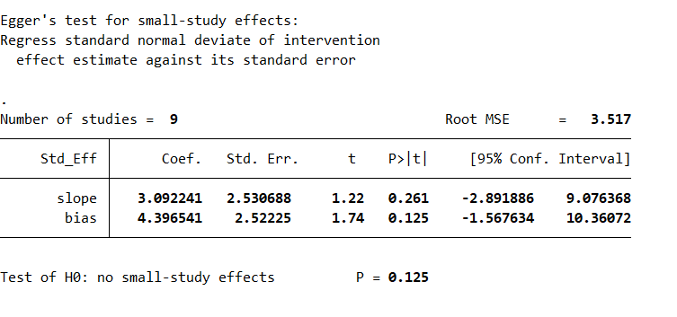
Supplementary Figure 12 Egger’s test for LVEF

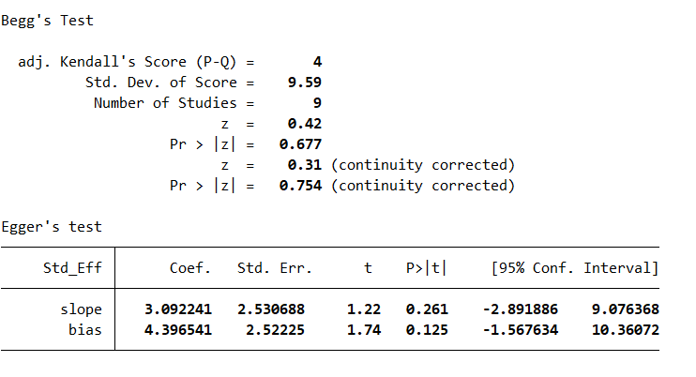
Supplementary Figure 13 Begger’s test for LVEF

5.E/A
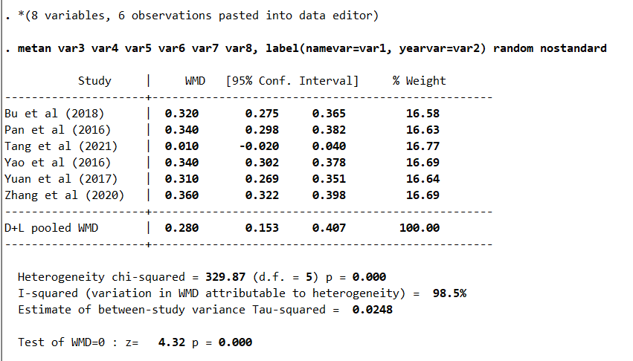
Supplementary Figure 14 Meta-analysis of E/A

Subgroup of E/A
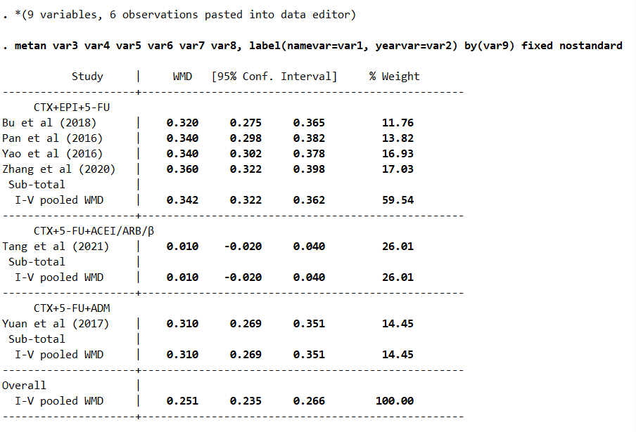
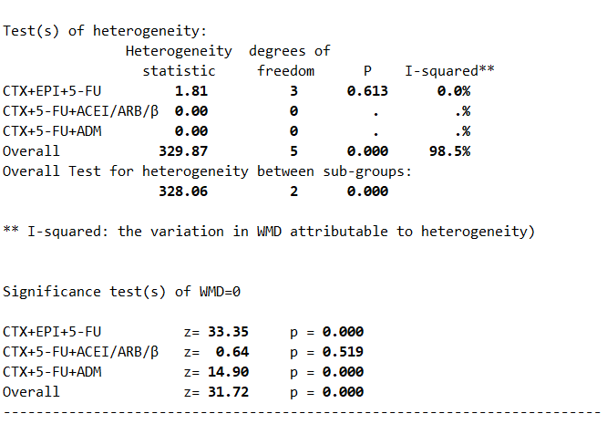
Supplementary Figure 15 Subgroup analysis of E/A

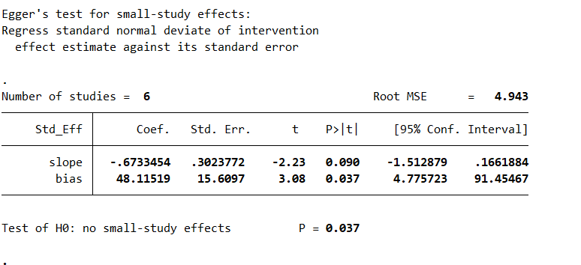
Supplementary Figure 16 Egger’s test for E/A

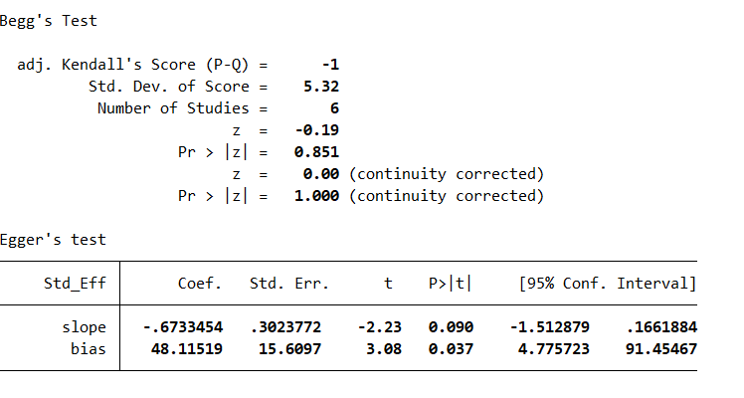
Supplementary Figure 17 Begger’s test for E/A

6.CK
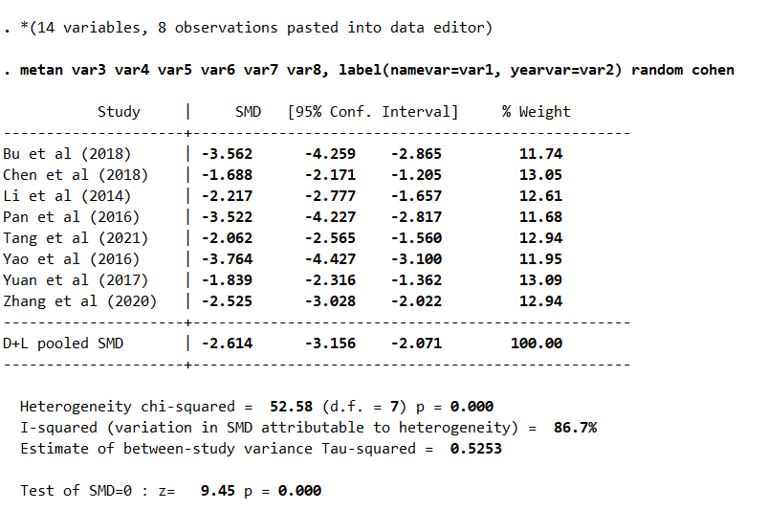
Supplementary Figure 18 Meta-analysis of CK

Sensitivity Analysis
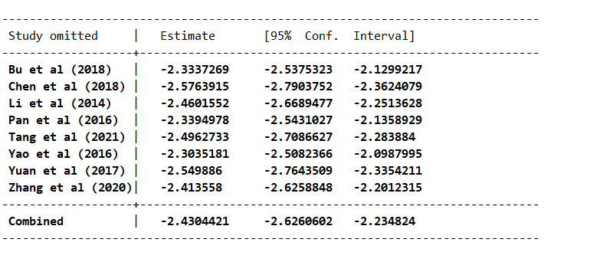
Supplementary Figure 19 Sensitivity analysis of CK

Meta-Regression
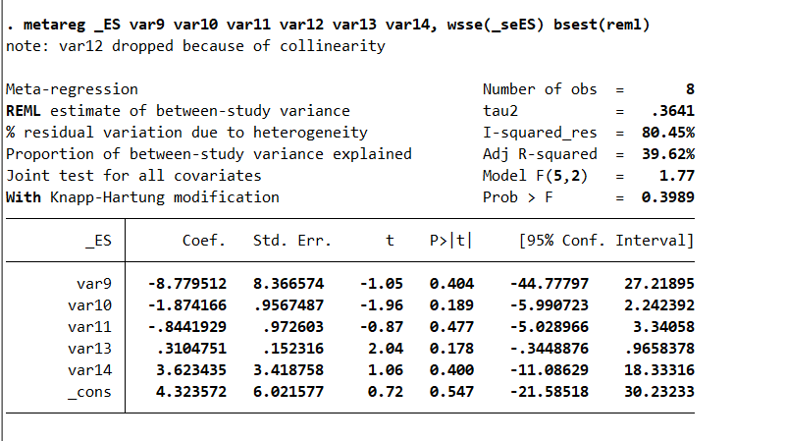
Supplementary Figure 20 Meta-regression analysis of CK
Ts:
var9 Years 2016-2021(1); Rest (2).
var10 Type of RCT (1), prospective research (2), and retrospective study (3).
var11 Chemotherapy plan CTX+5-FU+EPI (1), DXT+CTX+ADM+DEX (2), THP (3), CTX+5-FU+ADM (4), CTX+5-FU+ACEI/ARB/β-blockers (5); trastuzumab (6).
var12 Dosage 40 mL/time (1); 50–60 mL/time (2) 60–100 mL/time (3) exclude 60 (4)
var13 Duration of treatment, use for 7 days, 21 days / cycle, 6 cycles, continue treatment for 1 week after chemotherapy (1); 21 days / cycle, 4 cycles (2); once every 3 weeks (3); 6 weeks (4); once every 3 weeks, 15 times in total (5); 1 week / cycle, 6 cycles (6).
var14 Disease stages I-III (1); III-IV (2); I-IV (3); None (4)

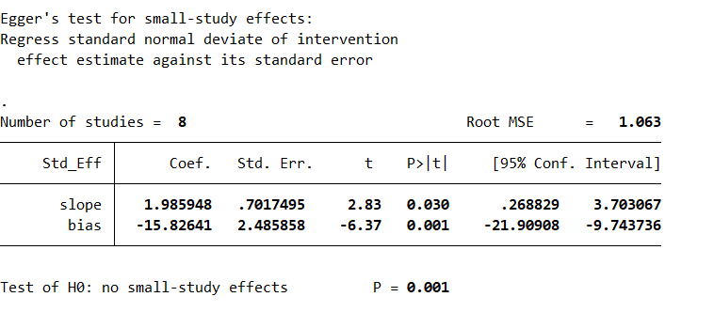
Supplementary Figure 21 Egger’s test for CK

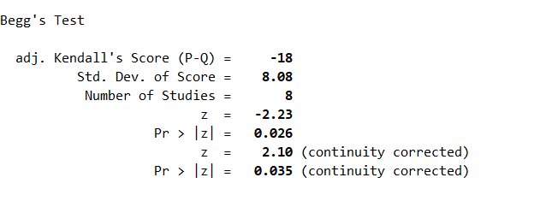
Supplementary Figure 22 Begger’s test for CK

7.CK-MB
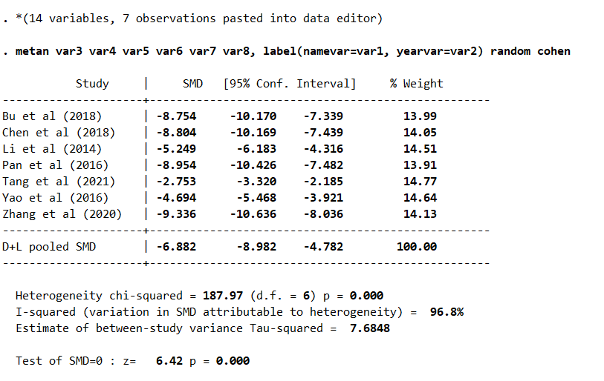
Supplementary Figure 23 Meta-analysis of CK-MB

Sensitivity Analysis
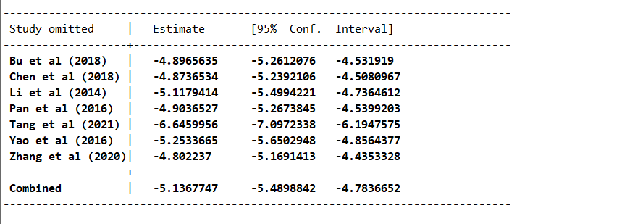
Supplementary Figure 24 Sensitivity analysis of CK-MB

Meta-Regression
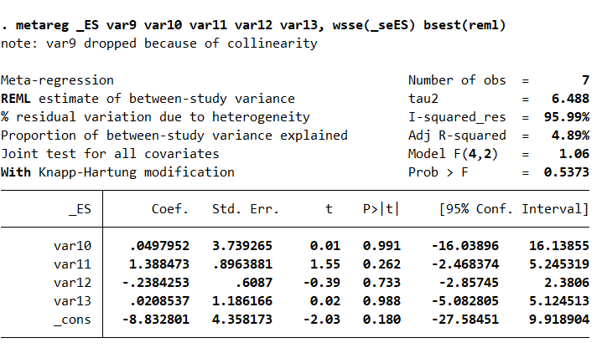
Supplementary Figure 25 Meta-regression of CK-MB
Ts:
var9 Years 2016-2021(1); Rest (2).
var10 Type of RCT (1), prospective research (2), and retrospective study (3).
var11 Chemotherapy plan CTX+5-FU+EPI (1), DXT+CTX+ADM+DEX (2), THP (3), CTX+5-FU+ADM (4), CTX+5-FU+ACEI/ARB/β-blockers (5); trastuzumab (6).
var12 Dosage 40 mL/time (1); 50–60 mL/time (2) 60–100 mL/time (3) exclude 60 (4)
var13 Duration of treatment, use for 7 days, 21 days / cycle, 6 cycles, continue treatment for 1 week after chemotherapy (1); 21 days / cycle, 4 cycles (2); once every 3 weeks (3); 6 weeks (4); once every 3 weeks, 15 times in total (5); 1 week / cycle, 6 cycles (6).

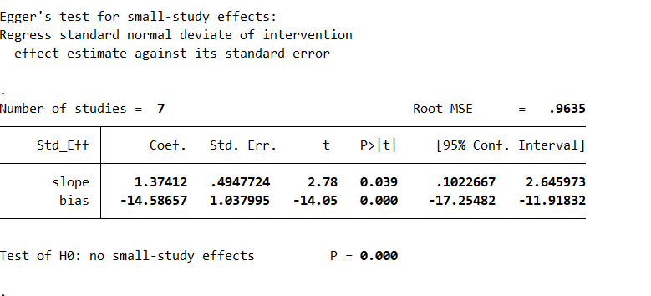
Supplementary Figure 26 Egger’s test for CK-MB

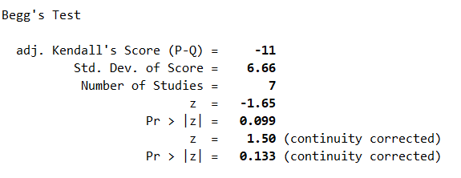
Supplementary Figure 27 Begger’s test for CK-MB

8.cTnI
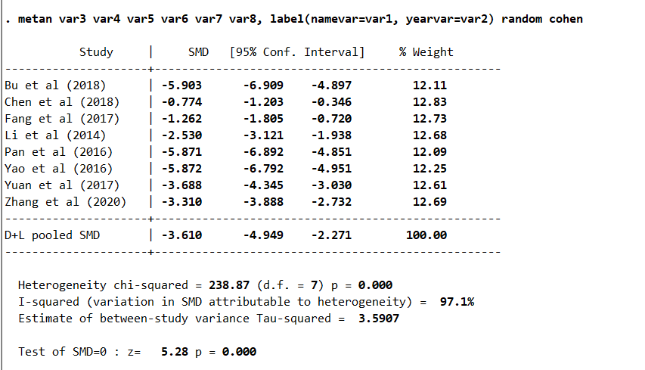
Supplementary Figure 28 Meta-analysis of cTnI

Sensitivity Analysis
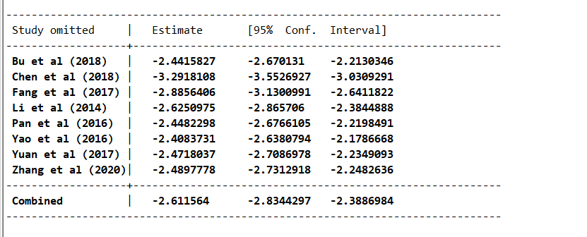
Supplementary Figure 29 Sensitivity analysis of cTnI

Meta-Regression

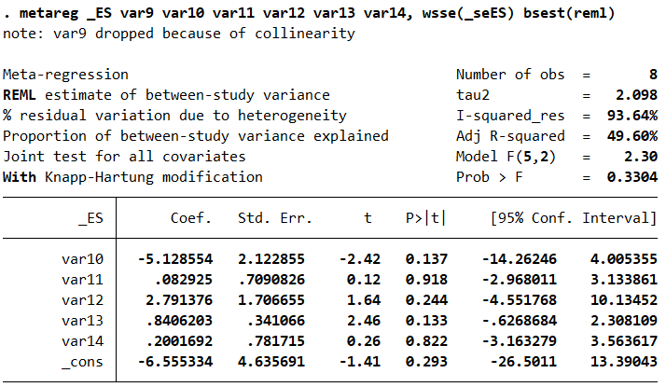Supplementary Figure 30 Meta-regression of cTnI
Ts:
var9 Years 2016-2021(1); Rest (2).
var10 Type of RCT (1), prospective research (2), and retrospective study (3).
var11 Chemotherapy plan CTX+5-FU+EPI (1), DXT+CTX+ADM+DEX (2), THP (3), CTX+5-FU+ADM (4), CTX+5-FU+ACEI/ARB/β-blockers (5); trastuzumab (6).
var12 Dosage 40 mL/time (1); 50–60 mL/time (2) 60–100 mL/time (3) exclude 60 (4)
var13 Duration of treatment, use for 7 days, 21 days / cycle, 6 cycles, continue treatment for 1 week after chemotherapy (1); 21 days / cycle, 4 cycles (2); once every 3 weeks (3); 6 weeks (4); once every 3 weeks, 15 times in total (5); 1 week / cycle, 6 cycles (6).
var14 Disease stages I-III (1); III-IV (2); I-IV (3); None (4)

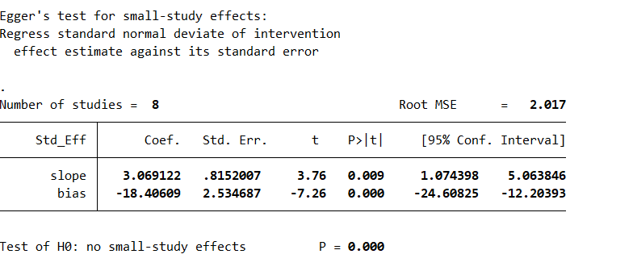
Supplementary Figure 31 Egger’s test for cTnI

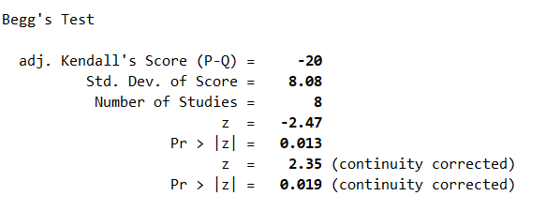
Supplementary Figure 32 Begger’s test for cTnI

9. SOD
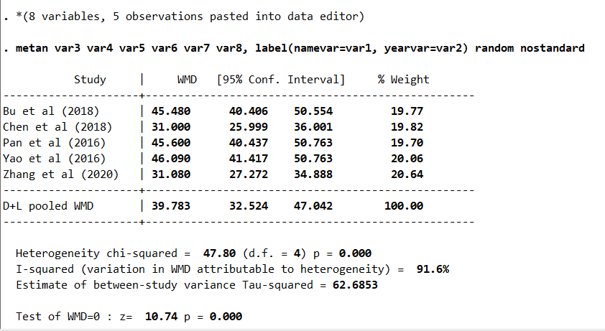
Supplementary Figure 33 Meta-analysis for SOD

Sensitivity Analysis
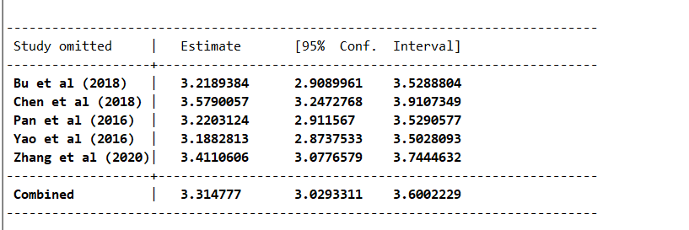
Supplementary Figure 34 Sensitivity analysis of SOD

Meta-Regression
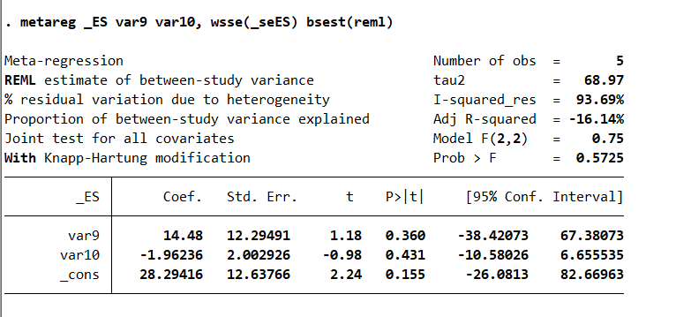
Supplementary Figure 35 Meta-regression of SOD
Ts:
var9 Type of RCT (1), prospective research (2), and retrospective study (3).
var10 Duration of treatment, use for 7 days, 21 days / cycle, 6 cycles, continue treatment for 1 week after chemotherapy (1); 21 days / cycle, 4 cycles (2); once every 3 weeks (3); 6 weeks (4); once every 3 weeks, 15 times in total (5); 1 week / cycle, 6 cycles (6).

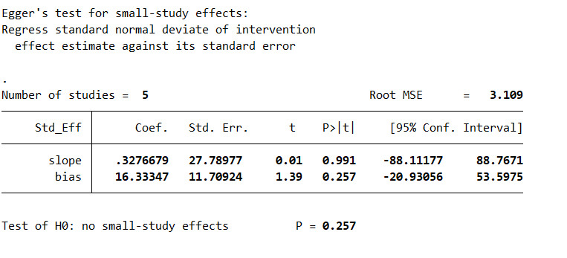
Supplementary Figure 36 Egger’s test for SOD

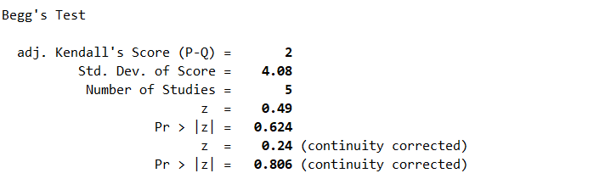
Supplementary Figure 37 Begger’s test for SOD

10.GSH
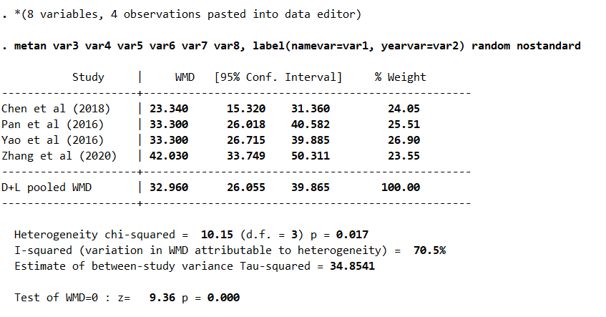
Supplementary Figure 38 Meta-analysis for SOD

Sensetivity Analysis
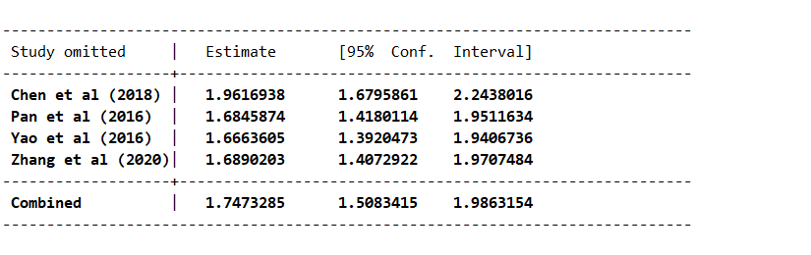
Supplementary Figure 39 Sensitivity analysis of GSH

Meta-Regression
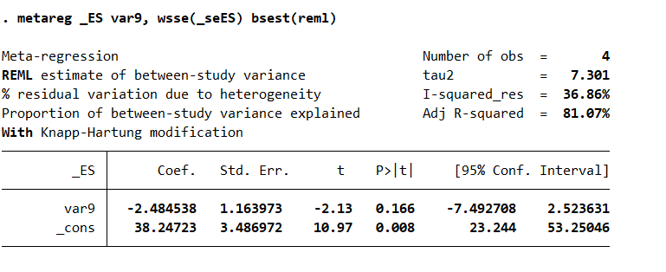
Supplementary Figure 40 Meta-regression of GSH
Ts:
var9 Duration of treatment, use for 7 days, 21 days / cycle, 6 cycles, continue treatment for 1 week after chemotherapy (1); 21 days / cycle, 4 cycles (2); once every 3 weeks (3); 6 weeks (4); once every 3 weeks, 15 times in total (5); 1 week / cycle, 6 cycles (6).

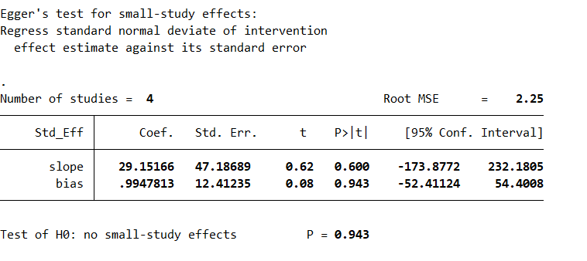
Supplementary Figure 41 Egger’s test for GSH

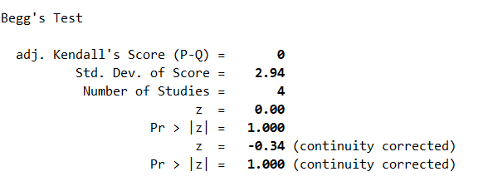
Supplementary Figure 42 Begger’s test for GSH

11.MDA
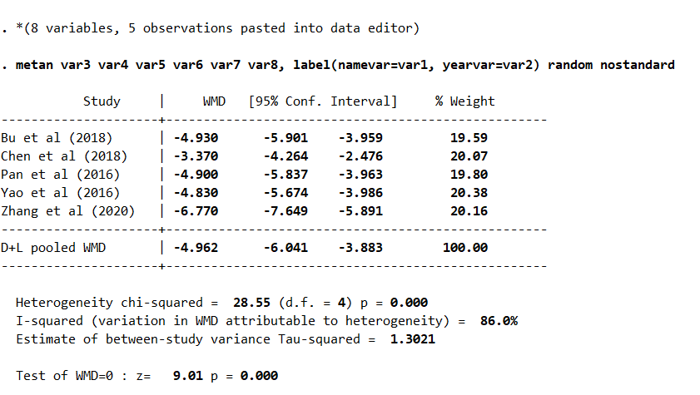
Supplementary Figure 43 Meta-analysis for GSH

Sensitivity Analysis
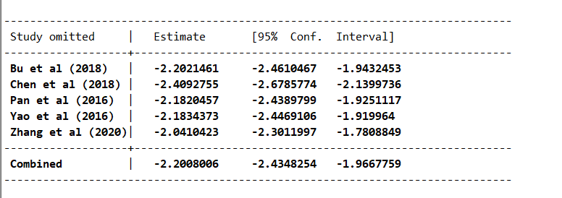
Supplementary Figure 44 Sensitivity analysis of MDA

Meta-Regression
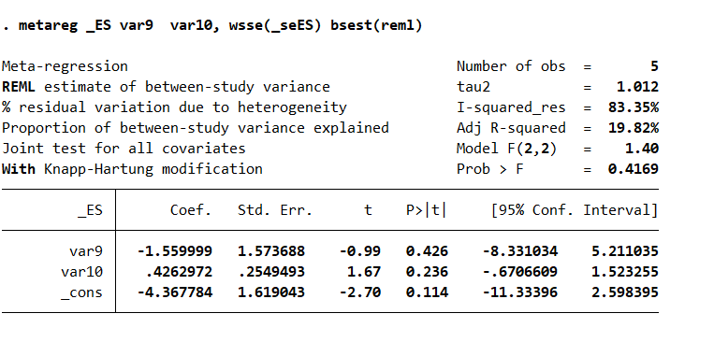
Supplementary Figure 45 Meta-regression of MDA
Ts:
var9 Type of RCT (1), prospective research (2), and retrospective study (3).
var10 Duration of treatment, use for 7 days, 21 days / cycle, 6 cycles, continue treatment for 1 week after chemotherapy (1); 21 days / cycle, 4 cycles (2); once every 3 weeks (3); 6 weeks (4); once every 3 weeks, 15 times in total (5); 1 week / cycle, 6 cycles (6).

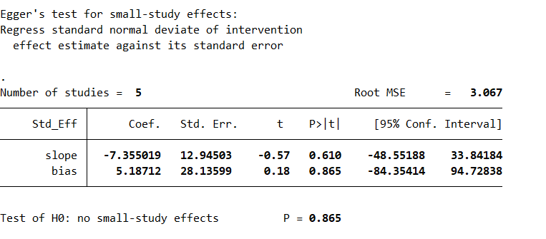
Supplementary Figure 46 Egger’s test for MDA

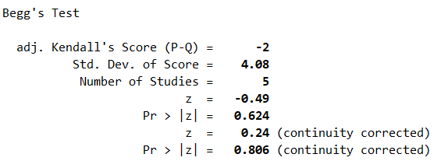
Supplementary Figure 47 Begger’s test for MDA

