Supplementary information

Optimization of trans-4-hydroxyproline synthesis pathway by rearrangement center carbon metabolism in Escherichia coli
Yu Gong^{1,3}, Ruiqi Wang^{1,3}, Ling Ma^{1,3}, Shuo Wang ^{1,3}, Changgeng Li ^{1,3}，Qingyang Xu^{1,3*}
1 College of Biotechnology, Tianjin University of Science & Technology, Tianjin, 300457, P. R. China.
2 Key Laboratory of Industrial Fermentation Microbiology, Ministry of Education, Tianjin University of Science & Technology, Tianjin, 300457, P. R. China.

Tab.S1 Primers used for strain construction in this study.
Fig. 1 Trans-4-Hydroxyproline Metabolic Pathway of Central Carbon Metabolic Rearrangement in Escherichia coli
Fig. 2 Shake flask fermentation parameters of strain Pro-1-HYP-7-1
Fig 3 Shake flask fermentation parameters of strain HYP-6-1-HYP-7-3
Fig 4 Intracellular NAD(P)H level of HYP-7-1 ,HYP-8 and HYP-9 strains.
Fig. 5 Comparison of strain production performance under different fermentation strategies in 5L fermentor
Fig. 6 Comparison of production performance of single strains under different fermentation strategies
Tab. S1 Primers used for strain construction
Primers | Sequence (5’→ 3’)
putA-Q-1 | GCGTATTCCCGACAAAGCC
putA-Q-2 | TAATGGACGGTGGGTTTCGTCATAGATGCCACGACCGTTAGA
putA-Q-3 | TCTAACGGTCGTGGCATCTATGACGAAACCCACCGTCCATTA
putA-Q-4 | AACAACGCTGACCCGCAC
pGRB-putA-S | AGTCCTAGGTATAATACTAGTGTGCGTCGCCTGCTGGAAAAGTTTTAGAGCTAGAA
pGRB-putA-A | TTCTAGCTCTAAAACTTTTCCAGCAGGCGACGCACACTAGTATTATACCTAGGACT
lacI-Q-1 | GACTATCAACTGGCACGGGAA
lacI-Q-2 | CGATTTGCTGGTGACCCAAGCGGGAAACGGTCTGATAAG
lacI-Q-3 | CTTATCAGACCGTTTCCCGCTTGGGTCACCAGCAAATCG
lacI-Q-4 | TTTTCACCAGTGAGACGGGC
pGRB-lacI-S | AGTCCTAGGTATAATACTAGTGCCACGTTTCTGCGAAAACGGTTTTAGAGCTAGAA
pGRB-lacI-A | TTCTAGCTCTAAAACCGTTTTCGCAGAAACGTGGCACTAGTATTATACCTAGGACT
yghX-UP-S | GCGCAACGTAGAACAGGAATT
yghX-UP-A | TGTGTGAAATTGTTATCCGCTCACAATTCCACACATTATACGAGCCGGATGATTAATTGTCAAGATTGAAGCGCCTTTACTACTCC
yghX-DN-S | AAAGACTGGGCCTTTCGTTTTATCTGTTGTTTGTCGGTGAACGCTCTCCTGAGTAGGACAAATGTCATAGTAATCCAGCAACTCTTGTG
yghX-DN-A | GAGCAGGTATTTACGTGAACCG
PGRB-yghX-S | AGTCCTAGGTATAATACTAGTGGTGCCTGACGACCATAAAAGTTTTAGAGCTAGAA
PGRB-yghX-A | TTCTAGCTCTAAAACTTTTATGGTCGTCAGGCACCACTAGTATTATACCTAGGACT
rpH-UP-S | ATAGCGCAGGGTACATTCCACT
rpH-UP-A | AATTGTTATCCGCTCACAATTCCACACATTATACGAGCCGGATGATTAATTGTCAACCTTCTTCAATAGAGGCGGTACA
rpH-DN-S | AAAGACTGGGCCTTTCGTTTTATCTGTTGTTTGTCGGTGAACGCTCTCCTGAGTAGGACAAATTGCCGCAGAGACCGACAT
rpH-DN-A | ACAGCGGTTGTGGTGGCA
pGRB-rpH-S | AGTCCTAGGTATAATACTAGTGGCTGGATCACCGCAGAGTAGTTTTAGAGCTAGAA
pGRB-rpH-A | TTCTAGCTCTAAAACTACTCTGCGGTGATCCAGCCACTAGTATTATACCTAGGACT
putA-Q-1 | GCGTATTCCCGACAAAGCC
putA-Q-2 | TAATGGACGGTGGGTTTCGTCATAGATGCCACGACCGTTAGA
putA-Q-3 | TCTAACGGTCGTGGCATCTATGACGAAACCCACCGTCCATTA
putA-Q-4 | AACAACGCTGACCCGCAC
pGRB-putA-S | AGTCCTAGGTATAATACTAGTGTGCGTCGCCTGCTGGAAAAGTTTTAGAGCTAGAA
pGRB-putA-A | TTCTAGCTCTAAAACTTTTCCAGCAGGCGACGCACACTAGTATTATACCTAGGACT
lacI-Q-1 | GACTATCAACTGGCACGGGAA
lacI-Q-2 | CGATTTGCTGGTGACCCAAGCGGGAAACGGTCTGATAAG
lacI-Q-3 | CTTATCAGACCGTTTCCCGCTTGGGTCACCAGCAAATCG
lacI-Q-4 | TTTTCACCAGTGAGACGGGC
pGRB-lacI-S | AGTCCTAGGTATAATACTAGTGCCACGTTTCTGCGAAAACGGTTTTAGAGCTAGAA
pGRB-lacI-A | TTCTAGCTCTAAAACCGTTTTCGCAGAAACGTGGCACTAGTATTATACCTAGGACT
yghX-UP-S | GCGCAACGTAGAACAGGAATT
yghX-UP-A | TGTGTGAAATTGTTATCCGCTCACAATTCCACACATTATACGAGCCGGATGATTAATTGTCAAGATTGAAGCGCCTTTACTACTCC
yghX-DN-S | AAAGACTGGGCCTTTCGTTTTATCTGTTGTTTGTCGGTGAACGCTCTCCTGAGTAGGACAAATGTCATAGTAATCCAGCAACTCTTGTG
yghX-DN-A | GAGCAGGTATTTACGTGAACCG
PGRB-yghX-S | AGTCCTAGGTATAATACTAGTGGTGCCTGACGACCATAAAAGTTTTAGAGCTAGAA
PGRB-yghX-A | TTCTAGCTCTAAAACTTTTATGGTCGTCAGGCACCACTAGTATTATACCTAGGACT
rpH-UP-S | ATAGCGCAGGGTACATTCCACT
rpH-UP-A | AATTGTTATCCGCTCACAATTCCACACATTATACGAGCCGGATGATTAATTGTCAACCTTCTTCAATAGAGGCGGTACA
rpH-DN-S | AAAGACTGGGCCTTTCGTTTTATCTGTTGTTTGTCGGTGAACGCTCTCCTGAGTAGGACAAATTGCCGCAGAGACCGACAT
rpH-DN-A | ACAGCGGTTGTGGTGGCA
pGRB-rpH-S | AGTCCTAGGTATAATACTAGTGGCTGGATCACCGCAGAGTAGTTTTAGAGCTAGAA
pGRB-rpH-A | TTCTAGCTCTAAAACTACTCTGCGGTGATCCAGCCACTAGTATTATACCTAGGACT
putA-Q-1 | GCGTATTCCCGACAAAGCC
putA-Q-2 | TAATGGACGGTGGGTTTCGTCATAGATGCCACGACCGTTAGA
putA-Q-3 | TCTAACGGTCGTGGCATCTATGACGAAACCCACCGTCCATTA
putA-Q-4 | AACAACGCTGACCCGCAC
pGRB-putA-S | AGTCCTAGGTATAATACTAGTGTGCGTCGCCTGCTGGAAAAGTTTTAGAGCTAGAA
pGRB-putA-A | TTCTAGCTCTAAAACTTTTCCAGCAGGCGACGCACACTAGTATTATACCTAGGACT
lacI-Q-1 | GACTATCAACTGGCACGGGAA
lacI-Q-2 | CGATTTGCTGGTGACCCAAGCGGGAAACGGTCTGATAAG
lacI-Q-3 | CTTATCAGACCGTTTCCCGCTTGGGTCACCAGCAAATCG
lacI-Q-4 | TTTTCACCAGTGAGACGGGC
pGRB-lacI-S | AGTCCTAGGTATAATACTAGTGCCACGTTTCTGCGAAAACGGTTTTAGAGCTAGAA
pGRB-lacI-A | TTCTAGCTCTAAAACCGTTTTCGCAGAAACGTGGCACTAGTATTATACCTAGGACT
yghX-UP-S | GCGCAACGTAGAACAGGAATT
yghX-UP-A | TGTGTGAAATTGTTATCCGCTCACAATTCCACACATTATACGAGCCGGATGATTAATTGTCAAGATTGAAGCGCCTTTACTACTCC
yghX-DN-S | AAAGACTGGGCCTTTCGTTTTATCTGTTGTTTGTCGGTGAACGCTCTCCTGAGTAGGACAAATGTCATAGTAATCCAGCAACTCTTGTG
yghX-DN-A | GAGCAGGTATTTACGTGAACCG
PGRB-yghX-S | AGTCCTAGGTATAATACTAGTGGTGCCTGACGACCATAAAAGTTTTAGAGCTAGAA
PGRB-yghX-A | TTCTAGCTCTAAAACTTTTATGGTCGTCAGGCACCACTAGTATTATACCTAGGACT
rpH-UP-S | ATAGCGCAGGGTACATTCCACT
rpH-UP-A | AATTGTTATCCGCTCACAATTCCACACATTATACGAGCCGGATGATTAATTGTCAACCTTCTTCAATAGAGGCGGTACA
rpH-DN-S | AAAGACTGGGCCTTTCGTTTTATCTGTTGTTTGTCGGTGAACGCTCTCCTGAGTAGGACAAATTGCCGCAGAGACCGACAT
rpH-DN-A | ACAGCGGTTGTGGTGGCA
pGRB-rpH-S | AGTCCTAGGTATAATACTAGTGGCTGGATCACCGCAGAGTAGTTTTAGAGCTAGAA
pGRB-rpH-A | TTCTAGCTCTAAAACTACTCTGCGGTGATCCAGCCACTAGTATTATACCTAGGACT
proB-trc-UP | CATCCGGCTCGTATAATGTGTGGAATTGTGAGCGGATAACAATTTCACACAGGAAACAGACCATGCGTGAGCGCATCTCC
proB-trc-DN | TTCACCGACAAACAACAGATAAAACGAAAGGCCCAGTCTTTCGACTGAGCCTTTCGTTTTATTTGTTACGCGCGGCTGGC
yjiT-UP-S | AATAGTTGTTGCCGCCTGAGT
yjiT-UP-A | TGTGTGAAATTGTTATCCGCTCACAATTCCACACATTATACGAGCCGGATGATTAATTGTCAAAAAACAGGCAGCAAAGTCCC
yjiT-DN-S | AAAGACTGGGCCTTTCGTTTTATCTGTTGTTTGTCGGTGAACGCTCTCCTGAGTAGGACAAATAAGCACTACCTGTGAAGGGATGT
yjiT-DN-A | CAGGGCTTCCACAGTCACAAT
PGRB-yjiT-S | AGTCCTAGGTATAATACTAGTAGGGATTATGAACGGCAATG  GTTTTAGAGCTAGAA
PGRB-yjiT-A | TTCTAGCTCTAAAACCATTGCCGTTCATAATCCCTACTAGTATTATACCTAGGACT
proA-trc-UP | TCCGGCTCGTATAATGTGTGGAATTGTGAGCGGATAACAATTTCACACAGGAAACAGACCATGCTGGAACAAATGGGCAT
proA-trc-DN | CAAACAACAGATAAAACGAAAGGCCCAGTCTTTCGACTGAGCCTTTCGTTTTATTTGTTACGCACGAATGGTGTAATCAC
yciQ-UP-S | TTACTTGAAGCATTGGGCGAAC
yciQ-UP-A | AATTGTTATCCGCTCACAATTCCACACATTATACGAGCCGGATGATTAATTGTCAACCAGTCAAGATGCCAGGGTTC
yciQ-DN-S | AAAGACTGGGCCTTTCGTTTTATCTGTTGTTTGTCGGTGAACGCTCTCCTGAGTAGGACAAATGTCTGACAAGAACCAGCAAATCCT
yciQ-DN-A | ATAGCTTCACCGTGGGCATAAC
PGRB-yciQ-S | AGTCCTAGGTATAATACTAGTAAACAACGTTTCTTGCCTCAGTTTTAGAGCTAGAA
PGRB-yciQ-A | TTCTAGCTCTAAAACTGAGGCAAGAAACGTTGTTTACTAGTATTATACCTAGGACT
proC-trc-UP | CGGATAACAATTTCACACAGGAAACAGACCGTGGGAACCATGACAACAATTGCT
proC-trc-DN | TCTTTCGACTGAGCCTTTCGTTTTATTTGCTAGCGCTTTCCGAGTTCTTCA
H-1-UP | AGGAAACAGACCATGGAATTCATGCTGACCCCGACCGAA
H-1-DN | TGCCTGCAGGTCGACTCTAGATTAAACCGGCTGAGCCAGAG
ldhA-Q-1 | AACGAGTCCTTTGGCTTTG
ldhA-Q-2 | ACTTGGATACGGATCGAACAGAAGTTAGCATCACGGGTAC
ldhA-Q-3 | GTACCCGTGATGCTAACTTCTGTTCGATCCGTATCCAAGT
ldhA-Q-4 | CGCCTCCAGATTGCTTA
pGRB-ldhA-S | AGTCCTAGGTATAATACTAGTATGTATGGCAAAACGGCAAA GTTTTAGAGCTAGAA
pGRB-ldhA-A | TTCTAGCTCTAAAACTTTGCCGTTTTGCCATACATACTAGTATTATACCTAGGACT
poxB-Q-1 | GAAGCACAACTTAGCGGAGAA
poxB-Q-2 | CGCTTGCCGTTCATTTTCCCGGCAAACTCAACTAACT
poxB-Q-3 | AGTTAGTTGAGTTTGCCGGGAAAATGAACGGCAAGCG
poxB-Q-4 | CGGTGGAATGGCTAACTCTT
pGRB-poxB-S | AGTCCTAGGTATAATACTAGTTACGATAATCCGTATGATGT GTTTTAGAGCTAGAA
pGRB-poxB-A | TTCTAGCTCTAAAACACATCATACGGATTATCGTAACTAGTATTATACCTAGGACT
ackA-Q-1 | GTGATATCGATCCGGCGATCATCACTGCGGTAGTTCTTCACTGAAATTT
ackA-Q-2 | GTTGTAAGGCAGGGCGTAGAG
ackA-Q-3 | AAATTTCAGTGAAGAACTACCGCAGTGATGATCGCCGGATCGATATCAC
ackA-Q-4 | TTGCGCGATAACCAGTTCTTC
pGRB-ackA-S | AGTCCTAGGTATAATACTAGTACCTGCCACCTGGGCAACGGGTTTTAGAGCTAGAA
pGRB-ackA-A | TTCTAGCTCTAAAACCCGTTGCCCAGGTGGCAGGTACTAGTATTATACCTAGGACT
aceA-Q-1 | ACCAAAGCCTTGTTCCG
aceA-Q-2 | TGCTGTGGATACCTGCCACCTACAAATTGAGTTATGTTCATGCCATCCCGACAGATAGAC
aceA-Q-3 | GTCTATCTGTCGGGATGGCATGAACATAACTCAATTTGTAGGTGGCAGGTATCCACAGCA
aceA-Q-4 | GCATTTAGCGCCCTCATC
pGRB-aceA-S | AGTCCTAGGTATAATACTAGTGTCGTGCCGATCAGATCCAAGTTTTAGAGCTAGAA
pGRB-aceA-S | TTCTAGCTCTAAAACTTGGATCTGATCGGCACGACACTAGTATTATACCTAGGACT
SucAB-UP-S | ATCATGAACTGCGTCAGTGTATGTC
SucAB-UP-A（BBa_j23109） | GGTCTGTTTCCTGCTAGCACAGTCCCTAGGACTGAGCTAGCTGTAAACGTAGTGGCTCGCGAAGGA
SucAB-DN-S（BBa_j23109） | TTTACAGCTAGCTCAGTCCTAGGGACTGTGCTAGCAGGAAACAGACCATGCAGAACAGCGCTTTGAAA
SucAB-UP-A（BBa_j23115） | GCTAGCATTGTACCAAGGGCTGAGCTAGCTATAAACGTAGTGGCTCGCGAAGGA
SucAB-DN-S（BBa_j23115） | TTTATAGCTAGCTCAGCCCTTGGTACAATGCTAGCATGCAGAACAGCGCTTTGAAA
SucAB-UP-A（BBa_j23114） | GCTAGCATTGTACCTAGGACTGAGCTAGCCATAAACGTAGTGGCTCGCGAAGGA
SucAB-DN-S（BBa_j23114） | TTTATGGCTAGCTCAGTCCTAGGTACAATGCTAGCATGCAGAACAGCGCTTTGAAA
SucAB-DN-A | ATCGGCCACTTTATCTTGCTGC
ycdN-UP-S | GATTTTGACGCCACCAACACC
ycdN-UP-A | GTTATCCGCTCACAATTCCACACATTATACGAGCCGGATGATTAATTGTCAACCAATCCACATCACACAATCCATC
ycdN-DN-S | CTGGGCCTTTCGTTTTATCTGTTGTTTGTCGGTGAACGCTCTCCTGAGTAGGACAAATGAAGGGATTTTTGGCTATCAGG
ycdN-DN-A | CATATCGTATTCGCCAGGCTG
xfP-trc-UP | TCGTATAATGTGTGGAATTGTGAGCGGATAACAATTTCACACAGGAAACAGACCGAATTCATGACCTCTCCAGTCATCG
xfP-trc-DN | ACAAACAACAGATAAAACGAAAGGCCCAGTCTTTCGACTGAGCCTTTCGTTTTATTTGGGATCCTTATTCATTGTCGCCA
PutAB1-UP-S | ATGCGAATTGGCATACCAAGA
PutAB1-UP-A | CGGCTCGTATAATGTGTGGAATTGTGAGCGGATAACAATTTCACACAGGAAACAGACCAATTAGTAACAAACGCCCTATAACGT
PutAB1-DN-S | GACAAACAACAGATAAAACGAAAGGCCCAGTCTTTCGACTGAGCCTTTCGTTTTATTTGATGCGAATTGGCATACCAAGA
PutAB1-DN-A | TTTTTGCATTAATTCCGGATTCT
PGRB-PntAB1-S | AGTCCTAGGTATAATACTAGTGCTTGTGTGGCTCCTGACACGTTTTAGAGCTAGAA
PGRB-PntAB1-A | TTCTAGCTCTAAAACGTGTCAGGAGCCACACAAGCACTAGTATTATACCTAGGACT
Yjip-UP1-S | GCCATACCGCCAGCAAGAT
Yjip-UP1-A | GCAAGGCGAAGGATTATTTTTGCAGATATTCCCCTTTCCACC
Z-1-S | GGTGGAAAGGGGAATATCTGCAAAAATAATCCTTCGCCTTGC
Z-1-A | GCCCCAAGGGGTTATGCTAGCCTACAAATTGAGTTATGTTCATTTAAATATGATGTTGTTCAGTTAATTTTTGCGGAACATTTTCA
Yjip-DN1-S | CTGAACAACATCATATTTAAATGAACATAACTCAATTTGTAGGCTAGCATAACCCCTTGGGGCGACGGATGACAAACGCAAAGC
Yjip-DN1-A | AAAGGCGGATTTTTACTGTGGA
Yjip-up2-S | CGTTGCGCCGAAAGAATT
Yjip-up2-A | GCTTTGCGTTTGTCATCCGTCTTACAGAGCTTTCAGGATTGCAT
Yjip-DN2-S | ATGCAATCCTGAAAGCTCTGTAAGACGGATGACAAACGCAAAGC
Yjip-DN2-A | AAAGGCGGATTTTTACTGTGGA
yeeP-UP-S | GGTCAGGAGGTAACTTATCAGCG
yeeP-UP-A | CCACACATTATACGAGCCGGATGATTAATTGTCAAATGGCAGGGCTCCGTTTT
yeeP-DN-S | TTCGTTTTATCTGTTGTTTGtcggtgaacgctctcctgagtaggacaaatGAACTGGATTTTCTTCTGAACCTGT

Fig. 1Trans-4-Hydroxyproline Metabolic Pathway of Central Carbon Metabolic Rearrangement in Escherichia coli The orange arrow indicates the overexpression of related endogenous genes in the chassis cells through chromosome integration or promoter replacement. The red arrow indicates that the related gene was deleted. The green arrow indicates the introduction of related heterologous genes. Yellow-green indicates the gene that relieves feedback inhibition. The blue solid line indicates the weakening gene. The blue dotted line represents the decomposition pathway gene. Hyp : from Dactylosporangium sp. Xfp : from Bifidobacterium adolescentis
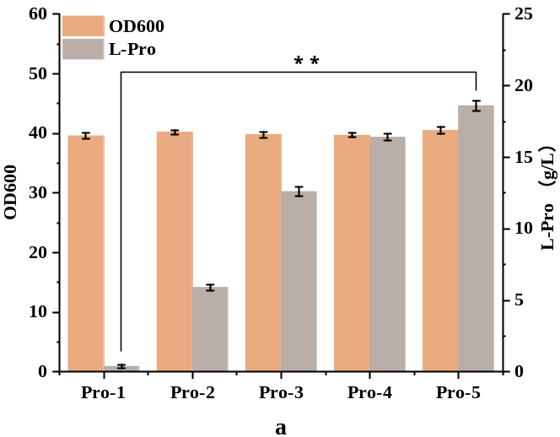
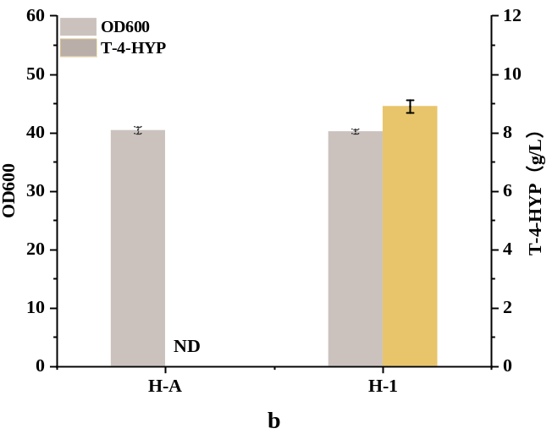
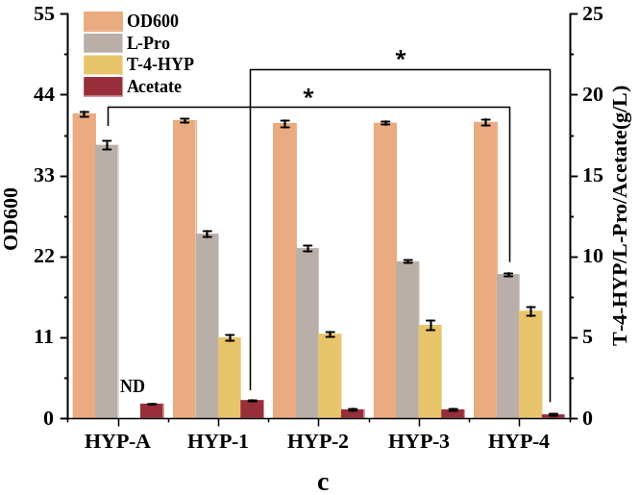

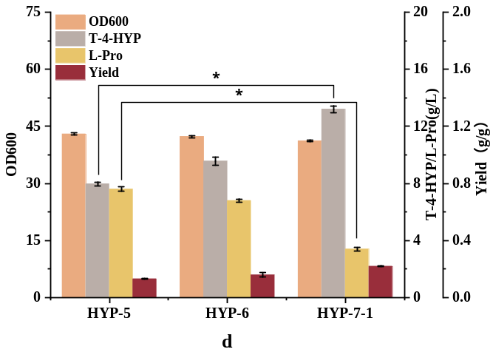
Fig S2. (a) Shake flask fermentation results of strain Pro-1-Pro-5 (b) Effects of T-4-HYP expression elements on T-4-HYaaP fermentation (c) Effects of enrichment precursors on T-4-HYP production, acetate formation, and cell growth. (d) Shake flask fermentation studies of strain HYP-5-HYP-7-1.
The genotype of strains: Pro-1, E. coli W3110，∆putA ;Pro-2, Pro-1 ∆lacI ,yghX::Ptrc- proB*; Pro-3, Pro-2 rpH::Ptrc- proB*; Pro-4, Pro-3 yjiT::Ptrc- proA; Pro-5, Pro-4 yciQ::Ptrc- proC; H-1, E. coli W3110 Ptrc-DaP4H; H-A, E. coli W3110 Ptrc99a; HYP-A, Pro-5 Ptrc99a; HYP-1, Pro-5, Ptrc99a-DaP4H; HYP-2, HYP-1, ∆ldhA; HYP-3, HYP-2, ∆poxB; HYP-4, HYP-3 ∆ackA; HYP-5, HYP-4, ∆aceA;
Data are expressed as mean and error bars are expressed as standard deviation ( n = 3 independent experiments ). * means 0.01 < P < 0.05, * * means P < 0.01.

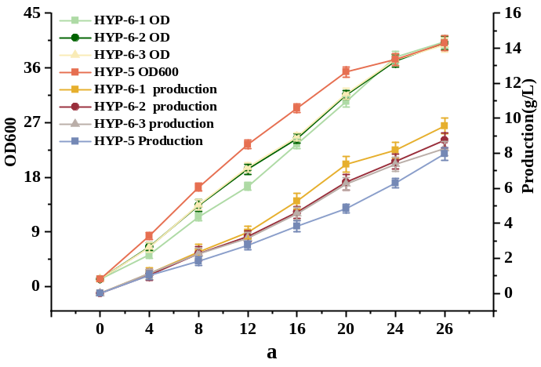
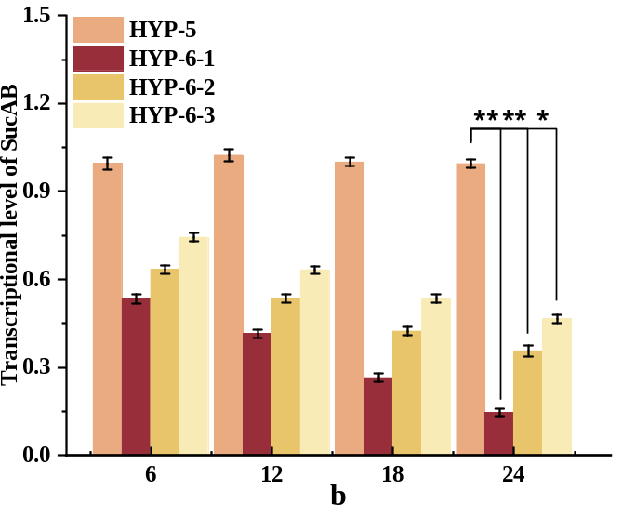
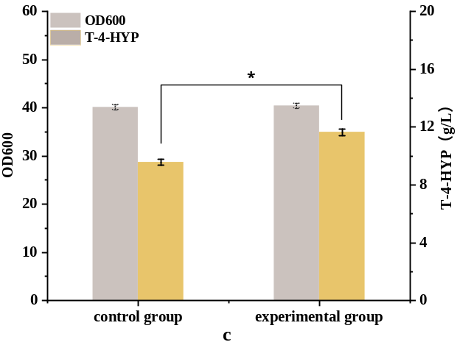
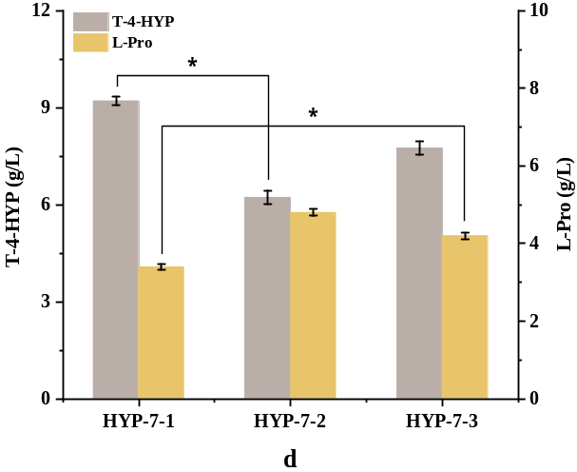
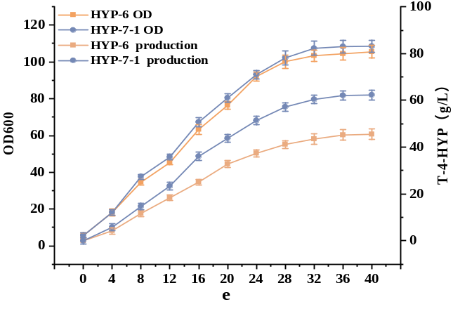

Fig. 3 (a) Effect of SucAB gene controlled by different promoters on T-4-HYP fermentation (b) Relative transcription level of SucAB gene in four strains with different culture times (c) Effect of adding α-ketoglutrate on T-4-HYP fermentation (d) Effect of xfp gene from different sources on T-4-HYP production (e) Comparison of fermentation performance between strains HYP-6 and HYP-7-1.
The genotype of strains: HYP-6-1, HYP-5 PBBa-j23109- SucAB; HYP-6-2, HYP-5 PBBa-j231115- SucAB; HYP-6-3, HYP-5 PBBa-j23114- SucAB; HYP-7-1, HYP-6-1 ycdN::Ptrc- Ba-xfp; HYP-7-2, HYP-6-1 ycdN::Ptrc- Ac-xfp; HYP-7-3, HYP-6-1 ycdN::Ptrc- Bl-xfp
Data are expressed as mean and error bars are expressed as standard deviation (n = 3 independent experiments). * means 0.01 < P < 0.05, * * means P<0.01.

Fig. 4 Fig. 4 The structures of NOG ,EMPand L-pro synthesis pathways; (a)The simplified scheme of non-oxidative glycolysis; ( b ) A simplified EMP ( glycolysis ) scheme ;( c ) L-pro synthesis pathway a : Glucose → 3 acetyl-CoA; b : Glucose → 2 acetyl-CoA + 2 CO₂ ; abbreviations : EMP pathway, Embden − Meyerhof − Parnas ; NOG pathway, non-oxidative glycolysis ; fructose-6-P, Fructose 6-phosphate ;
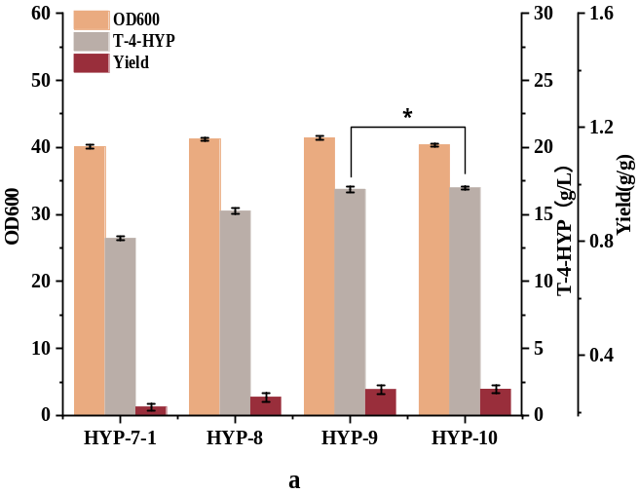
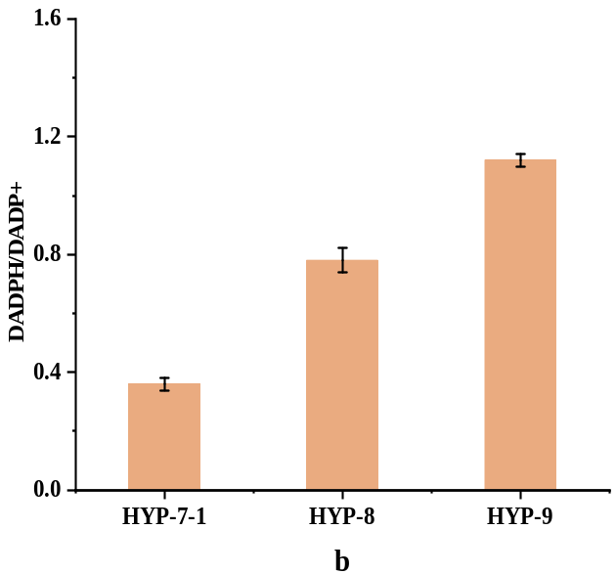

Fig. 5 Shake flask fermentation parameters of strains HYP-7-1, HYP-8, HYP-9, and HYP-10 (a), and Intracellular NAD(P)H/NAD(P) ratio of strains HYP-7-1, HYP-8, and HYP-9 (b). HYP-8, HYP-7-1, Ptrc- PntAB; HYP-9, HYP-8,yjiP::Ptrc- PntAB;
Data are expressed as mean and error bars are expressed as standard deviation (n = 3 independent experiments). * means 0.01 < P < 0.05, * * means P < 0.01.

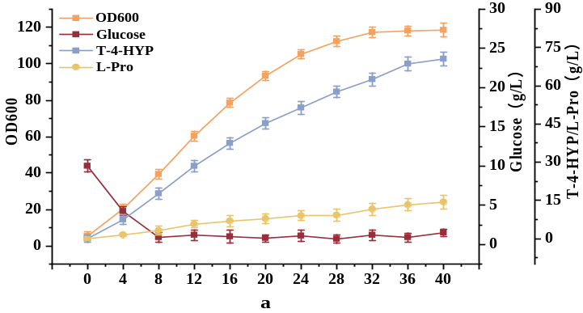
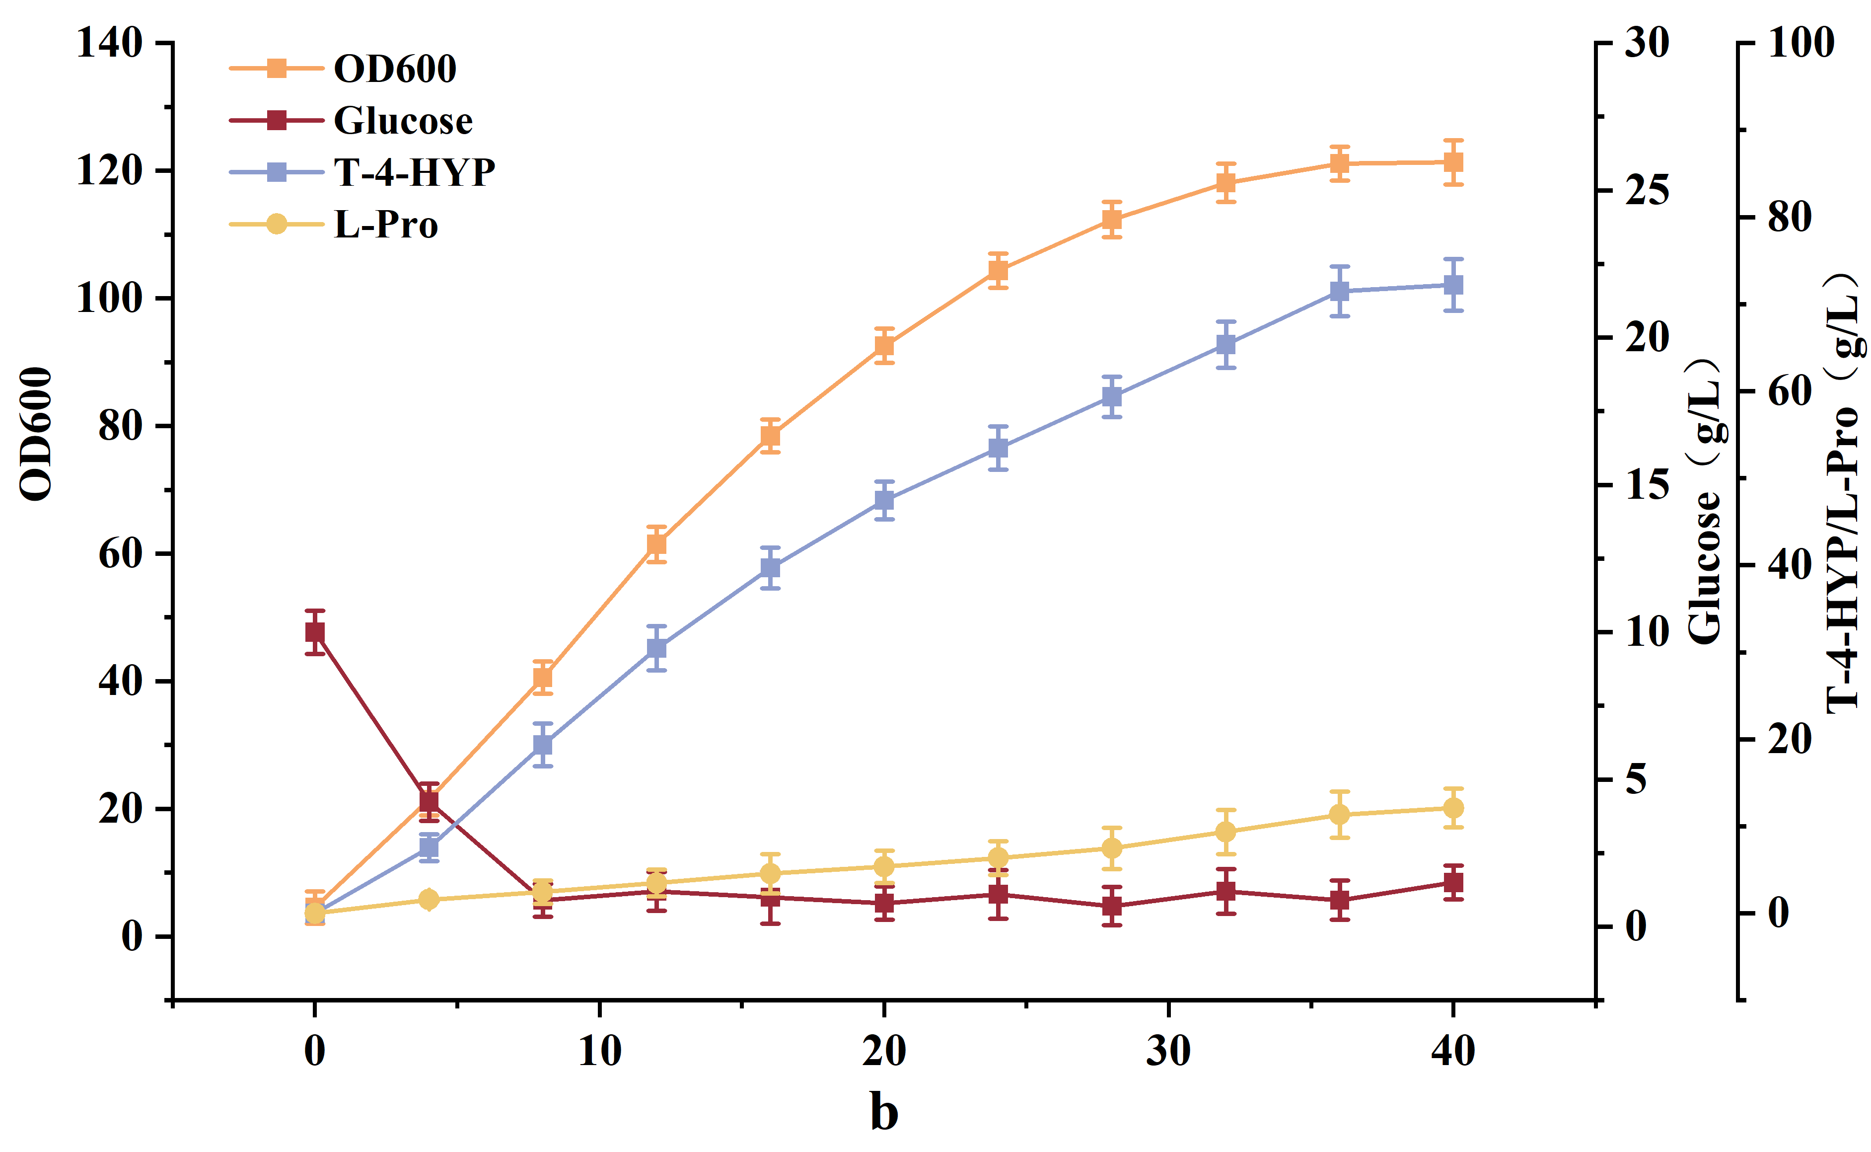
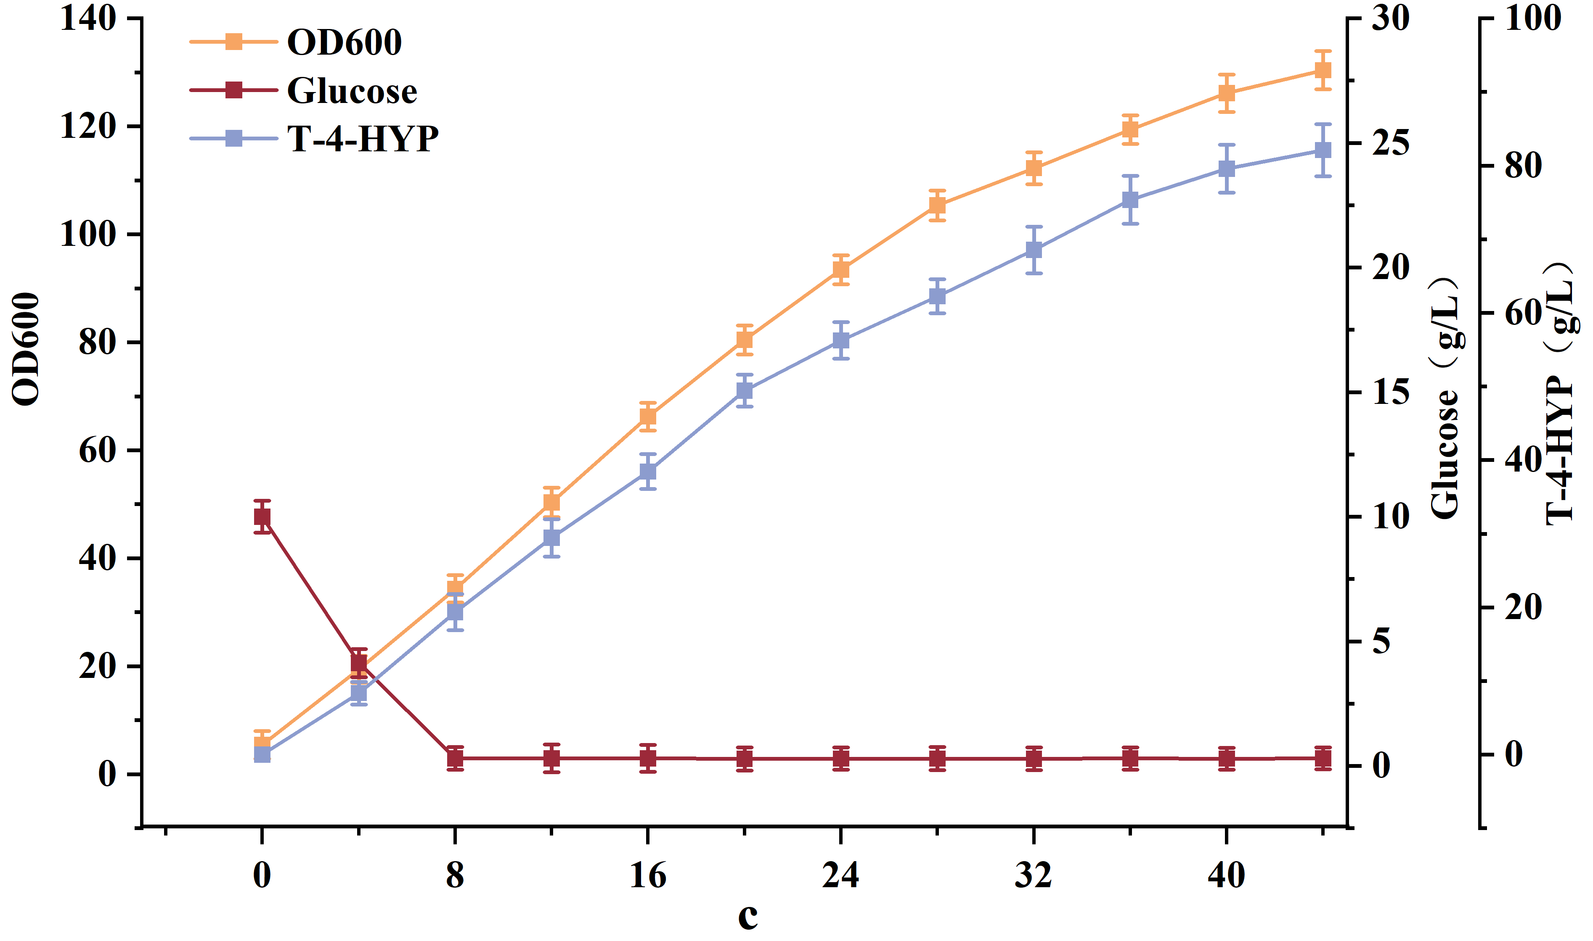

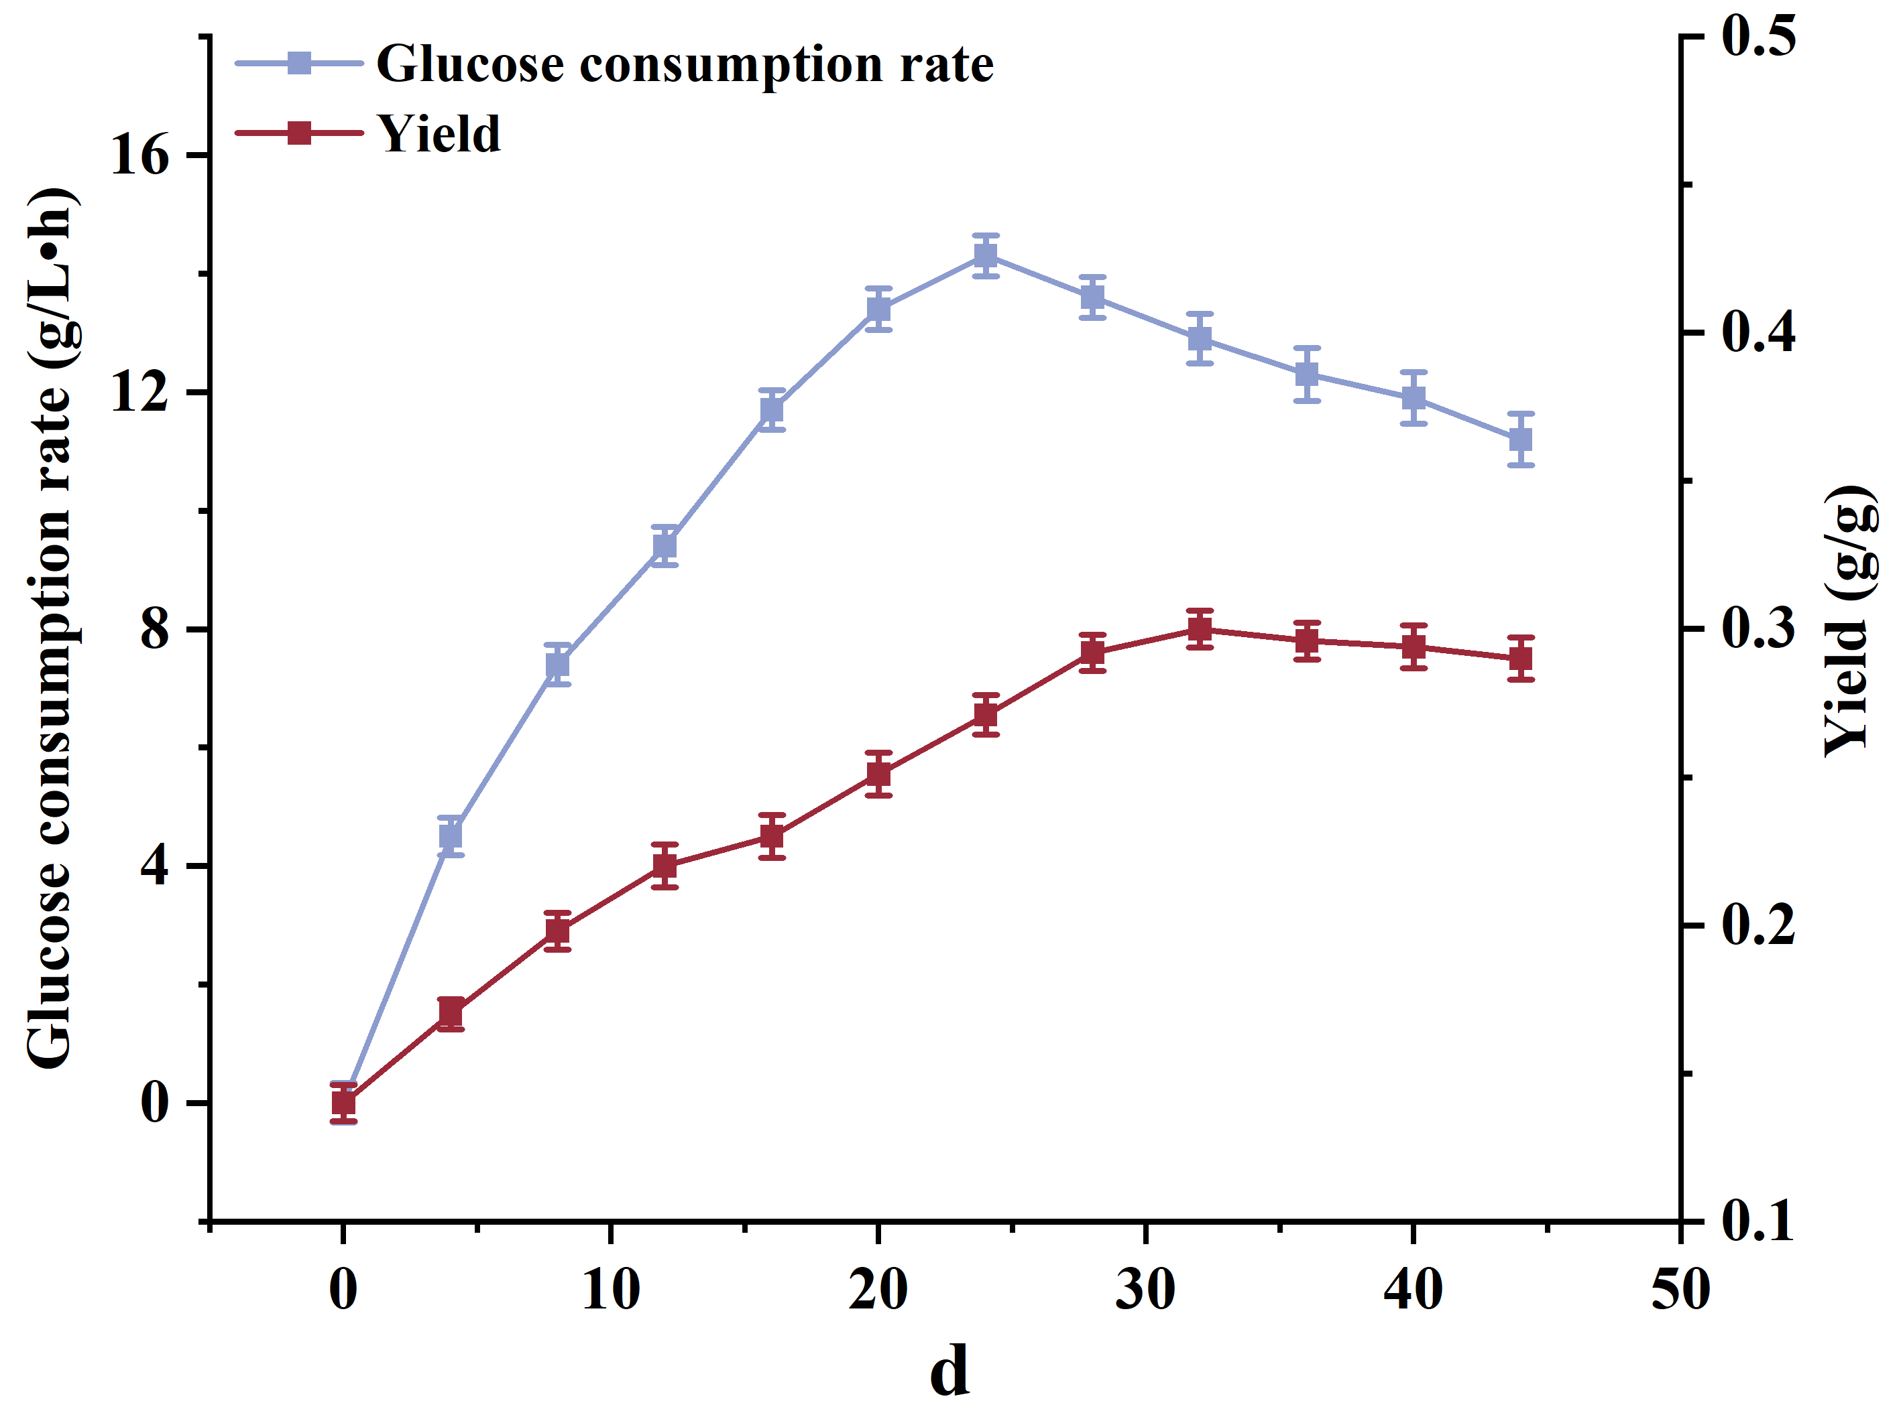
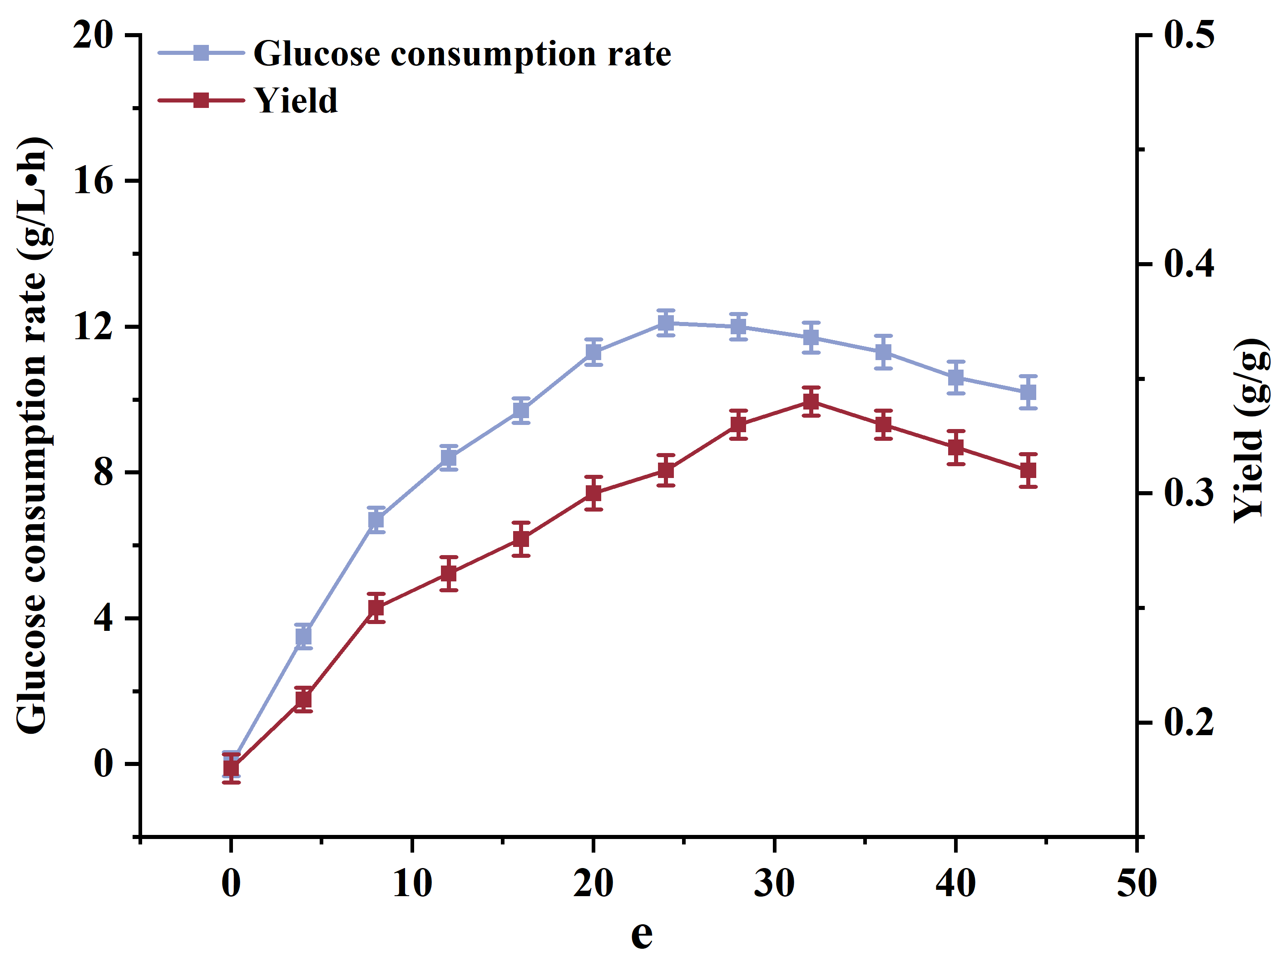
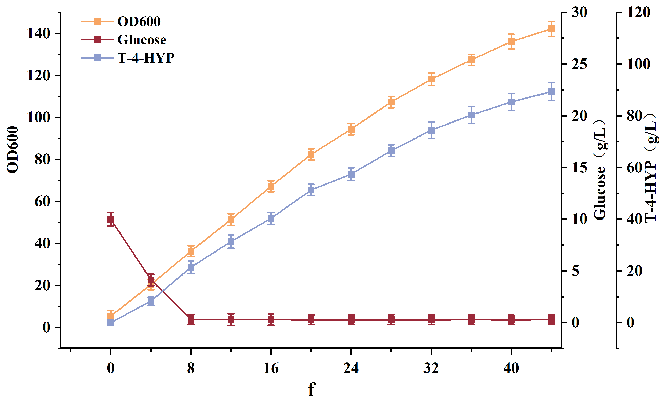

Fig. 6 (a ) The fermentation parameters of strain HYP-9 ; ( b ) Fermentation parameters of strain HYP-10 ; ( c ) Effect of adjusting sugar feeding rate on T-4-HYP fermentation ( d, e ) Effect of adjusting sugar feeding rate on yield ( f ) Effect of continuous feeding of Fe²⁺ on T-4-HYP fermentation.
Data are expressed as mean and error bars are expressed as standard deviation (n = 3 independent experiments). * means 0.01 < P < 0.05, * * means P < 0.01.

