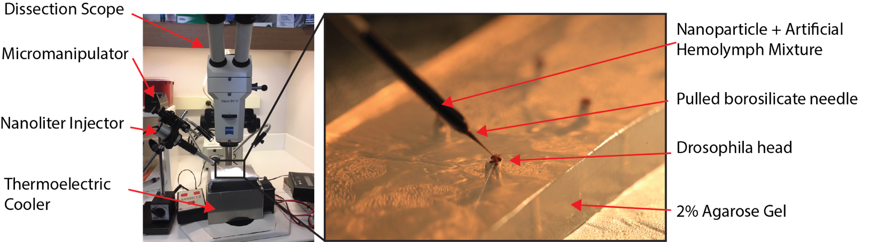

Supplemental Figure S1| Drosophila nanoinjection set up. Left: Macro view of nanoinjection apparatus below a dissection scope. Right: Cold immobilized Drosophila loaded into a 2% Agarose gel for injection between the ocelli.

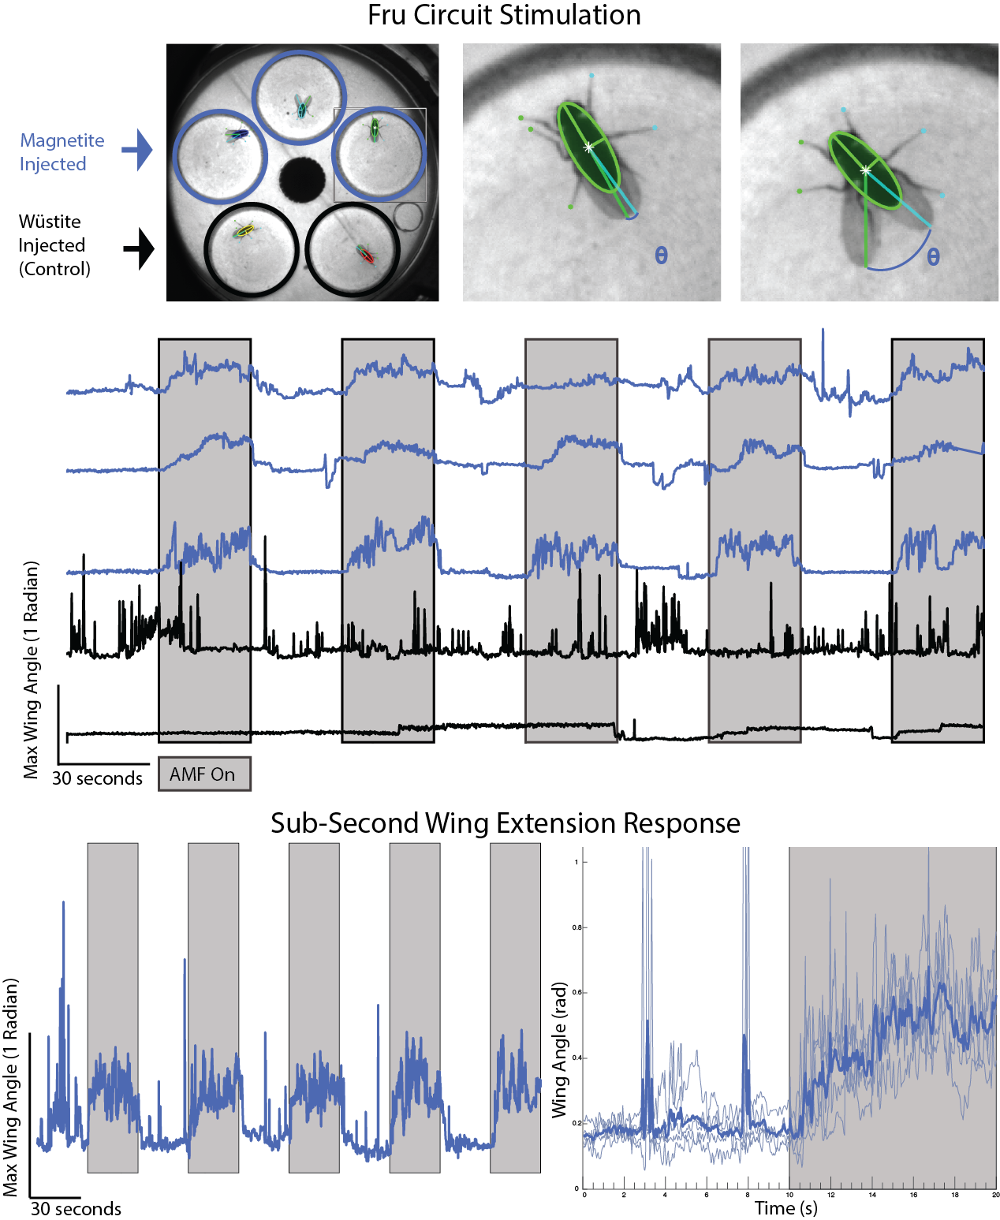
Supplemental Figure S2| TRPA1 magnetogenetics drives fast behavioral responses in freely behaving flies. Top: FlyTracker analysis of fruit fly wing extension. Middle: Traces of wing angle (FlyTracker) when exposed to 30 s pulses of AMF stimulation (10 kA/m; 390 kHz) shows robust response in 19nm magnetite (Fe₃O₄) particle injected flies (blue) with a specific absorption rate 245 W/g when compared to non-heating 19nm wüstite (FeO) injected controls (black). Bottom: Example fly data shows sub-second behavioral wing extension in response to AMF stimulation. All experimental repeats (N=5; thin lines) are averaged (bold line).
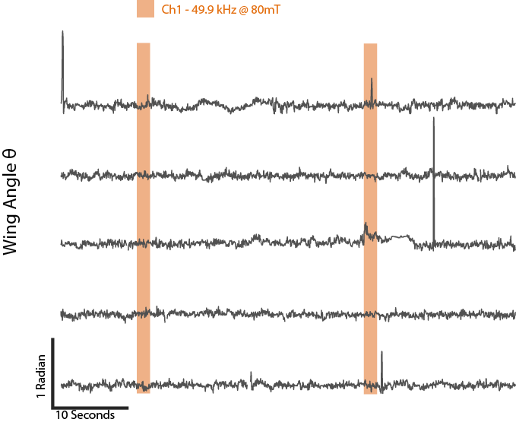

Supplemental Figure S3| Uninjected Control Fly Response to AMF stimulation. Example wing angle measurements quantified using DeepLabCut for 5 uninjected flies expressing TRPA1 in Fru-Gal4 circuit when exposed to alternating magnetic fields for 2 stimulations of 1.8 s (49.9 kHz; 80 mT). No significant wing opening response during AMF is observed.

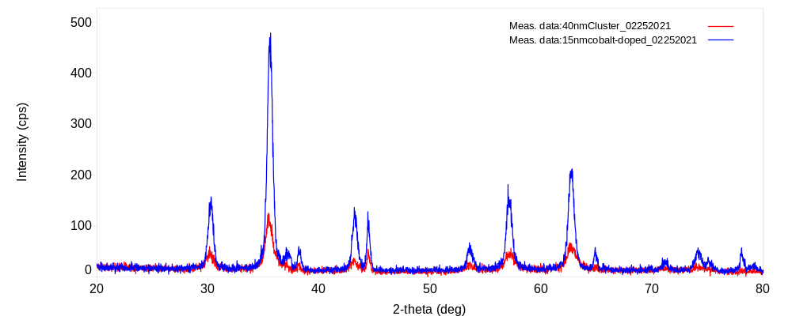
Supplemental Figure S4| XRD analysis of Nanoparticles. Cobalt doped nanoparticles shown in blue and iron oxide nanoclusters shown in red. XRD analysis showed a lattice constant of 8.38305Å for the cobalt-doped nanoparticle and a crystallite size of 14.1nm. Iron oxide nanoclusters had a lattice constant of 8.3432Å.

Supplemental Video S1 | Slow Thermal Ramp of Cobalt Injected Drosophila for Fru circuit stimulation
Left: Shows chamber containing 5 flies expressing TRPA1-A channels from the UAS promoter driven by Fru-GAL4. Stimulation of this circuit results in a wing extension. 15nm Cobalt-doped iron oxide nanoparticles (Fe_{2.35}Co_{0.65}O₄) injected flies are shown within orange circles. Right: DeepLabCut analysis of fruit fly wing extension (θ) shows traces of wing extensions when exposed to 20 second pulses of AMF stimulation (19 mT; 49.9 kHz) shown in orange boxes. The responses are muted because slow ramp stimulation does not efficiently activate the rate sensing TRPA1-channel. The white scrub line shows where the video lines up with the traces. Top to bottom traces correspond to chambers top 3 chambers left to right followed by the bottom 2 chambers left to right.

Supplemental Video S2 | Fast Thermal Ramp of Cobalt Injected Drosophila for Fru circuit stimulation
Left: Shows chamber containing the same 5 flies as in Supplemental Video S1, expressing TRPA1-A channels from the UAS promoter driven by Fru-GAL4. Stimulation of this circuit results in a wing extension. 15nm Cobalt-doped iron oxide nanoparticles (Fe_{2.35}Co_{0.65}O₄) injected flies are shown within orange circles. Right: DeepLabCut analysis of fruit fly wing extension (θ) shows traces of wing extensions when exposed to 1.8 second pulses of AMF stimulation (80 mT; 49.9 kHz) shown in orange boxes. The white scrub line shows where the video lines up with the traces. Top to bottom traces correspond to chambers top 3 chambers left to right followed by the bottom 2 chambers left to right.

Supplemental Video S3 | Drosophila Hb9 circuit stimulation with wüstite injected controls
Shows chamber containing 5 flies expressing TRPA1-A channels from the UAS promoter driven by Hb9-GAL4. Stimulation of this circuit results in side-to-side movement. 19nm magnetite (Fe₃O₄) injected flies are shown within blue circles. 19nm wüstite (FeO – non-heating control nanoparticles) injected flies are shown within black circles. Positions of the flies were tracked with FlyTracker and overlaid on top of the flies showing the previous 10 seconds of fly movement during the video. Flies are exposed to a single 30 second pulse of the alternating magnetic field (40 kA/m or ~50mT; 380 kHz).

Supplemental Video S4 | Multiplexed Drosophila Fru circuit stimulation
Left: Shows chamber containing 5 flies expressing TRPA1-A channels from the UAS promoter driven by Fru-GAL4. Stimulation of this circuit results in a wing extension. 15nm Cobalt-doped iron oxide nanoparticles (Fe_{2.35}Co_{0.65}O₄) injected flies are shown within orange circles and 40nm iron oxide nanocluster (Fe₃O₄) injected flies are shown in blue circles. Right: DeepLabCut analysis of fruit fly wing extension (θ) shows traces of wing extensions when exposed to 3 second pulses of AMF stimulation for channel 1 (80 mT; 49.9 kHz) shown in orange boxes and stimulation for channel 2 (12 mT; 555 kHz) shown in blue boxes. The white scrub line shows where the video lines up with the traces. Top to bottom orange traces correspond to chambers top 3 chambers left to right followed by the bottom 2 chambers left to right.

