Table S1: A total of 24 potential contaminants were identified from extraction blanks (n=14; 0.09% of total reads) and PCR negative controls (n=10; 0.87% of total reads) using the prevalence method in the R package decontam (Davis, et al., 2018). The relative abundance (%) of each ASV in the full dataset prior to their removal is reported in the last column.
ASV | Source | Phylum | Family | Genus | Rel Abund (%)
Contam01 | PCR | Proteobacteria | Halomonadaceae | Halomonas | 0.37
Contam02 | PCR | Proteobacteria | Halomonadaceae | Halomonas | 0.23
Contam03 | PCR | Proteobacteria | Moraxellaceae | Acinetobacter | 0.05
Contam04 | PCR | Proteobacteria | Moraxellaceae | Acinetobacter | 0.04
Contam05 | PCR | Proteobacteria | Erwiniaceae | Pantoea | 0.01
Contam06 | PCR | Proteobacteria | Pseudomonadaceae | Pseudomonas | 0.002
Contam07 | PCR | Proteobacteria | Pseudomonadaceae | Pseudomonas | 0.05
Contam08 | PCR | Actinobacteriota | Nocardiaceae | Rhodococcus | 0.05
Contam09 | PCR | Proteobacteria | Sphingomonadaceae | Sphingomonas | 0.0003
Contam10 | PCR | Firmicutes | Staphylococcaceae | Staphylococcus | 0.07
Contam11 | Extraction | Firmicutes | Butyricicoccaceae | UCG-008 | 1E-05
Contam12 | Extraction | Proteobacteria | Moraxellaceae | Acinetobacter | 0.009
Contam13 | Extraction | Proteobacteria | Erwiniaceae | Pantoea | 0.003
Contam14 | Extraction | Proteobacteria | Pseudomonadaceae | Pseudomonas | 0.0003
Contam15 | Extraction | Proteobacteria | Pseudomonadaceae | Pseudomonas | 0.02
Contam16 | Extraction | Bacteroidota | Prevotellaceae | Prevotella | 0.0002
Contam17 | Extraction | Proteobacteria | Sphingomonadaceae | Unknown Sphingomonadaceae | 0.02
Contam18 | Extraction | Proteobacteria | Sphingomonadaceae | Sphingomonas | 0.01
Contam19 | Extraction | Proteobacteria | Sphingomonadaceae | Sphingomonas | 0.0007
Contam20 | Extraction | Proteobacteria | Xanthobacteraceae | Bradyrhizobium | 0.0004
Contam21 | Extraction | Proteobacteria | Beijerinckiaceae | Methylobacterium | 0.02
Contam22 | Extraction | Proteobacteria | Beijerinckiaceae | Methylobacterium | 0.0003
Contam23 | Extraction | Proteobacteria | Rhodobacteraceae | Paracoccus | 9E-05
Contam24 | Extraction | Firmicutes | Peptostreptococcales-Tissierellales | Peptoniphilus | 0.0009

Table S2: Taxonomic classification based on the Silva v138 database (Phylum, Family, Genus) and NCBI database (BLASTn) of the 20 most abundant ASVs (Top20), core taxa, and ASVs identified in the indicator species analysis for male and female echidna fecal samples. Where an ASV was identified in both male and female samples, the Gender is listed as Both. The average relative abundance (%) of each ASV in male and female samples is shown in the last two columns.
ASV | Analysis | Gender | Phylum | Family | Genus | BLASTn Top Hit | Rel Abund (%) in Males | Rel Abund (%) in Females
ASV001 | Top20/Core Taxa | Both | Fusobacteriota | Fusobacteriaceae | Fusobacterium | F. mortiferum | 10.07 | 8.96
ASV002 | Top20/Core Taxa | Both | Bacteroidota | Bacteroidaceae | Bacteroides | B. massiliensis | 6.91 | 6.41
ASV003 | Top20/Core Taxa | Both | Bacteroidota | Bacteroidaceae | Bacteroides | B. dorei | 4.17 | 7.73
ASV004 | Top20/Core Taxa | Both | Proteobacteria | Enterobacteriaceae | Escherichia-Shigella | Pseudescherichia vulneris | 4.11 | 2.54
ASV005 | Top20/Core Taxa | Both | Firmicutes | Lactobacillaceae | Lactobacillus | L. agilis | 2.63 | 1.93
ASV006 | Top20/Core Taxa | Both | Bacteroidota | Bacteroidaceae | Bacteroides | B. dorei | 1.26 | 2.48
ASV007 | Top20/Core Taxa | Both | Fusobacteriota | Fusobacteriaceae | Fusobacterium | F. mortiferum | 1.61 | 2.00
ASV008 | Top20/Core Taxa | Both | Bacteroidota | Bacteroidaceae | Bacteroides | B. thetaiotaomicron | 1.77 | 2.02
ASV009 | Top20/Core Taxa | Female | Bacteroidota | Bacteroidaceae | Bacteroides | B. acidifaciens | 0.86 | 1.87
ASV010 | Top20/Core Taxa | Both | Proteobacteria | Morganellaceae | Proteus | P. mirabilis | 1.04 | 2.38
ASV011 | Top20/Core Taxa | Female | Fusobacteriota | Fusobacteriaceae | Fusobacterium | F. perfoetens | 0.58 | 1.73
ASV012 | Top20/Core Taxa | Both | Proteobacteria | Enterobacteriaceae | Unknown Enterobacteriaceae | Enterobacter hormaechei | 2.54 | 1.37
ASV013 | Top20/Core Taxa | Both | Firmicutes | Peptostreptococcaceae | Peptoclostridium | Clostridium hiranonis | 1.53 | 1.60
ASV014 | Top20/Core Taxa | Both | Bacteroidota | Bacteroidaceae | Bacteroides | B. timonensis | 1.47 | 1.27
ASV015 | Top20 | Male | Fusobacteriota | Fusobacteriaceae | Cetobacterium | C. somerae | 4.40 | 0.57
ASV016 | Top20/Core Taxa | Female | Firmicutes | Lachnospiraceae | Blautia | Blautia schinkii | 0.34 | 1.22
ASV017 | Top20 | Female | Proteobacteria | Enterobacteriaceae | Unknown Enterobacteriaceae | Citrobacter freundii | 0.52 | 1.33
ASV018 | Top20/Core Taxa | Both | Firmicutes | Acidaminococcaceae | Phascolarctobacterium | P. faecium | 0.87 | 1.03
ASV019 | Top20/Core Taxa | Both | Firmicutes | Lactobacillaceae | Lactobacillus | L. gasseri | 2.05 | 0.99
ASV020 | Top20 | Female | Proteobacteria | Morganellaceae | Providencia | P. vermicola | 0.30 | 1.10
ASV021 | Top20/Core Taxa | Female | Bacteroidota | Tannerellaceae | Parabacteroides | P. distasonis | 0.65 | 0.84
ASV022 | Top20 | Male | Firmicutes | Streptococcaceae | Streptococcus | S. equinus | 0.92 | 1.05
ASV023 | Top20/Core Taxa | Male | Bacteroidota | Bacteroidaceae | Bacteroides | B. rodentium | 0.96 | 0.58
ASV024 | Top20/Indicator Species | Male | Firmicutes | Lactobacillaceae | Lactobacillus | L. gallinarum | 1.48 | 0.58
ASV025 | Top20 | Male | Firmicutes | Lactobacillaceae | Lactobacillus | L. reuteri | 1.01 | 0.37
ASV026 | Top20 | Male | Bacteroidota | Bacteroidaceae | Bacteroides | B. clarus | 0.46 | 0.22
ASV027 | Core Taxa | Both | Firmicutes | Butyricicoccaceae | Butyricicoccus | B. pullicaecorum | 0.20 | 0.21
ASV028 | Core Taxa | Both | Desulfobacterota | Desulfovibrionaceae | Desulfovibrio | D. piger | 0.19 | 0.21
ASV029 | Core Taxa | Both | Proteobacteria | Sutterellaceae | Parasutterella | P. secunda | 0.25 | 0.30
ASV030 | Core Taxa | Male | Bacteroidota | Bacteroidaceae | Bacteroides | B. faecichinchillae | 0.17 | 0.35
ASV031 | Core Taxa | Both | Bacteroidota | Bacteroidaceae | Bacteroides | B. luti | 0.11 | 0.34
ASV032 | Core Taxa | Male | Firmicutes | Lachnospiraceae | Unknown Lachnospiraceae | Clostridium methoxybenzovorans | 0.40 | 0.77
ASV033 | Core Taxa | Both | Firmicutes | Lachnospiraceae | Unknown Lachnospiraceae | Faecalimonas umbilicata | 0.47 | 0.77
ASV034 | Core Taxa | Both | Firmicutes | Erysipelatoclostridiaceae | Erysipelatoclostridium | Clostridium saccharogumia | 0.51 | 0.33
ASV035 | Core Taxa | Male | Firmicutes | Lactobacillaceae | Lactobacillus | L. musae | 0.50 | 0.52
ASV036 | Core Taxa | Both | Firmicutes | Lachnospiraceae | Lachnoclostridium | Enterocloster clostridioformis | 0.29 | 0.30
ASV037 | Core Taxa | Both | Bacteroidota | Barnesiellaceae | Barnesiella | Coprobacter fastidiosus | 0.61 | 0.38
ASV038 | Core Taxa | Both | Firmicutes | Erysipelotrichaceae | Dielma | D. fastidiosa | 0.17 | 0.17
ASV039 | Core Taxa | Male | Firmicutes | Unknown Lactobacillales | Unknown Lactobacillales | Enterococcus sulfureus | 0.49 | 0.53
ASV040 | Indicator Species | Male | Bacteroidota | Bacteroidaceae | Bacteroides | B. sartorii | 0.70 | 0.30

Davis, N.M., Proctor, D.M., Holmes, S.P., Relman, D.A., and Callahan, B.J. (2018) Simple statistical identification and removal of contaminant sequences in marker-gene and metagenomics data, Microbiome 6: 226.

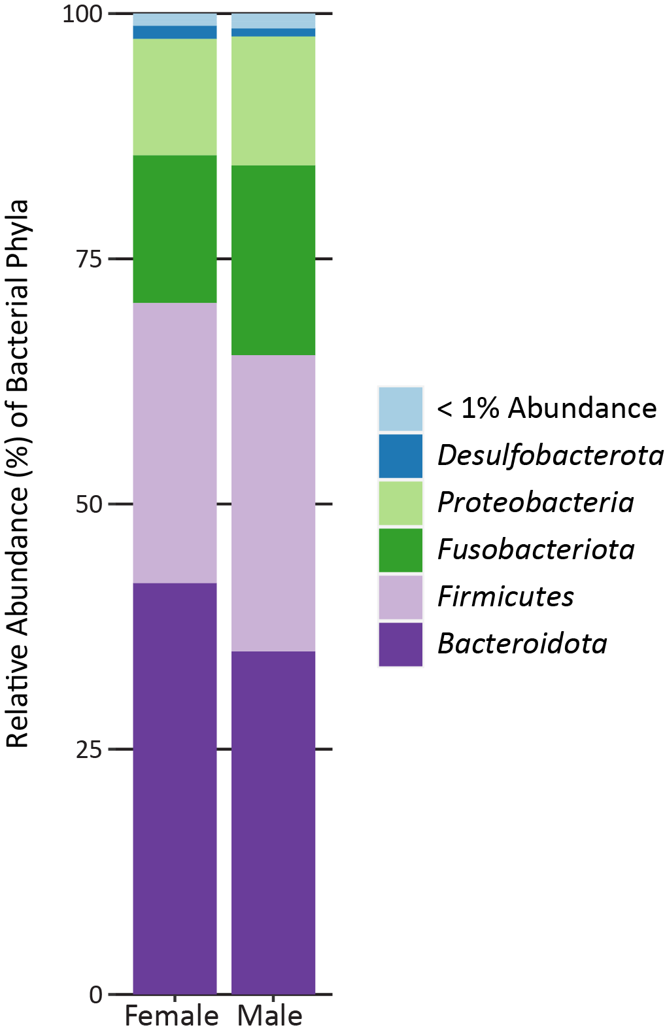
Figure S1: Relative abundance of bacterial phyla for captive echidna by sex. Phyla whose relative abundance was less than 1% were pooled into the “< 1% Abundance” category.
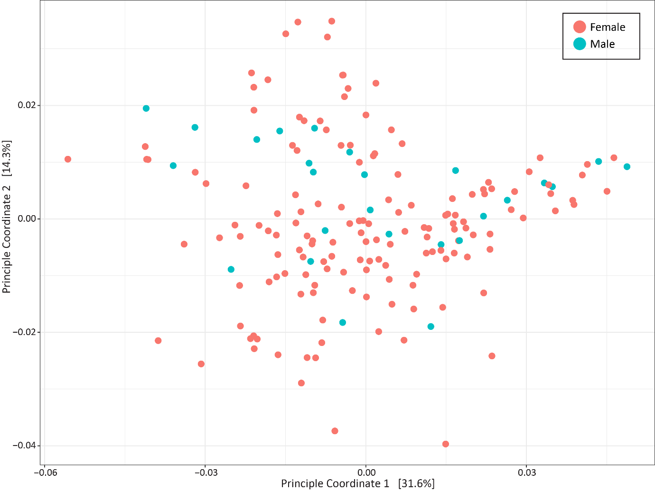
Figure S2: Weighted unifrac PCoA. All samples by sex.

