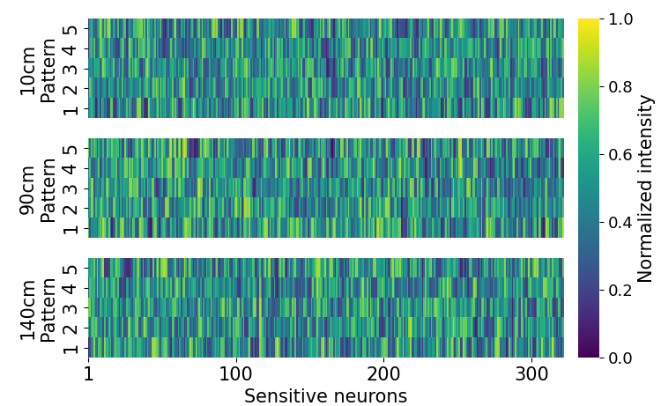
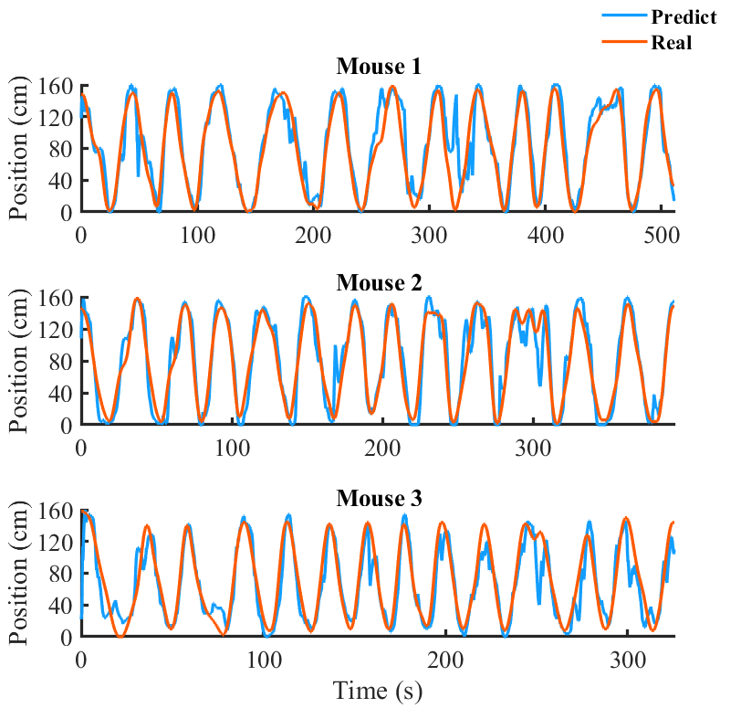
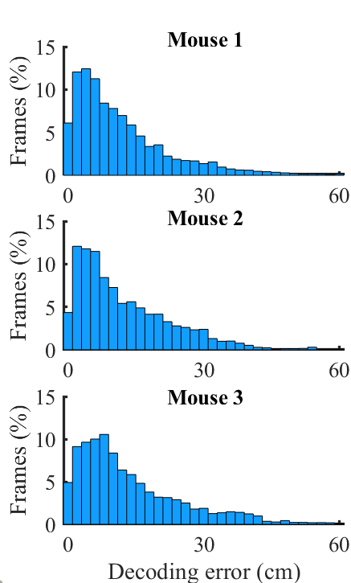
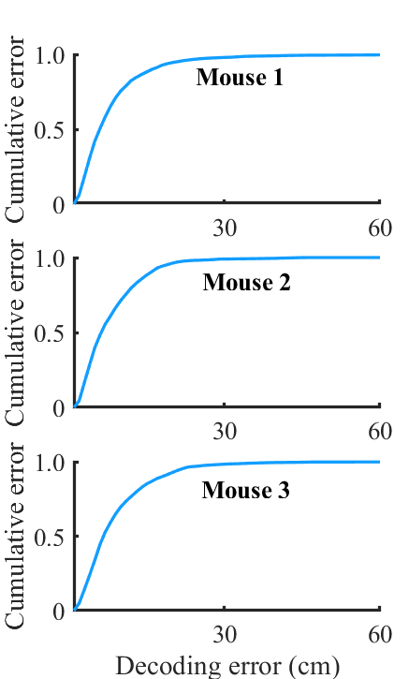
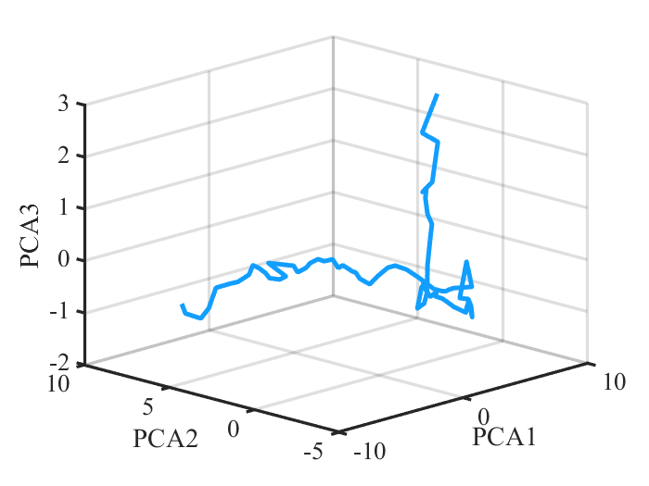
(a)
(e)
(c)
(d)
(b)

Supplementary Figure 1. Position reconstruction experiment. (a) Examples of the firing patterns of sensitive neurons in linear track experiments. (b) The neuronal ensemble activity of a mouse running in a linear track described in a high-dimensional neural state space. Features were extracted from the output of the last hidden layer in an MLP neural network model. Principle component analysis (PCA) was applied to features for better visualization. (c, d) Histogram and the cumulative fraction of the decoding error in the real-time session. The decoding model with the best performance in the training session was implemented in each mouse respectively. (e) The running trajectory reconstruction of a mouse in the real-time session. The red curve demonstrates the real position of a mouse tracked by the video camera and the blue curve represents the reconstructed position.

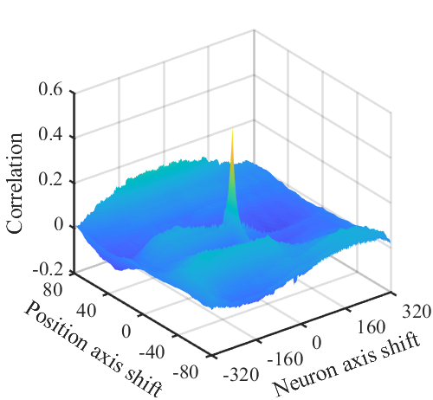
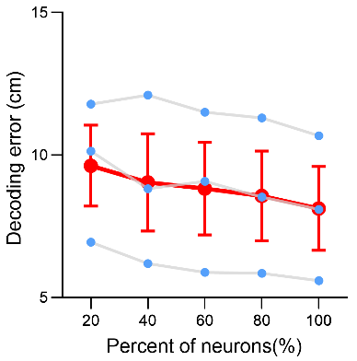
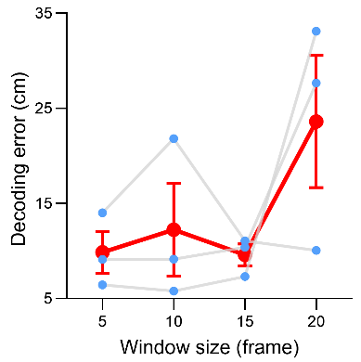
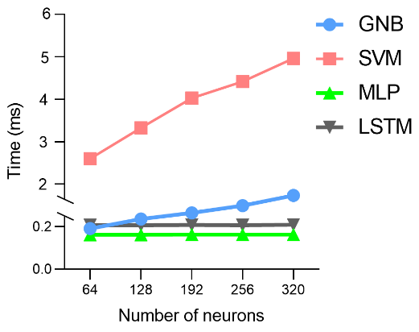
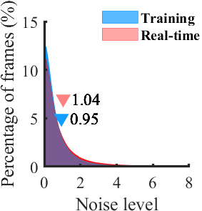
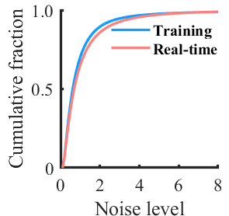
(a)
(b)
(c)
(d)
(f)
(e)

Supplementary Figure 2. Position reconstruction decoding models. (a, b) Histogram and the cumulative fraction of the noise level in the training session and real-time session (paired Student’s t-test did not show significant differences: t=0.04121, df=79, p = 0.9672). (c) Cross-correlation of place field maps between the training session and real-time session. (d) Position reconstruction error as a function of the time window size using the LSTM model. Blue dots represent the decoding error measured in three mice, and the red dots represent the mean error (Pearson correlation, $R^{2}$= 0.5646, p = 0.2486). (e) Position reconstruction error as a function of the percentage of sampled neurons using the MLP model. Error decreased by incorporating more neurons (Pearson correlation, $R^{2}$= 0.9716, p = 0.002). (f) Processing time as a function of the number of sampled neurons in a mouse using different models (Pearson correlation, GNB: $R^{2}$= 0.9926, p = 0.0003; SVM: $R^{2}$= 0.9876, p = 0.0006; MLP: $R^{2}$= 0.7701, p = 0.0505; LSTM: $R^{2}$= 0.5103, p = 0.1752).

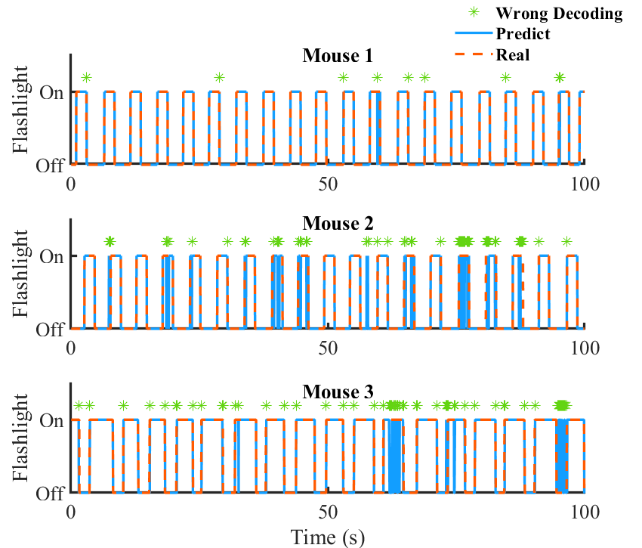
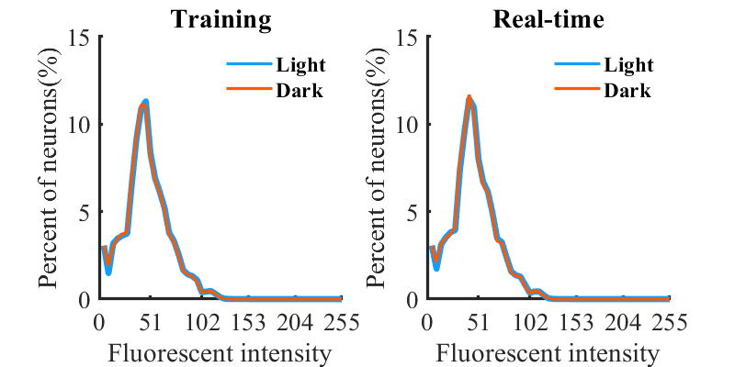
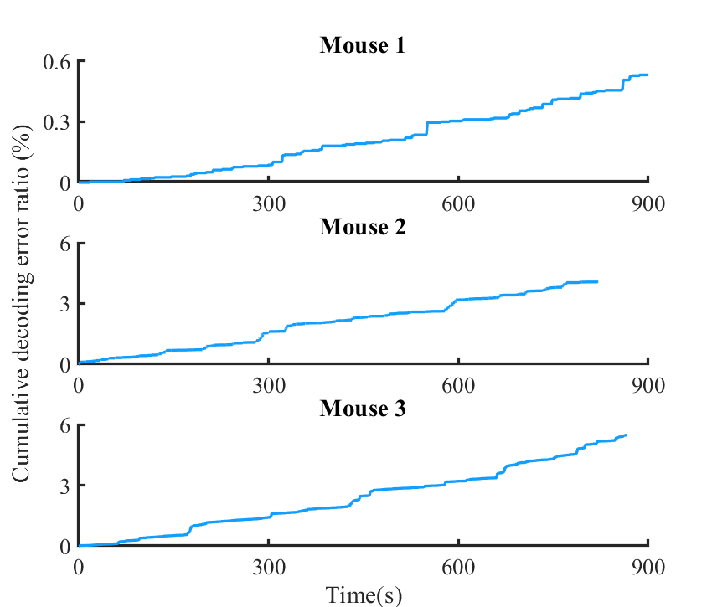
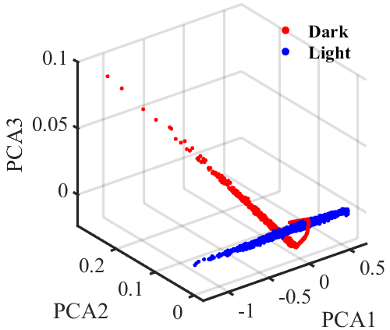
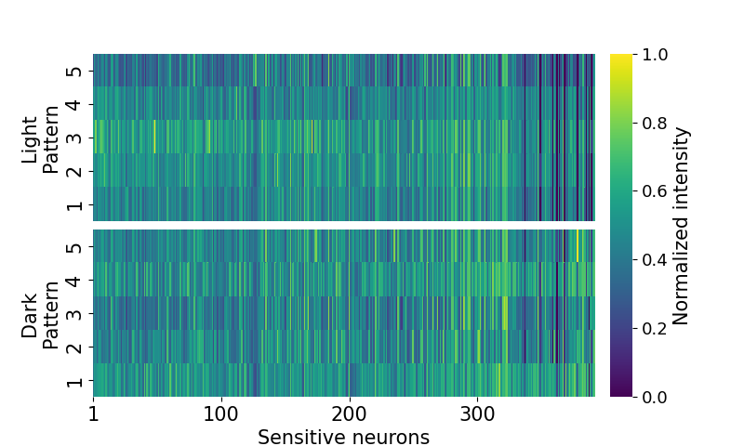
(c)
(a)
(b)
(d)
(e)

Supplementary Figure 3. Visual stimuli identification experiment. (a) Distributions of neurons’ fluorescent intensity. Paired Student’s t-test didn’t show significant differences (Training: t=
$4.403×{10}^{-14}$, df=51, p > 0.9999; Real-time: t=$9.703×{10}^{-14}$, df=51, p > 0.9999). (b) Examples of the firing patterns of sensitive neurons in visual stimuli experiments. (c) Visual stimuli responses described in a high-dimensional neural state space. Features were extracted from the output of the last hidden layer in an MLP neural network model. Principle component analysis (PCA) was applied to features for better visualization. (d) Examples of the decoding performance in the real-time session (100×30 frames). The decoder with the best performance in the training session was used in each mouse respectively. The red dashed line and solid blue line represent the real and predicted status of the auditory stimuli respectively. The wrong decoding frame is marked with a green star. (e) Cumulative decoding error ratio with respect to time.

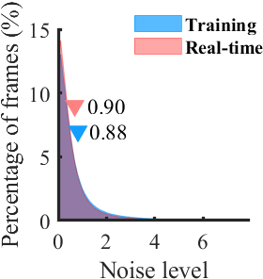
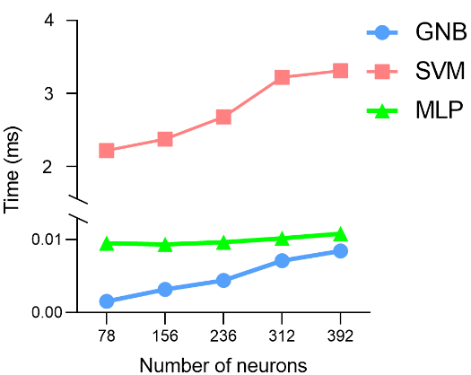
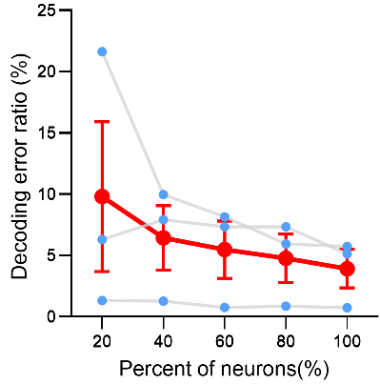
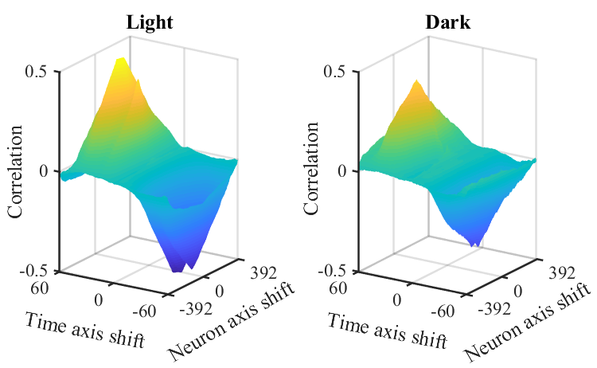
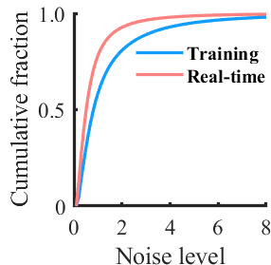
(a)
(e)
(d)
(c)
(b)

Supplementary Figure 4. Visual stimuli decoding models. (a, b) Histogram and the cumulative fraction of the noise level in the training session and real-time session (paired Student’s t-test did not show significant differences: t=0.1362, df=79, p = 0.8920). (c) Cross-correlation of firing rate maps between the training session and real-time session in light and dark environments. (d) Decoding error as a function of the percentage of sampled neurons using the MLP model. Blue dots represent the decoding error measured on three mice, and the red dots represent the mean error. Error decreased considering more neurons (Pearson correlation, $R^{2}$= 0.8702, p = 0.0207). (e) Processing time as a function of the number of sampled neurons in a mouse using different models (Pearson correlation, GNB: $R^{2}$= 0.9853, p = 0.0008; SVM: $R^{2}$= 0.9523, p = 0.0045; MLP: $R^{2}$= 0.8162, p = 0.0355).

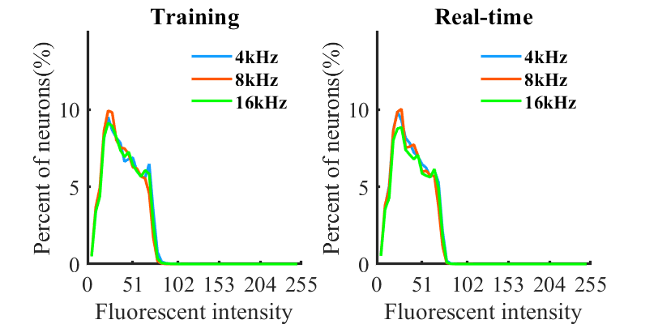
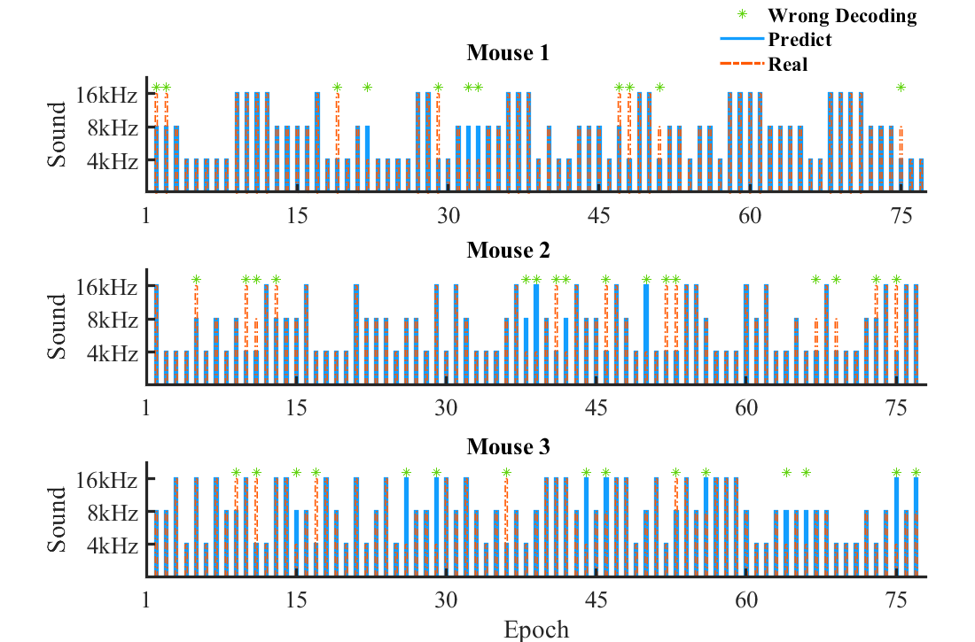
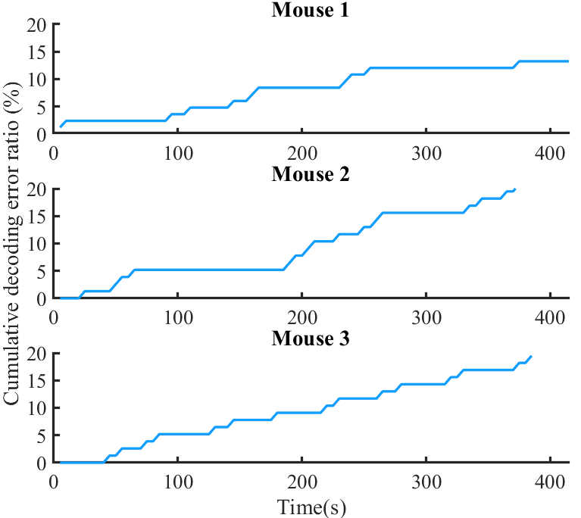
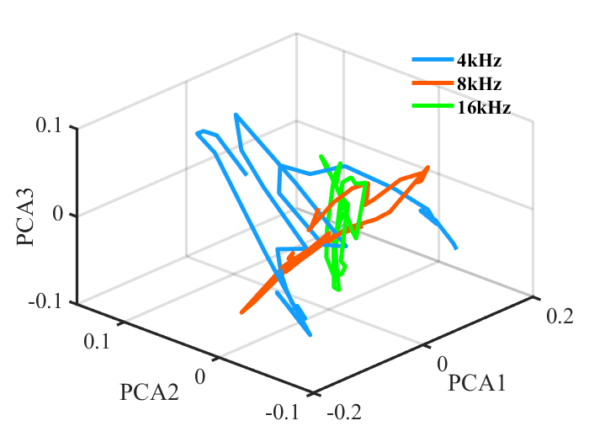
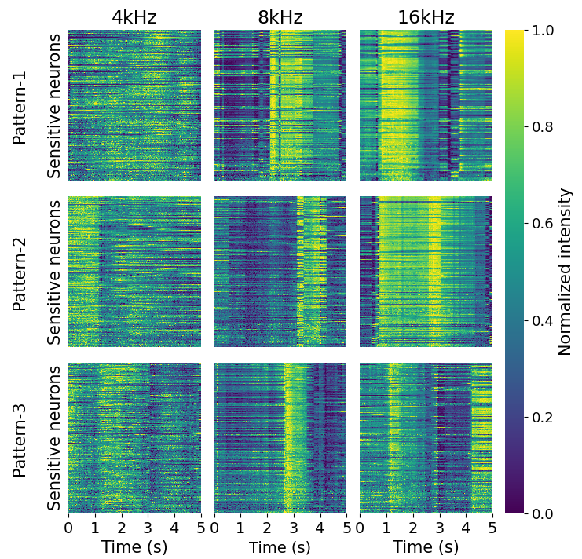
(a)
(c)
(b)
(d)
(e)

Supplementary Figure 5. Auditory stimuli identification experiment. (a) Distributions of neuronal fluorescent intensity. One-way ANOVA did not show significant differences (Training: F(2,102)=0.4342, p =0.6490; Real-time: F(2,102)=2.853, p =0.0623). (b) Examples of the firing patterns of sensitive neurons in auditory stimuli experiments. (c) Auditory stimuli responses described in a high-dimensional neural state space. Features were extracted from the output of the last hidden layer in a CNN model. Principle component analysis (PCA) was applied to features for better visualization. (d) Examples of the decoding performance using the CNN model in the real-time session. The red dashed line and solid blue line represent the real and predicted status of the auditory stimuli respectively. The wrong decoding frame is marked with a green star. (e) decoding error ratio with respect to time.

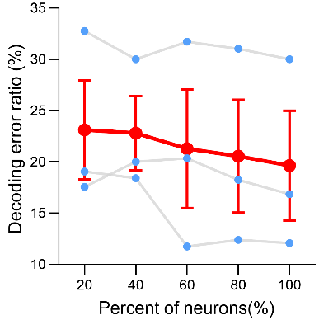
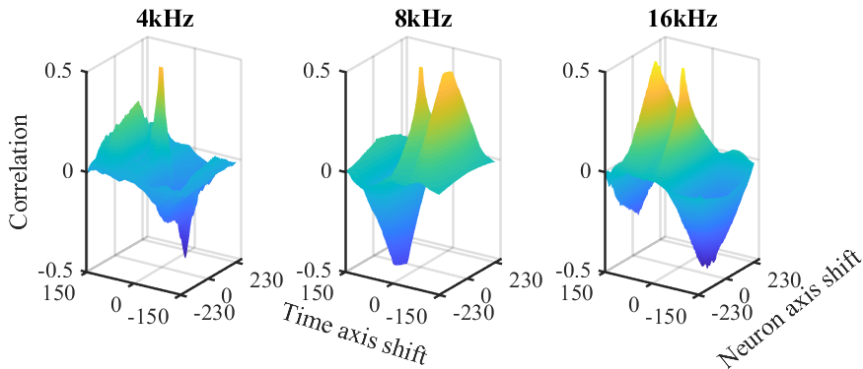
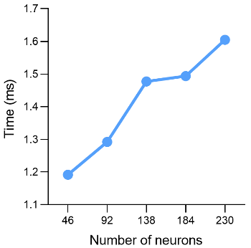
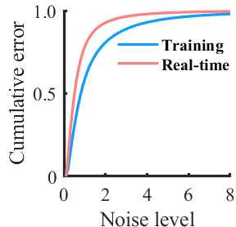
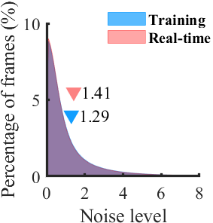
(d)
(e)
(c)
(b)
(a)

Supplementary Figure 6. Auditory stimuli decoding models. (a, b) Histogram and the cumulative fraction of the noise level in the training session and real-time session (paired Student’s t-test did not show significant differences: t=1.226, df=79, p = 0.2238). (c) Cross-correlation of firing rate maps between the training session and real-time session in three environments. (d) Decoding error as a function of the percentage of sampled neurons using the CNN model. Blue dots represent the decoding error measured on three mice, and the red dots represent the mean error. Error decreased considering more neurons (Pearson correlation, $R^{2}$= 0.9717, p = 0.002). (e) Processing time as a function of the number of sampled neurons in a mouse using the CNN model (Pearson correlation, GNB: $R^{2}$= 0.9518, p = 0.0046).

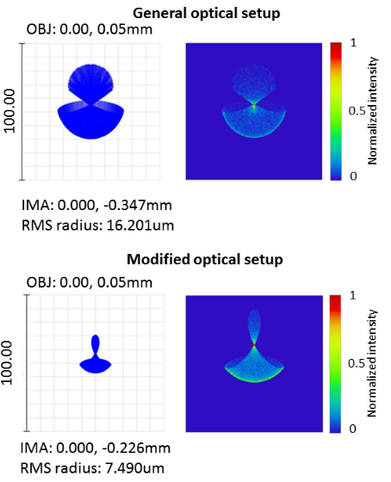
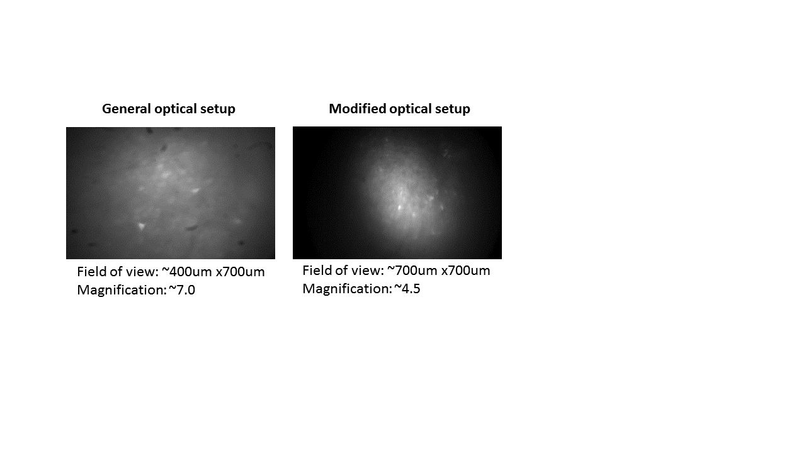
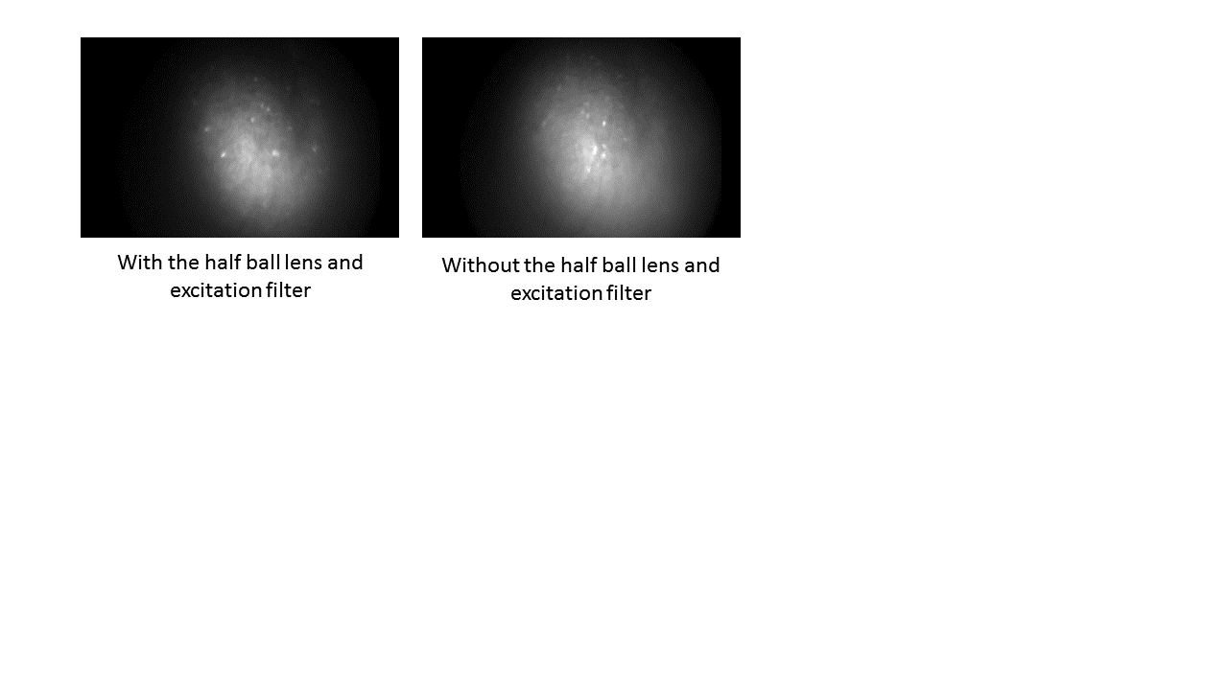
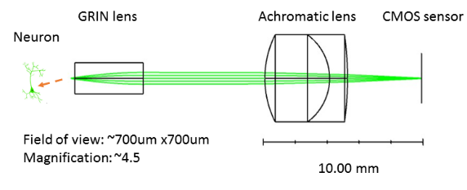
(c)
(a)
(b)
(d)

Supplementary Figure 7. Simulation and imaging of hippocampal CA1 neurons in freely behaving mice. (a) Zemax simulation of emission path of our modified optical system. (b) The spot diagram and normalized intensity distribution are shown for an object located at (0.00mm, 0.05mm). (c) The modified optical system has a smaller magnification in comparison to the conventional one and provides a larger field of view. (d) Imaging with/without a half ball lens and an excitation filter shows similar imaging quality.

 | Mouse_1 | Mouse_2 | Mouse_3 | All (cm/frame)
  Decoder |  | mean
  Decoder |  | median
GNB | 17.76  12 | 20.00  14 | 30.60  22 | 22.79 ± 3.42  16.00 ± 2.64
svm | 10.45  8 | 16.42  12 | 13.06  10 | 13.31 ± 1.49  10.00 ± 1.00
mlp | 10.29  8 | 16.24  12 | 16.98  14 | 14.50 ± 1.83  11.33 ± 1.52
lstm | 11.16  10 | 17.13  12 | 16.44  14 | 14.91 ± 1.63  12.00 ± 1.00
Supplementary Table 1. The mean and median decoding error (cm/frame) in the training session of the position reconstruction experiment. The first row in each cell represents the mean error and the second row represents the median error. The overall error is expressed as mean/median ± standard error mean (SEM).

 | Mouse_1 | Mouse_2 | Mouse_3 | All
  Decoder
GNB | 22.95% | 34.28% | 4.40% | 20.54% ± 8.70%
svm | 3.99% | 4.01% | 1.22% | 3.08% ± 0.92%
mlp | 5.36% | 4.63% | 0.73% | 3.57% ± 1.43%
Supplementary Table 2. The average decoding error ratio in the training session of the light stimuli experiment. The overall error ratio is expressed as mean ± SEM.

 | Mouse_1 | Mouse_2 | Mouse_3 | All
  Decoder
GNB | 71.09% | 77.50% | 81.34% | 76.64% ± 2.59%
svm | 42.81% | 39.85% | 40.05% | 40.91% ± 0.82%
mlp | 39.33% | 37.16% | 37.84% | 38.11% ± 0.55%
CNN | 17.67% | 22.76% | 22.89% | 21.11% ± 1.48%
Supplementary Table 3. The average decoding error ratio in the training session of the sound stimuli experiment. The overall error ratio is expressed as mean ± SEM.

