Supplementary information
Supplementary Table 1| Midpoint potentials (E_{1/2}) of a quasi-one-electron redox reaction of the redox species candidates. Anodic and cathodic peak potentials are shown as E_{ap} and E_{cp}.
 | Ferrocene | TEMPO | [Fe(phen-Me₄)₃]²⁺ | [Fe(phen)₃]²⁺ | [Ru(bpy)₃]²⁺
E_{ap} / V vs. Fc⁺/Fc | 0.0342 | 0.279 | 0.511 | 0.734 | 0.916
E_{cp} / V vs. Fc⁺/Fc | −0.0342 | 0.209 | 0.435 | 0.670 | 0.850
E_{1/2} / V vs. Fc⁺/Fc | 0.00 | 0.244 | 0.473 | 0.702 | 0.883

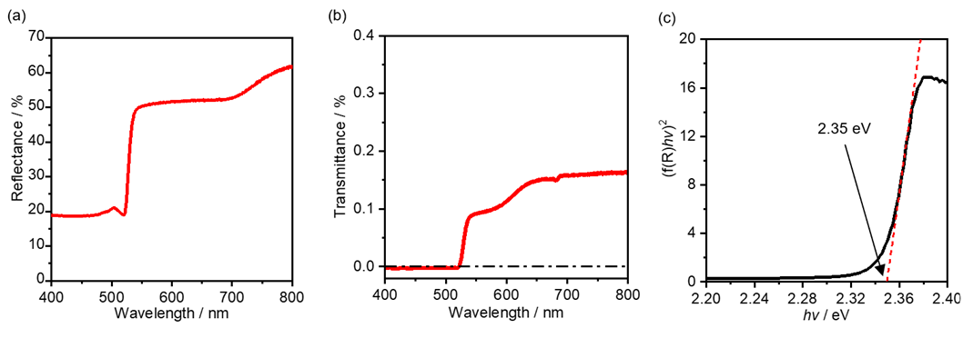
Supplementary Fig. 1| Optical bandgap of CdS single crystal. a Reflectance spectrum for a CdS single crystal. b Transmittance spectrum for a CdS single crystal. c Tauc plot based on the reflectance spectrum. The optical bandgap was estimated via a Tauc plot using the Kubelka-Munk function because the transmittance of the CdS single crystal is quite small. The optical bandgap was estimated to be 2.35 eV.

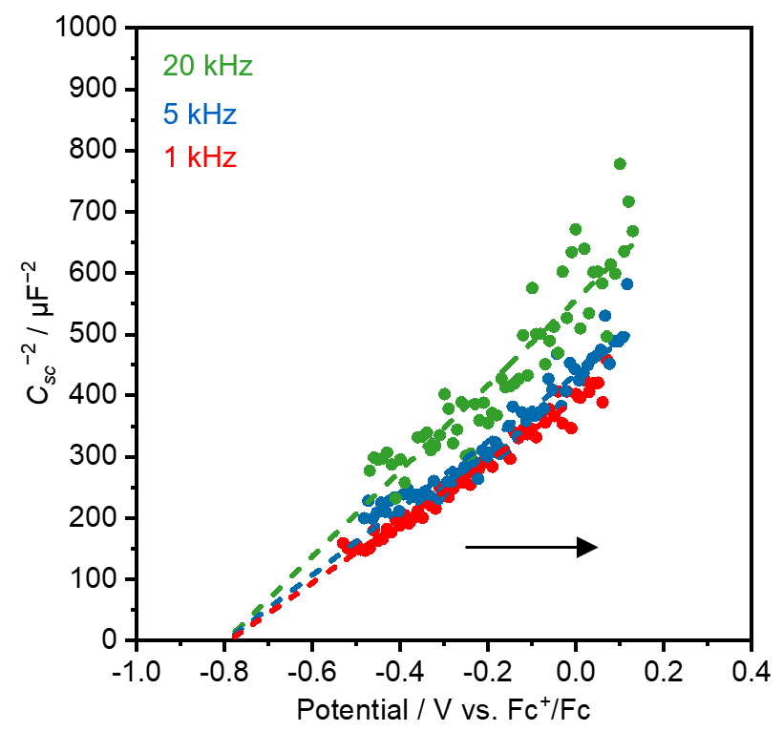
Supplementary Fig. 2| Flat band potential of the CdS photoanode. Mott-Schottky plots at various frequencies for a CdS photoanode in ACN containing 100 mM TBAPF₆. The flat band potential was estimated to be −0.82 V vs. Fc⁺/Fc independent of the frequencies. Donor density (N_{D}) was calculated from the slope of the plots: 8.07×10¹⁶ cm⁻³ (20 kHz), 1.03×10¹⁷ cm⁻³ (5 kHz), and 1.13×10¹⁷ cm⁻³ (1 kHz). The band diagram of CdS was obtained from the optical bandgap, the flat band potential, and the donor density. The Fermi level (E_{F}) of CdS was approximated to be a flat band potential of −0.82 V vs. Fc⁺/Fc. The difference between CBM (E_{C}) and E_{F} (Δ) was calculated based on the following equation:
Where k is Boltzmann constant, T is room temperature, and N_{C} is effective density of states of conduction band (2.2×10¹⁸ cm⁻³ for CdS¹). As a result, the potentials of CBM and VBM were estimated to be −0.90 V vs. Fc⁺/Fc and 1.45 V vs. Fc⁺/Fc, respectively.

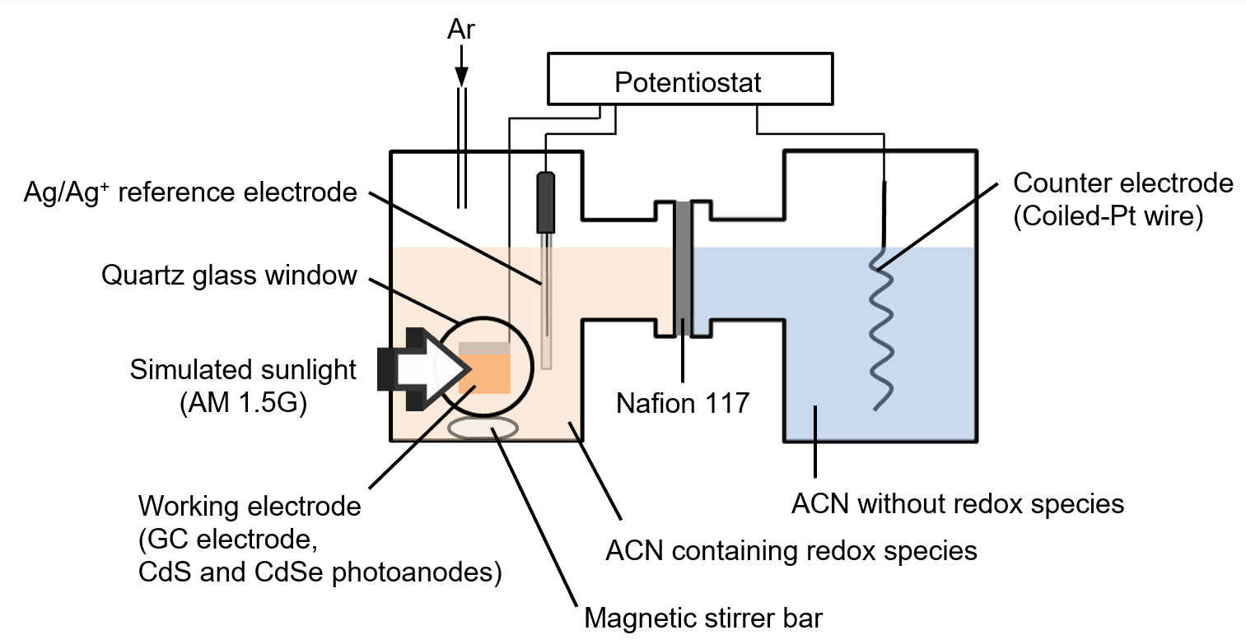
Supplementary Fig. 3| H-type cell setup. Three-electrode H-type cell configuration for electrochemical and PEC measurements.

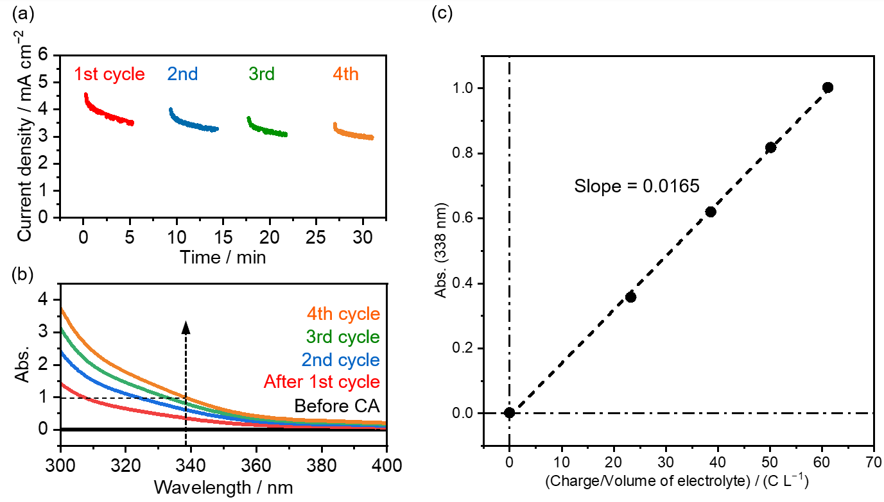
Supplementary Fig. 4| Calibration curve for bromide oxidation. a CA with a GC plate electrode in ACN containing 50 mM TBABr and 100 mM TBAPF₆ at an applied potential of 0.47 V vs. Fc⁺/ Fc under stirring at 330 rpm. B Absorption spectra of the electrolyte solution before and after each cycle of CA. c Calibration curve to quantify the oxidation of bromide. The absorption at 338 nm was plotted against the charge introduced during CA per the volume of the electrolyte solution.

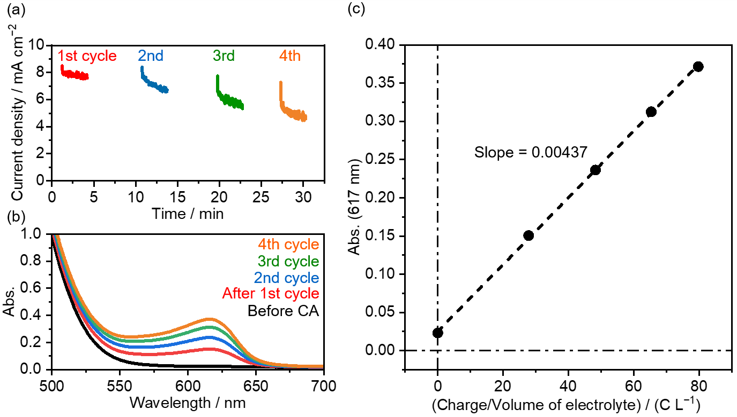
Supplementary Fig. 5| Calibration curve for ferrocene oxidation. a CA with a GC plate electrode in ACN containing 30 mM ferrocene and 100 mM TBAPF₆ at an applied potential of 0.12 V vs. Fc⁺/ Fc under stirring at 330 rpm. B Absorption spectra of the electrolyte solution before and after each cycle of CA. c Calibration curve to quantify the oxidation of ferrocene. Here, absorption at 617 nm was plotted against the charge introduced during CA per the volume of the electrolyte solution.

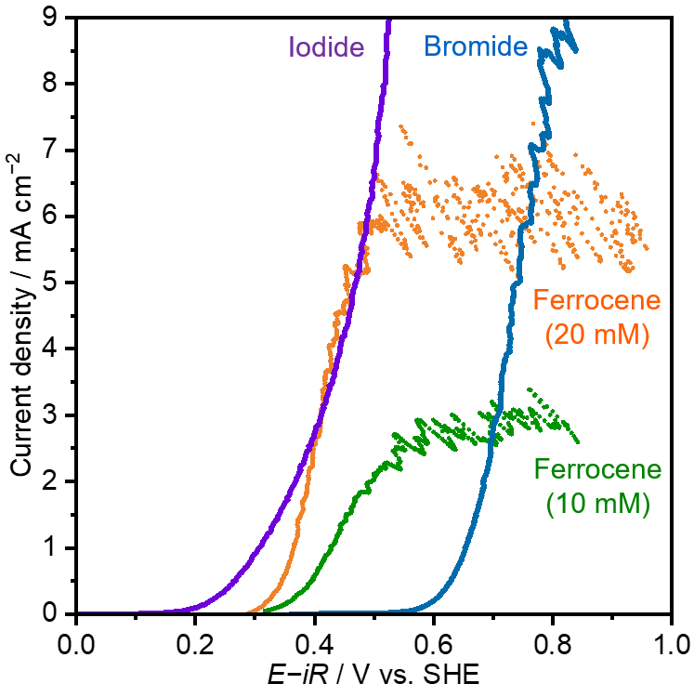
Supplementary Fig. 6| Current density-potential relationship of redox species oxidation on a GC plate electrode. LSVs of 100 mM iodide (purple), 50 mM bromide (blue), and ferrocene (10 mM: green, 20 mM: orange) on the GC plate electrode at scan rate of –10 mV s⁻¹ under stirring the electrolyte solution. LSVs were performed after stabilization of the current by CA. The potential was iR-corrected.

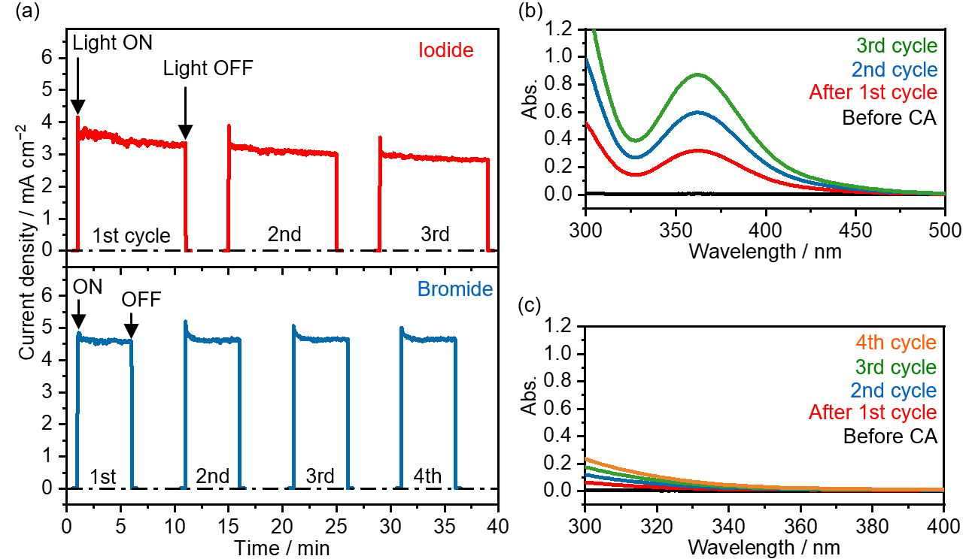
Supplementary Fig. 7| Absorption spectra of the electrolyte solution after each cycle of CA with a CdS photoanode in iodide and bromide solution. a CA with a CdS photoanode in ACN containing 100 mM iodide (red) and 50 mM bromide (blue) at an applied potential of 0.082 V vs. Fc⁺/Fc under stirring the electrolyte solution. Light source: Simulated sunlight (AM 1.5G). b Absorption spectra of the iodide solution after each cycle of CA. c Absorption spectra of the bromide solution after each cycle of CA.

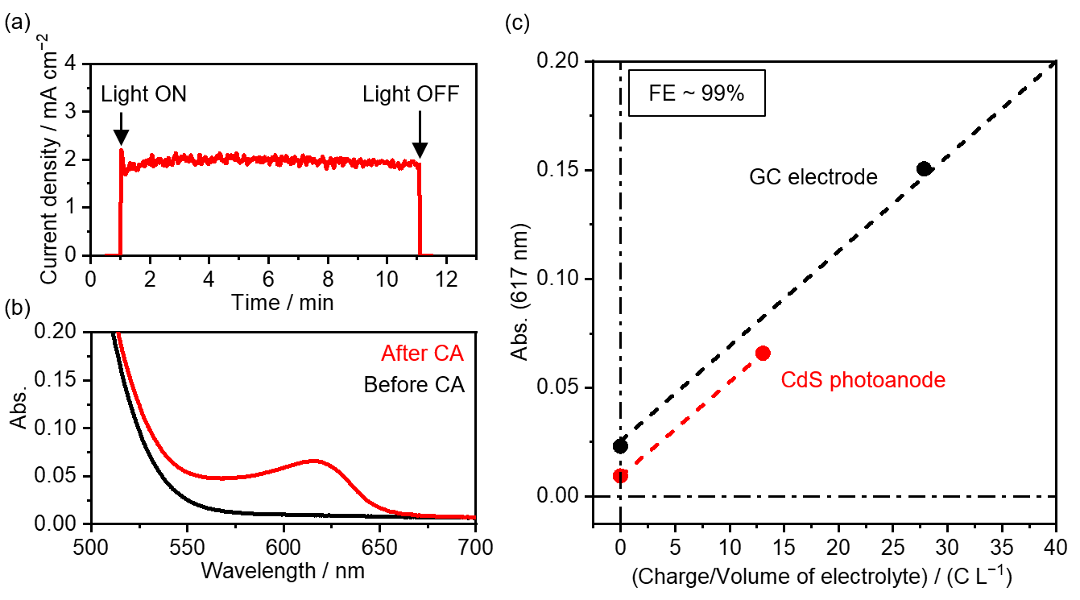
Supplementary Fig. 8| PEC oxidation of ferrocene on a CdS photoanode. A CA with a CdS photoanode in ACN containing 10 mM ferrocene and 100 mM TBAPF₆ at an applied potential of −0.28 V vs. Fc⁺/Fc under stirring the electrolyte solution at 330 rpm. b Absorption spectra of the electrolyte solution before and after CA. c Abs. vs. (charge/volume of electrolyte) plots to obtain FE for ferrocene oxidation on a CdS photoanode.

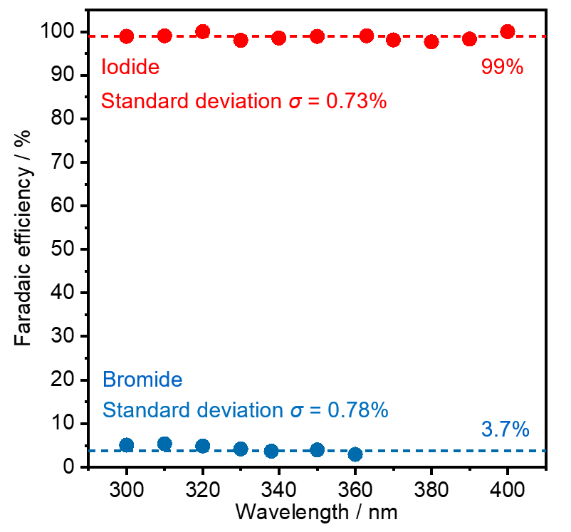
Supplementary Fig. 9| Faradaic efficiency. Faradaic efficiency of iodide and bromide oxidation on a CdS photoanode calculated from the calibration curve at various wavelengths.

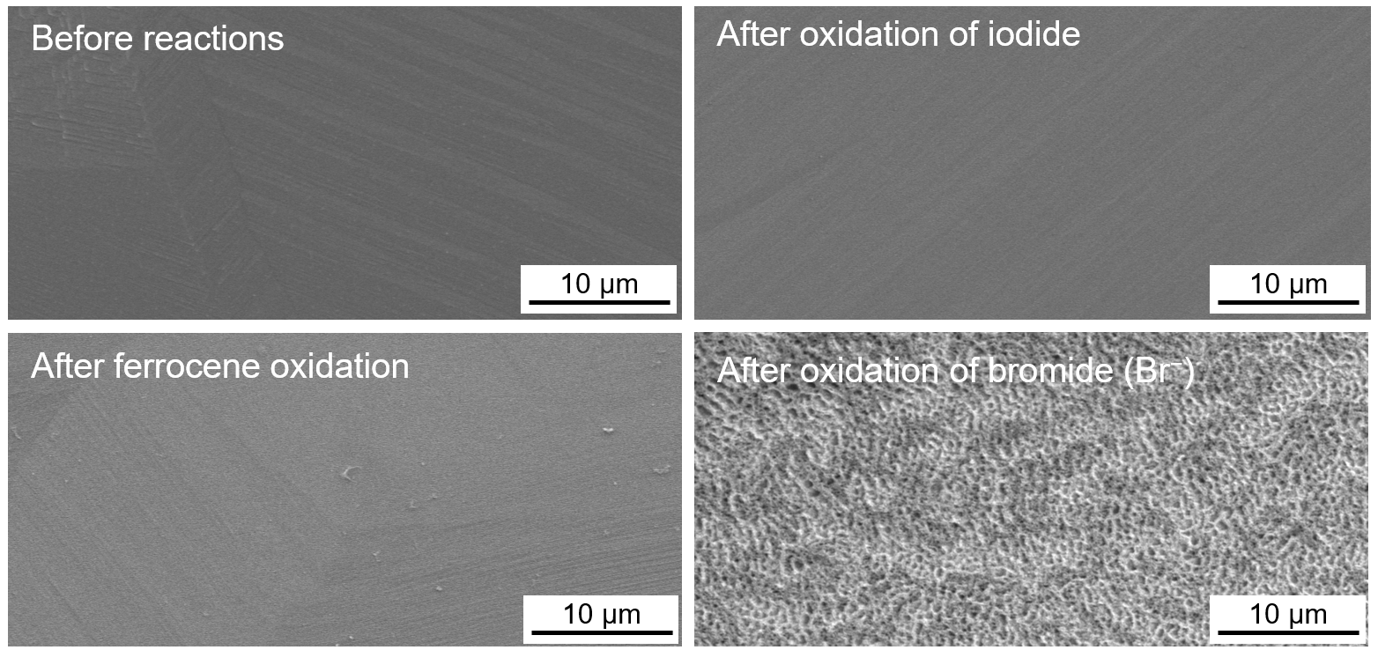
Supplementary Fig. 10| SEM images. Top-view SEM images of CdS photoanodes before and after oxidation of redox species.

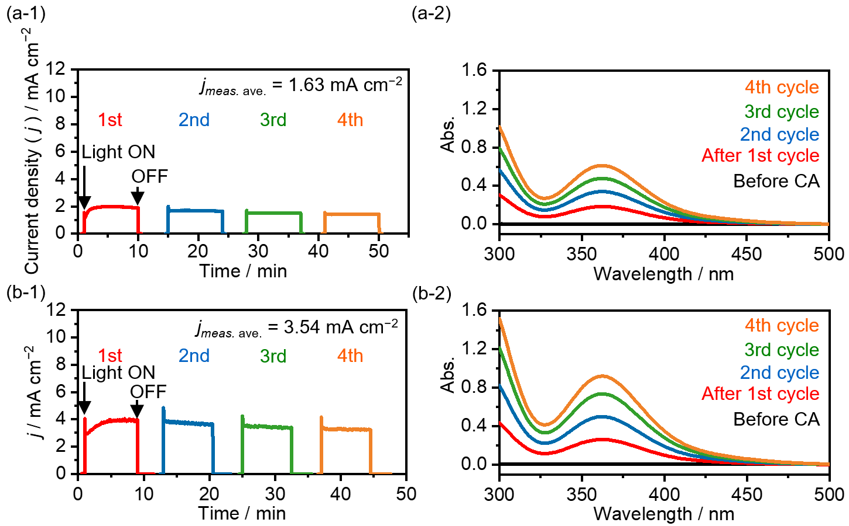
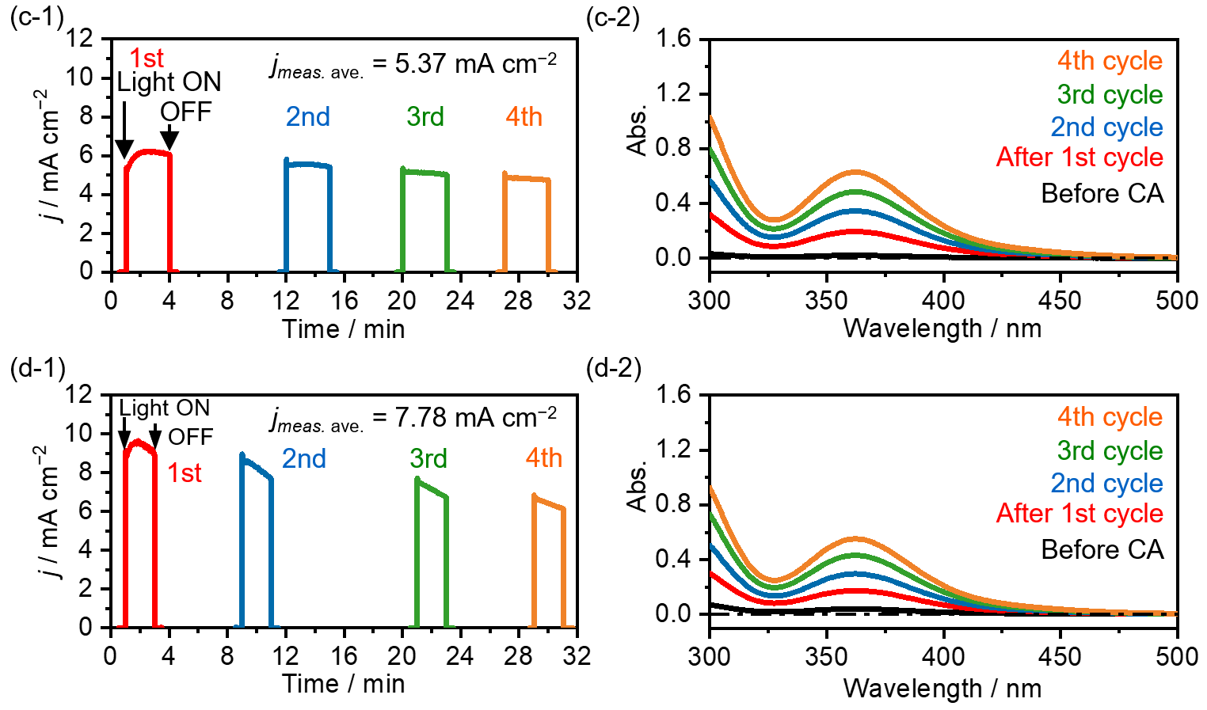
Supplementary Fig. 11| PEC oxidation of iodide on a CdSe photoanode at various applied potentials. CA with a CdSe photoanode in ACN containing 100 mM KI and 100 mM TBAPF₆ at an applied potential of (a-1) −0.68 V vs. Fc⁺/Fc, (b-1) −0.60 V vs. Fc⁺/Fc, (c-1) −0.36 V vs. Fc⁺/Fc, and (d-1) −0.12 V vs. Fc⁺/Fc upon stirring the electrolyte solution at 330 rpm; the absorption spectra corresponding to each CA are also shown. (a-2)–(d-2) Absorption spectra after each cycle of CA at corresponding applied potentials.

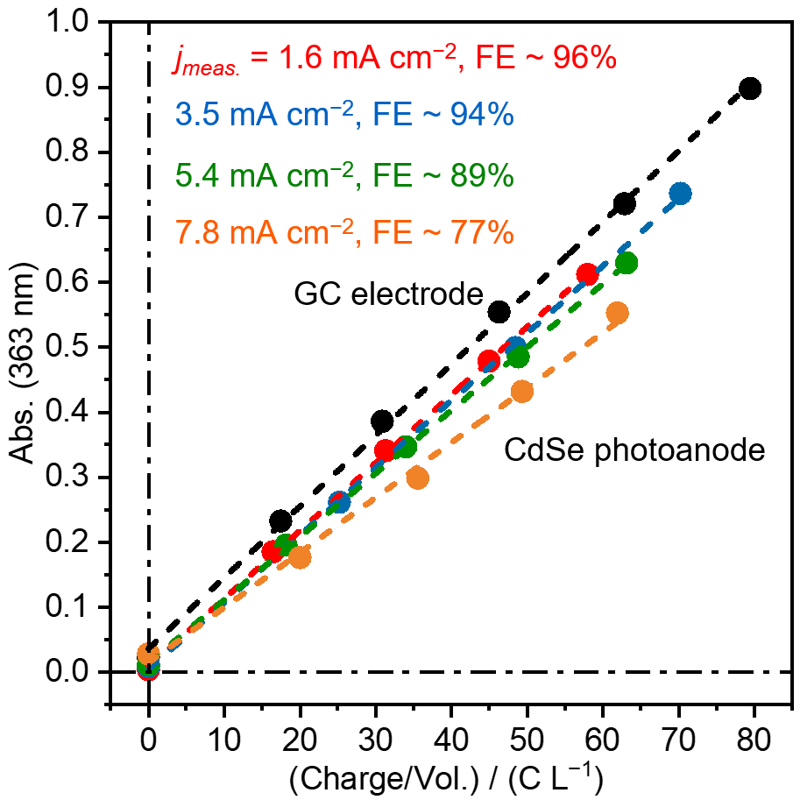
Supplementary Fig. 12| PEC results for iodide oxidation. Absorption vs. Charge/Vol. plots and FE in PEC oxidation of iodide on a CdSe photoanode at various applied potentials.

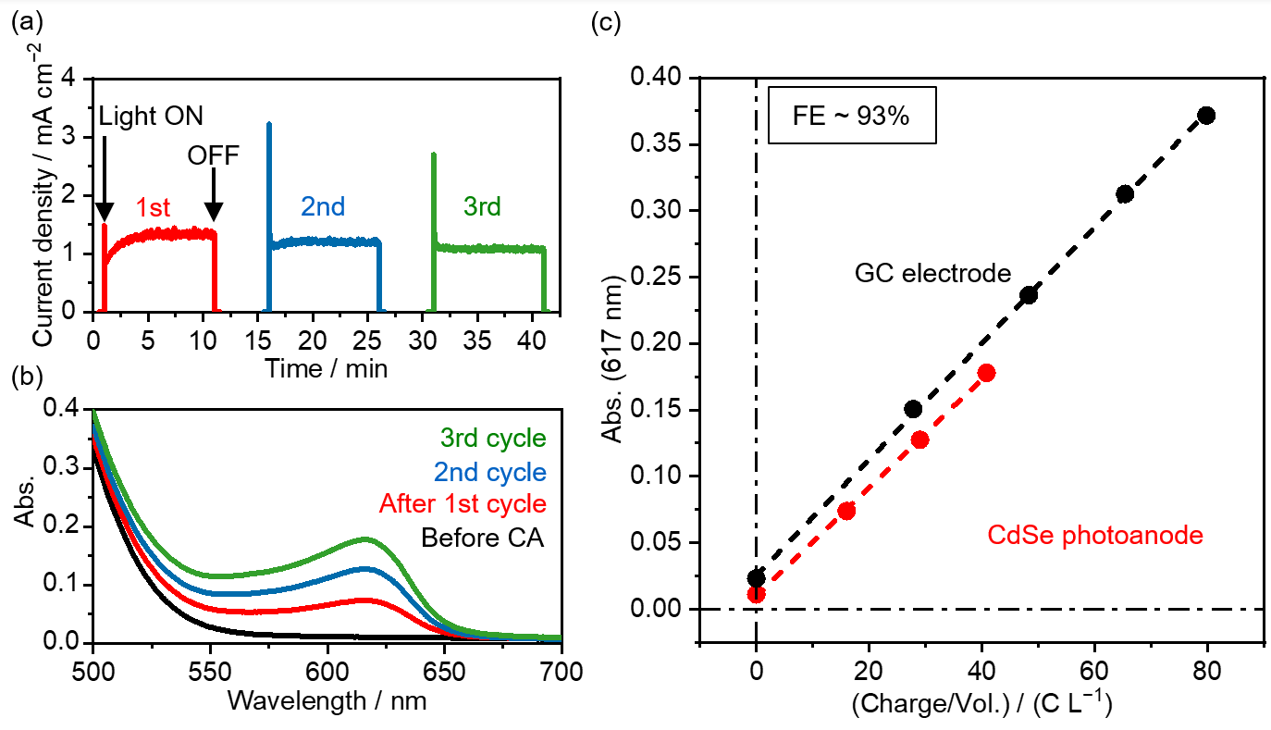
Supplementary Fig. 13| PEC oxidation of 10 mM ferrocene on a CdSe photoanode. a CA with a CdSe photoanode in ACN containing 10 mM ferrocene and 100 mM TBAPF₆ at an applied potential of −0.28 V vs. Fc⁺/Fc upon stirring the electrolyte solution at 330 rpm. b Absorption spectra of the electrolyte solution before and after CA. c Abs. vs. (Charge/volume of electrolyte) plots to obtain FE for ferrocene oxidation on a CdSe photoanode.
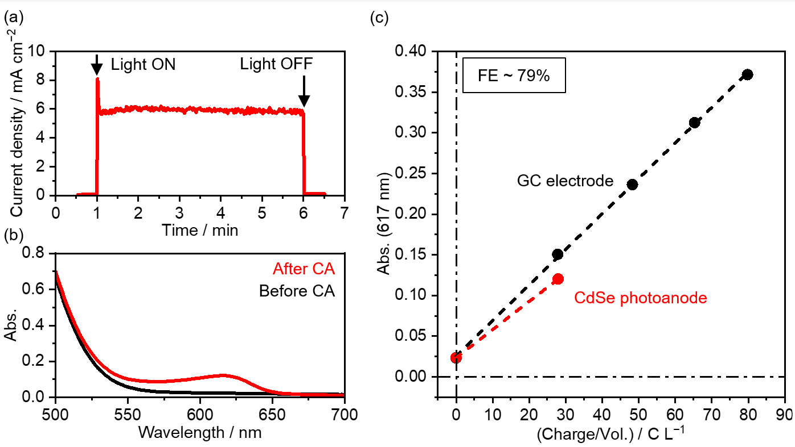
Supplementary Fig. 14| PEC oxidation of 20 mM ferrocene on a CdSe photoanode. a CA with a CdSe photoanode in ACN containing 20 mM ferrocene and 100 mM TBAPF₆ at an applied potential of 0.23 V vs. Fc⁺/Fc under stirring the electrolyte solution at 330 rpm. B Absorption spectra of the electrolyte solution before and after CA. c Abs. vs. (Charge/volume of electrolyte) plots to obtain FE for ferrocene oxidation on a CdSe photoanode.

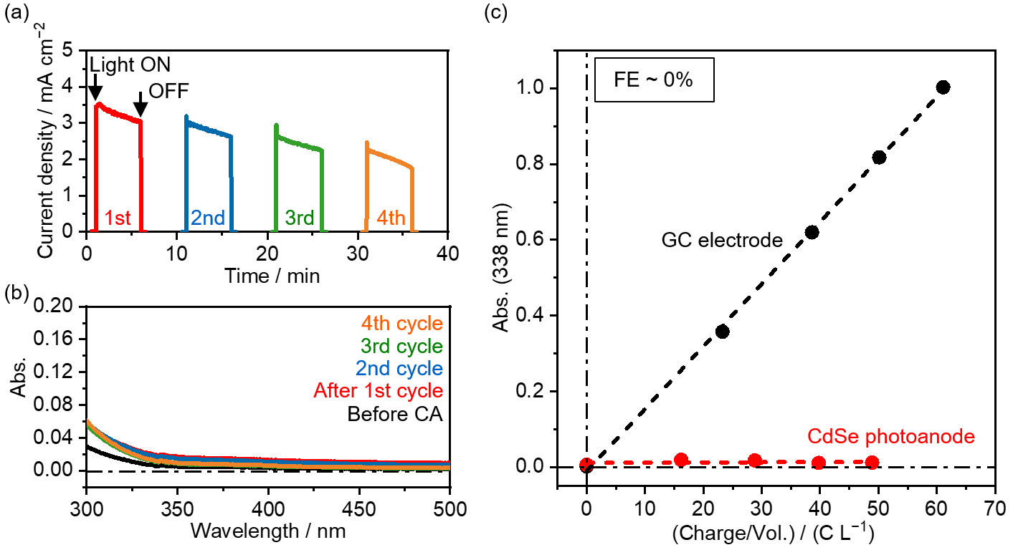
Supplementary Fig. 15| PEC oxidation of 50 mM ferrocene on a CdSe photoanode. A CA with a CdSe photoanode in ACN containing 50 mM bromide and 100 mM TBAPF₆ at an applied potential of −0.42 V vs. Fc⁺/Fc upon stirring the electrolyte solution at 330 rpm. b Absorption spectra of the electrolyte solution before and after CA. c Abs. vs. (Charge/volume of electrolyte) plots to obtain FE for bromide oxidation on a CdSe photoanode.

Reference
1. Elbar, M. et al. Effect of top-cell CGS thickness on the performance of CGS/CIGS tandem solar cell. Solar Energy 122, 104–112 (2015).

