Extended Data Figures
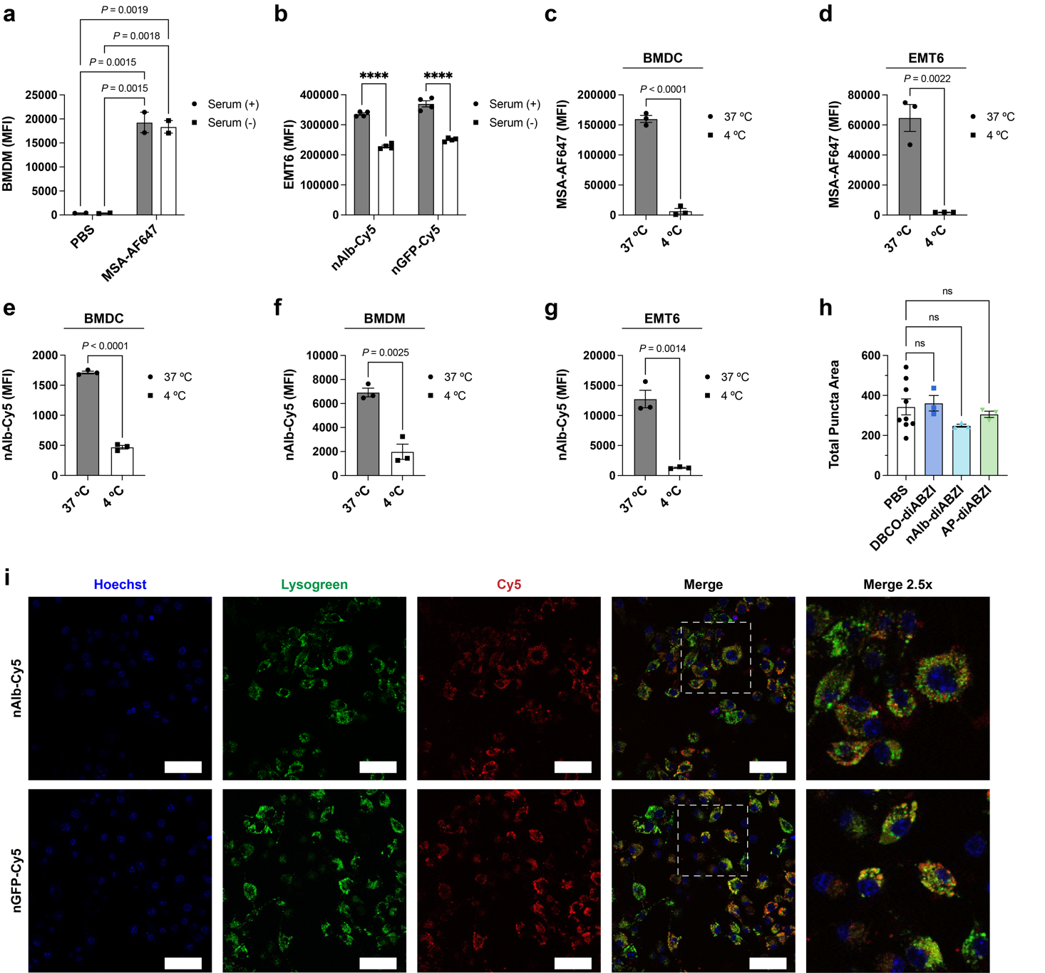
Extended Data Figure 1: In vitro analysis of nanobody delivery. (a) Uptake of MSA-AF647 (1 µM) in BMDM cells as well as (b) nAlb-Cy5 (2 µM) and nGFP-Cy5 (2 µM) in EMT6 cells with the addition of control PBS (+serum) or in a serum starved condition (-serum). P values determined by two-way ANOVA with post-hoc Tukey’s correction for multiple comparisons; ****P<0.0001. (c) Uptake of MSA-AF647 (1 µM) in BMDC cells and (d) EMT6 cells at 37 ºC and 4 ºC. P values determined by Student’s t-test. (e-g) Uptake of nAlb-Cy5 (2 µM) in (e) BMDC cells, (f) BMDM cells, and (g) EMT6 cells at 37 ºC and 4 ºC. P values determined by Student’s t-test. (h) Integrated pixel intensity of Gal8-yFP puncta, per cell, for DBCO-PEG11-diABZI, nAlb-diABZI, and AP-diABZI at 0.25 µM (mean ± SEM, n=3-9). P values determined via one-way ANOVA, with Tukey's post-hoc. (i) Colocalization analysis of nAlb-Cy5 (2 µM) and nGFP-Cy5 (2 µM) for Raw 264.7 cells to visualize the cell nuclei (Hoechst, blue), lysosomes (Lysogreen, green), and Cy5 (Cy5, red). Merged images of the stains provided, in addition to a 2.5x zoom of the merged image (white box). (scale bar: 100 µm)

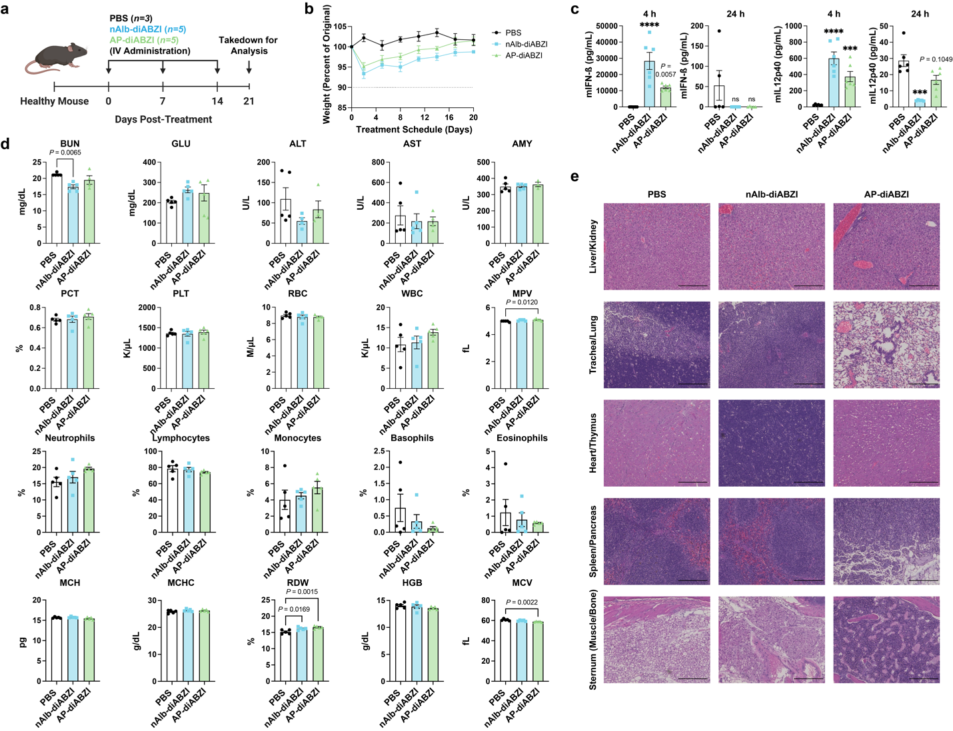
Extended Data Figure 2: (a) Scheme for treating healthy C57BL/6 female mice with PBS, 1.25 µg nAlb-diABZI, or 1.25 µg AP-diABZI. (b) Body weight change of mice during treatments. (c) Quantification of plasma cytokines 4 hours after the first treatment and 24 hours after the final treatment (n=3-5, *P≤0.05, ***P≤0.001, ****P<0.0001 by one-way ANOVA compared to PBS). (d) Blood biochemistry and (e) immunohistochemistry analysis of healthy C57BL/6 mice. After 3 treatments, mice were euthanized and blood samples were collected to determine changes in RBCs, white blood cells (WBCs), neutrophils, platelets, and lymphocytes. Serum samples were also used to analyze liver and kidney function, by measuring changes in ALT/AST, blood urea nitrogen (BUN), and creatinine. Tissue was sectioned, H&E stained, and imaged. Images use a scale bar of 200 µm. No significant changes were observed. (*P≤0.05, **P≤0.01, and ***P≤0.001 compared to PBS by one-way ANOVA).

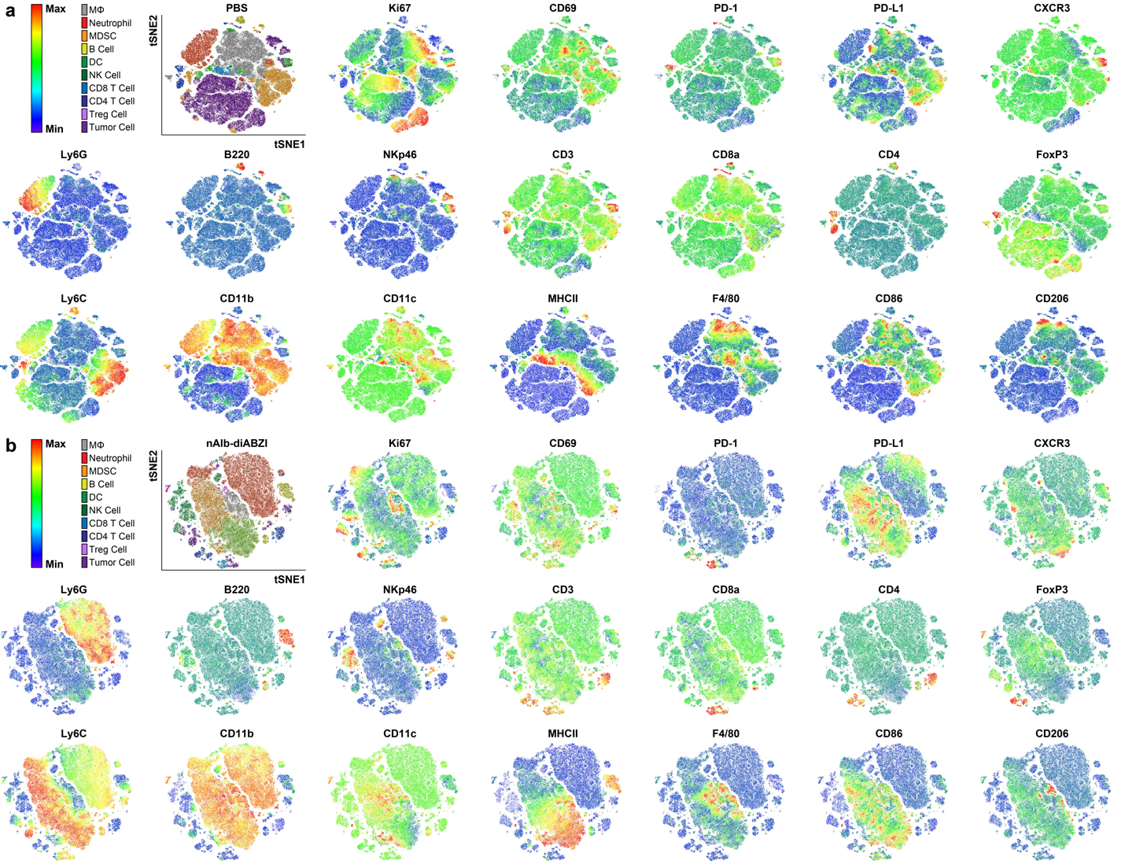
Extended Data Figure 3: tSNE plots of live cells in EMT6 tumors after three doses of (a) PBS or (b) nAlb-diABZI (1.25 µg), colored by cell population with relative expression levels. DC: dendritic cell; Mϕ: macrophage; NK: natural killer cell; MDSC: myeloid-derived suppressor cells.

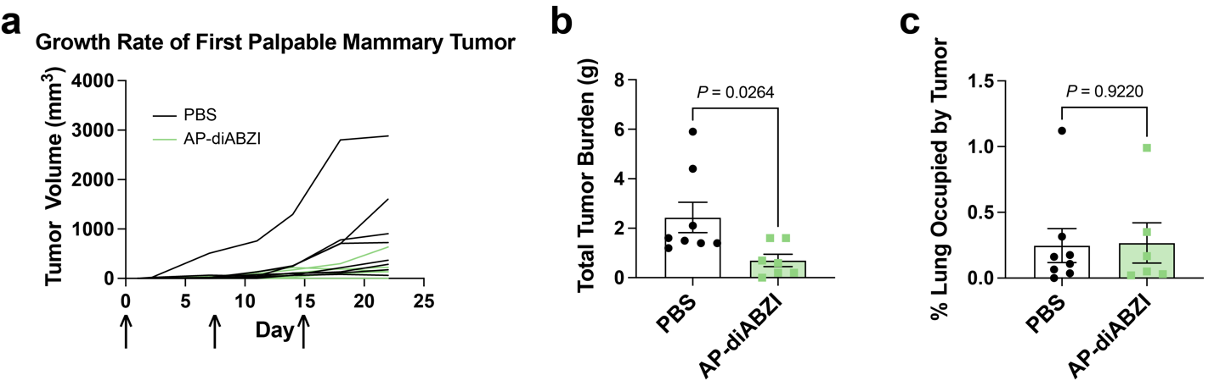
Extended Data Figure 4: Female FVB/N-Tg (MMTV-PyVT)^{634Mul} mice with tumors were treated with PBS or AP-diABZI (1.25 µg of diABZI per dose) once a week for 3 weeks starting at approximately 8-10 weeks of age. (a) Growth rates of tumors during treatment until the study was terminated on day 22. At necropsy, tumors were removed and (b) weighted in addition to (c) histological analysis of lungs to determine tumor burden.

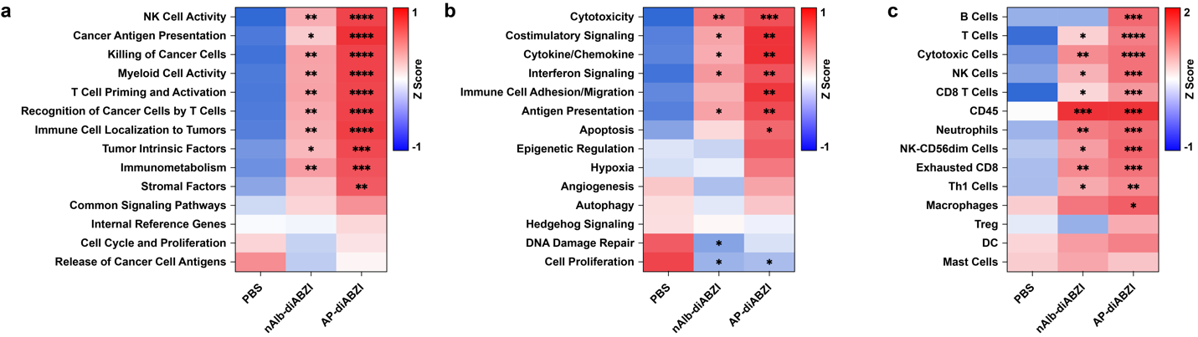
Extended Data Figure 5: Annotated matrices for (a) functional gene annotations, (b) biological signatures, and (c) cell types from IO360 Pan Cancer NanoString gene expression panel comparing PBS, nAlb-diABZI (1.25 µg), and AP-diABZI (1.25 µg) 24 hours after three doses (n=3-4). P values determined by one-way ANOVA with post-hoc Tukey’s correction for multiple comparisons; *P≤0.05, **P≤0.01, ***P≤0.001, and ****P<0.0001 compared to PBS control.

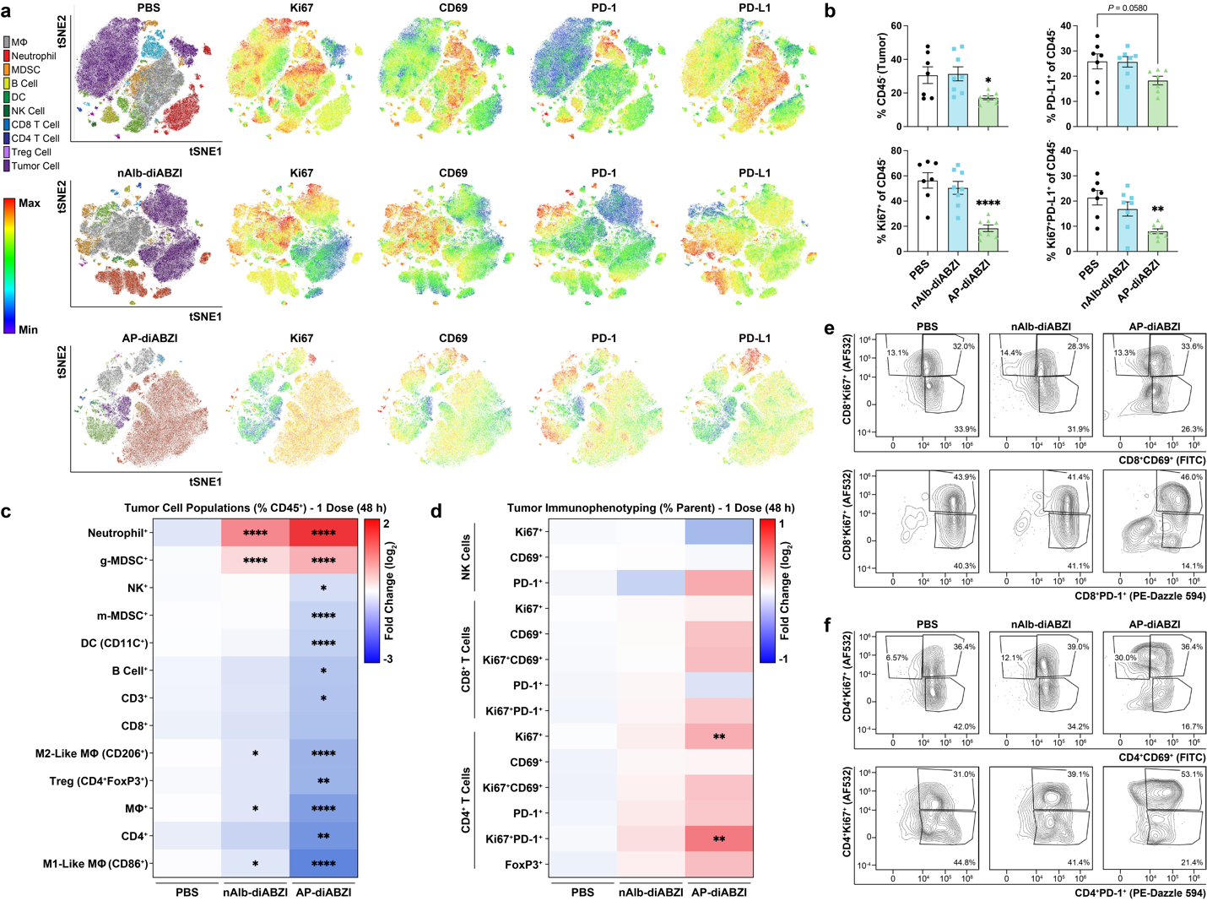
Extended Data Figure 6: Flow cytometric analysis of EMT6 tumor bearing female Balb/c mice 48 h following a single dose of nAlb-diABZI (1.25 µg, n=8), AP-diABZI (1.25 µg, n=8), or PBS (n=7). (a) tSNE plots of live cells in EMT6 tumors, colored by cell population with relative expression level of Ki67, CD69, PD-1, and PD-L1 as indicated on heat map. DC: dendritic cell; Mϕ: macrophage; NK: natural killer cell; MDSC: myeloid-derived suppressor cell. (b) Analysis of the frequency of live CD45⁻ cells and frequency of PD-L1 and Ki67 expressing CD45⁻ cells in the tumor. (c-d) Heat maps summarizing the fold change in the percentage of (c) indicated cell population and (d) frequency of NK cells, CD8⁺ T cells, and CD4⁺ T cells expressing the indicated marker in EMT6 tumors. (B-D) P values determined by one-way ANOVA with post-hoc Tukey’s correction for multiple comparisons to PBS; *P≤0.05, **P≤0.01, ***P≤0.001, and ****P<0.0001 compared to the PBS control. (e-f) Representative flow cytometry dot plots summarizing the distribution of Ki67⁺ to CD69⁺ and PD-1⁺ CD8⁺ T cells and CD4⁺ T cells in EMT6 tumors. All results are the mean ± SEM.

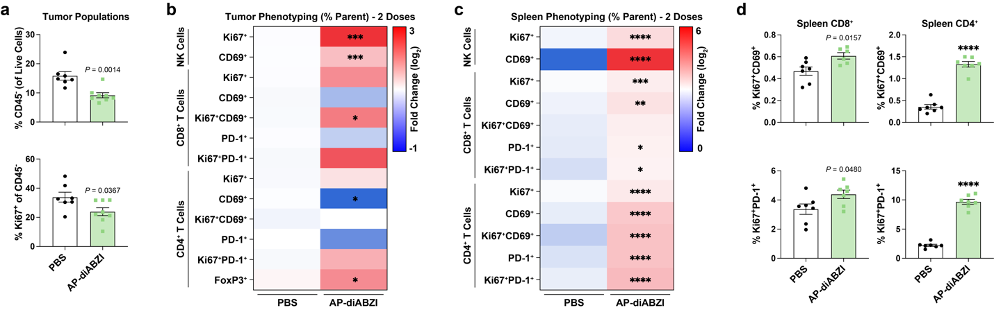
Extended Data Figure 7: Flow cytometric analysis of orthotopic EMT6 breast tumors 24 h following two intravenous doses of AP-diABZI (1.25 µg, n=8), or PBS (n=7) to analyze (a) tumor cell percentages, (b) frequency of NK cells, CD8⁺ T cells, and CD4⁺ T cells expressing the indicated marker in EMT6 tumors, (c) spleen phenotyping heat map of frequency of NK cells, CD8⁺ T cells, and CD4⁺ T cells. (d) Bar plots for activation and proliferation markers Ki67⁺CD69⁺ and Ki67⁺PD-1⁺ in CD8⁺ T cells and CD4⁺ T cells from spleens. *P≤0.05, **P≤0.01, ***P≤0.001, and ****P<0.0001 indicate a statistically significant difference between PBS and AP-diABZI treated groups as determined by Student’s t-test. All results are the mean ± SEM.

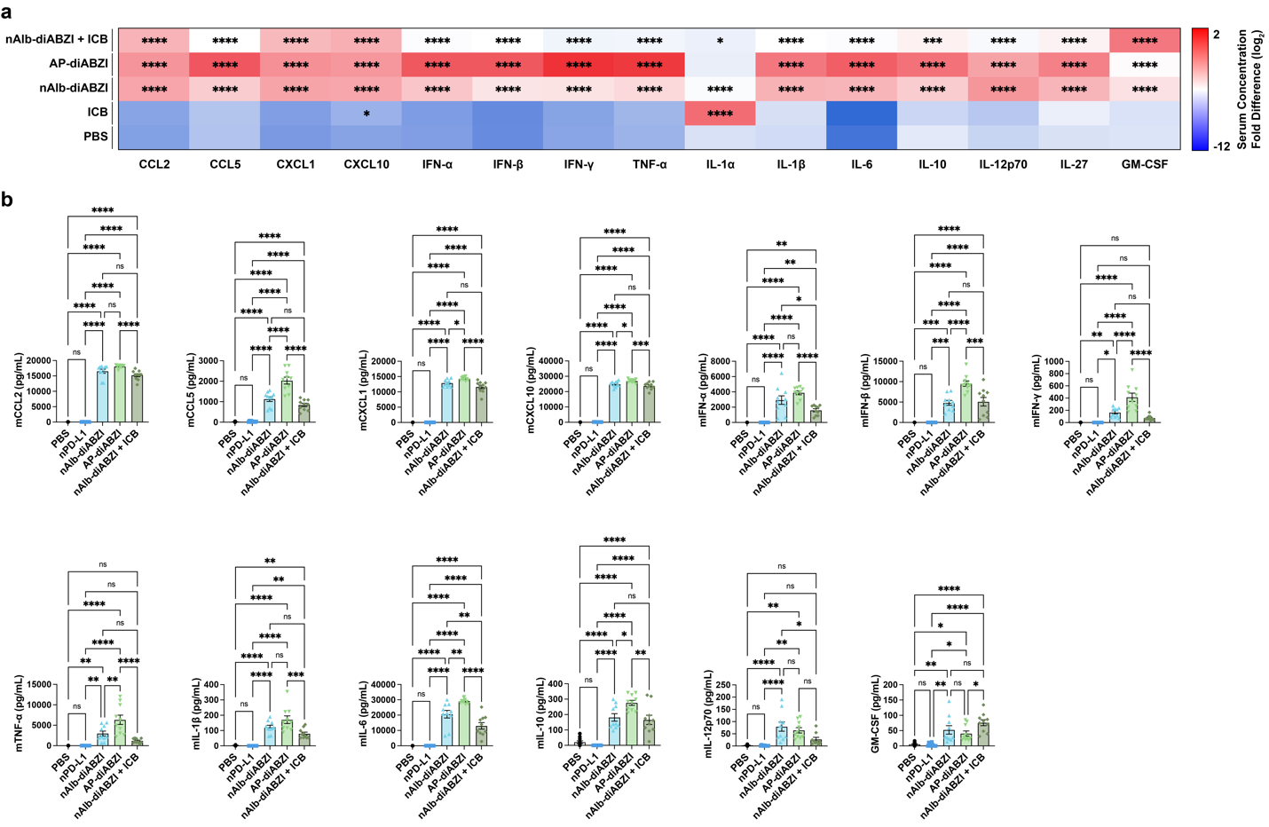
Extended Data Figure 8: Serum cytokine concentration in B16.F10 tumor bearing C57BL/6 female mice 4 hours after the first treatment (n=6-10) as (a) heat maps and (b) bar plots. P values determined by one-way ANOVA with post-hoc Tukey’s correction for multiple comparisons; *P≤0.05, **P≤0.01, ***P≤0.001, and ****P<0.0001 compared to the PBS control.

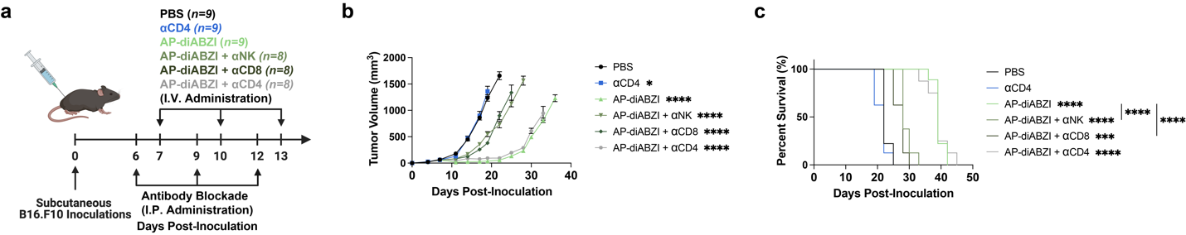
Extended Data Figure 9: (a) Schematic of B16.F10 tumor inoculation and treatment schedule with depletion antibodies (n=8-9). Anti-NK1.1 (NK) IgG, anti-CD8 IgG, and anti-CD4 IgG were injected I.P. at 200 µg and AP-diABZI was injected I.V. at 1.25 µg of diABZI per injection. (b) Tumor growth curves and (c) Kaplan-Meier survival plots for mice with B16.F10 tumors treated as indicated. SEM with P value determined by two-way ANOVA with post-hoc Tukey’s correction for multiple comparisons; ****P<0.0001 on day 22 for all groups compared to PBS. Endpoint criteria of 1500 mm³ tumor volume with P value was determined by log-rank test; ****P<0.0001 compared to PBS control. Replicates are noted as biological, and data shown as mean ± SEM

Extended Data Figure 10: Quantification of flow cytometric analysis presented in Fig. 7n showing the distribution of memory of OVA-specific (SIINFEKL/H-2kB tetramer⁺) or non-SIINFEKL-specific (tetramer⁻) CD8⁺ T cells. Represented bar plots include effector memory T_{EM} (CD44⁺CD62L⁻), activated CD69⁺ effector memory T_{EM} (CD44⁺CD69⁺CD62L⁻), naïve (CD44⁻CD62L⁺), and central memory T_{CM} (CD44+CD62L⁺). ****P<0.0001 indicates a statistically significant difference between tetramer negative and tetramer positive treated groups as determined by Student’s t-test. All results are the mean ± SEM.

