APPENDIX

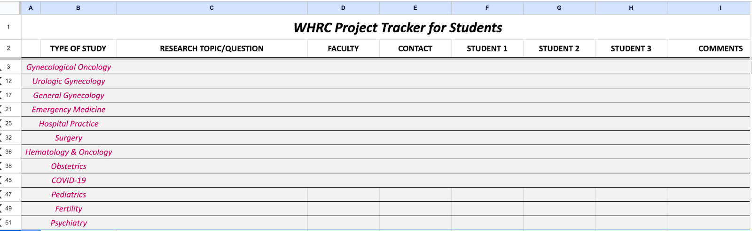
Appendix 1: Example research project tracker for students to access and update.

2.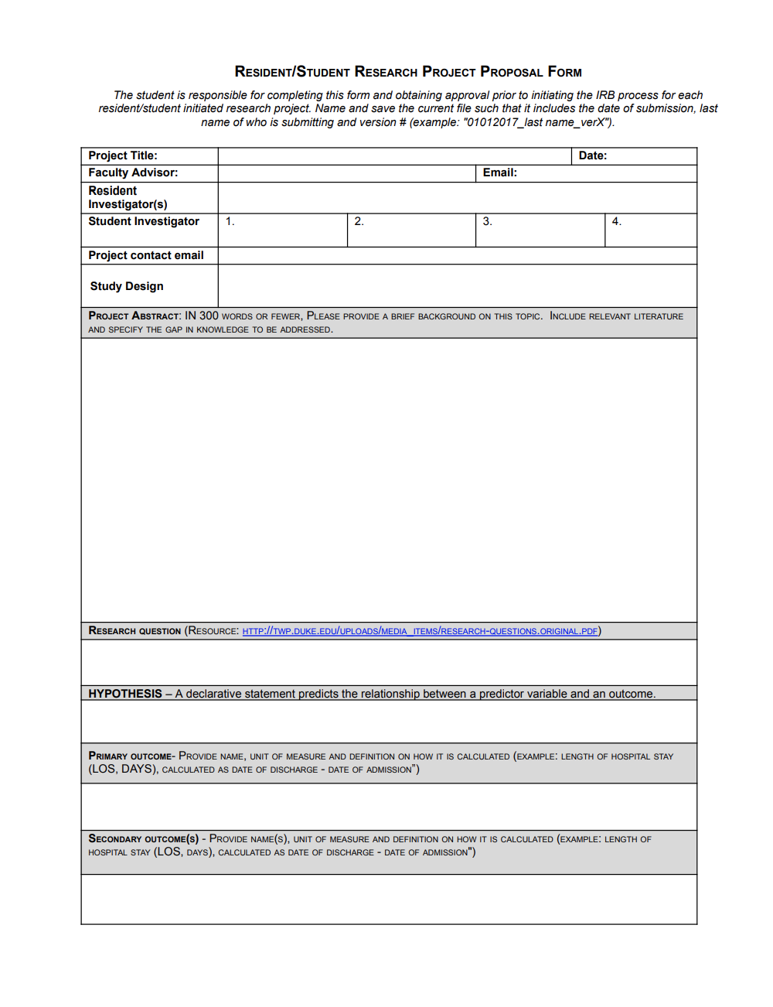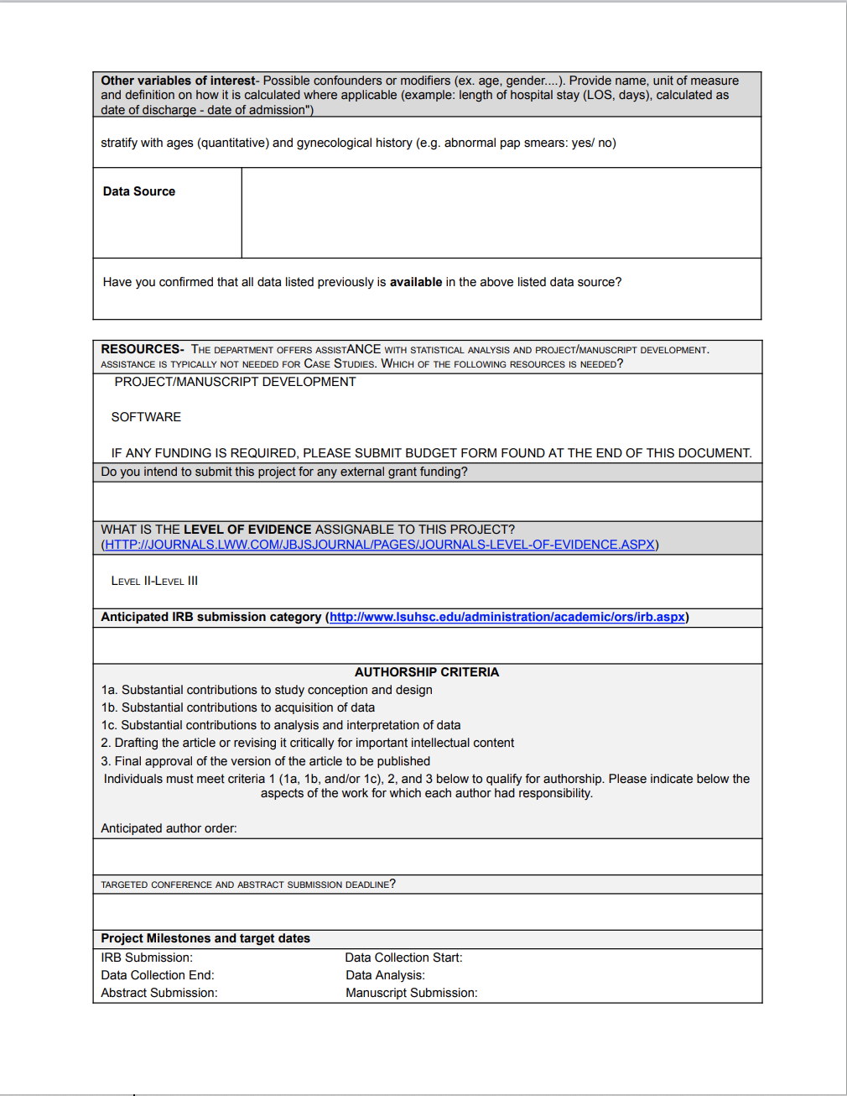
Appendix 2: Example research idea proposal form, which students must complete prior to IRB submission. This proposal form is reviewed by Consortium leadership to validate clinical question and ensure outcomes and participants are satisfactory.

3.
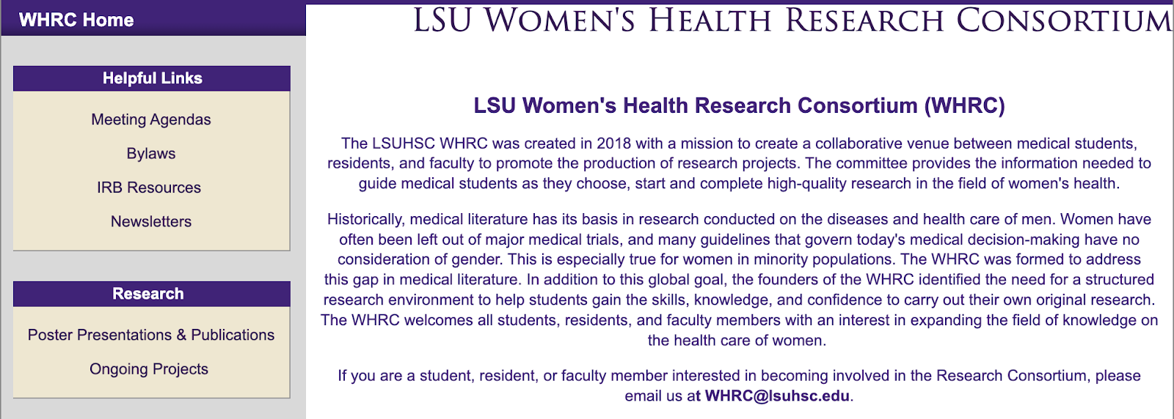
Appendix 3: Example landing webpage for Consortium members to access resources and research information.

