Insights into the synergistic radioprotection by secondary metabolites of Pterocarpus santalinus L. aqueous extract
Ghali E N Hanuma Kumar¹, Sravan Kumar Sandopu¹, Dharmendra Kumar Maurya^{2**} and Meriga Balaji^{1*}
¹Department of Biochemistry, Sri Venkateswara University, Tirupati 517502, India
²Radiation Biology & Health Sciences Division, Bhabha Atomic Research Centre, Mumbai 400085, India

* Corresponding author:
Dr. Meriga Balaji
Assistant Professor,
Department of Biochemistry,
Sri Venkateswara University, Tirupati 517502, India
Email: balaji.meriga@gmail.com

** Alternate corresponding author:
Dr. Dharmendra Kumar Maurya
Scientific Officer / F
Radiation Biology & Health Sciences Division,
Bhabha Atomic Research Centre, Mumbai, 400 085, INDIA
Tel.: +91-22-25590407; Fax.: +91-22-25505151
Email.: dkmaurya@barc.gov.in

Supplementary material
Materials and methods
Preparation of PSAE
With the prior authorization from the Principal Chief Conservator of Forests, Government of Andhra Pradesh (A.P.), the heartwood of P. santalinus was collected and confirmed by a botanist (Reference No. 1708) from the Department of Botany, Sri Venkateswara University, Tirupati, A.P., India. Then, it was shade dried, powdered, and subjected to maceration by soaking in water (100%) as a solvent system with intermittent shaking [1]. After 5 to 7 days of maceration, the aqueous extract solution was concentrated in a rotary evaporator (Heidolph, Germany) under reduced pressure to obtain the powdered form of P. santalinus aqueous extract (PSAE) (15%, w/w) and stored at -20 °C.
Quantification of PSAE constituents
Quantitative estimation of PSAE constituents was performed as evident by the estimation of total phenolic, flavonoid, and tannin contents. Total phenolic estimation of PSAE was done as per the protocol of Ainsworth and Gillespie [2], by measuring the quantity of phenols, using gallic acid as a standard, and expressed as mg gallic acid equivalents (GAEq.). The total flavonoid content of PSAE was quantified by the aluminum chloride method, using quercetin as standard as per the method of Chang et al. [3] and expressed as mg quercetin equivalents (QEq.). Similarly, levels of total tannins were measured as per the procedure of Hosu et al. [4] The difference in absorbance (∆A) between the samples was measured at 470 nm, 520 nm, and 570 nm. Based on ∆A470 and ∆A520, the value at ∆A570 was calculated as follows:
∆A520 = 1.1 × ∆A470
∆A520 = 1.54 × ∆A570
The total tannin content (g/L of PSAE) was calculated as follows:
TTC (g/L) = 15.7 × minimum (∆A520)
Ultra-High-Performance Liquid Chromatography-High Resolution Mass Spectrometry (UHPLC-HRMS)
The UHPLC-HRMS/MS of PSAE analysis was performed in a Hybrid Quadrupole-TOF LC/MS/MS Mass Spectrometer system (Sciex Triple ToF 5600, Singapore) which was connected with Kinetex C18 100A (30 × 2.1 mm, 1.7 µm) Phenomenex column at a flow rate of 0.4 ml min⁻¹. The mobile phase comprises Solvent A-0.1% acetic acid in water and Solvent B-0.1% acetic acid in acetonitrile and methanol in the ratio 8:2 [5]. The mass measurements were recorded with a scan range from 200–2000 m/z in ESI negative mode. The data was analyzed using Peak View 2.1 Software (AB SCIEX Triple TOF 5600, Singapore) and equipped with MasterViewTM (Version 1.0, AB SCIEX).
Assessment of antioxidant capacities
Ferric reducing assay
The ferric reducing capacity of PSAE was assessed using the method of Ghali et al. [1] Assay mixture consisted of 400 µl of 1% potassium ferricyanide, 400 µl of different concentrations of PSAE (0, 10, 20, 40, 60, 80 µg ml⁻¹). Once after mixing, samples were incubated at 50 °C for 20 min. To these samples, 400 µl of 10% trichloroacetic acid (TCA) was added and centrifuged at 3000 x g for 10 min. The upper layer (500 µl) of the solution was carefully removed and mixed with 500 µl of 0.1% FeCl₃. Absorbance was taken at 700 nm against blank. Higher absorbance indicates a higher capacity of reduction of ferric ion as the assay is based on the principle of reduction of Fe³⁺ to Fe²⁺.
Molybdenum reduction assay
The molybdenum reduction assay is otherwise known as total antioxidant assay which is based on the reduction of molybdenum [Mo (VI) to Mo (V)] by an electron donor and the formation of an acidic pH complex. Briefly, reaction mixture comprised of molybdenum reagent solution (28 ml of 100 mM NaH₂PO₄, 4 ml of 100 mM ammonium molybdate, and 60 ml of 100 mM H₂SO₄) and different concentrations of PSAE (0, 10, 20, 40, 60, 80 µg ml⁻¹). All the samples were mixed thoroughly and incubated at 95 °C for 90 min. The absorbance of samples was taken at 695 nm against blank [6].
Cell cytotoxicity assay
Cytotoxicity assay was performed to predict the toxicity of the substances to various cells using MTT [3-(4, 5-dimethyl thiazol-2-yl)-2, 5-diphenyl tetrazolium bromide] assay, considered the first standard in vitro bioassay method, and is based on the reduction of tetrazolium dye MTT to its insoluble purple-colored formazan crystals. For estimation of cytotoxicity of PSAE, 1 x 10⁴ RAW 264.7 cells were seeded and incubated for 72 h. Then, cells were mixed with a range of concentrations of PSAE (0, 12.5, 25, 50, 100, 200 µg ml⁻¹). Cells obtained at 72 h post-experimentation were incubated with MTT reagent for 4 h followed by the addition of 100 µl of solubilization buffer (10% SDS, 0.01 N HCl). The absorbance was taken at 550 nm and 630 nm using a Bio-Tek microplate ELISA reader [7].
Results
Quantification and Ultra-High-Performance Liquid Chromatography-High Resolution Mass Spectrometry (UHPLC-HRMS)
Table S1 depicts the amounts of phenols, flavonoids, and anthocyanins present in PSAE. It showed the presence of 4.061µg/mg (Gallic acid equivalents) of phenols, 6.616 µg/mg (Quercetin equivalents) of flavonoids, and 0.008 mg (Cyn3-glu/g) of anthocyanins in PSAE. Using UHPLC-HRMS, phytochemical entities such as phenols and flavonoids in PSAE were tentatively identified. As shown in Fig. S1 and Table S2, a total of 11 compounds were detected, namely Chlorogenic acid, 4-Coumaric acid, Quercetin, Rutin, Apigenin, Dehydromelanoxin, Melanoxin, Cryptomeridiol, Santalin A, Santalin B, and Santalin Y, of which chlorogenic acid and 4-coumaric acid are naturally occurring hydroxycinnamic acids and members of polyphenols, Quercetin and Rutin are flavonoids, a flavone- Apigenin, two benzofurans- Dehydromelanoxin and Melanoxin, a sesquiterpenoid-Cryptomeridiol, and polyphenolic dyes like santalin-A, B & Y. Their ESI-MS signals gave deprotonated ions at m/z 353.09, m/z 163.04, m/z 301.08, m/z 609.17, m/z 269.06, m/z 299.07, m/z 301.08, m/z 239.06, m/z 581.27, m/z 595.09 and m/z 585.16 respectively. Furthermore, the structures of phytocompounds of PSAE were represented in Fig. S1.
PSAE significantly exhibits the antioxidant capacity
Fig. S2a and b show the ferric reducing capacity and the molybdenum reducing capacity of PSAE, respectively. The FRAP assay is a commonly used method wherein Fe³⁺ is reduced to Fe²⁺. In contrast, molybdenum reduction assay, commonly known as total antioxidant capacity, depends on the reduction of Mo (VI) to Mo (V), indicating the antioxidant capacity of various biological sample extracts. In the absence of PSAE, there is no significant reducing capacity, which was increased in a concentration-dependent manner on PSAE treatment (0, 10, 20, 40, 60, 80 µg/ml) and reached the maximum level at a higher concentration (80 µg/ml) when compared to that of the control group.
Cell cytotoxicity assay
To evaluate the toxic levels of PSAE, RAW264.7 macrophages were employed, which are commonly used cell lineage to determine cell viability. In the present study, Fig. S2c demonstrated that cell viability in the control group is 100 % viability. In addition, treatment with different concentrations of PSAE (12.5, 25, 50, 100, 200 µg/ml) in triplicate for 24 h at 37°C followed by incubation of cells with MTT reagent, showed non-toxic nature till 100 µg/ml. However, treatment of macrophages with a concentration of 200 µg/ml started showing toxicity (<10%).

Table Captions
Table S1
Quantification of phytoconstituents of PSAE
Table S2
UHPLC-HRMS/MS identified major compounds of PSAE

Figure Captions
Fig. S1 MS/MS fragmentation of the major phytocompounds and their structures identified in PSAE.
Fig. S2 Antioxidant capacity of PSAE (a) Ferric reducing capacity. (b) Molybdenum reduction assay. (c) Measurement of % cell viability in RAW 264.7 cells using MTT assay.

Table S1
Quantitative estimation of phytocompounds in PSAE
Phytocompounds | Content
Total Phenols content (µg mg⁻¹ in terms of GAEq.) | 4.06
Total Flavonoids (µg mg⁻¹ in terms of Q. Eq.) | 6.62
Total Anthocyanins (mg Cyn3-glu/g) | 0.008

Table S2
MS/MS fragmentation of phytocompounds of PSAE
[M-H]  (g/mol.) | Empirical formula | MS/MS fragmentation | Phytocompounds | Chemical nature
353.09 | C₁₆H₁₈O₉ | 191.0644, 179.2451 | Chlorogenic acid | Hydroxy cinnamic acid (Polyphenol)
163.04 | C₉H₈O₃ | 119.0506, 93.0352 | 4-Coumaric acid | Hydroxy cinnamic acid  (Polyphenol)
301.08 | C₁₅H₁₀O₇ | 273.0399, 257.0451, 193.0140, 178.9984 | Quercetin | Flavonoid (polyphenol)
609.17 | C₂₇H₃₀O₁₆ | 301.0345, 300.0265, 255.0289 | Rutin | Flavonoid (polyphenol)
269.06 | C₁₅H₁₀O₅ | 225.0559, 151.0040, 149.0248, 117.0350 | Apigenin | Flavone (polyphenol)
299.07 | C₁₇H₁₆O₅ | 284.04, 255.04, 240.05 | Dehydromelanoxin | Benzofuran
301.08 | C₁₇H₁₈O₅ | 268.05, 241.06 | Melanoxin | Benzofuran
239.06 | C₁₅H₂₈O₂ | 179.04, 149.06 | Cryptomeridiol | Sesquiterpenoid
581.27 | C₃₃H₂₆O₁₀ | 345.07 | Santalin A | Polyphenol
595.09 | C₃₄H₂₈O₁₀ | 549.03, 429.03, 311.04, 227.04 | Santalin B | Polyphenol
585.16 | C₃₃H₃₀O₁₀ | 429.12, 271.07, 213.06 | Santalin Y | Polyphenol

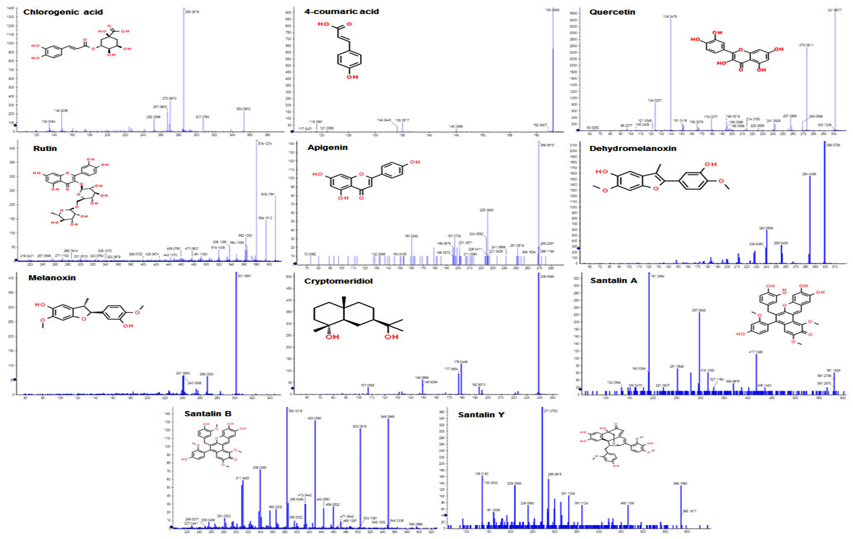

Fig. S1 MS/MS fragmentation of the major phytocompounds and their structures-identified in PSAE.
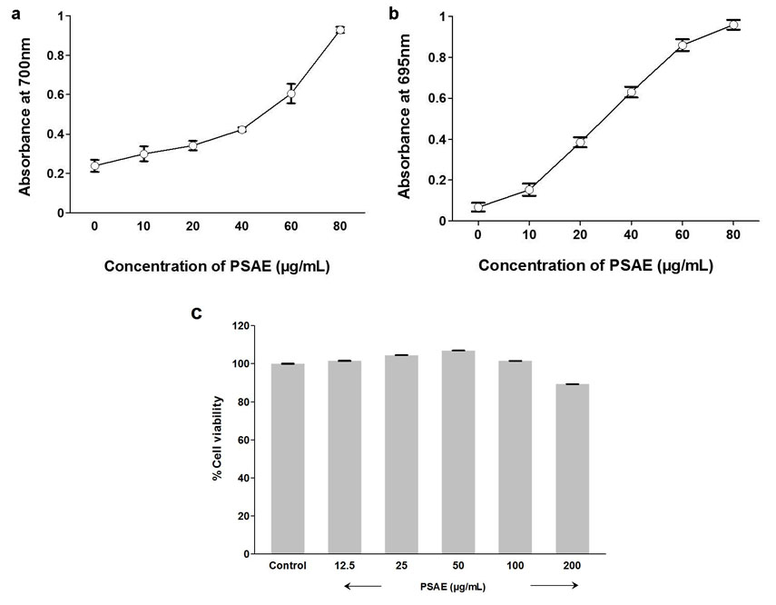
Fig. S2 Antioxidant capacity of PSAE (a) Ferric reducing capacity. (b) Molybdenum reduction assay. (c) Measurement of % cell viability in RAW 264.7 cells using MTT assay.

References
1. Ghali EHK, Maurya DK, Meriga B (2018) Radioprotective Properties of Pterocarpus santalinus chloroform extract in murine splenic lymphocytes and possible mechanism. Cancer Biotherapy Radiopharmaceuticals 33:427-437
2. Ainsworth EA, Gillespie KM (2007) Estimation of total phenolic content and other oxidation substrates in plant tissues using Folin–Ciocalteu reagent. Nature protocols 2:875-877
3. Chang C-C, Yang M-H, Wen H-M et al. (2002) Estimation of total flavonoid content in propolis by two complementary colorimetric methods. Journal of food drug analysis 10
4. Hosu A, Cristea V-M, Cimpoiu C (2014) Analysis of total phenolic, flavonoids, anthocyanins and tannins content in Romanian red wines: Prediction of antioxidant activities and classification of wines using artificial neural networks. Food chemistry 150:113-118
5. Prakash O, Baskaran R, Kudachikar V (2019) Characterization, quantification of free, esterified and bound phenolics in Kainth (Pyrus pashia Buch.-Ham. Ex D. Don) fruit pulp by UPLC-ESI-HRMS/MS and evaluation of their antioxidant activity. Food Chemistry 299:125114
6. Saxena S, Verma J, Gautam S (2016) Potential prophylactic properties of apple and characterization of potent bioactive from cv.“Granny Smith” displaying strong antimutagenicity in models including human lymphoblast TK6+/− cell line. Journal of Food Science 81:H508-H518
7. Pandey MK, Sandur SK, Sung B et al. (2007) Butein, a tetrahydroxychalcone, inhibits nuclear factor (NF)-κB and NF-κB-regulated gene expression through direct inhibition of IκBα kinase β on cysteine 179 residue. Journal of Biological Chemistry 282:17340-17350

