Supplementary File 1: Raw datasets presented in this manuscript
Supplementary Table 1: Flow cytometry antibodies and panels
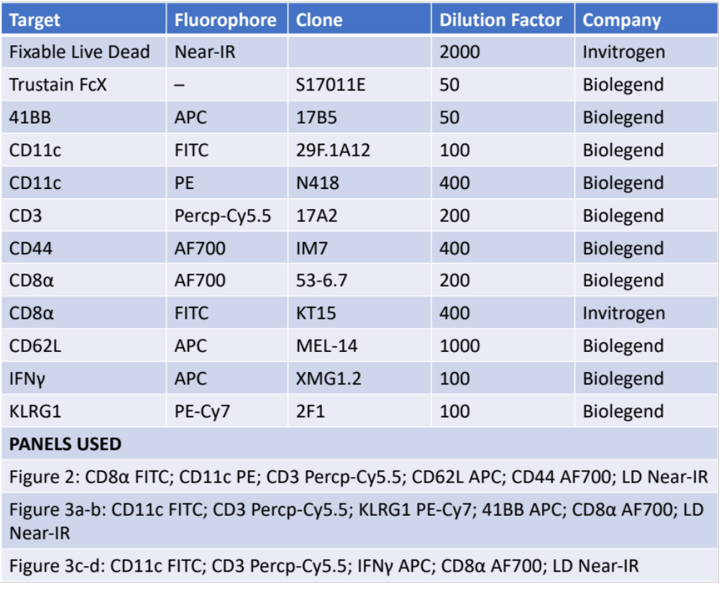

Supplementary Figure 1: Flow cytometry gating structure for the datasets. Cells were gated by FSCxSSC lymphocytes, single cells, and live cells followed by positivity for CD3, CD8, and CD11c. The population positive for all three were further analyzed by CD62L and CD44 in tumor suspensions and for activation markers (41BB, KLRG1, IFNγ) in splenocytes. Splenocytes were stimulated using a cocktail of gp100₂₅₋₃₃, Trp2₁₈₀₋₁₈₈, costimulatory antibodies, and cell transport inhibitor for 5 hours with or without cell transport inhibitor. Cell counts were normalized and represented as counts per 100,000 viable, single, lymphocytes.
