SUPPLEMENTARY FILES
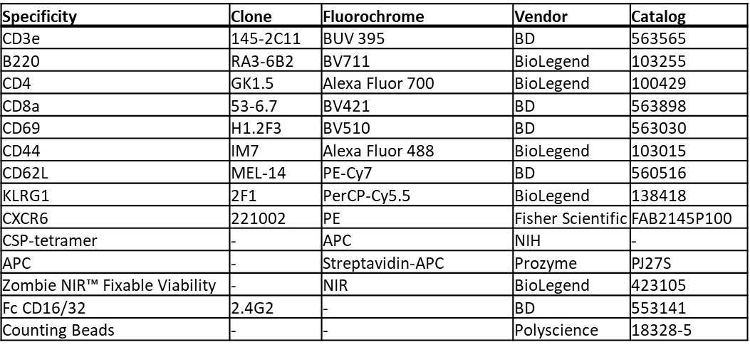
Supplementary Table 1: Flow cytometry materials
Flow cytometry reagents and antibodies that were used to assess liver resident memory cells.

Supplementary File 1: Nanostring DEG data
(See Excel Sheet)

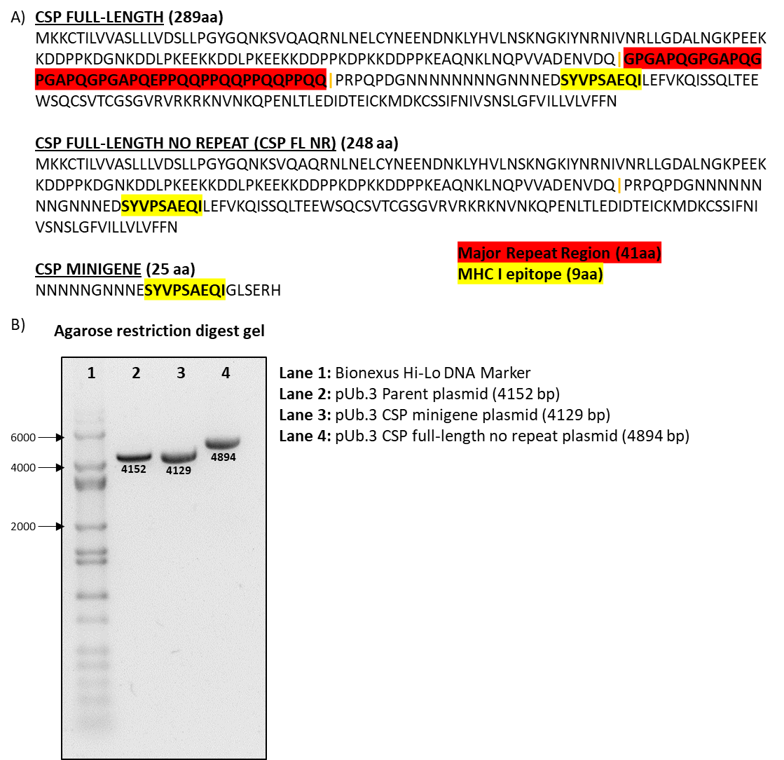
Supplementary Figure 1: CSP DNA vaccines
A) Py CSP DNA vaccine insert amino acid sequences.
B) Agarose restriction digest gel of 100 ng plasmid digested and cut once with a restriction enzyme to linearize to visualize true sizes on the gel. A Bionexus Hi-Lo DNA Marker ladder was run in lane 1 for reference with key band sizes listed in base pairs (bp).

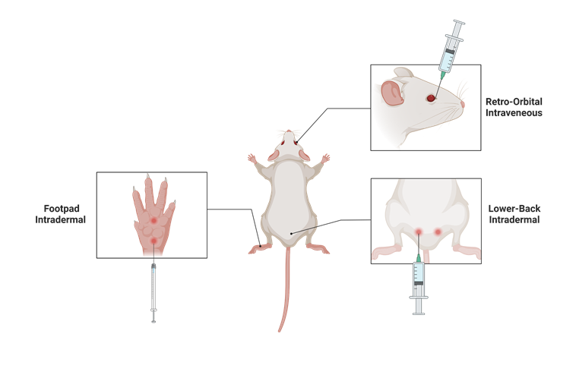
Supplementary Figure 2: Mouse injection sites
Images adapted from BioRender template.

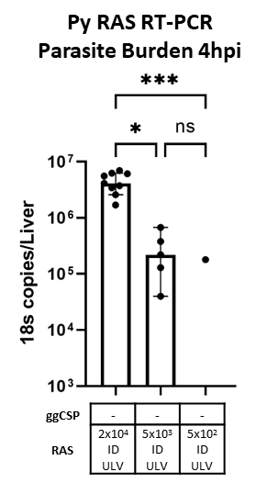
Supplementary Figure 3: Ultra-low volume ID-RAS dose de-escalation parasite liver burden
Naïve mice were immunized with cryo-RAS ID ULV (2.5 μL, X2 injections). Four hours post injection livers were excised and processed for real-time reverse transcription polymerase chain reaction (RT-PCR) to measure parasite burden with pan-Plasmodium 18s rRNA primers. Error bars represent the SD of the mean of N=5 mice from one experiment. RT-PCR data was analyzed with Kruskal-Wallis test with Dunn’s multiple comparisons, ***p<0.001, *p<0.05, ns p>0.05. RT-PCR data are shown as absolute 18s rRNA copy numbers based on absolute calibrators. 2x10⁴ ID ULV data (left column) reproduced from Figure 1E for comparison.

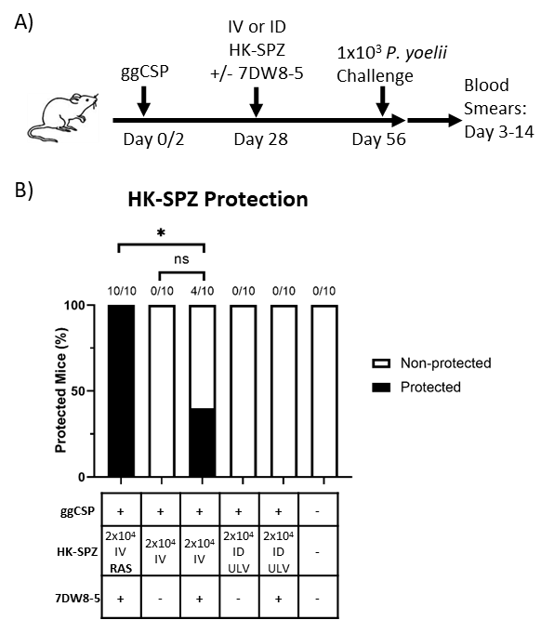
Supplementary Figure 4: HK-spz with or without 7DW8-5 are not protective in prime-and-trap.
A) Experimental design of prime-and-trap protection studies.
B) Results of protection studies after challenge with 1x10³ WT purified Py spz administered four weeks after trapping with 2x10⁴ HK-spz +/- 7DW8-5 administered IV or ID ULV (2.5 μL, X2 injections). 2x10⁴ IV RAS+7DW8-5 was used as positive control. Protection data from N=10 mice across two independent experiments and was analyzed with Fisher Exact Test, *p<0.05, ns p>0.05.

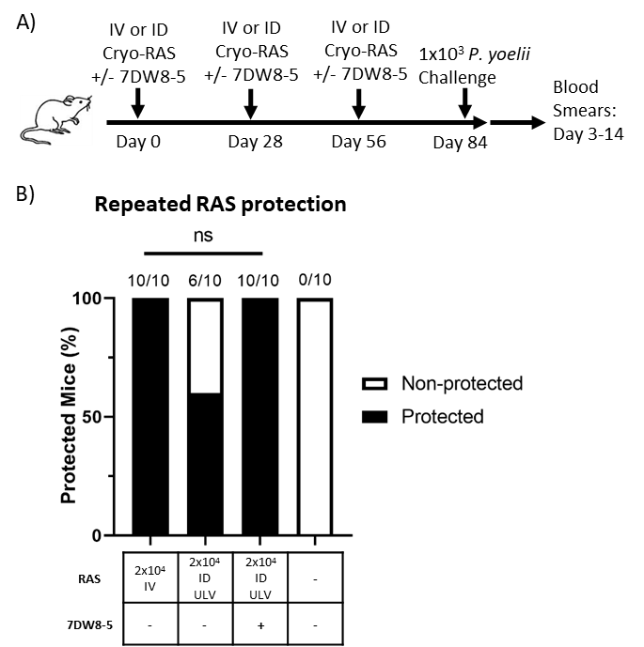
Supplementary Figure 5: 7DW8-5 potentiates ultra-low volume repeated ID-RAS only vaccination
A) Experimental design of repeated RAS protection studies.
B) Results of protection studies after challenge with 1x10³ WT purified Py spz administered four weeks after final RAS immunization. RAS was administered IV or ID ULV (2.5 μL, X2 injections) with or without 7DW8-5. Protection data from N=10 mice across two independent experiments and was analyzed with Fisher Exact Test, ns p>0.05 (p-value=0.08).

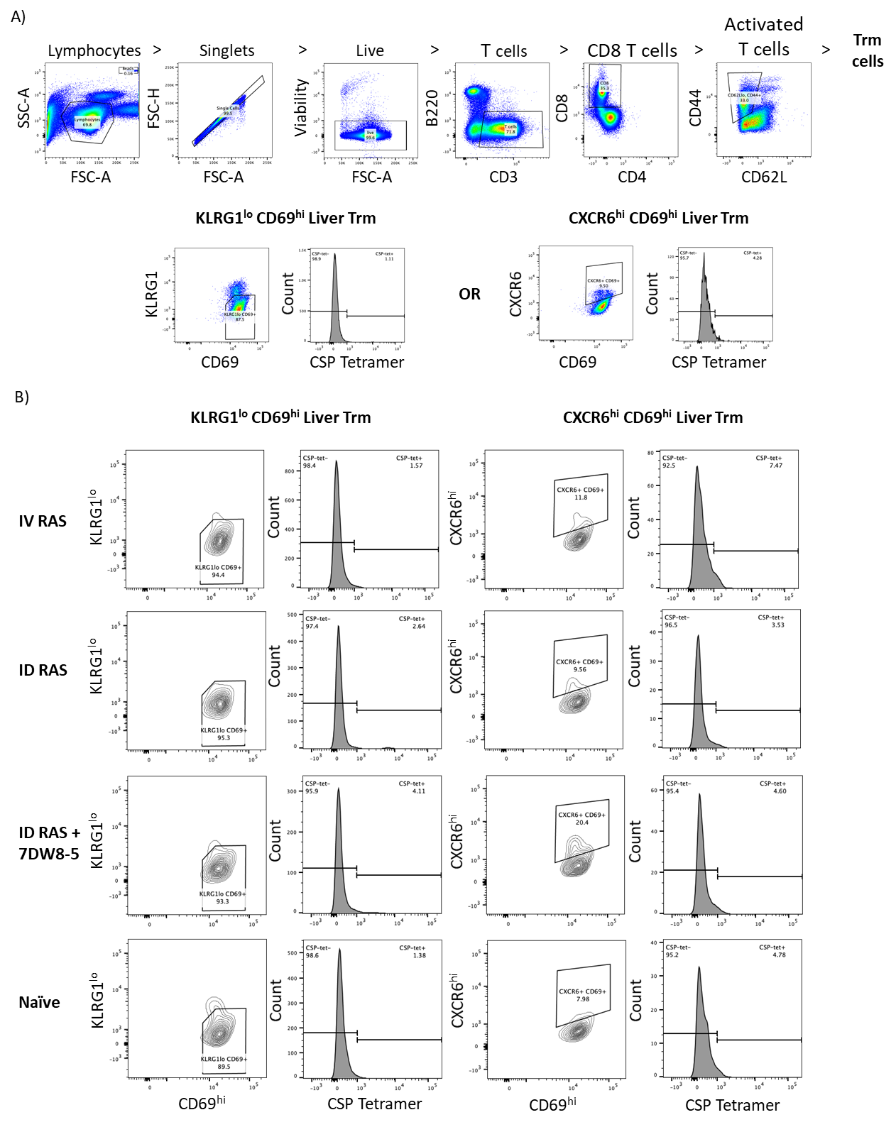
Supplementary Figure 6: Flow cytometry gating strategy for mouse cells
A) Flow cytometry liver cell gating strategies, one representative animal is shown.
B) CSP-specific CD8⁺ liver Trm cell gating strategies, one representative animal per group is shown.

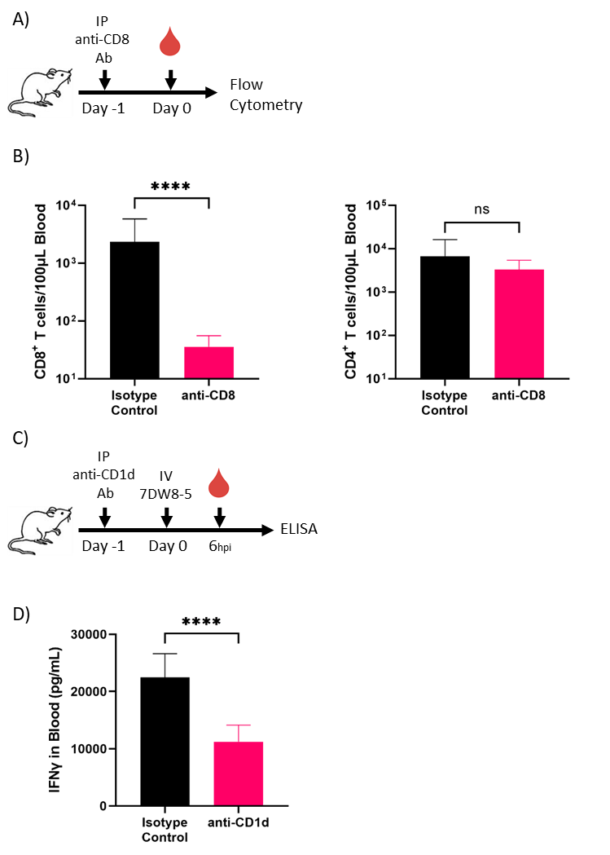
Supplementary Figure 7: Cell depletion/blocking confirmation
A) Experimental design of mouse whole blood leukocyte flow cytometry to confirm CD8 cell depletion at specified schedule and dose.
B) Flow cytometry of leukocytes from (A) mouse blood. Error bars represent SD of N=9 mice from one experiment. Mann–Whitney test, ****p<0.0001, ns p>0.05.
C) Experimental design of mouse blood plasma ELISA studies to confirm CD1d cell blocking at specified schedule and dose.
D) IFN-γ cytokine levels in plasma from (C) mouse blood. Error bars represent SD of N=10 mice from one experiment. Unpaired T test, ****p<0.0001.

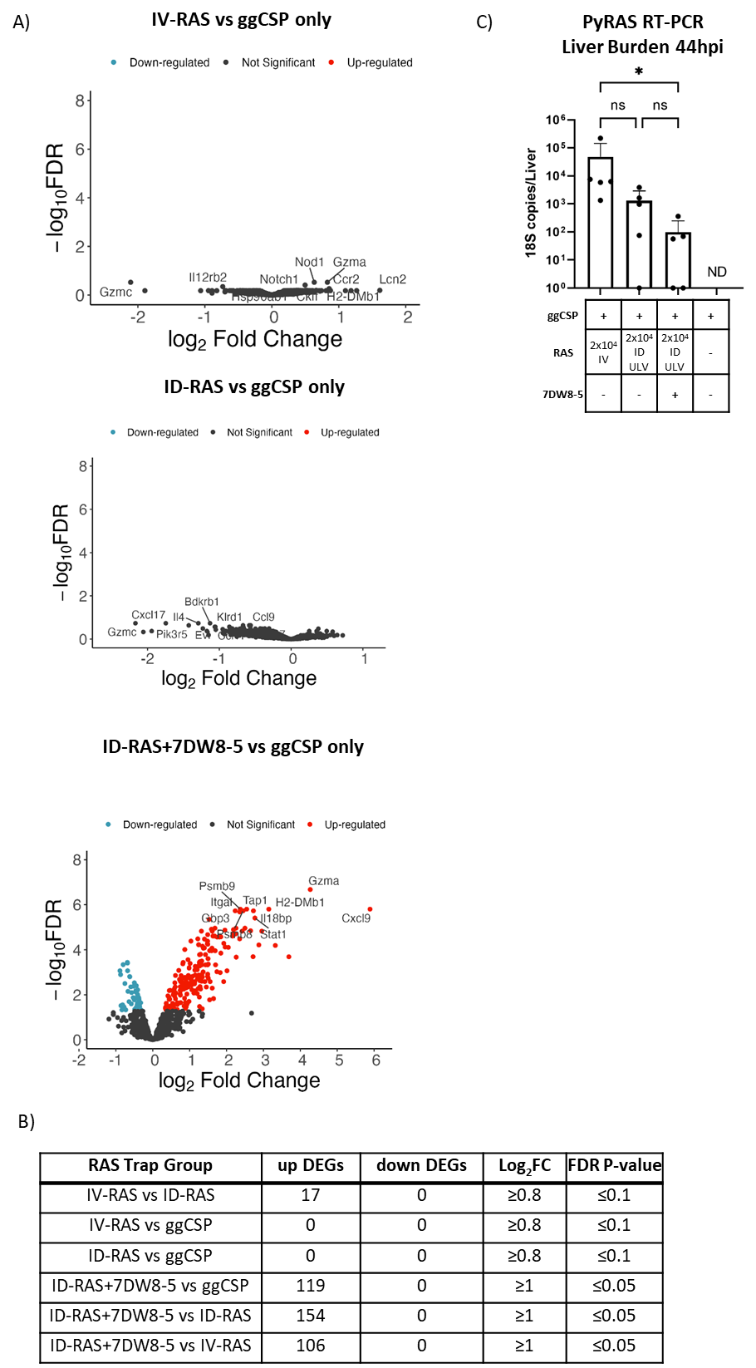
Supplementary Figure 8: Nanostring differentially expressed genes and parasite liver burden
A) Volcano plots of Figure 3F liver transcriptomic data. Only significance genes are highlighted, and the top 10 most significant genes are labeled. Significance defined as FDR Adj. p≤0.05 and log2 fold change of ±1.
B) Summary of differentially expressed genes (DEGs) for indicated groups.
C) Livers from Figure 3F were harvested 44 hours after trapping with RAS IV (100 μL) or ID ULV (2.5 μL, X2 injections) with or without 7DW8-5 and subjected to Nanostring analysis (Figure 3) or RT-PCR liver burden analysis (shown here). 18s pan Plasmodium primers were utilized to measure parasite liver burden. RT-PCR data are shown as absolute 18s rRNA copy numbers based on absolute calibrator. Error bars represent SD of mean of N=5 mice from one experiment. Data was analyzed with Kruskal-Wallis test with Dunn’s multiple comparisons, *p<0.05, ns p>0.05. ND=Not Detected

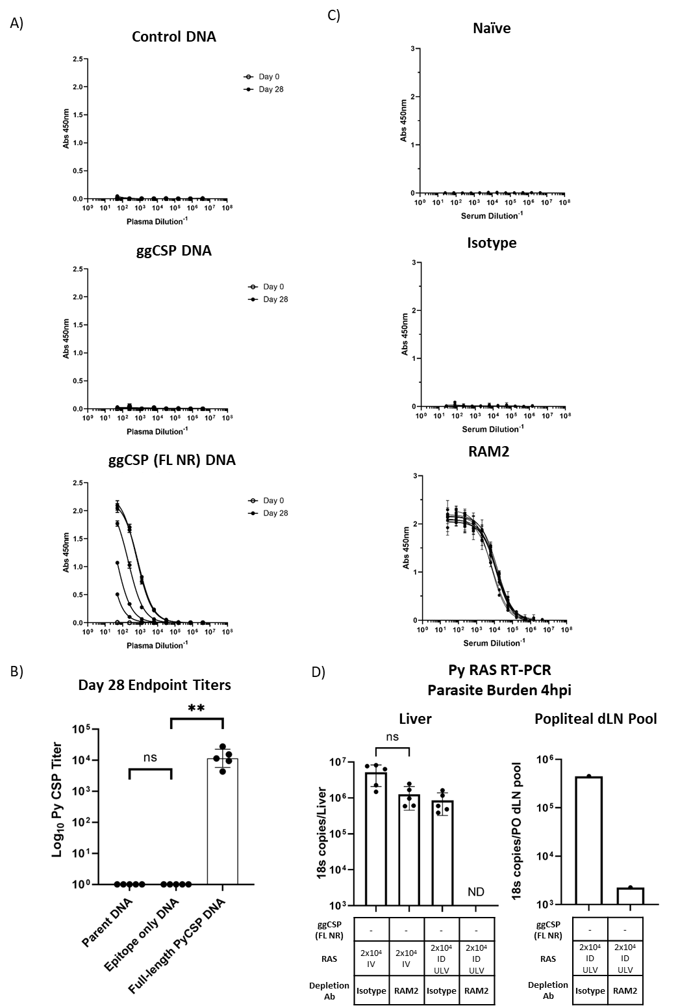
Supplementary Figure 9: PyCSP antibodies impact spz vaccination
A) Mice were primed with ggCSP, ggCSP (FL NR), or control DNA (pUb.3 plasmid backbone without the CSP insert). Serum was isolated from mouse blood on Day 0 and Day 28 for CSP ELISA analysis. Data reported as anti-CSP IgG titers.
B) Day 28 CSP ELISA endpoint titers from (A) mice. Error bars represent SD of mean of N=5 mice from one experiment. ELISA data was analyzed with Kruskal-Wallis test with Dunn’s multiple comparisons, **p<0.01, ns p>0.05.
C) Anti-RAM2 serum direct ELISA dilutions from a subset of isotype, RAM2, or naïve mice from Figure 5 mice.
D) Naïve mice were injected with 150µg RAM2 or isotype control mAb IP. 24 hours later, mice were immunized with cryo-RAS IV (100 μL) or ID ULV (2.5 μL, X2 injections). Four hours post injection livers (left), and popliteal draining lymph nodes (PO dLN) (right) were excised and processed for real-time reverse transcription polymerase chain reaction (RT-PCR) to measure parasite burden with18s pan Plasmodium primers. Error bars represent the SD of the mean of N=5 mice from one experiment. PO dLN samples were collected from the injected side of ID-RAS animals and samples were processed in a pool of N=5 mice. Data was analyzed with Kruskal-Wallis test with Dunn’s multiple comparisons, ns p>0.05. ND=Not Detected.

