Supplementary

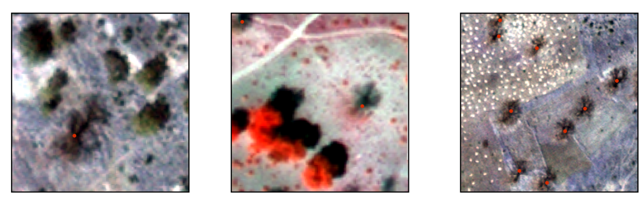
Fig. S1: Examples of baobab trees as seen in satellite imagery. The first and the last Skysat images are shown in true colors, while the second image is shown in false colors.

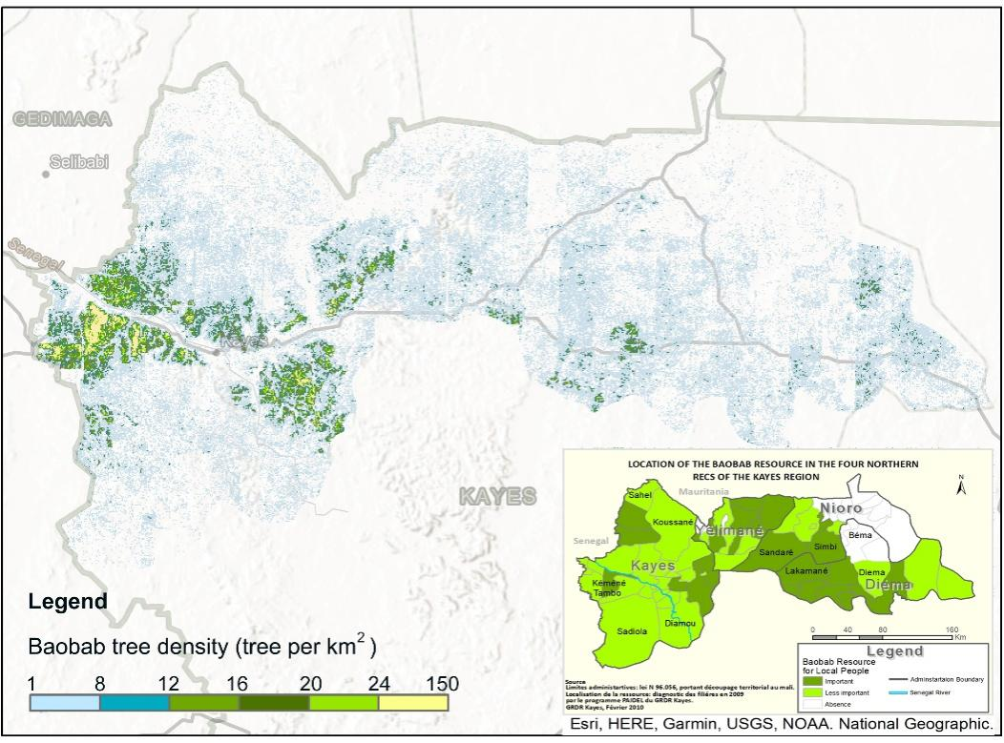

Fig. S2: Local report showing high density map of baobab trees in Kayes, Mali. This area was also detected by our study as a hotspot region of baobab trees: GRDR, 2012. La filière baobab en region de Kayes. Pour un développement économique garant de la souveraineté alimentaire.GRDR, Kayes, Mali. 2p.

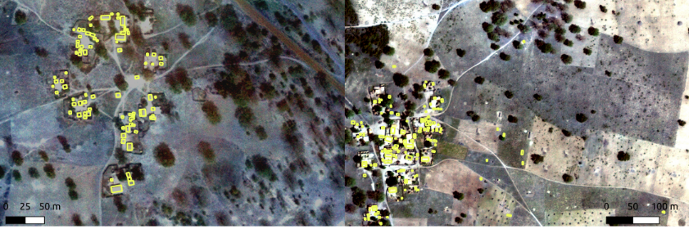

Fig. S3: Examples of Google building data showing buildings as yellow polygons superimposed on Skysat images. Inconsistencies with Skysat images may be a result of different image acquisition time

