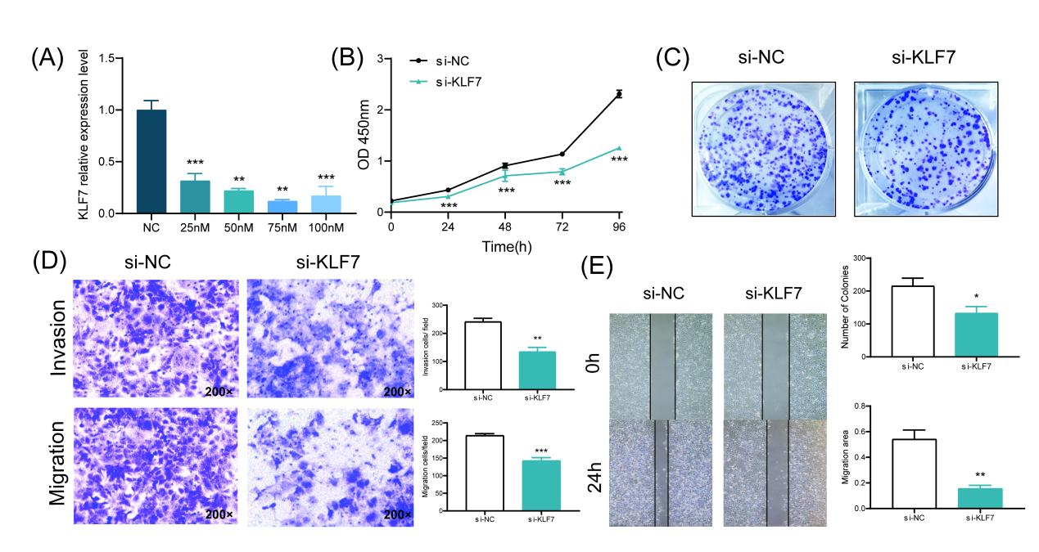
Figure S1. Effects of down-regulated KLF7 on biological behavior of EC cells.(A) The mRNA expression levels of KLF7 in Ishikawa cells after down-regulation of KLF7 with different concentrations si-KLF7 were detected by qRT-PCR. (B) CCK8 assay was used to detect the proliferation abilities of Ishikawa cells after down-regulated KLF7. (C) The colony formation ability of Ishikawa cells after down-regulation of KLF7 were detected by plate Colony assay. (D) The invasion and migration abilities of Ishikawa cells after down-regulation of KLF7 were detected by Transwell assay (200×). (E) The healing abilities of Ishikawa cells after down-regulation of KLF7 were detected by scratch experiment (40×). T-test, *P<0.05, **P<0.01, ***P<0.001 the difference was statistically significant.

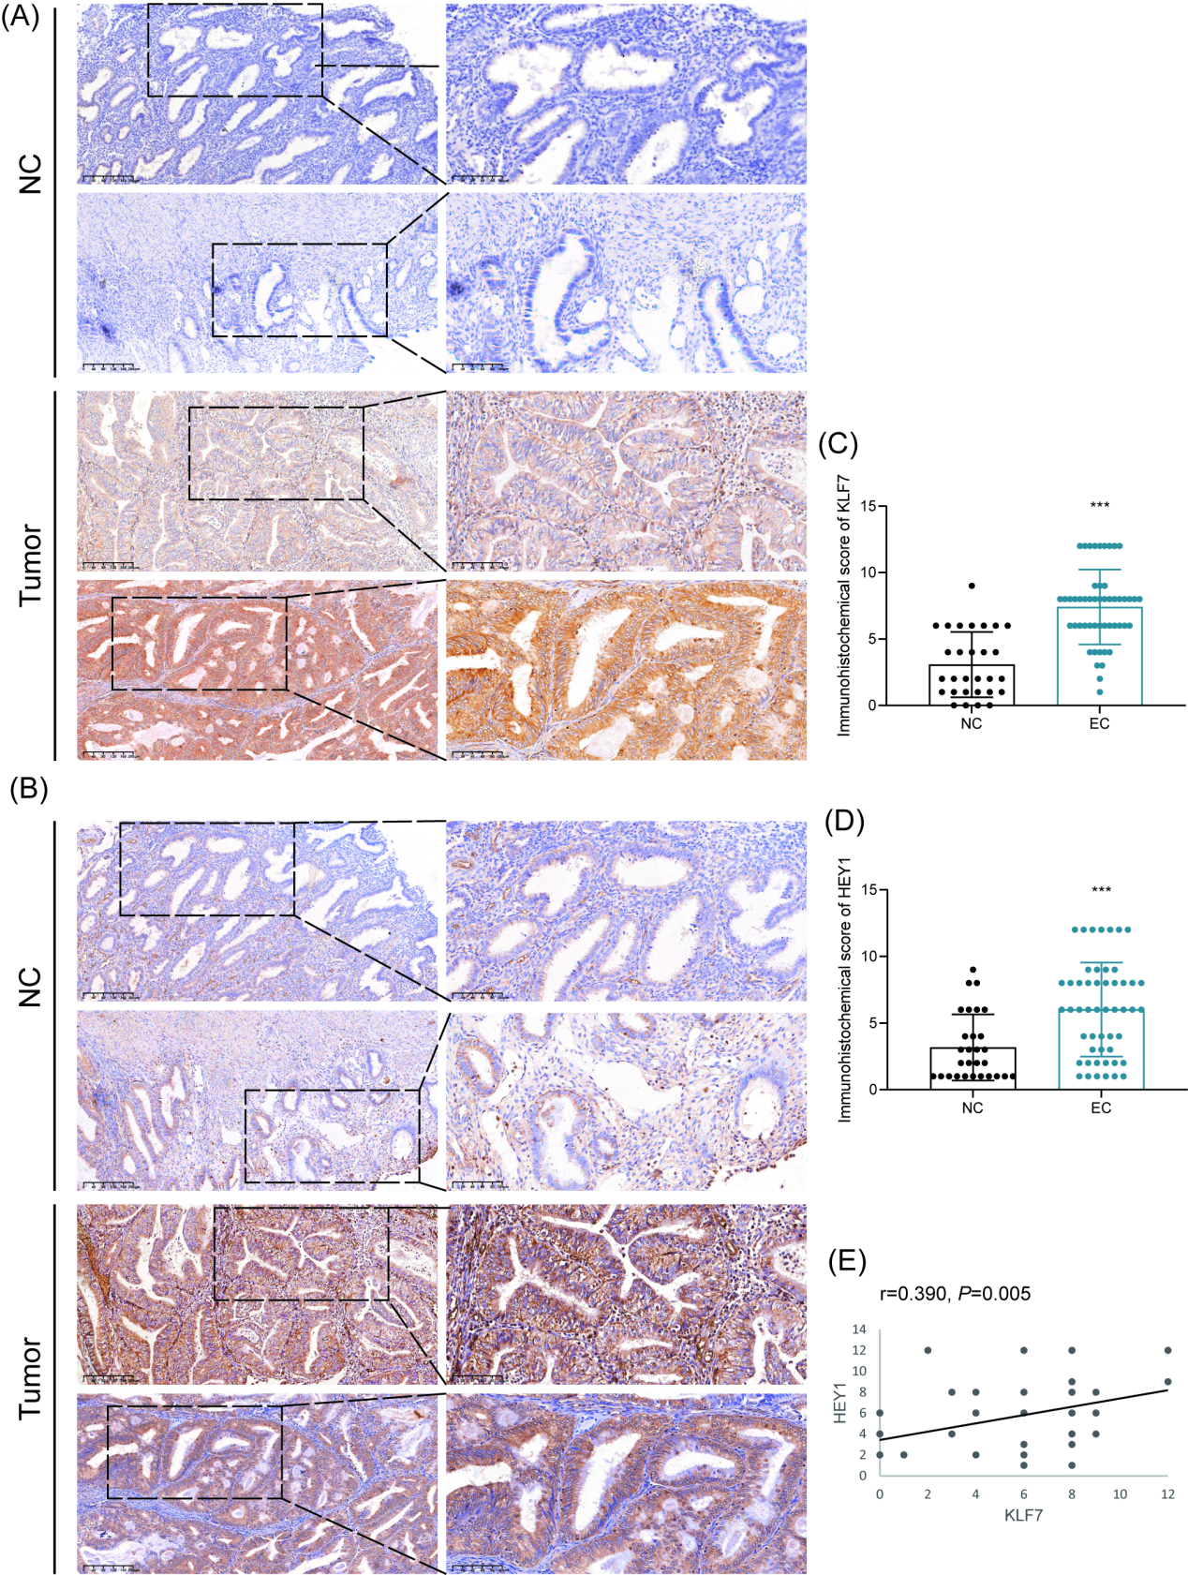
Figure S2. The expression levels of KLF7/HEY1 in tumor tissues of patients with EC. (A-B) Immunohistochemistry was used to detect the expression level of KLF7(A) and HEY1(B) in non-cancerous tissues and tumor tissues with EC (100×(up), 200×(down)). (C-D) Immunohistochemical score of KLF7(C) and HEY1(D). (E) The correlation between KLF7 and HEY1 expression levels in tumor tissue. T-test, Spearman correlation, ***P<0.001 the difference was statistically significant.

Table S1. The primer sequences
Primer | Sequences(5’→3’) | Size
Human-GPR40–F | GCTGCTCTGCGTAGGACCCTA | 125bp
Human-GPR40–R | CCAGCGGATTAAGCACCACACT | 125bp
Human-GPR120–F | ACCTCGGAACACCTCCTGGATG | 110bp
Human-GPR120–R | ATCTGGTGGCTCTCCGAGTAGG | 110bp
Human-KLF7-F | CTCAATGGTGGTGCTTGCTT | 233bp
Human-KLF7-R | TGGAAAACCTGCTCGCTCTA | 233bp
Human-HEY1–F | TGTCTGAGCTGAGAAGGCTGGT | 112bp
Human-HEY1–R | TTCAGGTGATCCACGGTCATCTG | 112bp
Human-IRX3–F | CTCCGCACCTGCTGGGACTTC | 116bp
Human-IRX3–R | CTCCACTTCCAAGGCACTACAG | 116bp
Human-FAM171A2–F | GGTGCTTATCCTGCTGTGTCTG | 118bp
Human-FAM171A2–R | CTGGTCTCGTTTGTTACCGTCAG | 118bp
Human-RHBDF2–F | CTACTGGCTGACCTTCGTCCAT | 137bp
Human-RHBDF2–R | ACTTCACGCTCTCGTACACACC | 137bp
Human-E-Cadherin–F | GCCTCCTGAAAAGAGAGTGGAAG | 131bp
Human-E-Cadherin–R | TGGCAGTGTCTCTCCAAATCCG | 131bp
Human- GAPDH-F | GGTGGTCTCCTCTGACTTCAA | 211bp
Human-GAPDH-R | TCTTCCTCTTGTGCTCTTGCT | 211bp
KLF7 (si-1)  KLF7-Homo-555 | GCCUUGAAUUGGAACGCUATT
KLF7 (si-1)  KLF7-Homo-555 | UAGCGUUCCAAUUCAAGGCTT

Table S2. Clinical features of benign lesions and EC
Index | Benign lesions (n=29) | EC (n=50)
BMI <24 | 68.97%(n=20) | 28.00%(n=14)
BMI 24-28 | 27.59%(n=8) | 46.00%(n=23)
BMI >28 | 3.44%(n=1) | 26.00%(n=13)
Mean BMI (range) | 22.96(21.64-24.61) | 26.10(23.67-27.98)***
TC (mmol/L) | 4.60(3.94-5.03) | 5.16(4.37-5.96)**
TG (mmol/L) | 1.09(0.81-1.42) | 1.41(0.99-2.05)
HDL (mmol/L) | 1.20(1.08-1.44) | 1.32(1.13-1.47)
LDL (mmol/L) | 2.55(2.14-3.08) | 3.09(2.49-3.69)**
GLU (mmol/L) | 4.85(4.46-5.15) | 5.78(5.44-7.30)***
FIGO stage:Ⅰ,Ⅱ | n=0 | n=45
FIGO stage: Ⅲ, Ⅳ | n=0 | n=5
Lymphatic metastasis | n=0 | n=1
Non- Lymphatic metastasis | n=29 | n=49
nonparametric rank sum test. **P<0.01, ***P<0.001

