Appendix A.
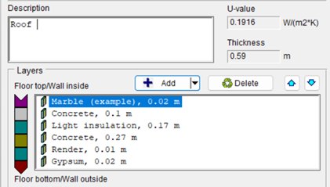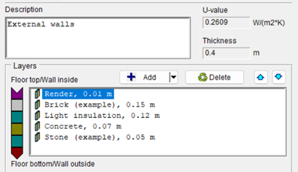
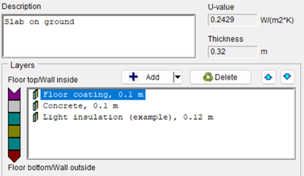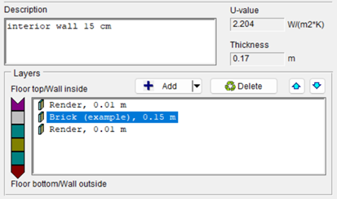
Figure A1. Detailed wall specification inputs on IDA ICE software (prototype 1,3B).
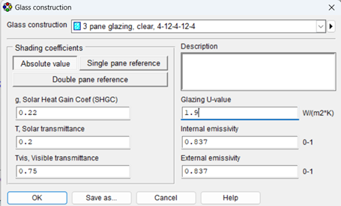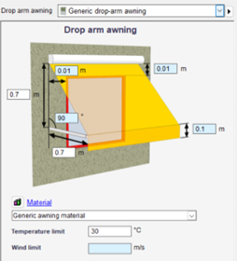
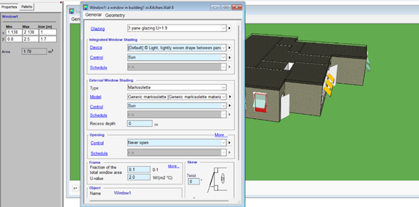
Figure A2. Detailed window specification inputs on IDA ICE software (prototype 1,3B).
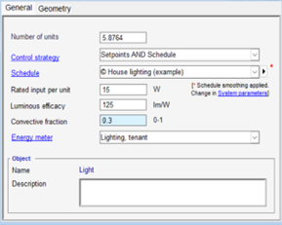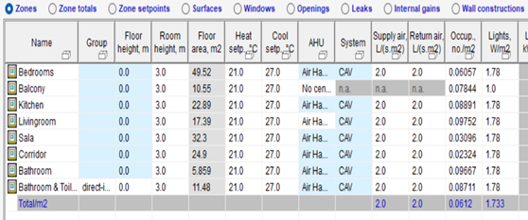
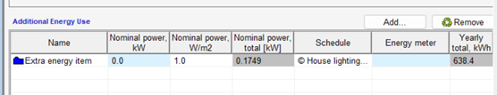
Figure A3. Interior and exterior lighting power densities for different units.
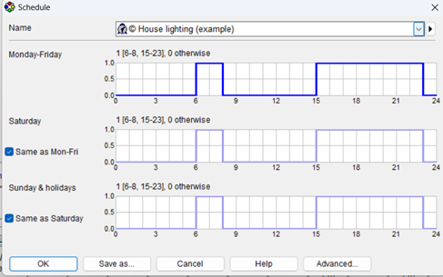
Figure A4. house lighting example (schedule).
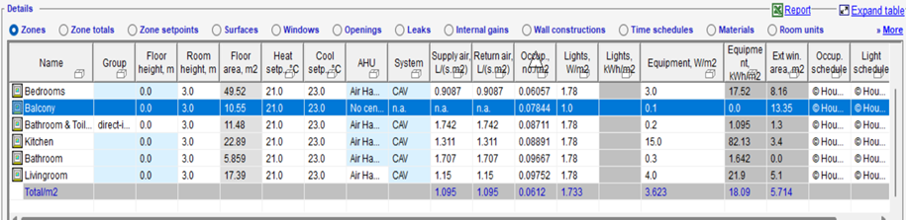
Figure A5. Estimated loads acceptable substitutes according to the Building America House Simulation Protocols report (Wilson et al. 2014 page 30).
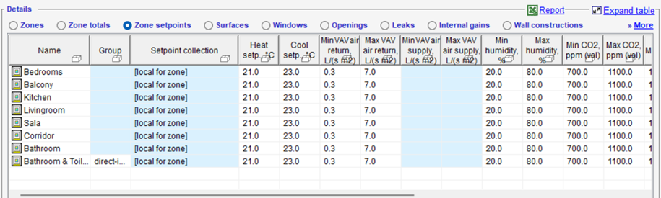
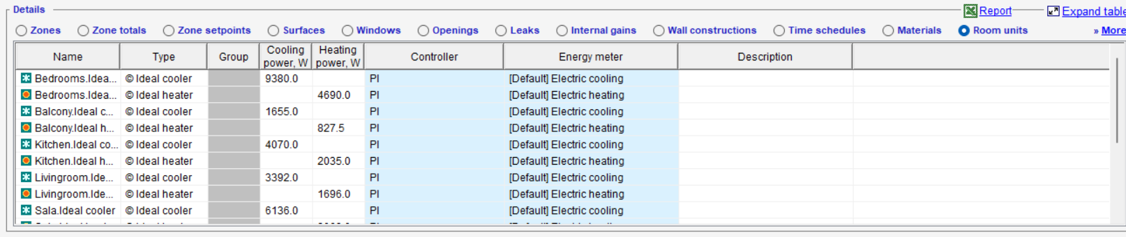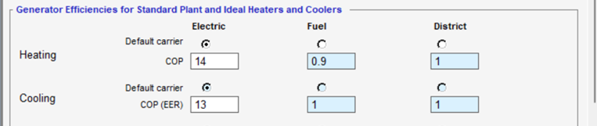
Figure A6. HVAC set points, controls, and operations inputs in IDA ICE.

