Supplementary information
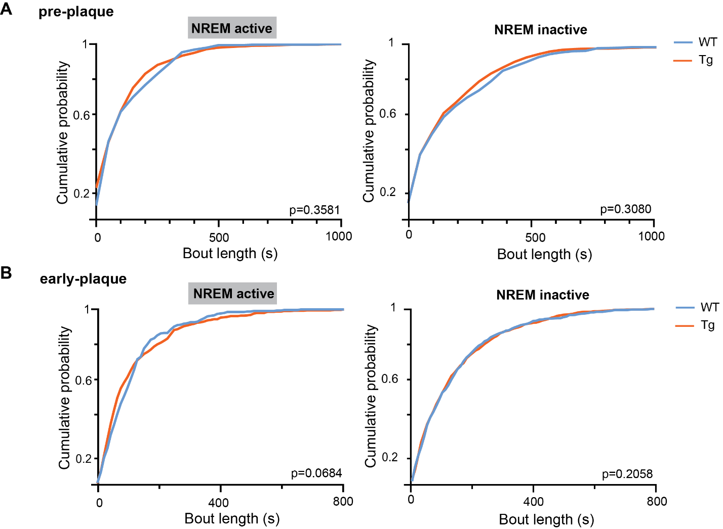
Supplementary figure 1: Cumulative distributions of NREM bout length during active and inactive phase
Cumulative probability plots of sleep bout lengths for each group. The left panels show the cumulative distribution of NREM bouts during the pre-plaque stage, while the right plot show the early-plaque stage. Kolmogorov-Smirnov tests (FDR p<0.05) were performed to evaluate if distributions were significantly different. s = seconds, WT = wildtype, Tg = TgF344-AD

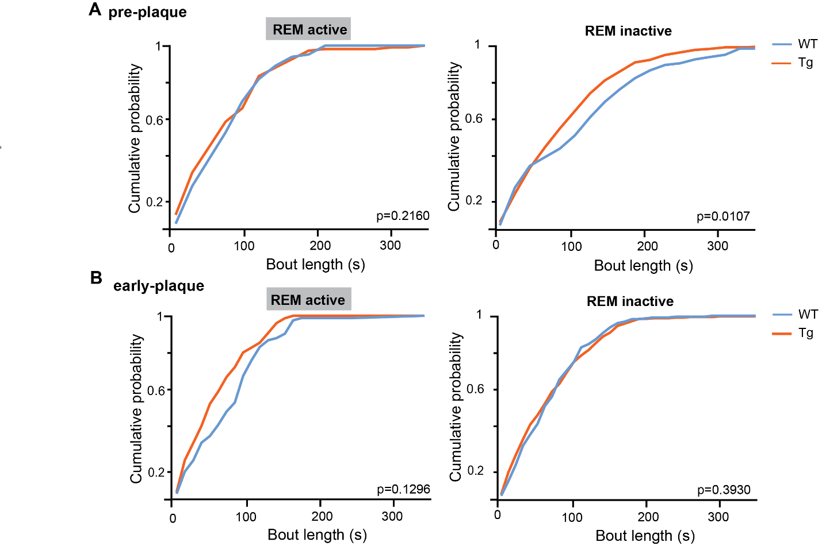Supplementary figure 2: Cumulative distributions of REM bout length during active and inactive phase
Cumulative probability plots of sleep bout lengths for each group. The left panels show the cumulative distribution of NREM bouts during the pre-plaque stage, while the right plot show the early-plaque stage. Kolmogorov-Smirnov tests (FDR p<0.05) were performed to evaluate if distributions were significantly different. s = seconds, WT = wildtype, Tg = TgF344-AD

Supplementary table 1: ANOVA of total time spent in REM and NREM during active and inactive phase
 | REM |  |  | NREM
 | Age*Genotype | Age | Genotype | Age*Genotype | Age | Genotype
Total | 0.0001 | 0.2006 | 0.0001 | 0.8864 | 0.0374 | 0.5804
Active | 0.4999 | 0.6531 | 0.1412 | 0.8714 | 0.5987 | 0.5380
Inactive | 0.1820 | 0.0185 | 0.4068 | 0.9649 | 0.0090 | 0.9826

Supplementary table 2: Post-hoc analysis total time spent in REM during 24 hours
 | Total REM time
 | p-values  (FDR p<0.05) | Difference | Lower 95% | Upper 95%
WT4M – TG4M | <0.0001 | 3.956 | 2.556 | 5.356
WT4M – WT6M | 0.0086 | 1.648 | 0.09668 | 3.199
TG4M – TG6M | 0.0001 | -2.578 | -3.979 | -1.178
WT6M – TG6M | 0.6087 | -0.2701 | -1.821 | 1.281

Supplementary table 3: ANOVA of time spent in certain vigilance state across 3-hour epochs
 | REM |  |  | NREM
 | Age*Gen | Age | Gen | Age*Gen | Age | Gen
Z0-Z3 | 0.7903 | 0.2547 | 0.0570 | 0.2782 | 0.0005 | 0.6065
Z3-Z6 | 0.2238 | 0.3733 | 0.9142 | 0.4225 | 0.0044 | 0.2446
Z6-Z9 | 0.5178 | 0.0042 | 0.4131 | 0.0306 | 0.1213 | 0.3107
Z9-Z12 | 0.2426 | 0.0156 | 0.7034 | 0.0029 | 0.0943 | 0.5875
Z12-Z15 | 0.7801 | 0.0707 | 0.5596 | 0.6259 | 0.9263 | 0.5405
Z15-Z18 | 0.0694 | 0.2561 | 0.0256 | 0.1922 | 0.2595 | 0.2781
Z18-Z21 | 0.3610 | 0.7949 | 0.0146 | 0.0255 | 0.2735 | 0.8959
Z21-Z24 | 0.5963 | 0.8334 | 0.0565 | 0.3014 | 0.7687 | 0.1419
Gen = genotype, Z = Zeitgeber

Supplementary table 4: post-hoc analysis time spent in NREM during inactive period
 | NREM Z6-Z9 |  |  |  | NREM Z9-Z12
 | p-values  (FDR p<0.05) | Diff | Lower 95% | Upper 95% | p-values  (FDR p<0.05) | Diff | Lower 95% | Upper 95%
WT4M – TG4M | 0.0486 | -9.0111 | -16.6796 | -1.3427 | 0.018 | 7.6111 | 2.1965 | 13.0258
WT4M – WT6M | 0.6163 | -1.9525 | -10.0864 | 6.1808 | 0.0092 | 9.8917 | 4.1486 | 15.3648
TG4M – TG6M | 0.0408 | 10.5667 | 2.8982 | 18.2351 | 0.2165 | -3.2778 | -8.6924 | 2.1369
WT6M – TG6M | 0.3724 | 3.5083 | -4.6253 | 11.6419 | 0.0759 | -5.5583 | -11.3014 | 0.1848
Z = Zeitgeber
Supplementary table 5: ANOVA results mean NREM bout length
 | Mean NREM bout length
 | Age*Genotype | Age | Genotype
Total | 0.7987 | 0.0001 | 0.9083
Active | 0.7160 | 0.0082 | 0.1482
Inactive | 0.3338 | 0.0014 | 0.1789

Supplementary table 6: results of ANOVA of power across different frequency bands during NREM
 | Delta | Gamma slow | Gamma fast | HFO
Genotype | 0.2762 | 0.5123 | 0.4396 | 0.1030
Age | 0.0011 | 0.1263 | 0.0121 | 0.2176
Genotype*Age | 0.8726 | 0.6217 | 0.4742 | 0.9901

Supplementary table 7: results of ANOVA of power, peak spectral frequency, and duration of SWR
 | Power | PSF | Duration
Genotype | 0.0604 | 0.9842 | 0.0088
Age | 0.3701 | 0.0851 | 0.6787
Genotype*Age | 0.3151 | 0.0379 | 0.6392

Supplementary table 8: post-hoc analysis of the peak spectral frequency of SWR
 | p-values (FDR p<0.05) | Difference | Lower 95% | Upper 95%
WT4M – TG4M | 0.2236 | -2.5086 | -5.6730 | 0.6558
WT4M – WT6M | 0.7676 | -0.4643 | -3.7529 | 2.8243
TG4M – TG6M | 0.0380 | 4.4113 | 1.24689 | 7.5758
WT6M – TG6M | 0.1944 | 2.3670 | -0.9215 | 5.6556

Supplementary table 9: results of ANOVA the ratio between short, medium, and long ripples vs all ripples
 | Short | Medium | Long
Genotype | 0.0473 | 0.4066 | 0.0160
Age | 0.8175 | 0.1253 | 0.6600
Genotype*Age | 0.3697 | 0.6751 | 0.1833

Supplementary table 10: results of ANOVA of vGLUT/vGAT ratio in hippocampal regions
 | CA1 | DG
Genotype | 0.1960 | 0.0215
Age | 0.0248 | 0.9538
Genotype*Age | 0.5347 | 0.9999

Supplementary table 11: ANOVA results mean REM bout length
 | Mean NREM bout length
 | Age*Genotype | Age | Genotype
Total | 0.0742 | 0.011 | 0.4436
Active | 0.3483 | 0.0486 | 0.2903
Inactive | 0.032 | 0.0003 | 0.4375

Supplementary table 12: post-hoc analysis of REM bout length during inactive phase
 | p-values  (FDR p<0.05) | Difference | Lower 95% | Upper 95%
WT4M – TG4M | 0.0588 | 19.9732 | 2.2842 | 37.6982
WT4M – WT6M | 0.0012 | 43.6893 | 23.3827 | 63.9958
TG4M – TG6M | 0.1551 | 13.0912 | -3.8238 | 31.6262
WT6M – TG6M | 0.3221 | -9.814+ | -30.1215 | 10.4916

Supplementary table 13: results of ANOVA of power across different frequency bands during REM
 | Delta | Theta low | Theta high | Gamma slow | Gamma fast
Genotype | 0.5371 | 0.9540 | 0.2591 | 0.8145 | 0.0455
Age | 0.4344 | 0.6698 | 0.0778 | 0.8184 | 0.0555
Genotype*Age | 0.5420 | 0.0444 | 0.1267 | 0.0594 | 0.2259

Supplementary table 14: results of ANOVA of PAC between theta and low and fast gamma frequencies
 | Slow gamma  (30-45 Hz) | Fast gamma  (80-110 Hz)
Genotype | 0.0945 | 0.0002
Age | 0.7953 | 0.0209
Genotype*Age | 0.0074 | 0.1506

Supplementary table 15: Post-hoc analysis of theta-slow gamma coupling
 | p-values (FDR p<0.05) | Difference | Lower 95% | Upper 95%
WT4M – TG4M | 0.0152 | -0.0045 | -0.0073 | -0.0017
WT4M – WT6M | 0.1036 | -0.0026 | -0.0055 | 0.0003
TG4M – TG6M | 0.049 | 0.0031 | 0.0045 | 0.0057
WT6M – TG6M | 0.3723 | 0.0011 | -0.0016 | 0.0040

Supplementary table 16: results of ANOVA of number of cholinergic synapses in hippocampal regions
 | CA1 | DG
Genotype | 0.0048 | 0.0001
Age | <0.0001 | <0.0001
Genotype*Age | 0.0180 | 0.0003

Supplementary table 17: post-hoc analysis of number of cholinergic synapses in the CA1 and DG
 | CA1 |  |  |  | DG
 | p-values (FDR p<0.05) | Diff | Lower 95% | Upper 95% | p-values (FDR p<0.05) | Diff | Lower 95% | Upper 95%
WT 4M–TG 4M | 0.6660 | -67.333 | -388.75 | 254.079 | 0.7170 | -53.70 | -508.69 | 401.291
WT 4M– WT 6M | 0.0792 | -307.944 | -629.36 | 13.467 | 0.0570 | -528.72 | -962.54 | -94.906
TG 4M–TG 6 M | 0.0004 | -995.122 | -1221.22 | -547.023 | 0.0002 | -1265.50 | -1740.72 | -790.278
WT 6M–TG 6M | 0.0016 | -643.511 | -980.61 | -306.411 | 0.0004 | -790.48 | -1245.47 | -335.487

