Supplementary
Table 1S. Alpha diversity index (Shannon) and richness (Chao1) of bacteria and fungi at genus level in water from the Schlema-Alberoda mine (R2; R4 and R5) and the Pöhla mine (P1; P2 and P5).

 |  | Shannon | Chao1
 | P1 | 3.064 | 220
 | P2 | 3.091 | 217
 | P5 | 3.123 | 224
Bacteria
 | R2 | 2.699 | 187
 | R4 | 2.540 | 182
 | R5 | 2.589 | 169
 | P1 | 2.666 | 42
 | P2 | 2.192 | 42
 | P5 | 1.871 | 30
Fungi
 | R2 | 0.961 | 29
 | R4 | 0.860 | 34
 | R5 | 0.830 | 23

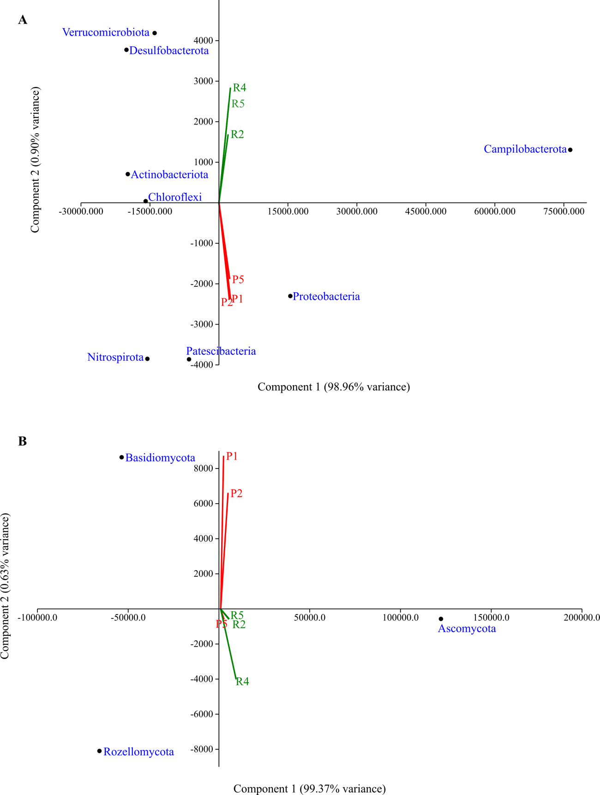Fig. 1S. Principal component analysis (PCA) plot of bacterial (A) and fungal (B) communities at phylum level comparing the microbial community structure of the mine water from the Schlema-Alberoda (R2; R4; R5) and Pöhla mines (P1; P2; P5). Colour in print.

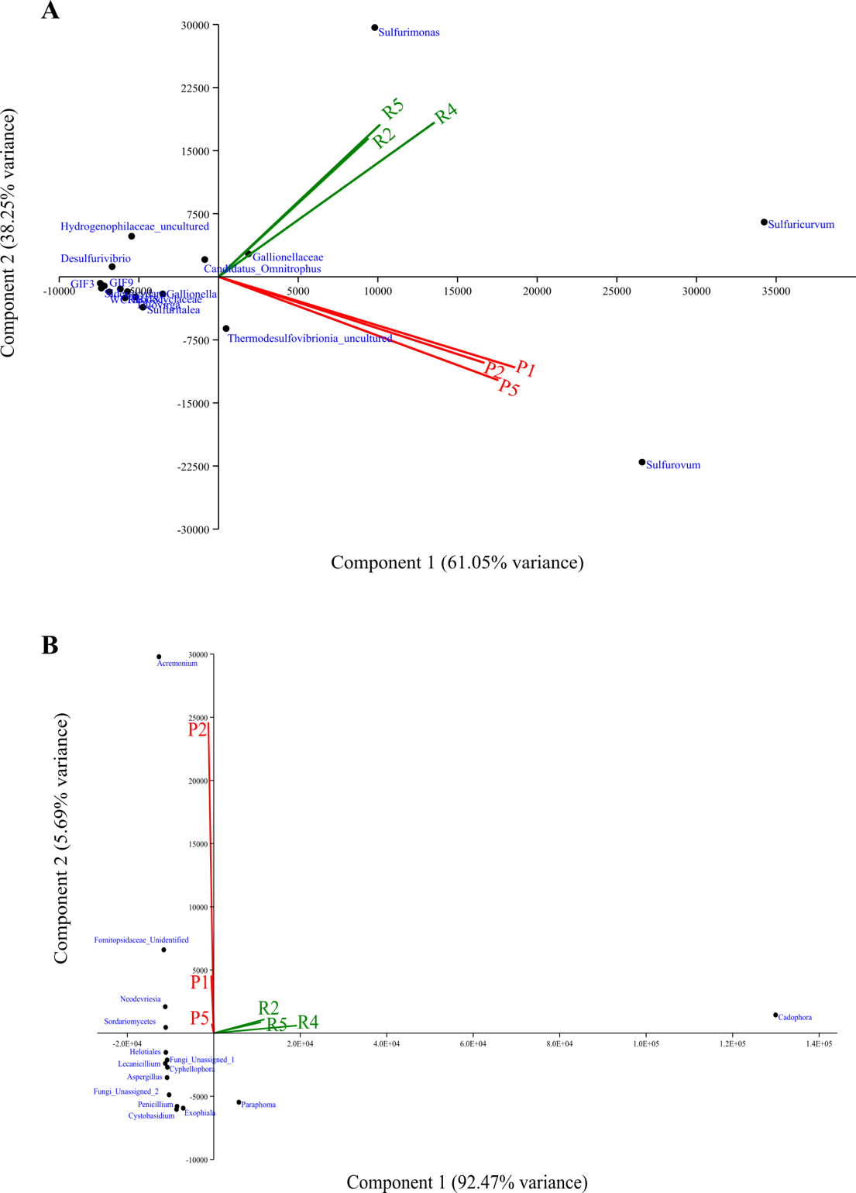
Fig. 2S. Principal component analysis (PCA) plot of bacterial (A) and fungal (B) communities at genus level comparing the microbial community structure of the mine water from the Schlema-Alberoda mine (R2; R4; R5) and the Pöhla mine (P1; P2; P5). Colour in print.

