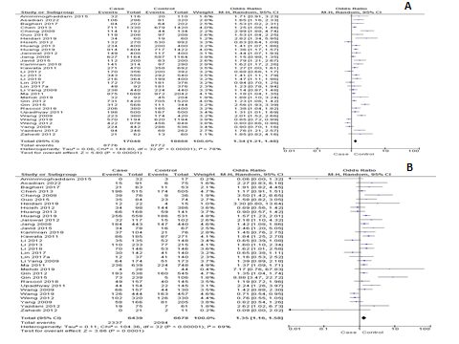
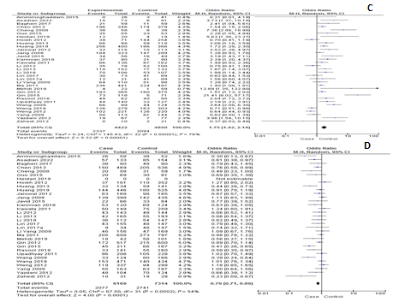
Fig: Forest plot of the association between the -31G/C polymorphism and the cancer risk in asian ancestry on the basis of different models. (A) C vs G, (B) CC vs CG, (C) CC vs GG, (D) GG vs CG, (E) CC+CG vs GG, (F) CG+GG vs CC and (G) CC+GG vs CG
