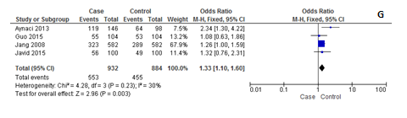
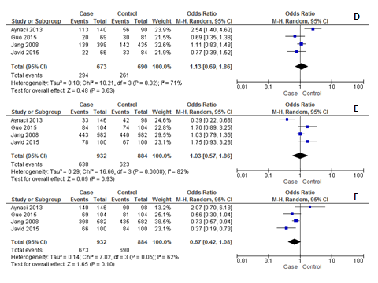
Fig: Forest plot of the stratified analysis of survivin gene SNP -31G/C on the basis of different genotype model in Respiratory system. (A) C vs G, (B) CC vs CG, (C) CC vs GG, (D) GG vs CG, (E) CC+CG vs GG, (F) CG+GG vs CC and (G) CC+GG vs CG

