Figure. S1 Mulliken Population charges with respect to atoms of M1069 (a) Before docking, (b) After docking with HSA and (c) After docking with A2AAR

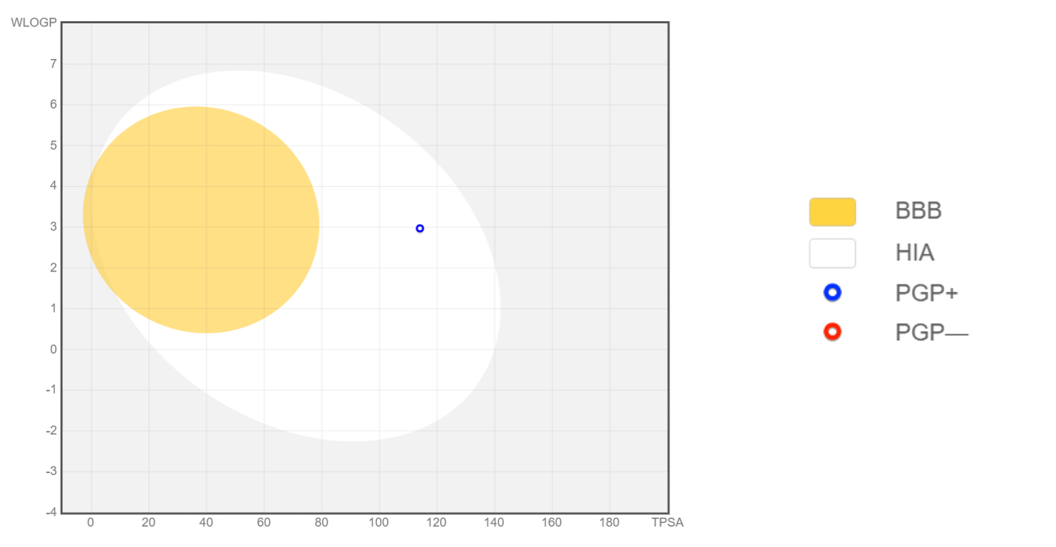
Figure. S2 Boiled egg of drug molecule (M1069), yellow region indicating the pathway of the drug through BBB, similarly white region representing the pathway through gastric intact.

