Additional file 1: Table S1: PRISMA checklist
Section/topic | # | Checklist item | Reported on page #
TITLE
Title | 1 | Identify the report as a systematic review, meta-analysis, or both. | Page 1
ABSTRACT
Structured summary | 2 | Provide a structured summary including, as applicable: background; objectives; data sources; study eligibility criteria, participants, and interventions; study appraisal and synthesis methods; results; limitations; conclusions and implications of key findings; systematic review registration number. | Pages 3–5
INTRODUCTION
Rationale | 3 | Describe the rationale for the review in the context of what is already known. | Pages 6–7
Objectives | 4 | Provide an explicit statement of questions being addressed with reference to participants, interventions, comparisons, outcomes, and study design (PICOS). | Pages 7–8
METHODS
Protocol and registration | 5 | Indicate if a review protocol exists, if and where it can be accessed (e.g., Web address), and, if available, provide registration information including registration number. | N/A
Eligibility criteria | 6 | Specify study characteristics (e.g., PICOS, length of follow-up) and report characteristics (e.g., years considered, language, publication status) used as criteria for eligibility, giving rationale. | Page 8
Information sources | 7 | Describe all information sources (e.g., databases with dates of coverage, contact with study authors to identify additional studies) in the search and date last searched. | Pages 9–10
Search | 8 | Present full electronic search strategy for at least one database, including any limits used, such that it could be repeated. | Page 9
Study selection | 9 | State the process for selecting studies (i.e., screening, eligibility, included in systematic review, and, if applicable, included in the meta-analysis). | Pages 8–9
Data collection process | 10 | Describe method of data extraction from reports (e.g., piloted forms, independently, in duplicate) and any processes for obtaining and confirming data from investigators. | Pages 11–12
Data items | 11 | List and define all variables for which data were sought (e.g., PICOS, funding sources) and any assumptions and simplifications made. | Page 10
Risk of bias in individual studies | 12 | Describe methods used for assessing risk of bias of individual studies (including specification of whether this was done at the study or outcome level), and how this information is to be used in any data synthesis. | Pages 10–11
Summary measures | 13 | State the principal summary measures (e.g., risk ratio, difference in means). | Pages 8, 11–12
Synthesis of results | 14 | Describe the methods of handling data and combining results of studies, if done, including measures of consistency (e.g., I²) for each meta-analysis. | Page 11

Section/topic | # | Checklist item | Reported on page #
Risk of bias across studies | 15 | Specify any assessment of risk of bias that may affect the cumulative evidence (e.g., publication bias, selective reporting within studies). | Page 12
Additional analyses | 16 | Describe methods of additional analyses (e.g., sensitivity or subgroup analyses, meta-regression), if done, indicating which were pre-specified. | Page 11
RESULTS
Study selection | 17 | Give numbers of studies screened, assessed for eligibility, and included in the review, with reasons for exclusions at each stage, ideally with a flow diagram. | Pages 12–13; Figure 1
Study characteristics | 18 | For each study, present characteristics for which data were extracted (e.g., study size, PICOS, follow-up period) and provide the citations. | Page 13
Risk of bias within studies | 19 | Present data on risk of bias of each study and, if available, any outcome level assessment (see item 12). | Page 16; Table S1
Results of individual studies | 20 | For all outcomes considered (benefits or harms), present, for each study: (a) simple summary data for each intervention group (b) effect estimates and confidence intervals, ideally with a forest plot. | Pages 13–16; Figures 2–5
Synthesis of results | 21 | Present results of each meta-analysis done, including confidence intervals and measures of consistency. | Pages 13–16; Figures 2–5
Risk of bias across studies | 22 | Present results of any assessment of risk of bias across studies (see Item 15). | Pages 16–17
Additional analysis | 23 | Give results of additional analyses, if done (e.g., sensitivity or subgroup analyses, meta-regression [see Item 16]). | Page 17
DISCUSSION
Summary of evidence | 24 | Summarize the main findings including the strength of evidence for each main outcome; consider their relevance to key groups (e.g., healthcare providers, users, and policy makers). | Page 18
Limitations | 25 | Discuss limitations at study and outcome level (e.g., risk of bias), and at review-level (e.g., incomplete retrieval of identified research, reporting bias). | Pages 24–27
Conclusions | 26 | Provide a general interpretation of the results in the context of other evidence, and implications for future research. | Page 27
FUNDING
Funding | 27 | Describe sources of funding for the systematic review and other support (e.g., supply of data); role of funders for the systematic review. | Page 29
PRISMA, Preferred Reporting Items for Systematic Reviews and Meta-analyses

Additional file 1: Table S2: Quality assessment of studies using the Newcastle-Ottawa Scale.
Source |  |  | Selection |  |  |  |  | Comparability |  | Outcome
Source | Total Score |  | Representative of the exposed cohort | Selection of the non- exposed cohort | Ascertainment of exposure | Demonstrate that outcome of interest was not present at start of study |  | Comparability of cohorts on the basis of design or analysis (variables) |  | Assessment of outcome | Was follow-up long enough for outcomes to occur? | Adequacy of follow-up of cohorts
Gearhart 2020 | 9 |  | 1 | 1 | 1 | 1 |  | 2 |  | 1 | 1 | 1
Okabe 2019 | 8 |  | 1 | 1 | 1 | 1 |  | 1 |  | 1 | 1 | 1
Pandit 2018 | 9 |  | 1 | 1 | 1 | 1 |  | 2 |  | 1 | 1 | 1
Souwer 2018 | 7 |  | 1 | 1 | 1 | 1 |  | 0 |  | 1 | 1 | 1
Ugolini 2015 | 7 |  | 1 | 1 | 1 | 1 |  | 0 |  | 1 | 1 | 1
Ommundsen 2014 | 9 |  | 1 | 1 | 1 | 1 |  | 2 |  | 1 | 1 | 1
Reisinger 2015 | 7 |  | 1 | 1 | 1 | 1 |  | 0 |  | 1 | 1 | 1
Neuman 2013 | 7 |  | 1 | 1 | 1 | 1 |  | 0 |  | 1 | 1 | 1
Tan 2012 | 8 |  | 1 | 1 | 1 | 1 |  | 0 |  | 1 | 1 | 1
Kristjansson 2010 | 9 |  | 1 | 1 | 1 | 1 |  | 2 |  | 1 | 1 | 1

Additional file 1: Table S3: Leave-one-out sensitivity analysis for prevalence of frailty.
Study/ subgroup omitted | Prevalence of frailty (%) | 95% CI (%) | tau² | I² (%)
Gearhart 2020 | 25.00 | 14.92–38.78 | 0.82 | 99.4
Okabe 2019 | 25.56 | 15.24–39.61 | 0.84 | 99.5
Pandit 2018 | 24.97 | 14.91–38.73 | 0.82 | 98.6
Souwer 2018 | 27.65 | 17.06–41.53 | 0.77 | 99.5
Ugolini 2015 | 23.46 | 14.62–35.44 | 0.68 | 99.5
Ommundsen 2014 | 24.12 | 14.64–37.07 | 0.76 | 99.5
Reisinger 2015 | 26.00 | 15.54–40.16 | 0.84 | 99.5
Neuman 2013 | 31.31 | 24.88–38.55 | 0.18 | 95.8
Tan 2012 | 25.75 | 15.40–39.78 | 0.83 | 99.6
CI, confidence interval.

Additional file 1: Table S4: Leave-one-out sensitivity analysis for risk estimate of frailty on severe complications.
Study/ subgroup omitted | OR | 95% CI | P value | tau² | I² (%)
Gearhart 2020 | 3.25 | 2.00–5.28 | <0.01 | 0.000 | 0
Okabe 2019 | 2.05 | 1.0 –4.15 | <0.05 | 0.202 | 76.0
Kristjansson 2010 | 2.11 | 0.96–4.63 | NS | 0.251 | 75.2
OR, odds ratio; CI, confidence interval; NS, non-significant.

Additional file 1: Table S5: Leave-one-out sensitivity analysis for risk estimate of frailty on 30-day/ inpatient postoperative mortality.
Study/ subgroup omitted | OR | 95% CI | P value | tau² | I² (%)
Pandit 2018 | 2.31 | 0.25–21.64 | NS | 1.735 | 66.3
Souwer 2018 | 1.19 | 0.89–1.58 | NS | 0.000 | 0
Reisinger 2015 | 2.33 | 0.45–12.01 | NS | 1.118 | 75.6
OR, odds ratio; CI, confidence interval; NS, non-significant.

Additional file 1: Table S6: Leave-one-out sensitivity analysis for risk estimate of frailty on postoperative mortality during 12 months.
Study/ subgroup omitted | OR | 95% CI | P value | tau² | I² (%)
Souwer 2018 | 5.41 | 1.93–15.14 | <0.01 | 0.450 | 79.1
Ommundsen 2014 | 8.43 | 6.44–11.02 | <0.01 | 0.000 | 0
Neuman 2013 | 4.33 | 1.43–13.05 | <0.01 | 0.262 | 36.9
OR, odds ratio; CI, confidence interval; NS, non-significant.

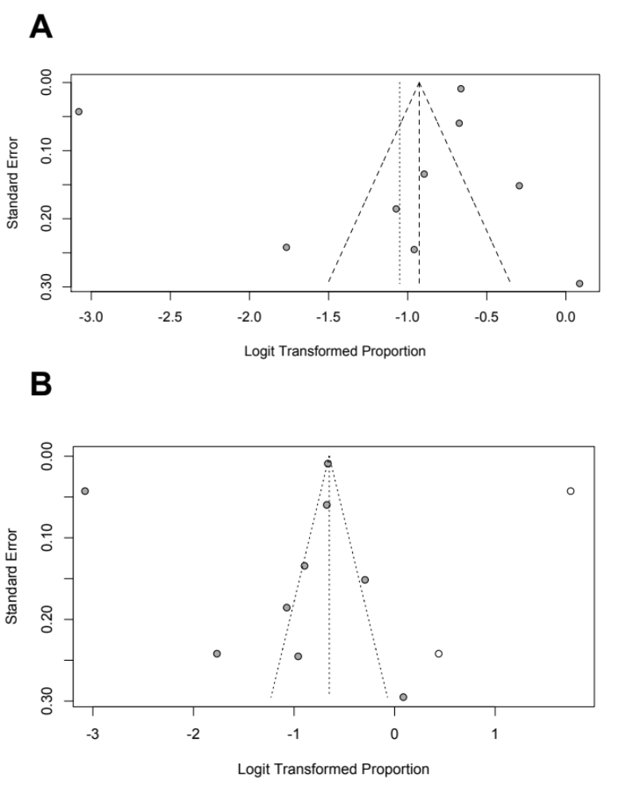
Additional file 1: Figure S1: Funnel plot evaluating publication bias in the meta-analysis on (A) prevalence of frailty in patients receiving surgery for colorectal cancer. (B) Duval-Tweedie’s trim and fill test suggesting trivial publication bias by filling 2 additional studies (adjusted prevalence rate: 34.3%; 95% confidence interval: 20.58–51.57, P <0.01; I² = 99.8%).

