Supplementary material:
Tables and figures:

S.No | District | Coordinates | NARP ACZ | Kharif - Rainfed Rice sowing window | Soil type
1 | Betul | 21° 22' to 22° 24' N, 77° 10' to 78° 33' E. Elevation: 658m | Satpura Plateau Zone (MP-9) | 3rd week of June-  4th week of July | Shallow Black Soil
2 | Alirajpur | 22° 18’ 19’’ N, 74° 21′ 9′′ E  Elevation: 777m | Jhabua Hills Zone | 4th week of June to Mid-July | Entisols, shallow to medium deep soils
3 | Raisen | 22° 47' to 23° 33' N, 77° 21' to 78° 49' E  Elevation: 402m | Vindhya Plateau Zone (MP-5) | 4th week of June to 3rd week of July | Medium Black Soil
4 | Shahdol | 23° 18' N, 81° 21' E  Elevation: 464m | North Hill Zone of Chattisgarh (MP-3) | 2nd week of June to 3rd week of July | Clayey loam and sandy loam soil
5 | Rewa | 22° 38’ to 24° 20’ N, 80° 28’ to 82° 12’ E  Elevation: 450m | Kymore Plateau and Satpura Hill Zone (MP-4) | 3rd week of June to 2nd week of July | Red & Black Soil
6 | Mandla | 22° 20' to 23° 22' N, 80° 18' to 81° 50' E  Elevation: 280m | North Hill Zone of Chattisgarh (MP-3) | 2nd week of June to 2nd week of July | Gravelly Soil
7 | Damoh | 23° 09' to 24° 27' N, 79° 03' to 79° 57' E  Elevation: 595m | Vindhya Plateau Zone (MP-5) | Transplanting from 2nd week of July to 4th week of July | Medium Black Soil
8 | Panna | 23° 45' to 25° 10' N, 79° 45' to 80° 40' E  Elevation: 410m | Bundelkhand Zone (MP-8)-64%, Kymore Plateau and Satpura Hill Zone (MP-4)-32% | 3rd week of June to 3rd week of July | Red & Black Soil
9 | Singrauli | 22° 47' to 24° 42' N, 81° 18' to 82° 48' E  Elevation: 463m | Kymore Plateau and Satpura Hill Zone (MP-4) | 3rd week of June to 2nd week of July | Red soil, Alluvial & Lateritic soil
10 | Dindori | 22° 17' to 23° 22' N, 80° 35' to 81° 58' E  Elevation: 640m | North Hill Zone of Chattisgarh (MP-3) | 2nd week of June – 2nd week of July | Gravelly Soil
Table.1. Details of study locations

S. No. | Genetic coefficients (Parameter definition) | Unit | IR-36
1. | Time period (expressed as growing degree days GDD in °C above a base temperature of 9 °C) from seedling emergence during which the rice plant is not responsive to changes in photoperiod. This period is referred to as the basic vegetative phase of the plant (P1) | GDD (°C days or °D) | 450.0
2. | Extent to which phasic development leading to panicle initiation is delayed (expressed as GDD in °C) for each hour increase in photoperiod above P2O (P2R) | GDD (°C days or °D) | 160.0
3. | Critical photoperiod or the longest day length (in hours) at which the development occurs at a maximum rate. At values higher than P2O developmental rate is slowed, hence there is delay due to longer day lengths (P2O) | h | 11.0
4. | Time period (in GDD °C) from beginning of grain filling (3 to 4 days after flowering) to physiological maturity with a base temperature of 9 °C (P5) | GDD (°C days or °D) | 500.0
5. | Potential spikelet number coefficient as estimated from the number of spikelets per g of main culm dry weight (less lead blades and sheaths plus spikes) at anthesis. (G1) | - | 41.0
6. | Single grain weight (g) under ideal growing conditions, i.e., non-limiting light, water, nutrients, and absence of pests and diseases (G2) | mg | 0.021
7. | Tillering coefficient (scaler value) relative to IR-64 cultivar under ideal conditions. A higher tillering cultivar would have coefficient greater than 1.0 (G3) | - | 1.00
8. | Temperature tolerance coefficient (G4). Usually 1.0 for varieties grown in normal environments. G4 for japonica type rice growing in a warmer environment would be 1.0 or greater. Likewise, the G4 value for indica type rice in very cool environments or season would be less than 1.0. THOT is Temperature (°C) above which spikelet sterility is affected by high temperature. Range 25-34°C. Default 28°C. Calibration: recommended to not change unless hot environment data are available. Converted old cultivars THOT = 28/G4. | °C | G4=1.00; THOT=28
9. | TCLDP: Temperature (°C) below which panicle initiation is further delayed (other than P1, P2O and P2R) by low temperature. Range 12-18°C. Default 15°C. | °C | Taken as default 15°C
10. | TCLDF: Temperature (°C) below which spikelet sterility is affected by low temperature. Range 10-20 °C. Default 15°C. | °C | Taken as default 15°C
Table.2. Modified genetic coefficients of rice variety (IR 36), utilized in DSSAT v.4.8

Year | 2017 |  | 2018 |  | 2019 |  | 2020 |  | 2021
Month | >115.6  and  <204.5 | >204.5 | >115.6  and  <204.5 | >204.5 | >115.6  and  <204.5 | >204.5 | >115.6  and  <204.5 | >204.5 | >115.6  and  <204.5 | >204.5
Jun | 248 | 36 | 380 | 64 | 211 | 52 | 262 | 36 | 277 | 35
Jul | 709 | 106 | 741 | 117 | 753 | 161 | 447 | 90 | 638 | 121
Aug | 401 | 90 | 510 | 96 | 987 | 282 | 1008 | 165 | 272 | 28
Sep | 205 | 29 | 229 | 44 | 551 | 59 | 308 | 61 | 449 | 89
Monsoon | 1563 | 261 | 1860 | 321 | 2502 | 554 | 1912 | 341 | 1636 | 273
Table.3. The number of heavy rainfall events during the last five years (IMD, 2021)

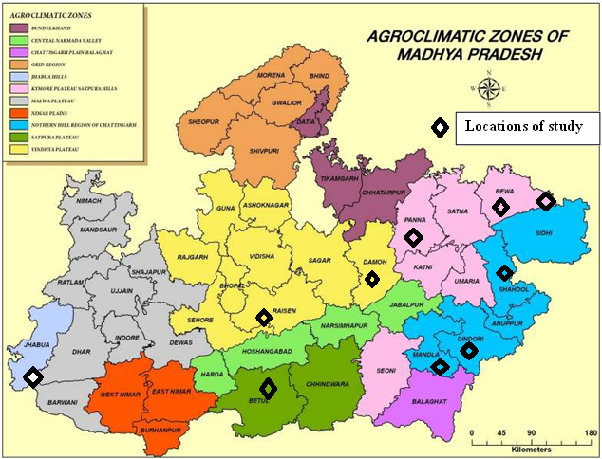

Figure.1. Locations of study. (Map courtesy: ICAR-CRIDA contingency plans for Madhya Pradesh)

