ANNEX A, Tables and figures contain the raw data of the specific study that was discussed in the manuscript

Table A1 The radon entry rate due to underground soil and various meteorological parameters during the measurements.

 | Rn entry rate |  | Temperature |  | Rainfall | Atm.Pressure |  | Wind speed
 | (Bq.m⁻³.h⁻¹) ± σ |  | (°C) ± σ |  | mm | (+760 mmHg) ± σ |  | (Km h⁻¹) ± σ
JUL | 5.8 | 0.6 | 25.0 | 3.4 | 2.1 | 3.3 | 1.8 | 3.4 | 1.7
JUL | 4.1 | 0.4 | 25.9 | 2.2 | 1.1 | 5.5 | 1.9 | 2.2 | 1.1
AUG | 5.8 | 0.6 | 27.3 | 1.8 | 0.8 | 5.5 | 2.0 | 1.8 | 1.0
AUG | 4.6 | 0.6 | 27.0 | 1.2 | 1.3 | 4.1 | 2.2 | 1.2 | 0.6
SEP | 2.9 | 0.3 | 22.4 | 3.2 | 2.5 | 6.8 | 3.2 | 3.2 | 2
SEP | 3.9 | 0.4 | 20.0 | 1.6 | 2.2 | 8.8 | 2.2 | 1.6 | 0.8
OCT | 5.6 | 0.7 | 18.7 | 3.4 | 2.5 | 4.5 | 2.7 | 3.4 | 2.0
OCT | 5.2 | 0.6 | 15.6 | 1.6 | 1.6 | 2.6 | 3.5 | 1.6 | 0.8
NOV | 4.8 | 0.6 | 15.1 | 1.8 | 2.7 | 7.5 | 3.3 | 1.8 | 1.0
NOV | 2.2 | 0.3 | 10.7 | 4.2 | 2.4 | 3.9 | 5.3 | 4.2 | 2.1
DEC | 2.2 | 0.2 | 8.6 | 3.8 | 2.7 | 4.9 | 6.0 | 3.8 | 1.9
DEC | 1.5 | 0.2 | 7.6 | 3.2 | 2.6 | 8.0 | 4.7 | 3.2 | 1.6
JAN | 1.8 | 0.2 | 2.5 | 4.0 | 1.5 | 10.4 | 5.0 | 4.0 | 2.0
JAN | 0.7 | 0.1 | 6.4 | 3.2 | 2.4 | 7.2 | 2.4 | 3.2 | 1.6
JAN | 1.0 | 0.1 | 6.2 | 4.6 | 2.6 | 5.3 | 5.9 | 4.6 | 2.3
FEB | 2.3 | 0.2 | 5.8 | 4.6 | 2.5 | 9.8 | 4.1 | 4.6 | 2.3
FEB | 2.1 | 0.2 | 4.6 | 4.4 | 2.3 | 2.9 | 5.6 | 4.4 | 2.2
MAR | 1.9 | 0.2 | 6.0 | 5.2 | 3.3 | 1.4 | 7.4 | 5.2 | 2.6
MAR | 2.7 | 0.3 | 12.1 | 4.4 | 2.2 | 0.1 | 5.4 | 4.4 | 2.2
APR | 3.9 | 0.4 | 13.0 | 3.8 | 2.4 | 3.0 | 2.7 | 3.8 | 1.9
APR | 2.7 | 0.3 | 15.2 | 3.8 | 1.4 | 0.8 | 2.9 | 3.8 | 1.9
MAY | 6.3 | 0.7 | 16.4 | 3.2 | 1.1 | 2.1 | 1.6 | 3.2 | 1.6
MAY | 5.6 | 0.7 | 19.5 | 3.6 | 2.2 | 3.3 | 3,0 | 3.6 | 1.8
JUN | 3.3 | 0.4 | 23.3 | 3.8 | 1.6 | 2.3 | 1.7 | 3.8 | 1.9
JUN | 4.5 | 0.5 | 24.1 | 4.0 | 2.2 | 1.4 | 2.6 | 4.0 | 2.0
JUL | 4.1 | 0.5 | 25.3 | 5.2 | 2.1 | 2.0 | 2.4 | 5.2 | 2.6
JUL | 3.7 | 0.5 | 24.3 | 4.8 | 2.0 | 2.1 | 2.7 | 4.8 | 2.4
JUL | 6.4 | 0.9 | 25.8 | 4.2 | 1.2 | 1.3 | 2.2 | 4.2 | 2.1
AUG | 5.4 | 0.6 | 25.5 | 4.2 | 0.9 | 1.4 | 2.2 | 4.2 | 2.1
AUG | 6.2 | 0.8 | 25.1 | 3.8 | 2.6 | 4.1 | 5.7 | 3.8 | 1.9
SEP | 4.6 | 0.5 | 22.1 | 3.6 | 2.5 | 2.5 | 3.3 | 3.6 | 1.8
SEP | 4.2 | 0.4 | 21.3 | 3.0 | 2.3 | 0.7 | 3.9 | 3.0 | 1.5
OCT | 3.4 | 0.3 | 19.3 | 3.4 | 1.5 | 0.3 | 2.5 | 3.4 | 1.7
OCT | 3.1 | 0.3 | 19.7 | 3.0 | 1.6 | 2.8 | 2.7 | 3.0 | 1.5

Table A2 The radon entry rate and radon concentration of the underground soil associated with the infiltration rate in the prototype device

 | Radon in soil gas (kB m⁻³) |  |  | Radon entry rate (B m⁻³ h⁻¹) |  | Infiltration rate (h⁻¹)
JUL |  | 11.2 | 1.7 | 5.8 | 0.9 | 0.069 | 0.015
JUL |  | 6.9 | 1.2 | 4.1 | 0.7 | 0.079 | 0.018
AUG |  | 10.3 | 1.7 | 5.8 | 0.9 | 0.076 | 0.017
AUG |  | 9.3 | 1.6 | 4.6 | 0.8 | 0.067 | 0.016
SEP |  | 9.1 | 1.3 | 2.9 | 0.4 | 0.042 | 0.008
SEP |  | 7.7 | 1.3 | 3.9 | 0.7 | 0.068 | 0.016
OCT |  | 10.9 | 1.6 | 5.6 | 0.8 | 0.069 | 0.014
OCT |  | 9.6 | 1.5 | 5.2 | 0.8 | 0.073 | 0.016
NOV |  | 8.7 | 1.2 | 4.8 | 0.7 | 0.074 | 0.014
NOV |  | 9.4 | 1.2 | 2.2 | 0.3 | 0.031 | 0.005
DEC |  | 14.4 | 1.9 | 2.2 | 0.3 | 0.020 | 0.004
DEC |  | 8.8 | 1.2 | 1.5 | 0.2 | 0.023 | 0.004
JAN |  | 18.7 | 1.7 | 1.8 | 0.2 | 0.013 | 0.002
JAN |  | 13.2 | 1.7 | 0.7 | 0.1 | 0.007 | 0.001
JAN |  | 15.3 | 1.7 | 1.0 | 0.1 | 0.009 | 0.001
FEB |  | 17.2 | 1.7 | 2.3 | 0.2 | 0.018 | 0.003
FEB |  | 19.4 | 2.3 | 2.1 | 0.3 | 0.015 | 0.002
MAR |  | 13.9 | 1.1 | 1.9 | 0.2 | 0.018 | 0.002
MAR |  | 16.4 | 1.7 | 2.7 | 0.3 | 0.022 | 0.003
APR |  | 20.2 | 2.3 | 3.9 | 0.4 | 0.026 | 0.004
APR |  | 15.1 | 1.7 | 2.7 | 0.3 | 0.024 | 0.004
MAY |  | 16.4 | 1.7 | 6.3 | 0.7 | 0.051 | 0.008
MAY |  | 15.9 | 1.7 | 5.6 | 0.6 | 0.047 | 0.007
JUN |  | 13.1 | 1.1 | 3.3 | 0.3 | 0.034 | 0.004
JUN |  | 11.0 | 1.1 | 4.5 | 0.5 | 0.054 | 0.008
JUL |  | 12.2 | 1.1 | 4.1 | 0.4 | 0.044 | 0.006
JUL |  | 12.9 | 1.8 | 3.7 | 0.5 | 0.038 | 0.008
JUL |  | 12.4 | 1.8 | 6.4 | 0.9 | 0.069 | 0.014
AUG |  | 11.5 | 1.3 | 5.4 | 0.6 | 0.063 | 0.010
AUG |  | 13.5 | 1.3 | 6.2 | 0.6 | 0.061 | 0.008
SEP |  | 14.2 | 1.9 | 4.6 | 0.6 | 0.043 | 0.008
SEP |  | 10.2 | 1.8 | 4.2 | 0.7 | 0.055 | 0.014
OCT | 9.2 |  | 1.2 | 3.4 | 0.4 | 0.048 | 0.009
OCT | 11.0 |  | 1.8 | 3.1 | 0.5 | 0.037 | 0.009

Table A3 Air and device temperature, the soil temperature gradient to 3m depth and radon entry rate in a model dwelling in a temperate climate and over a low radon content underground soil.

Air Temperature | 24.9 | 26.9 | 21.1 | 17.2 |  | 11.9 | 6.4 | 5.6 | 4.8 | 8.8 | 14.4 | 18.9 | 23.9 | 24.9 | 25.7 | 21.6 | 17.2
Device Temperature | 24.9 | 26.9 | 21.1 | 18.0 |  | 18.0 | 18.0 | 18.0 | 18.0 | 18.0 | 18.0 | 18.9 | 23.9 | 24.9 | 25.7 | 21.6 | 18.0
Soil Temperature | JUL | AUG | SEP | OCT |  | NOV | DEC | JAN | FEB | MAR | APR | MAY | JUN | JUL | AUG | SEP | OCT
surface (0 m) | 37 | 35 | 28 | 19 |  | 12 | 7 | 5 | 8 | 12 | 20 | 27 | 34 | 37 | 35 | 28 | 19
0.25 | 30 | 30 | 25 | 18 |  | 13 | 8 | 6 | 7 | 10 | 15 | 22 | 26 | 30 | 30 | 25 | 18
0.5 | 27 | 28 | 25 | 20 |  | 15 | 10 | 7 | 7 | 10 | 14 | 19 | 23 | 27 | 28 | 25 | 20
Radon entry surface (1m) | 26 | 27 | 25 | 21 |  | 17 | 13 | 10 | 10 | 11 | 14 | 18 | 22 | 26 | 27 | 25 | 21
1.2 | 25 | 26 | 25 | 22 |  | 18 | 14 | 11 | 10 | 11 | 14 | 18 | 22 | 25 | 26 | 25 | 22
1.5 | 23 | 24 | 24 | 21 |  | 18 | 14 | 12 | 11 | 12 | 14 | 17 | 20 | 23 | 24 | 24 | 21
1.8 | 22 | 24 | 24 | 22 |  | 19 | 18 | 14 | 12 | 12 | 14 | 17 | 19 | 22 | 24 | 24 | 22
3 | 19 | 21 | 22 | 21 |  | 20 | 20 | 16 | 15 | 14 | 15 | 16 | 17 | 19 | 21 | 22 | 21
(T_{air} - T_{1m soil}) / T_{1m soil} | 0.02 | 0.00 | 0.16 | 0.19 |  | 0.30 | 0.50 | 0.45 | 049 | 0.21 | 0.01 | 0.03 | 0.08 | 0.02 | 0.04 | 0.14 | -0.19
ΔT = (T_{z} - T_{1m soil}) | JUL | AUG | SEP | OCT |  | NOV | DEC | JAN | FEB | MAR | APR | MAY | JUN | JUL | AUG | SEP | OCT
Device | -0.6 | 0.1 | -3.9 | -3.2 |  | 0.9 | 5.2 | 7.8 | 8.5 | 6.9 | 3.7 | 0.6 | 1.7 | -0.6 | -1.1 | -3.4 | -3.2
Air | -0.6 | 0.1 | -3.9 | -4.0 |  | -5.2 | -6.4 | -4.6 | -4.7 | -2.3 | 0.1 | 0.6 | 1.7 | -0.6 | -1.1 | -3.4 | -4.0
Soil surface (0 m) | 11.6 | 8.6 | 3.2 | -1.9 |  | -4.7 | -5.8 | -5.0 | -1.9 | 1.2 | 6.1 | 9.1 | 11.5 | 11.6 | 8.6 | 3.2 | -1.9
0.25 | 4.5 | 2.8 | -0.2 | -2.8 |  | -4.2 | -4.9 | -4.0 | -2.6 | -1.2 | 0.8 | 3.5 | 4.2 | 4.5 | 2.8 | -0.2 | -2.8
0.5 | 1.4 | 1.2 | -0.5 | -1.6 |  | -2.3 | -3.2 | -3.1 | -2.1 | -1.4 | 0.0 | 0.8 | 1.1 | 1.4 | 1.2 | -0.5 | -1.6
Radon entry surface (1m) | 0.0 | 0.0 | 0.0 | 0.0 |  | 0.0 | 0.0 | 0.0 | 0.0 | 0.0 | 0.0 | 0.0 | 0.0 | 0.0 | 0.0 | 0.0 | 0.0
1.2 | -0.7 | -0.5 | -0.1 | 0.3 |  | 0.7 | 0.8 | 0.6 | 0.3 | 0.1 | 0.0 | -0.4 | -0.6 | -0.7 | -0.5 | -0.1 | 0.3
1.5 | -2.7 | -2.7 | -1.1 | 0.2 |  | 1.3 | 1.6 | 2.1 | 1.5 | 0.6 | -0.6 | -1.6 | -2.4 | -2.7 | -2.7 | -1.1 | 0.2
1.8 | -3.1 | -2.4 | -1.1 | 0.7 |  | 2.2 | 4.8 | 3.4 | 2.4 | 1.2 | -0.3 | -1.8 | -2.9 | -3.1 | -2.4 | -1.1 | 0.7
3 | -6.3 | -5.9 | -3.3 | 0.1 |  | 2.9 | 7.1 | 6.2 | 5.5 | 3.1 | 0.2 | -2.6 | -4.9 | -6.3 | -5.9 | -3.3 | 0.1
ΔΤ / Δz | JUL | AUG | SEP | OCT |  | NOV | DEC | JAN | FEB | MAR | APR | MAY | JUN | JUL | AUG | SEP | OCT
0.25 | 6.0 | 3.7 | -0.3 | -3.7 |  | -5.6 | -6.5 | -5.3 | -3.5 | -1.6 | 1.1 | 4.7 | 5.6 | 6.0 | 3.7 | -0.3 | -3.7
0.5 | 2.8 | 2.4 | -1.0 | -3.2 |  | -4.6 | -6.4 | -6.2 | -4.2 | -2.8 | 0.0 | 1.6 | 2.2 | 2.8 | 2.4 | -1.0 | -3.2
averaged ΔΤ / Δz | 4.4 | 3.1 | -0.6 | -3.5 |  | -5.1 | -6.5 | -5.8 | -3.8 | -2.2 | 0.5 | 3.1 | 3.9 | 4.4 | 3.1 | -0.6 | -3.5
±σ | 2.3 | 0.9 | 0.5 | 0.4 |  | 0.7 | 0.1 | 0.6 | 0.5 | 0.8 | 0.8 | 2.2 | 2.4 | 2.3 | 0.9 | 0.5 | 0.4
Radon entry surface (1m) | 0.0 | 0.0 | 0.0 | 0.0 |  | 0.0 | 0.0 | 0.0 | 0.0 | 0.0 | 0.0 | 0.0 | 0.0 | 0.0 | 0.0 | 0.0 | 0.0
1.2 | -3.5 | -2.5 | -0.5 | 1.5 |  | 3.5 | 4 | 3 | 1.5 | 0.5 | 0 | -2 | -3 | -3.5 | -2.5 | -0.5 | 1.5
1.5 | -5.4 | -5.4 | -2.2 | 0.4 |  | 2.6 | 3.2 | 4.2 | 3 | 1.2 | -1.2 | -3.2 | -4.8 | -5.4 | -5.4 | -2.2 | 0.4
1.8 | 3.88 | -3.0 | 1.37 | 0.87 |  | 2.75 | 6 | 4.25 | 3 | 1.5 | 0.38 | 2.25 | 3.63 | 3.9 | -3 | 1.38 | 0.88
3 | 3.15 | -2.95 | -1.65 |  | 0.05 | 1.45 | 3.55 | 3.1 | 2.75 | 1.55 | 0.1 | -1.3 | 2.45 | 3.2 | 2.95 | 1.65 | 0.05
averaged ΔΤ / Δz | -4.0 | -3.5 | -1.4 | 0.7 |  | 2.6 | 4.2 | 3.6 | 2.6 | 1.2 | -0.4 | -2.2 | -3.5 | -4.0 | -3.5 | -1.4 | 0.7
±σ | 1.0 | 1.3 | 0.7 | 0.6 |  | 0.8 | 1.3 | 0.7 | 0.7 | 0.5 | 0.6 | 0.8 | 1.0 | 1.0 | 1.3 | 0.7 | 0.6
Radon entry rate | 8.2 | 7.7 | 4.7 | 7.8 |  | 4.7 | 3.0 | 1.1 | 3.3 | 3.5 | 4.8 | 8.9 | 5.6 | 4.7 | 8.6 | 6.6 | 5.0
±σ | 0.8 | 0.8 | 0.4 | 0.9 |  | 0.5 | 0.3 | 0.3 | 0.3 | 0.4 | 0.5 | 0.5 | 0.6 | 0.5 | 0.9 | 0.7 | 0.5
√(T_{air} -T_{d})/T_{d} |  |  |  | 0.21 |  | 0.58 | 0.80 | 0.83 | 0.86 | 0.71 | 0.45
±σ |  |  |  | -0.8 |  | -6.1 | 11.6 | 12.4 | 13.2 | -9.2 | -3.6

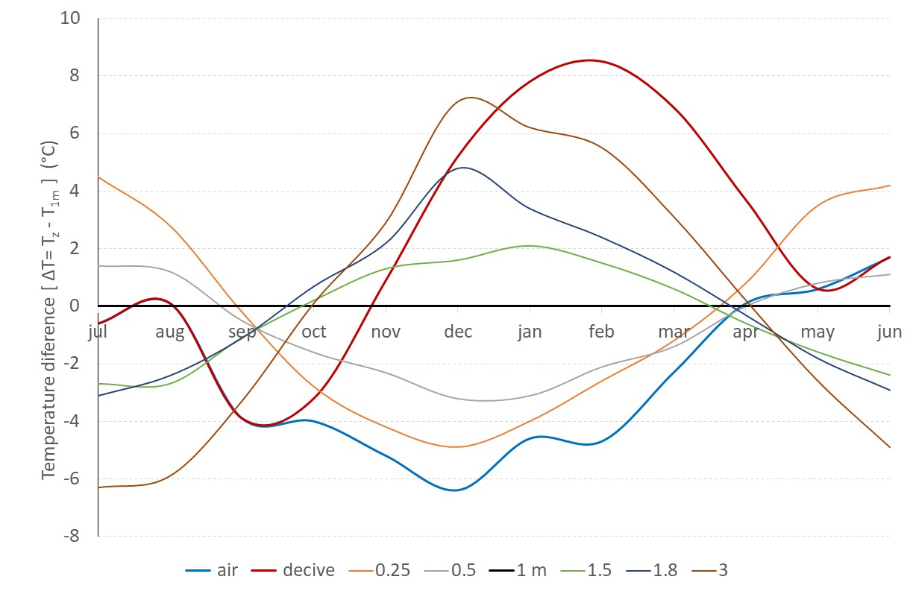
Figure A1 The soil temperature gradient and the device-dwelling and air

