Supplemental Materials
Estimation of the basic reproduction number of novel coronavirus (COVID-19) in Bangladesh: A 65-day’s outbreak data-driven analysis
Md. Hasan, Akhtar Hossain, Wasimul Bari, Syed Shariful Islam

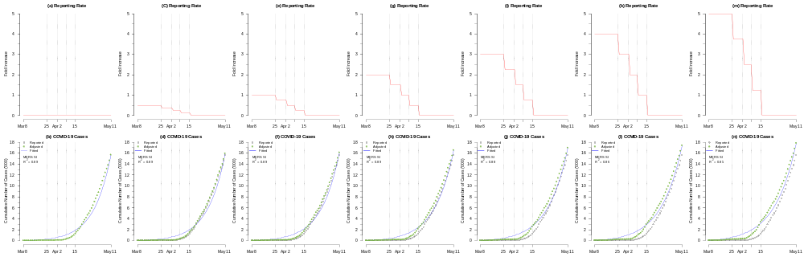
Figure S1: The scenarios of the change in the reporting rate (top panels) and the exponential growth fitting (bottom panels) based on the MERS SI. The top panels, i.e., (a), (c), (e), (g), (i), (k), and (m) show the assumed change in the reporting rate. The bottom panels, i.e., (b), (d), (f), (h), (j), (l), and (n) show the reported (or observed, black circles), adjusted (green dots) and fitted (blue curve) the number of COVID-19 infections. The vertical grey line represents the date when the number of tests reached 100, 500, 1000, and 2000. Panels (a) and (b) show the scenarios that the reporting rate was unchanged. Panels (c) and (d) show the scenarios that the reporting rate increased by 0.5-fold. Panels (e) and (f) show the scenarios that the reporting rate increased by 1-fold. Panels (g) and (h) show the scenarios that the reporting rate increased by 2-fold. Panels (i) and (j) show the scenarios that the reporting rate increased by 3-fold. Panels (k) and (l) show the scenarios that the reporting rate increased by 4-fold. Panels (m) and (n) show the scenarios that the reporting rate increased by 5-fold.

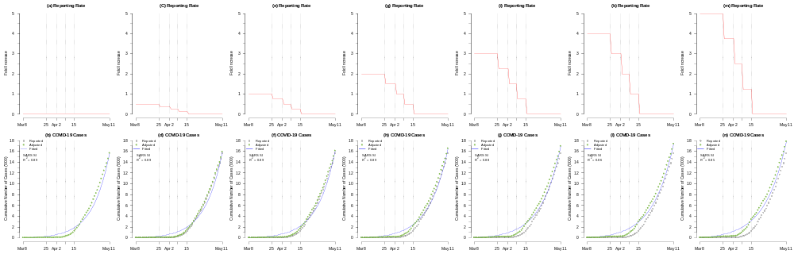
Figure S2: The scenarios of the change in the reporting rate (top panels) and the exponential growth fitting (bottom panels) based on the SARS SI. The top panels, i.e., (a), (c), (e), (g), (i), (k), and (m) show the assumed change in the reporting rate. The bottom panels, i.e., (b), (d), (f), (h), (j), (l), and (n) show the reported (or observed, black circles), adjusted (green dots) and fitted (blue curve) the number of COVID-19 infections. The vertical grey line represents the date when the number of tests reached 100, 500, 1000, and 2000. Panels (a) and (b) show the scenarios that the reporting rate was unchanged. Panels (c) and (d) show the scenarios that the reporting rate increased by 0.5-fold. Panels (e) and (f) show the scenarios that the reporting rate increased by 1-fold. Panels (g) and (h) show the scenarios that the reporting rate increased by 2-fold. Panels (i) and (j) show the scenarios that the reporting rate increased by 3-fold. Panels (k) and (l) show the scenarios that the reporting rate increased by 4-fold. Panels (m) and (n) show the scenarios that the reporting rate increased by 5-fold.

