Supplemental material

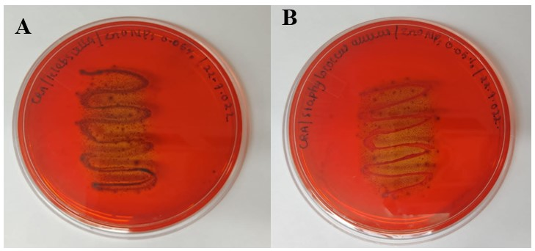
S. Figure 1: Screening for biofilm production (A) K. pneumoniae and (B) S. aureus on Congo red agar.

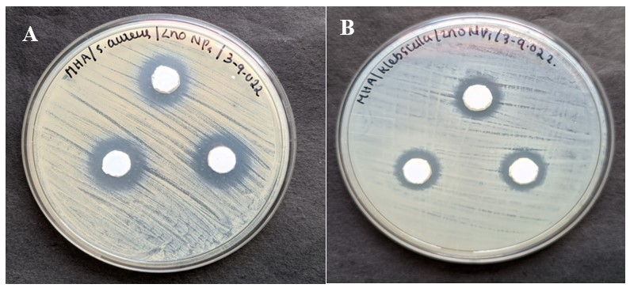
S. Figure 2: Antibacterial activity analysis of ZnO NPs against (A) S. aureus and (B) K. pneumoniae.

