Changes of histidine-rich glycoprotein levels in critically ill septic patients
Ayu Nabila Kusuma Pradana¹, Tomohiko Akahoshi¹*, Jie Guo¹, Yukie Mizuta³, Shuntaro Matsunaga¹, Sayuko Narahara², Masaharu Murata², Ken Yamaura³
¹Department of Advanced Emergency and Disaster Medicine, Graduate School of Medical Sciences, Kyushu University, Fukuoka 812-8582, Japan.
²Center for Advanced Medical Innovation, Kyushu University, Fukuoka 812-8582, Japan.
³Department of Anesthesiology and Critical Care Medicine, Graduate School of Medical Sciences, Kyushu University, Fukuoka 812-8582, Japan.
*akahoshi.tomohiko.006@m.kyushu-u.ac.jp

Supplementary Table 1. Japanese Society on Acute Medicine (JAAM) DIC score¹³
Scoring system | Score
Systemic inflammatory response syndrome criteria
≥ 3 | 1
0-2 | 0
Platelet counts (x 10⁹/L)
< 80 or more than 50% decrease within 24 hours | 3
>80 and < 120 or more than 30% decrease within 24 hours | 1
>120 | 0
Prothrombin time (PT ratio)
≥ 1.2 | 1
<1.2 | 0
FDP (D-dimer)
≥25 µg/mL (use conversion chart) | 3
≥10, <25 µg/mL (use conversion chart) | 1
The diagnosis of DIC is made if the score is 4 or more
Criteria for systemic inflammatory response syndrome
- Temperature >38 0C or <36 0C
- Heart rate >90 x/min
- Respiratory rate >20 x/min or PaC02<32 torr (<4.3 kPa)
- White cell blood counts >12,000/mm3, <4,000cells/mm3, or 10% immature (band) forms

FDP, fibrin/fibrinogen degradation product
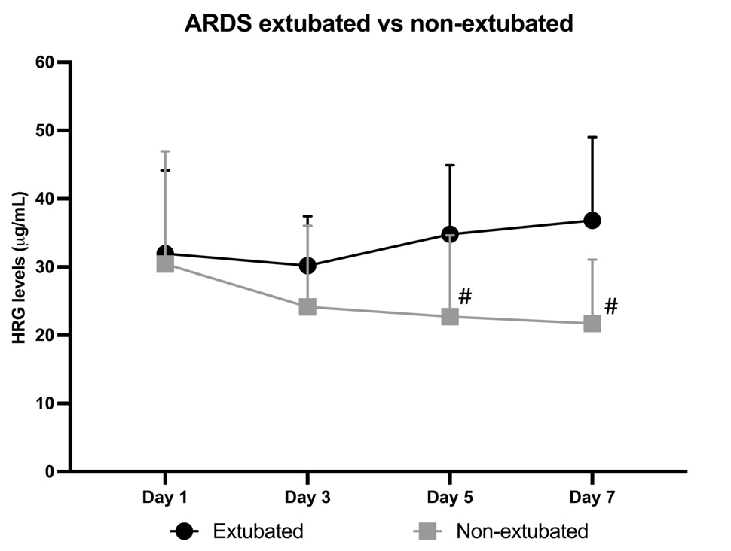

Supplementary Figure 1. HRG levels in extubated and non-extubated ARDS patients
Non-extubated ARDS patients had lower HRG levels than extubated patients (19) on days 5 and 7, and 9 of 15 non-extubated ARDS patients died within 28 days. Data presented as mean and standard deviation. #P <0.05 vs. the other group.

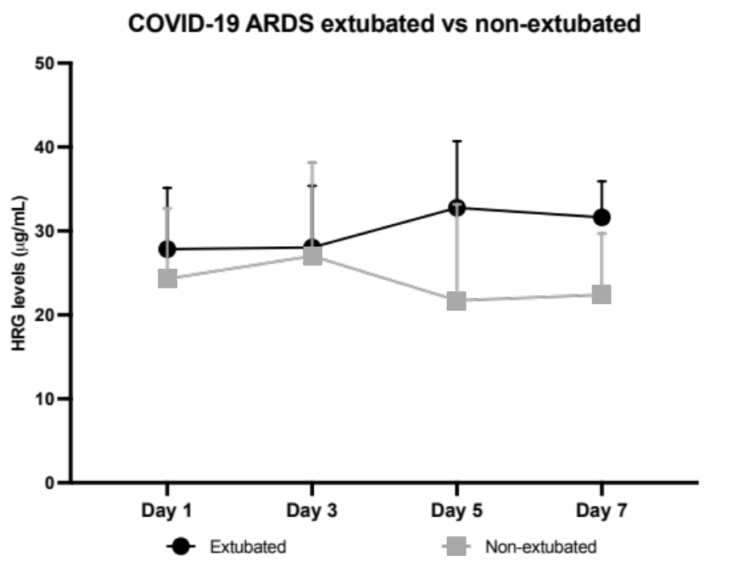

Supplementary Figure 2. HRG levels in extubated and non-extubated COVID-19 ARDS patients
Non-extubated (n=7) COVID-19 ARDS patients had slightly lower HRG levels than extubated patients (n=13), but not significantly. 2 of 7 non-extubated COVID-19 ARDS patients died within 28 days. Data presented as mean and standard deviation.

