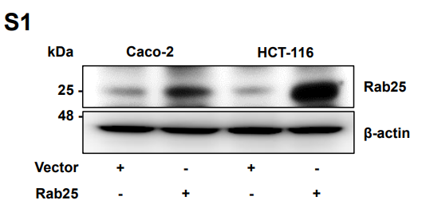
Supplementary Information

Supplementary Fig S1. The immunoblot image of Rab25 overexpression. The cell lysates were analyzed by immunoblotting with indicated antibodies.

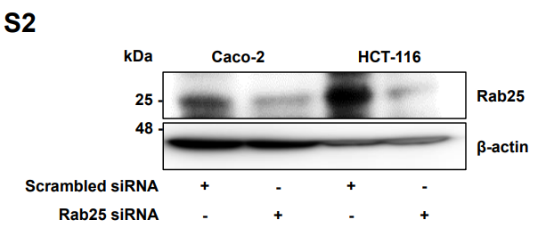
Supplementary Fig S2. The immunoblot image of silencing of Rab25. The cell lysates were analyzed by immunoblotting with indicated antibodies.

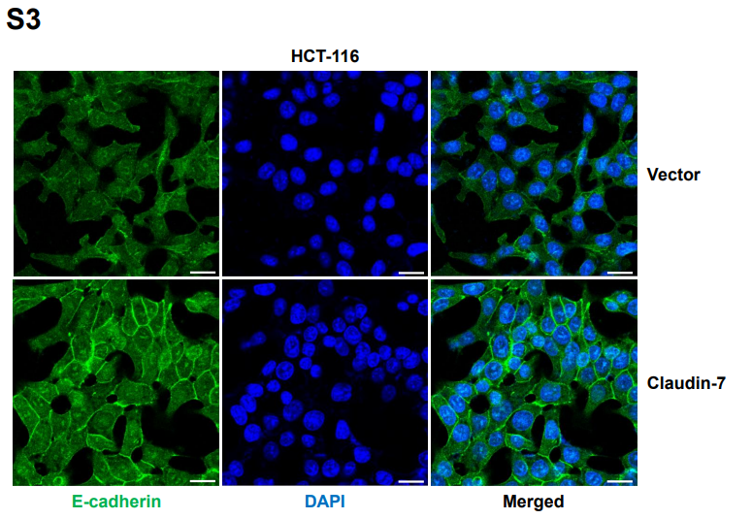
Supplementary Fig S2. The immunofluorescence image of E-cadherin expression induced by claudin-7. The expression of E-cadherin was visualized by immunofluorescence. Original magnification, ×400; scale bar, 20 𝜇m

